Steps done:

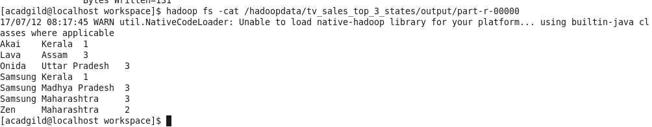
1) The total sales of each company per state are retrieved.

2) Using the output file for the first part, top 3 state wise sales for each company are generated.

