|  |  |  |
| --- | --- | --- |
| IPG | Standard Operating Procedure | fiserv_logo_orange_rgb |
| Fiserv/Financial Operations IPG / PGH |
| Version No: 01 | FISERV/EMI INSTALMENTS/SOP/01 | Effective Date: 23.02.2023 |

Contents

[SOP for EMI FLOW(INSTALLMENT) 1](file:///D:\Users\F98KGJ3\AppData\Local\Microsoft\Windows\INetCache\Content.Outlook\KN5QFR3G\SOP%20for%20Manual%20Refund.docx#_Toc128063964)

# **Scope**

Scope defines the processes of EMI flow (installment transactions) queries from merchant for card transactions.

# **Document objective**

The objective of the document is to define the processes and turnaround time as defined. This document can also form basis for a reference manual.

# **Process**

stage 1 – In IPG for IPP/EMI flow two integrations methods/types are present.

Connect:

* 1. Tenure selection will be present on Fiserv page based on the tenure configured in backend.
  2. For backend related queries please refer attached file below



API:

1. Tenure selection will be present on Merchant page.
2. Merchant needs to trigger transaction on the corresponding store id triggered at IPG end.

Stage 2 – Based on the Merchant requirement Fiserv will receive EMI integration or boarding for IPP/EMI MID/Store.

# **Abbreviations**

N/A

# **EMI TRANSACTIONS FLOW VIA CONNECT INTERGATION**

1. User/customer will enter the details on Fiserv page such as payment method, Bank, etc. and click on continue button. This initial process is performed on the parent MID configured at IPG end.

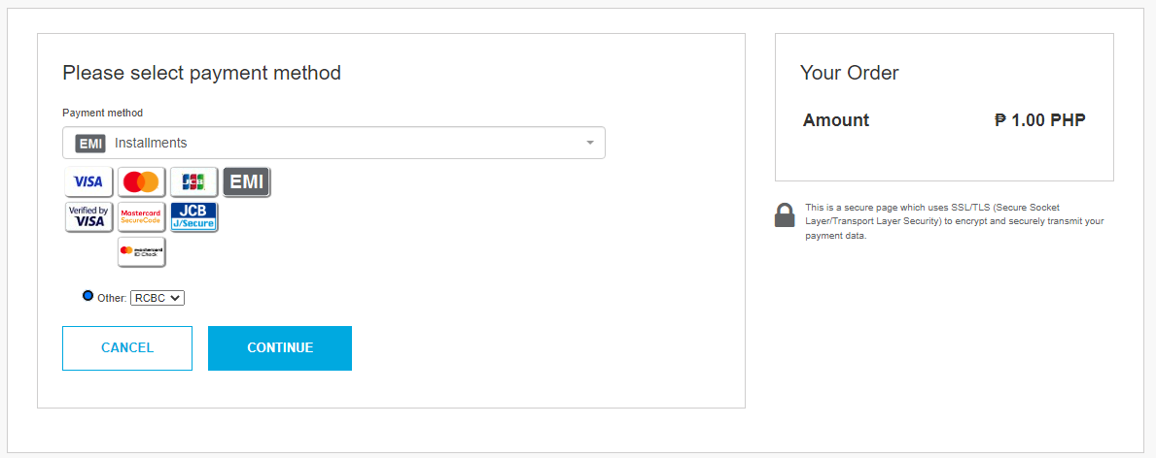

1. Once clicking on continue button the transaction will route ocean and take the tenure details from backend configured for MID/store. Based on the tenure present in the backend the customer will select the tenure for the installment and add the mandatory details displayed on the tenure selection page and proceed further.

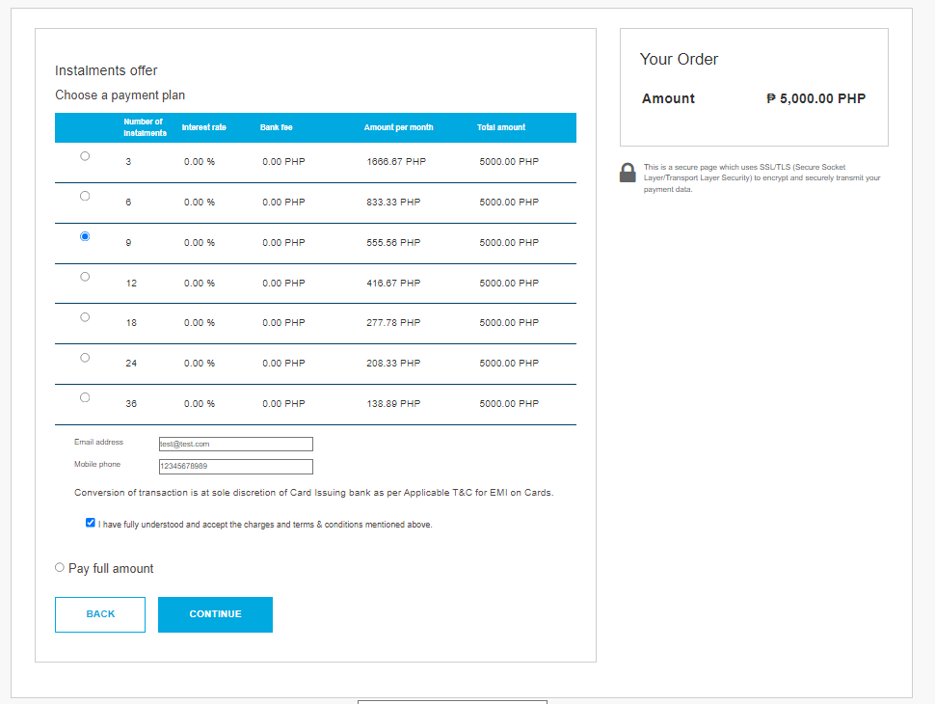

1. Post tenure selection transaction will route to enter the card details as mentioned in below screenshot.

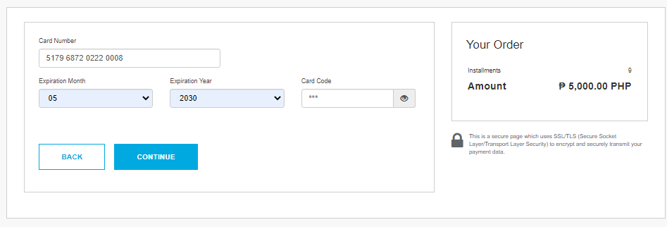

1. Once card details entered the validation will be taken place whether the card BIN is eleigible for the IPP/EMI transaction. If eligible transaction will further proceed for authentication and authorization. If card bin is not eligilble transaction will get delined with EMI Unavailable.
2. Plesae Refer the below attached doc for connect request and response flow from IPG to ocean and ocean to IPG.



# **EMI TRANSACTIONS FLOW VIA API INTERGATION**

API transactions is initiated by Merchant at there end. The tenure selection and the other details will be taken at merchant end on the MID configured in backend at IPG and ocean end. Once card details entered at merchant page the transaction will process further with authentication and authorization.

**Queries and Issue :**

1. **EMI unavailable:** The issue will occur if EMI file not uploaded from merchant end for tenures and if MID is not configured /added in the mid\_configuration table. And if the Card Bin is not eligible for IPP/EMI.

If the query receive from merchant that there transactions are failing with N: -E001:EMI unavailable. We must check the logs in Kibana and the error receiving in logs based on that need to follow below steps from IPG and Ocean end.

* 1. First step to check the store configuration whether the installment service is enabled on the mentioned store and ocean MID is configured.

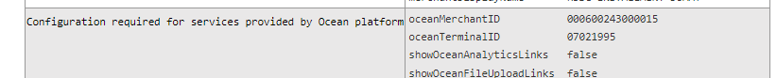

* 1. If the MID is configured check in IPP/Ocean DB the MID is configured or not using belo queries.

select merch\_id from mid\_configuration where merch\_id ='000600243000122' and merch\_id\_sht ='08022019' and status='Active';

SELECT BANK\_ID, BANK\_NAME, ONUS FROM EMI\_BANK\_DETAILS WHERE BANK\_ID IN (SELECT DISTINCT(BANK\_ID) FROM RCBC\_EMI\_MID\_CONFIGURATION WHERE MID ='000600243000122');

* 1. If MID is present in the above two tables mentioned in the queries. Need to check the tenures are configured at the backend using below query.

select a.tenure,b.interest\_rate,b.processing\_fee,b.min\_amount,b.max\_amount,a.emi\_mid, a.emi\_tid from RCBC\_EMI\_MID\_CONFIGURATION a, RCBC\_SCHEME\_CONFIGURATION   
where a.bank\_id='001' and a.MID='000600243000122' and a.rcbc\_scheme\_id = b.rcbc\_scheme\_id order by a.tenure asc;

1. **Installment Option is not visible on the mentioned MID:** Need to check the store configuration whether the installment service is enabled on the mentioned store.

If installment service is not enabled on the store/MID then need to convey the same to merchant (get approval from sale to enable the installment service on the store/MID).

1. In case if MID is not present in mid\_configuration table need to insert the MID in IPP/EMI/Ocean DB using below query.

For checking the ID:

select \* from mid\_configuration order by id desc;

To insert the MID: We need to check the values from DR\_Rac DB using below queries and pass the values in insert query.

select \* from MDB.ADDRESS;

select \* from MDB.MERCHANT;

**IPP/EMI/OCEAN DB QUERY**:

insert into mid\_configuration  
(id,MID\_NUMBER,MAX\_TRANSACTION\_LIMIT,MERCHANT\_NAME,MCC\_CODE,MERCHANT\_CITY,MERCHANT\_STREET\_ADDRESS,MERCHANT\_STATE\_PROV\_CODE,MERCHANT\_POS\_COUNTRY\_CODE,MERCHANT\_POS\_ZIP\_CODE,MERCHANT\_PHONE\_NUMBER,  
MERCHANT\_EMAIL\_ID,  
CREATEDTS,UPDATEDTS,merch\_id,merch\_id\_sht,status)  
VALUES  
(1183,'21000058',0,'POWER PREMIUM GADGETS','4812','PASIG CITY','3F PIA BLDG 65 EAST CAPITOL','PHL',0,'1603','09065690889','admin@[powerpremiumgadgets.com](http://powerpremiumgadgets.com/)',SYSDATE,SYSDATE,  
'000600243000585','21000058','Active');