Rahul Jain

Abstract

Demo API Architecture & Security Recommendations

Design Document

Demo

**Architecture:**

Architecture for API Gateway (scenario of serverless app consuming APIs using API Gateway)

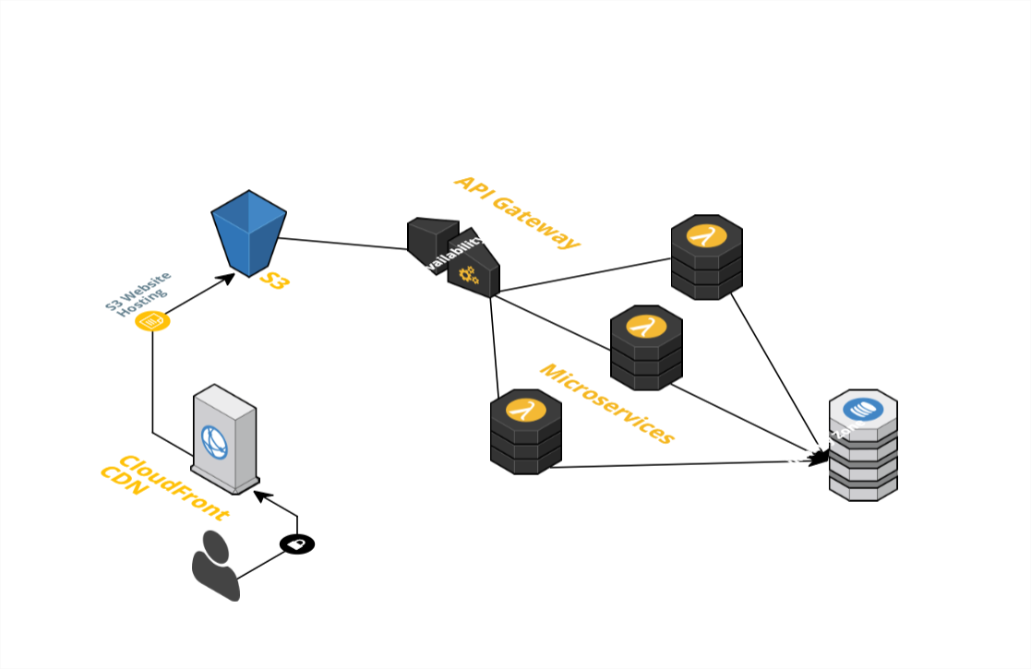

**Security Considerations:**

1. Define API Keys for secure calls to the API
2. CORS- To allow only specific origins to make calls for the API
3. AWS Cognito – Use authentication for making secure API calls
4. Secure the transport channel via encryption of the request/response using the JWT
5. Protect the APIs by defining the policies for SQL Injection, blacklisted domains, etc.