A Project Description

On

**Page Rank Algorithm**

**RAHUL JAUHARI 2020A7PS0106H**

**SANCHIT GUPTA 2020A7PS2069H**

**ABHIRAJ KHARE 2020A7PS0161H**

Under the supervision of

**FACULTY: Dr. N L Bhanumurthy**

**SUBMITTED AS AN EVALUATION COMPONENT OF**

**Course: Information Retrieval CS F469**

**BIRLA INSTITUTE OF TECHNOLOGY AND SCIENCE PILANI**

**HYDERABAD CAMPUS**

**Storing connections from a graph in a list:**

The user will enter the connections of the graph and we’re storing it in a list.

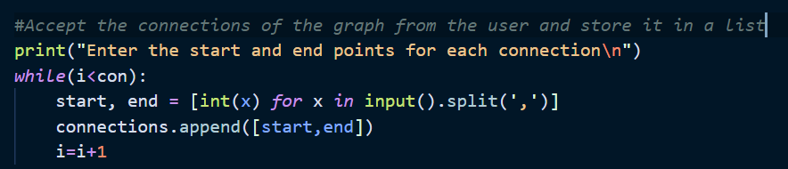

**Counting the number of outgoing connections from a node:**

It calculates the number of pages that can be reached from that web page.

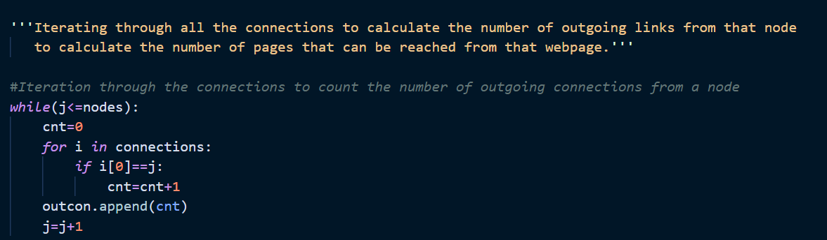

The above function counts the number of outgoing connections of the graph from a node.

**Probability Transtition Matrix:** The principal left eigen vector of the transition matrix indicates the probability of being on each webpage.

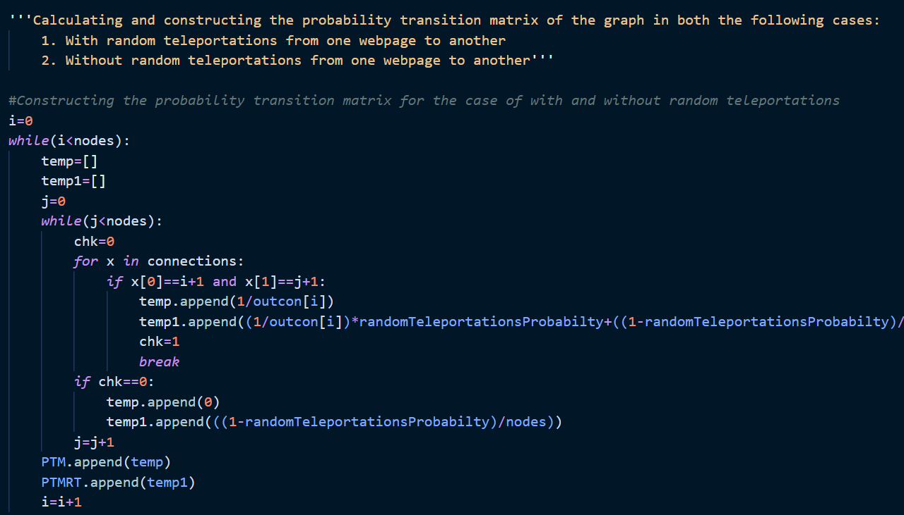

**Eigen Values and Left Eigenvector:**

Using the linear algebra module in scipy. eigenval,eigenleftvector=linalg.eig(a=np.array(PTMRT),b=None,left=True,right=False,overwrite_a=False,overwrite_b=False,check_finite=False).

The principal left eigen vector of the transition matrix indicates the probability of being on each webpage.

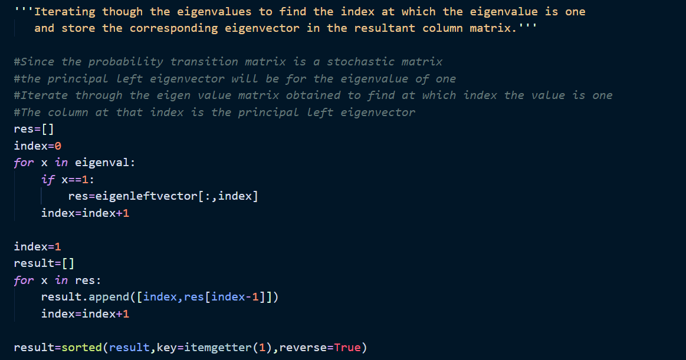

**Probability of being on each web page:**

The principal left eigen vector of the transition matrix represent the probability of being on each web page.

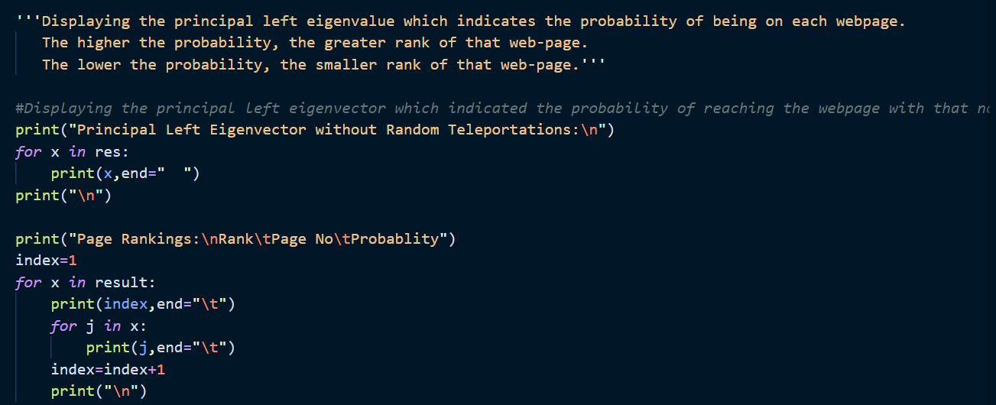

**Test Case 1:**

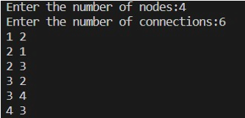

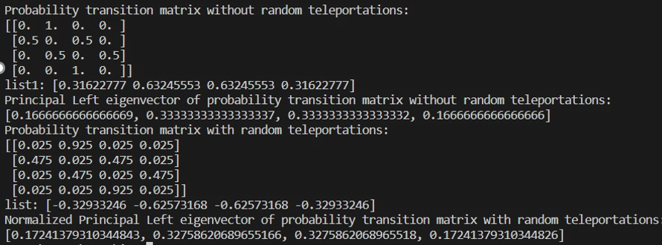

**Test Case 2:**

