REPORT
Optimising NYC Taxi Operations
Exploratory Data Analysis | Yellow Taxi Trip Records 2023

1. Data Preparation

1.1 Loading the Dataset
The dataset used for this analysis is the NYC Yellow Taxi Trip Records for the year 2023, sourced from the NYC Taxi and Limousine Commission (TLC). The data is provided in Parquet format, with one file per month, resulting in 12 files for the full year.
Each file contains trip-level records with fields including pickup and dropoff datetime, trip distance, fare amount, passenger count, payment type, and zone IDs. The data was loaded using the pandas read_parquet() function.

Each monthly file contains millions of rows. Loading all 12 files at once would be computationally infeasible; therefore, a strategic sampling approach was applied before combining the files.

1.1.1 Sampling the Data and Combining the Files
To make the dataset computationally manageable while preserving statistical representativeness, a stratified time-based sampling approach was used:
- For each monthly file, the pickup datetime column (tpep_pickup_datetime) was used to extract the date and hour of each trip.
- For every unique date in the month, trips were grouped by hour (0-23).
- From each hourly group, 5% of trips were sampled randomly using random_state=42 for reproducibility.
- The sampled data for all hours and dates within a month was combined, and then all 12 months were concatenated into a single DataFrame.
- The resulting combined dataset was saved as a Parquet file for efficient reuse.

Sampling by both date and hour (rather than just hour) ensures that day-specific events, such as holidays or unusual traffic on particular dates, are fairly represented. Sampling only by hour would collapse all days together, masking date-level variation.

Target size: ~250,000 to 300,000 rows. This represents approximately 5% of the full 2023 dataset while retaining the temporal distribution of trips throughout the year.

2. Data Cleaning

2.1 Fixing Columns

2.1.1 Fix the Index
After combining all 12 monthly files, the DataFrame index contained duplicate values from each file's original indexing. The index was reset using reset_index(drop=True) to create a clean sequential integer index from 0 to n-1.
Additionally, the store_and_fwd_flag column was dropped as it indicates only whether a trip record was stored in vehicle memory before transmission to the vendor. This is an operational/technical flag with no relevance to demand analysis, pricing, or operational efficiency.

2.1.2 Combine the two airport_fee columns
The dataset contained two airport fee columns: airport_fee (lowercase) and Airport_fee (title case). This duplication likely arose from a naming inconsistency introduced when combining monthly files where different vendors used different column name conventions.
To resolve this, both columns were merged into a single airport_fee column using the following approach:
- NaN values in each column were replaced with 0.
- The two columns were summed together into the final airport_fee column.
- The redundant Airport_fee column was then dropped.

The approach is valid because for any given trip, only one of the two columns holds the actual fee value (1.25 USD for LaGuardia and JFK pickups) while the other is NaN. Summing after filling NaN with 0 correctly consolidates the values without duplication.

2.2 Handling Missing Values

2.2.1 Find the proportion of missing values in each column
Missing value analysis was performed by computing isnull().sum() for each column and expressing it as a percentage of total rows. The key columns with missing values were:
 | Missing Count | Missing %
passenger_count | 71590 | 3.423739
RatecodeID | 71590 | 3.423739
congestion_surcharge | 71590 | 3.423739

2.2.2 Handling missing values in passenger_count
Two types of invalid values were identified and handled:
- NaN values: Imputed with the mode of passenger_count (= 1 passenger), as this is the most representative typical trip.
- Zero values: Trips with 0 passengers are not valid taxi trips (a taxi cannot carry zero passengers). These were replaced with the mode (= 1) as well.

Using the mode rather than the mean is appropriate here because passenger_count is a discrete variable and the mean would produce non-integer (e.g., 1.3) values that are not meaningful.

2.2.3 Handle Missing Values in RatecodeID
The data dictionary defines valid RatecodeID values as 1 to 6. RatecodeID = 99 is not defined and represents an error code or data entry issue. These invalid entries were first replaced with NaN, and then all NaN values (including originally missing ones) were filled with the mode of the valid entries, which corresponds to RatecodeID = 1 (Standard rate) — the most common rate type for NYC yellow taxi trips.

2.2.4 Impute NaN in congestion_surcharge
Missing congestion surcharge values indicate that the surcharge information was not recorded, most likely because it was not applicable to that trip. These NaN values were filled with 0, meaning no surcharge applied.

2.3 Handling Outliers and Standardising Values

2.3.1 Check outliers in payment type, trip distance and tip amount columns
Statistical summaries (describe()) were inspected for key columns to identify anomalous values. The following categories of outliers were identified and removed:

Outlier Condition | Action | Rationale
passenger_count > 6 | Removed | NYC taxis legally seat a maximum of 6 passengers; higher values are data errors
trip_distance ≈0 but fare_amount > 300 | Removed | Physically impossible — a near-zero distance cannot produce a $300+ fare
trip_distance = 0 AND fare_amount = 0 with different PU/DO zones | Removed | Trips with zero distance and zero fare in different zones never actually occurred
trip_distance > 250 miles | Removed | Unrealistic for NYC taxis; maximum reasonable trip is ~100 miles (e.g., NYC to Philadelphia)
payment_type = 0 | Removed | Not defined in the data dictionary; represents an invalid or corrupted record
fare_amount > 300 | Removed | Extremely rare and likely erroneous; NYC taxi fares rarely exceed $200 even for airport trips
total_amount > 300 | Removed | Consistent cap applied alongside fare_amount filter
fare_amount = 0 with Credit Card or Cash payment | Removed | Valid trips with these payment types must have a fare; zero fare indicates a corrupted record
trip_duration ≤ 0 or > 180 minutes | Removed | Negative/zero duration is physically impossible; 3+ hour trips are extremely rare in NYC
Trips outside the year 2023 | Removed | Analysis scope is strictly 2023; out-of-range datetimes indicate data errors

Standardising Values
After outlier removal, several derived columns were added to support temporal and analytical queries:
- pickup_hour: Hour of the day (0-23) extracted from tpep_pickup_datetime
- pickup_day: Day name (e.g., Monday) extracted from tpep_pickup_datetime
- pickup_month / pickup_month_name: Month number and name
- pickup_dayofweek: Day of week as integer (0=Monday, 6=Sunday)
- is_weekend: Boolean flag (True for Saturday and Sunday)
- trip_duration: Trip length in minutes, computed as (dropoff - pickup) / 60 seconds
- quarter: Quarter of the year (1-4) derived from pickup datetime
Also ensured integer types for all ID columns.

3. Exploratory Data Analysis

3.1 General EDA: Finding Patterns and Trends

3.1.1 Classify Variables into Categorical and Numerical
Variables in the dataset were classified as follows:

Variable | Classification
VendorID | Categorical — Nominal (code for taxi vendor, no inherent order)
tpep_pickup_datetime | Categorical — Temporal (date-time stamp)
tpep_dropoff_datetime | Categorical — Temporal (date-time stamp)
passenger_count | Numerical — Discrete (whole number count of passengers)
trip_distance | Numerical — Continuous (distance in miles, can be decimal)
RatecodeID | Categorical — Nominal (rate type codes 1-6, no order)
PULocationID | Categorical — Nominal (zone codes, not quantities)
DOLocationID | Categorical — Nominal (zone codes, not quantities)
payment_type | Categorical — Nominal (payment method codes)
pickup_hour | Categorical — Ordinal (0-23, ordered but circular)
trip_duration | Numerical — Continuous (minutes, can be decimal)
fare_amount | Numerical — Continuous (USD, any decimal value)
extra | Numerical — Continuous (miscellaneous surcharges in USD)
mta_tax | Numerical — Continuous (fixed 0.50 USD MTA tax)
tip_amount | Numerical — Continuous (USD, credit card tips only)
tolls_amount | Numerical — Continuous (USD, total tolls paid)
improvement_surcharge | Numerical — Continuous (USD, 0.30 surcharge)
total_amount | Numerical — Continuous (total charged in USD)
congestion_surcharge | Numerical — Continuous (USD, CBD congestion charge)
airport_fee | Numerical — Continuous (USD, LaGuardia/JFK pickup fee)

3.1.2 Analyse the distribution of taxi pickups by hours, days of the week, and months
Hourly Trends:
Taxi pickup activity follows a clear bimodal distribution throughout the day. Demand is lowest in the early morning hours (3-5 AM), begins rising sharply from 6 AM, peaks during the evening rush hour (typically around 6-7 PM), and remains elevated through the late evening (9-11 PM). A moderate morning peak is also visible around 8-9 AM, corresponding to commuter activity.
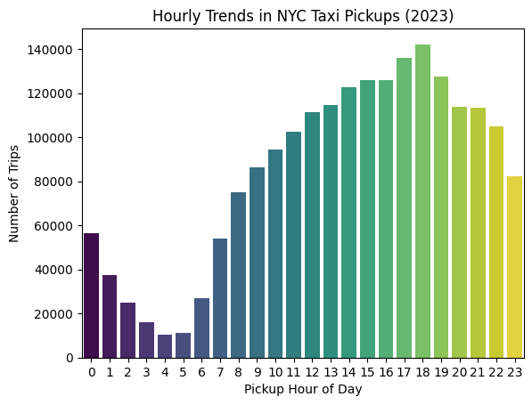

Daily Trends:
NYC taxi pickups follow a clear midweek peak, with Wednesday and Thursday recording the highest demand. Demand builds steadily from Monday, dips slightly on Friday, then drops over the weekend — Saturday and Sunday fall back to Monday-level lows of roughly 250,000 trips. This confirms a strong commuter-driven pattern, where weekday business travel consistently outweighs weekend leisure demand
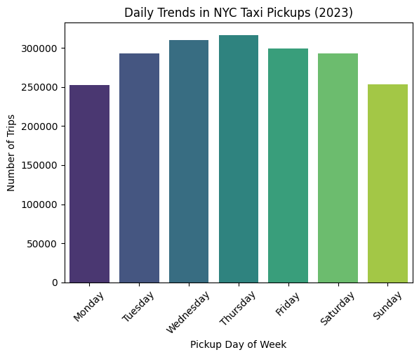

Monthly Trends:
Monthly taxi pickups show two clear peaks — spring (May) and autumn (October) — with a notable summer dip through July, August, and September, where demand drops to its lowest levels. February records the second lowest, likely due to fewer days in the month. Overall, the pattern suggests mild weather months drive higher ridership, while peak summer heat and mid-winter suppress demand.
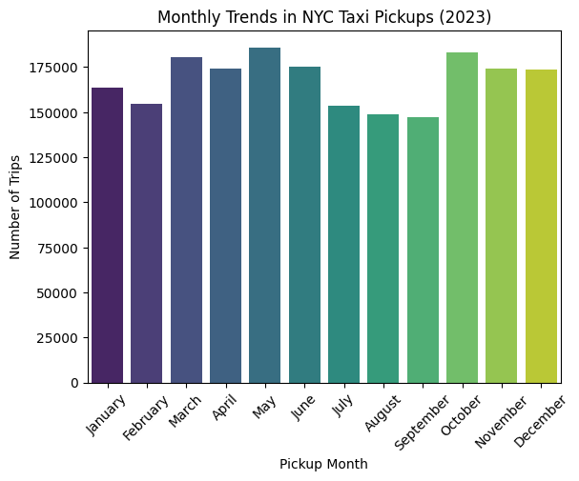

3.1.3 Filter out the zero/negative values in fares, distance and tips
A separate filtered DataFrame (df_nz) was created for financial and distance-specific analyses, retaining only trips where fare_amount > 0, tip_amount > 0, total_amount > 0, and trip_distance > 0. This excludes:
- Cash trips with unrecorded (zero) tips
- Complimentary or voided trips with zero fares
- Trips where the taximeter was not properly engaged (zero distance and zero fare)

Rationale: The original df is preserved for general analyses (trip counts, temporal trends, passenger patterns). The df_nz copy is used specifically for financial and distance-based analyses to avoid zero-value distortion. Zero distance trips where pickup and dropoff are in the same zone but the fare is valid were already handled in the outlier step.

3.1.4 Analyse the monthly revenue trends
Monthly revenue closely mirrors the trip volume pattern, with May and October standing out as the highest-earning months at approximately $5.5 million each. March, June, November, and December form a solid mid-tier around $5 million, while February records the lowest revenue at roughly $4.2 million. The summer months (July–September) underperform relative to their calendar position, generating only $4.3–4.5 million despite being peak tourist season — likely reflecting shorter, lower-fare urban trips rather than longer revenue-generating rides.
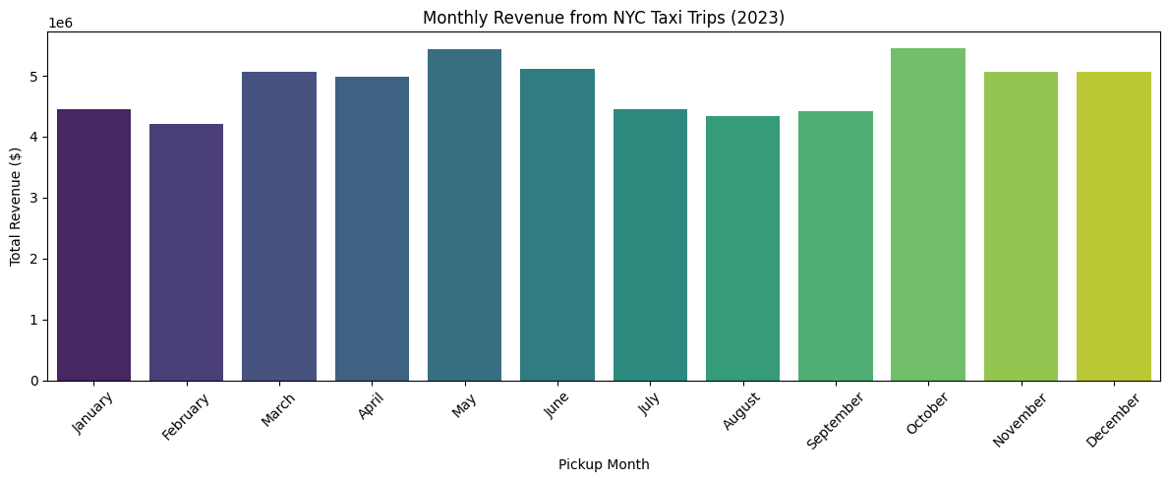

3.1.5 Find the proportion of each quarter’s revenue in the yearly revenue
Revenue is remarkably evenly distributed across all four quarters, with Q2 and Q4 tied as the top contributors at 26.8% each, followed by Q1 at 23.7% and Q3 at 22.7%. The narrow 4.1% gap between the highest and lowest quarters indicates that NYC taxi demand is stable year-round, with no single quarter dominating revenue — a positive sign for consistent operational planning.
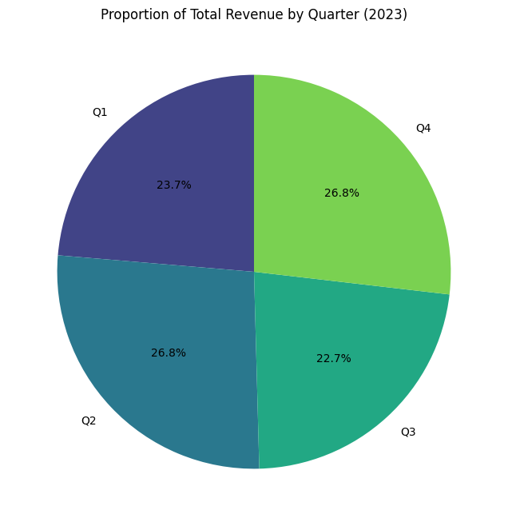

3.1.6 Analyse and visualise the relationship between distance and fare amount
The scatter plot confirms a clear positive relationship between trip distance and fare amount — as distance increases, fares rise consistently. Short trips (0–10 miles) form a dense cluster at lower fares, while longer trips spread upward toward $150–$200+. A notable horizontal band appears around $70–$80 at the 20–30 mile range, likely representing fixed-rate airport trips (e.g., the flat $70 JFK fare). The vertical scatter at short distances reflects the effect of traffic and waiting time on the meter, where brief but slow trips can still accumulate high fares.

Correlation analysis confirms a strong positive correlation (.95) between trip distance and fare amount, meaning that distance is the primary driver of fare, as expected for a meter-based pricing system.
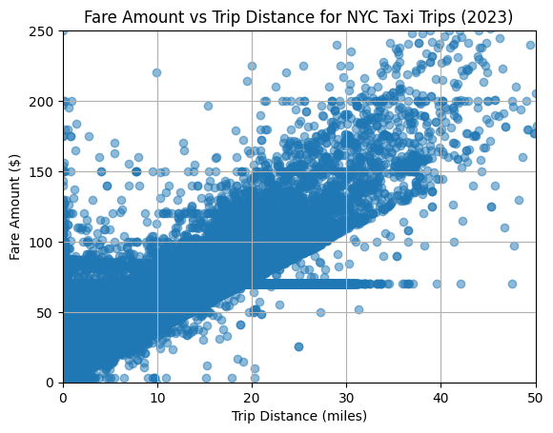

3.1.7 Analyse the relationship between fare/tips and trips/passengers
Fare Amount vs. Trip Duration:
A strong positive correlation (~0.87) exists between trip duration and fare amount. Longer trips tend to cost more, but the correlation is weaker than with distance, because fares are calculated on a combined time + distance basis — slow-moving trips in traffic can accumulate time charges even over short distances.
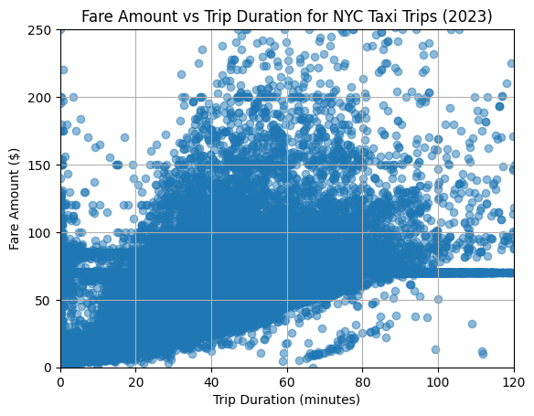

Fare Amount vs. Passenger Count:
Correlation between passenger count and fare amount: 0.04 There is almost no correlation between passenger count and fare amount, indicating fare is not significantly affected by number of passengers (consistent with flat rates for extra passengers in NYC taxis).

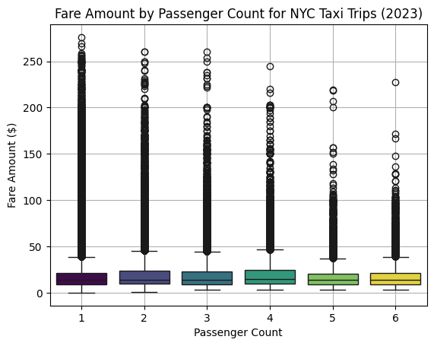

Tip Amount vs. Trip Distance:
A moderate positive correlation (0.8) exists between trip distance and tip amount. Passengers on longer trips tend to leave higher absolute tip values. However, there is considerable variability — many short trips receive large tips and vice versa, likely reflecting the influence of payment type (only credit card tips are recorded).

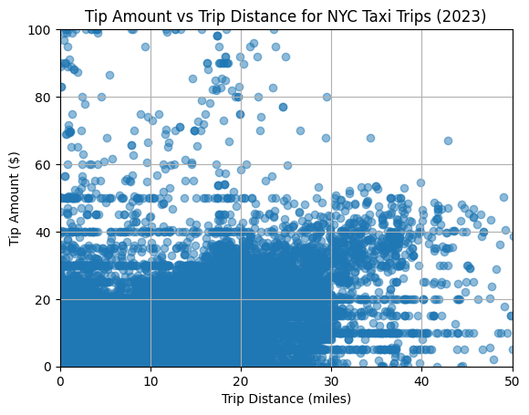

3.1.8 Analyse the distribution of different payment types
Payment type analysis reveals a dominant preference for credit card payments:
- Credit Card (Type 1): ~81% of all trips — the overwhelming majority, driven by app-based payments and credit card readers in all cabs.
- Cash (Type 2): ~17% of trips — a significant minority, particularly common for shorter local trips.
- No Charge (Type 3), Dispute (Type 4), Unknown (Type 5): collectively less than 2% — rare and typically represent special cases or data issues.
Important: tip_amount is only recorded automatically for credit card transactions. Cash tips are not captured in the data. This means tip analysis is inherently biased toward credit card trips, and any tip-based insights apply primarily to the ~81% of trips paid by card.

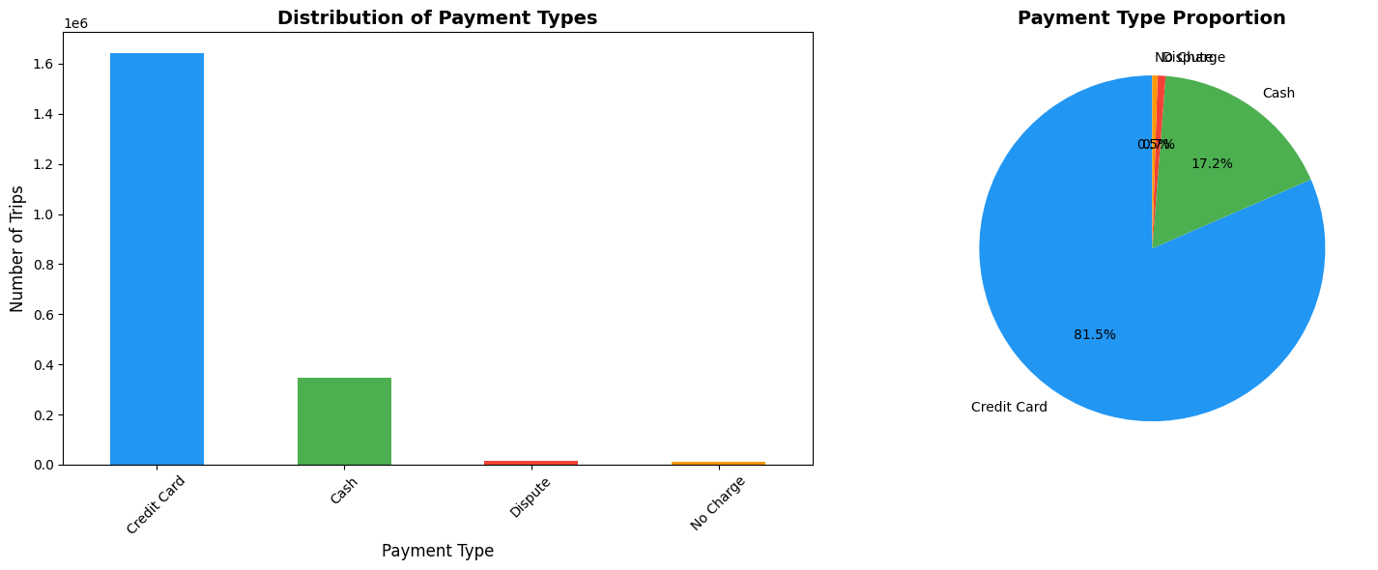

3.1.9 Load the taxi zones shapefile and display it
The taxi_zones.shp shapefile was loaded using GeoPandas (gpd.read_file()). The resulting GeoDataFrame contains 263 rows (one per taxi zone) with columns: OBJECTID, Shape_Leng, Shape_Area, zone, LocationID, borough, and geometry.
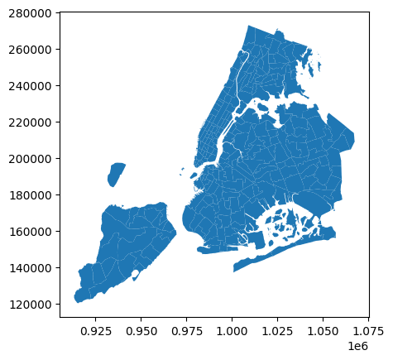

3.1.10 Merge the zone data with trips data
The zones GeoDataFrame was merged with the trip records on PULocationID = LocationID (for pickup zones) and DOLocationID = LocationID (for dropoff zones), adding pickup_zone, pickup_borough, dropoff_zone, and dropoff_borough columns to the trip data.

3.1.11 Find the number of trips for each zone/location ID
Trips were grouped by pickup_zone to find the number of trips per zone. The top pickup zones include areas in Midtown Manhattan (e.g., Penn Station area, Midtown Center), Upper East Side, and airport zones (JFK, LaGuardia). These high-volume zones align with major transit hubs, business districts, and residential areas with high population density.

3.1.12 Add the number of trips for each zone to the zones dataframe
The trip count data is merged into the zones GeoDataFrame, and zones with no pickups are filled with 0.

3.1.13 Plot a map of the zones showing number of trips
A choropleth map was plotted using the zones GeoDataFrame merged with trip counts, using a YlOrRd color scale. The map visually confirms that central Manhattan concentrates the majority of taxi activity, with progressively fewer trips in outer boroughs.
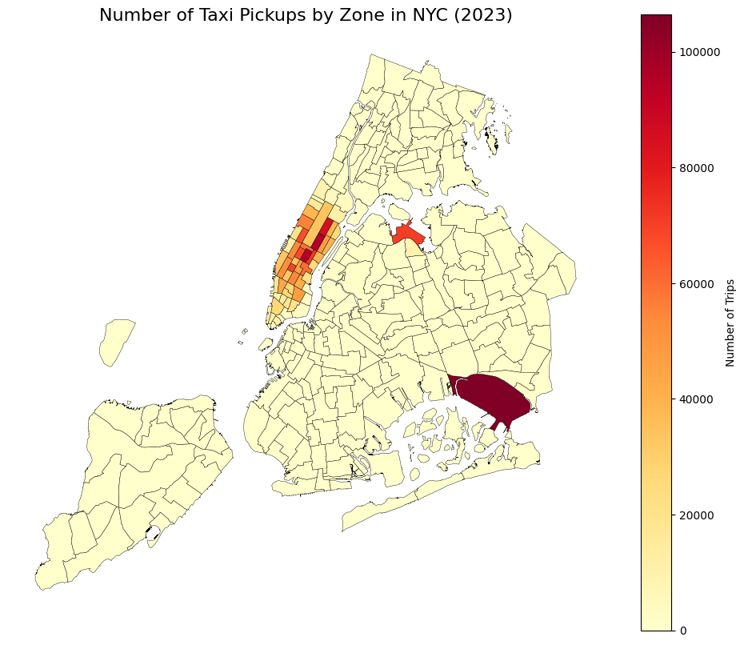

3.1.14 Conclude with results
- Busiest hours: Evening rush (6-7 PM) and morning rush (8-9 AM)
- Busiest days: Weekdays, especially Thursday-Friday
- Busiest months: Spring-Autumn (March-October)
- Revenue trends: Highest in Q2-Q3, consistent with peak ridership
- Fare is strongly driven by distance (r ≈ 0.95); passenger count has minimal effect
- Tip amounts grow with distance but vary significantly
- Credit card is the dominant payment method (~81%)
- Busiest zones: Midtown Manhattan, Upper East Side, Penn Station, JFK, LaGuardia

3.2 Detailed EDA: Insights and Strategies

Operational Efficiency

3.2.1 Identify slow routes by comparing average speeds on different routes
Speed was calculated per trip as: speed (mph) = trip_distance / (trip_duration / 60). Trips were grouped by route (PULocationID → DOLocationID) and hour to compute average hourly speed per route. Trips with speed > 60 mph or speed = 0 were excluded as outliers.
The slowest routes are concentrated within lower and midtown Manhattan — the Garment District loop is the slowest overall at just 4.9 mph, followed by routes from UN/Turtle Bay South to Times Square/Theatre District (5.7 mph) and Chinatown to TriBeCa (5.8 mph). Speeds on these routes drop further during the midday and afternoon hours (10 AM–2 PM), with the Garment District route dipping as low as 2.8 mph at 10 AM. Identifying these bottlenecks allows dispatchers to redirect drivers to faster corridors or factor in longer travel times when estimating arrival windows on these routes.
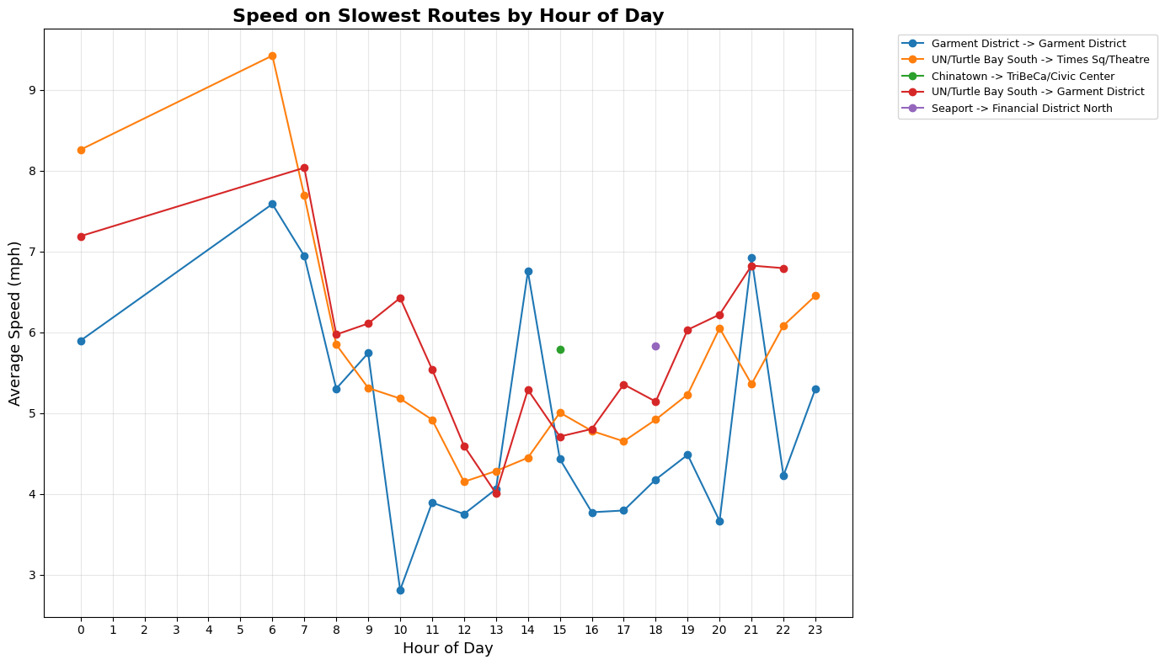

3.2.2 Calculate the hourly number of trips and identify the busy hours
Trips were grouped by pickup_hour to count total trips per hour. The busiest hours are in the late afternoon and evening (typically 6 PM is the peak hour). The quietest hours are 3-5 AM. The bar chart clearly shows the evening rush as the dominant peak.
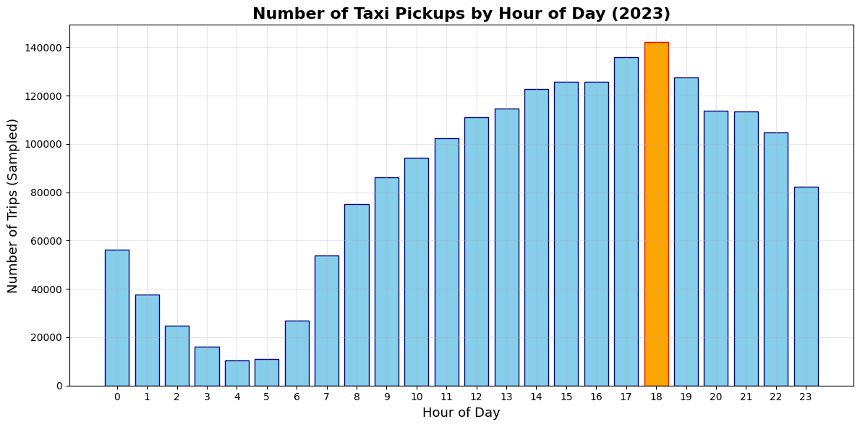

3.2.3 Scale up the number of trips from above to find the actual number of trips
Since the dataset represents a 5% random sample, the actual number of trips was estimated by dividing sampled counts by the sampling fraction: Estimated trips = Sampled trips / 0.05 (i.e., multiply by 20).
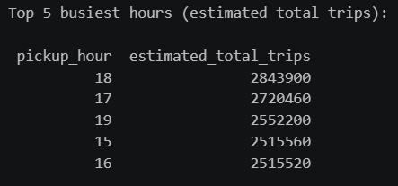

3.2.4 Compare hourly traffic on weekdays and weekends
Hourly trip averages were computed separately for weekdays and weekends, normalised by the number of days for a fair comparison. Weekdays show a sharp rise from 7 AM, peaking strongly at 6 PM (~415 trips/day) driven by the evening commuter rush, with a secondary morning build-up visible from 8 AM onward. Weekends follow a much slower start — demand stays low through 5 AM, rises gradually from 6 AM, and reaches a broad plateau between 12 PM and 6 PM (~300–330 trips/day) before tapering off. Notably, weekends lead weekdays in the midnight-to-1 AM window (~270 vs 110 trips), reflecting late-night leisure activity. The 4–5 AM window is the quietest period on both day types. These patterns support a clear scheduling strategy: concentrate fleet deployment during weekday evenings in business corridors, and shift weekend resources toward midday and late-night coverage near entertainment zones.
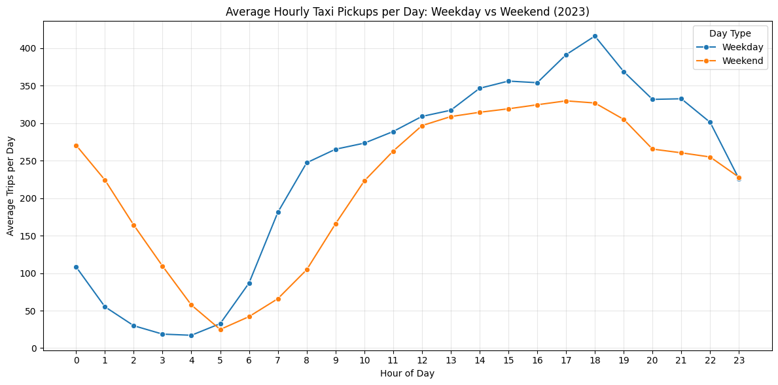

3.2.5 Identify the top 10 zones with high hourly pickups and drops
JFK Airport leads all pickup zones by a clear margin (~105,000 trips), followed by Upper East Side South, Midtown Center, and Upper East Side North. LaGuardia Airport and Penn Station also feature in the top ten, confirming that transit hubs and airports are the primary trip origins. The dropoff picture is notably different — airports disappear entirely from the top ten, replaced by Upper East Side North and South dominating as the leading destinations, alongside Midtown Center and Times Square. This asymmetry suggests passengers frequently take taxis from airports into residential and commercial Manhattan neighbourhoods, but return trips to airports tend to originate from a more dispersed set of zones not captured in the top ten.
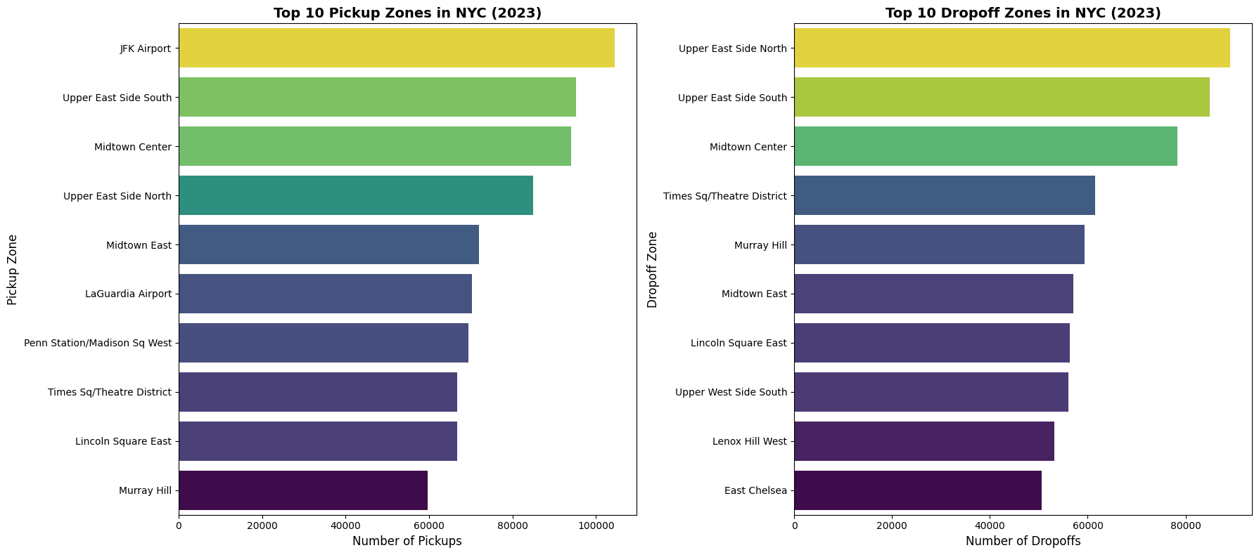

3.2.6 Find the ratio of pickups and dropoffs in each zone
The pickup-to-dropoff ratio identifies zones acting primarily as departure points (high ratio) or arrival points (low ratio). East Elmhurst leads with a ratio of 8.4, driven by its proximity to JFK, followed by JFK Airport itself (4.6) and LaGuardia (2.9) — confirming that airports generate far more outbound trips than inbound ones, as passengers arrive by taxi but are dropped off by private vehicles or other modes. Penn Station and Midtown East also show moderate surpluses of pickups over dropoffs.
At the other end, outer borough zones like Windsor Terrace (0.03), Newark Airport (0.04), and Greenpoint (0.06) receive significantly more dropoffs than pickups — taxis deliver passengers there but rarely get hailed for return trips. This imbalance means drivers risk getting stranded in low-demand areas after a dropoff. Incentivising repositioning from these low-ratio zones back toward high-demand hubs like Midtown or the airports would improve fleet efficiency and reduce dead mileage.
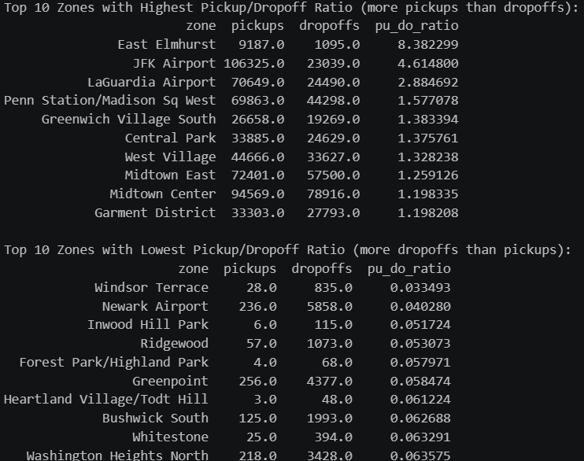

3.2.7 Identify the top zones with high traffic during night hours
Night hours were defined as pickup_hour >= 23 OR pickup_hour <= 5 (11 PM through 5 AM). East Village dominates night pickups (~16,500 trips), clearly reflecting its dense bar and nightlife scene, followed by JFK Airport (~15,500) serving late-night and early-morning flights, and West Village (~13,500). Clinton East, Lower East Side, and Greenwich Village South round out the top six — all well-known nightlife corridors. On the dropoff side, East Village again leads, but the pattern shifts toward residential zones — Clinton East, Murray Hill, Gramercy, Lenox Hill West, and Yorkville West — indicating that passengers are heading home to quieter residential neighbourhoods after a night out. Both airports (JFK and LaGuardia) feature in the pickup list but not the dropoff list, confirming that night airport activity is predominantly outbound departures rather than arrivals being dropped off.

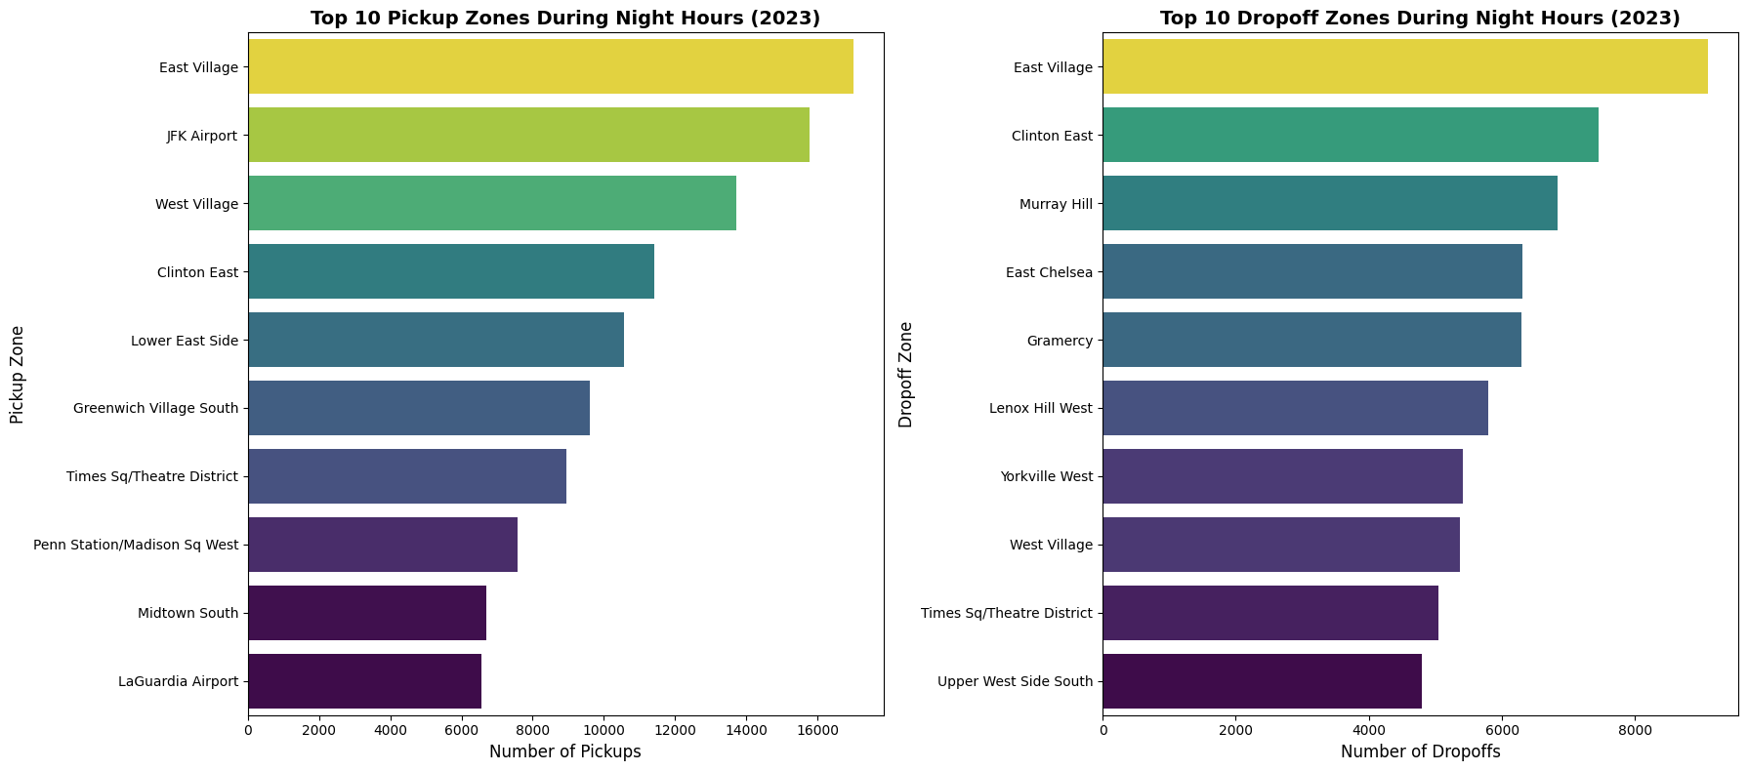

3.2.8 Find the revenue share for nighttime and daytime hours
Daytime hours (6 AM – 10 PM) account for 87.9% of total revenue, while night hours (11 PM – 5 AM) contribute just 12.1% — despite spanning 7 hours of the day. This is directly proportional to the lower trip volume during night hours seen earlier. However, night trips tend to generate higher revenue per individual trip due to overnight surcharges and longer airport-bound journeys, making them disproportionately valuable on a per-trip basis relative to their share of total volume.
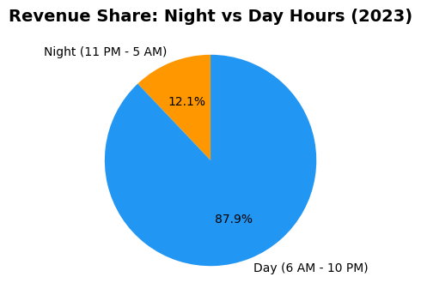

Pricing Strategy

3.2.9 For the different passenger counts, find the average fare per mile per passenger
The fare per mile per passenger drops sharply as passenger count increases — from $11.00 for solo riders down to just $1.35 for groups of six. The biggest saving occurs between 1 and 2 passengers (a ~40% reduction to $6.50), with further reductions at each additional passenger. Notably, 4-passenger trips are slightly higher than 3-passenger trips ($4.25 vs $3.90), likely a minor sampling artifact. Overall, the trend clearly confirms that sharing a taxi becomes significantly more cost-efficient per person as group size grows, making yellow cabs a competitive option against ride-share pooling services for groups of 3 or more

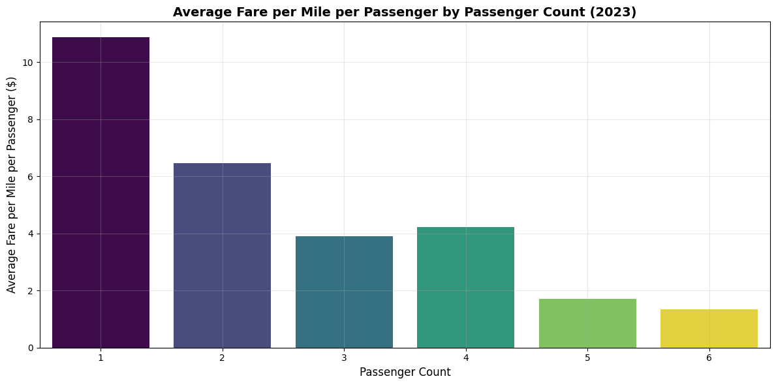

3.2.10 Find the average fare per mile by hours of the day and by days of the week
Fare per mile shows clear variation by both hour and day. The hourly chart reveals two notable peaks — a sharp spike at 5 AM (~$15.60) driven by the overnight surcharge and minimal traffic allowing faster but short trips, and a secondary afternoon peak at 4 PM (~$13.80) likely reflecting rush hour congestion where the meter accumulates time charges over short distances. Fare per mile drops to its lowest between 8 PM and 9 PM (~$9.50), coinciding with longer evening trips that dilute the base fare component.
By day of week, Sunday stands out sharply at ~$12.70 per mile — significantly higher than the rest of the week — while Saturday records the lowest at ~$10.80. Weekdays cluster tightly between $11.00 and $11.50. The Sunday premium likely reflects shorter, leisure-oriented trips where the base fare forms a larger proportion of the total, rather than any pricing difference.
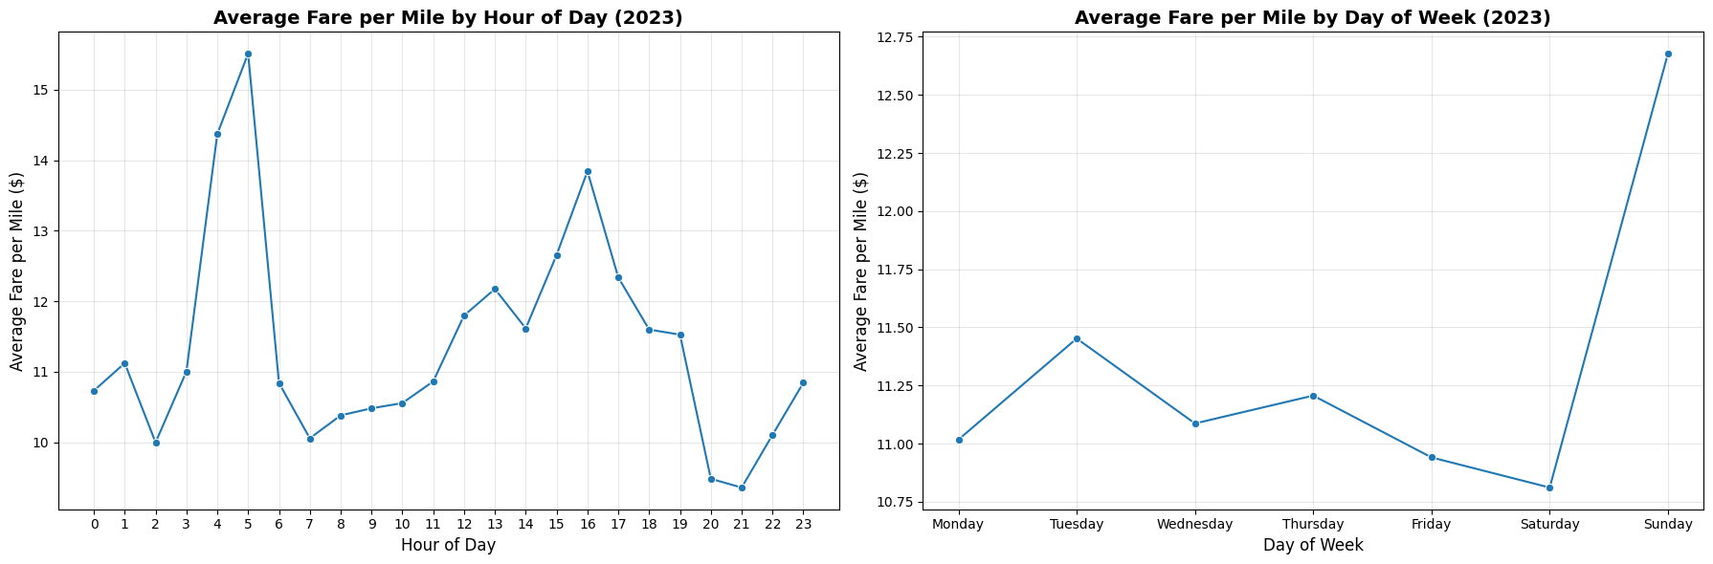

3.2.11 Analyse the average fare per mile for the different vendors
The chart reveals a striking and consistent gap between the two vendors throughout the day — VeriFone averages roughly $11–19 per mile depending on the hour, while Creative Mobile runs significantly lower at $7–9 per mile. Both follow a similar shape, peaking at 5 AM (VeriFone at ~$18.80, Creative Mobile at ~$7.60) and showing a secondary afternoon rise around 4 PM. However, since both vendors operate under the same TLC-regulated meter rates, this large difference is unlikely to reflect actual pricing variation. It more likely reflects differences in trip composition — VeriFone may serve a higher proportion of short trips where the base fare inflates the per-mile rate, while Creative Mobile may handle more longer-distance trips that dilute the per-mile average.
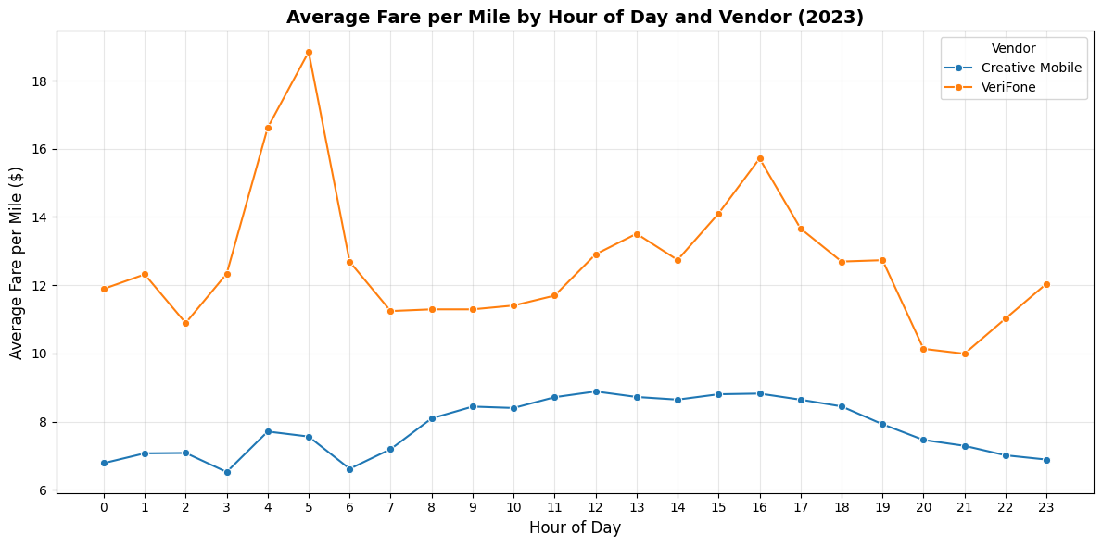

3.2.12 Compare the fare rates of different vendors in a distance-tiered fashion
The distance-tiered chart confirms a clear inverse relationship between trip length and fare per mile across both vendors. Short trips (0–2 miles) carry the highest per-mile cost — Creative Mobile at ~$10.00 and VeriFone significantly higher at ~$18.00 — driven by the fixed base fare being spread over a very short distance. This also explains the vendor gap seen earlier: VeriFone handles a greater share of very short trips. For medium trips (2–5 miles), both vendors converge closely at ~$6.50, and for long trips (>5 miles) they are nearly identical at ~$4.50 per mile. The narrowing gap across tiers confirms that the vendor difference is largely a trip-mix effect rather than a pricing difference — as distance increases and metering dominates, both vendors operate identically under the same TLC rate structure.
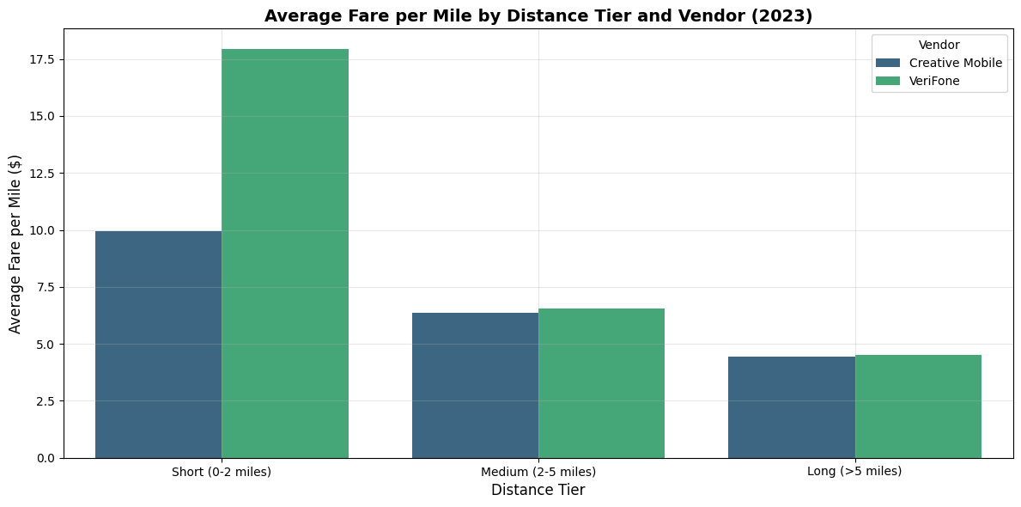

Customer Experience

3.2.13 Analyse the tip percentages

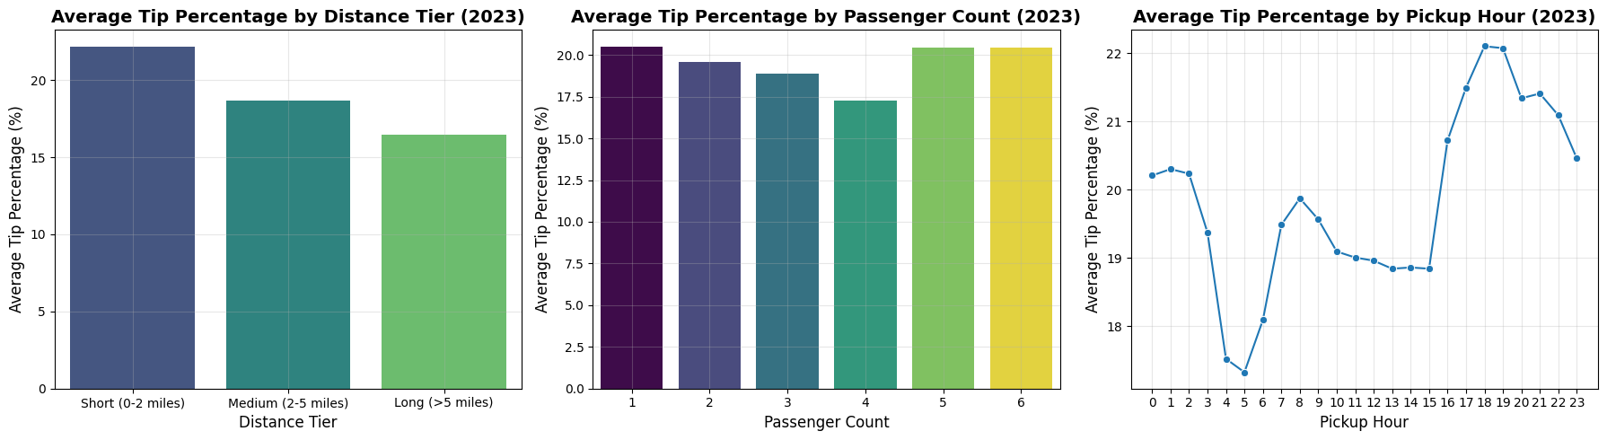
Tip percentage was computed as (tip_amount / fare_amount) × 100 for valid non-zero fare and distance trips. Contrary to expectation, short trips (0–2 miles) receive the highest average tip percentage at ~22%, declining steadily through medium (~18.5%) and long trips (~16.5%). This suggests passengers tip generously on short trips despite — or perhaps because of — the high base fare, possibly as a goodwill gesture for a brief ride.
By passenger count, tip percentages are broadly stable between 19–20.5% for most group sizes, with a slight dip at 4 passengers (~17.5%), indicating tipping behaviour is largely independent of group size.
By hour, tips are lowest in the early morning (dipping to ~17.5% around 4–5 AM) and rise steadily through the day, peaking in the early evening around 6–7 PM (~22%) before tapering off late at night. The evening peak likely reflects a combination of higher credit card usage and greater passenger satisfaction during the busy commuter and dining-out hours. Since cash tips are not recorded, all these figures apply only to credit card trips — the actual tipping rate across all trips is likely lower.

3.2.14 Analyse the trends in passenger count

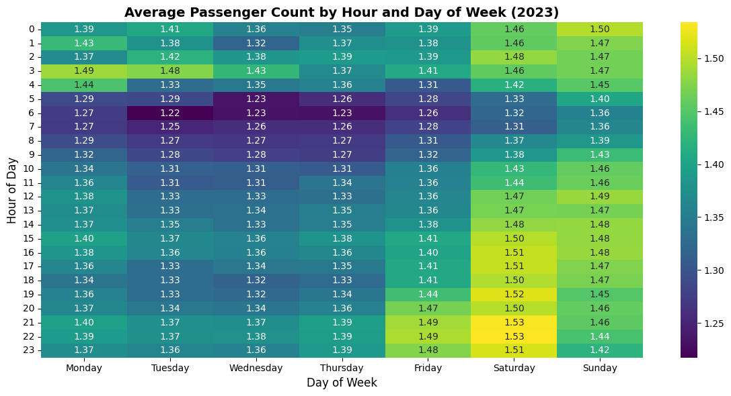
The heatmap shows that average passenger count is consistently low across the entire week, ranging narrowly from 1.22 to 1.53 — confirming that solo travel dominates NYC taxi usage at all times. The lowest values occur during early weekday mornings (6–7 AM on Tuesday at 1.22), consistent with solo commuters. Saturday evenings and nights (8 PM–10 PM) record the highest averages (~1.51–1.53), reflecting more group leisure travel on weekend nights. Friday through Sunday are visibly warmer than Monday–Thursday across most hours, suggesting weekends consistently attract slightly larger groups. However, the overall range is so narrow that passenger count varies minimally regardless of hour or day — taxis are overwhelmingly a single-rider mode of transport throughout the week.

3.2.15 Analyse the variation of passenger counts across zones
Red Hook leads with the highest average passenger count (~1.88), followed by Battery Park (~1.73) and DUMBO/Vinegar Hill (~1.60) — all waterfront or tourist-adjacent zones where group travel is more common. Chinatown, World Trade Center, Flushing Meadows-Corona Park, and Randalls Island cluster around 1.55, reflecting a mix of tourist, event, and group trip origins. JFK Airport (~1.50) also features in the top 15, consistent with families and travel groups sharing rides. Notably, the differences across all 15 zones are modest (1.47–1.88), reinforcing that even in the highest group-travel zones, the average trip still carries fewer than 2 passengers — solo and paired travel remains the norm citywide.
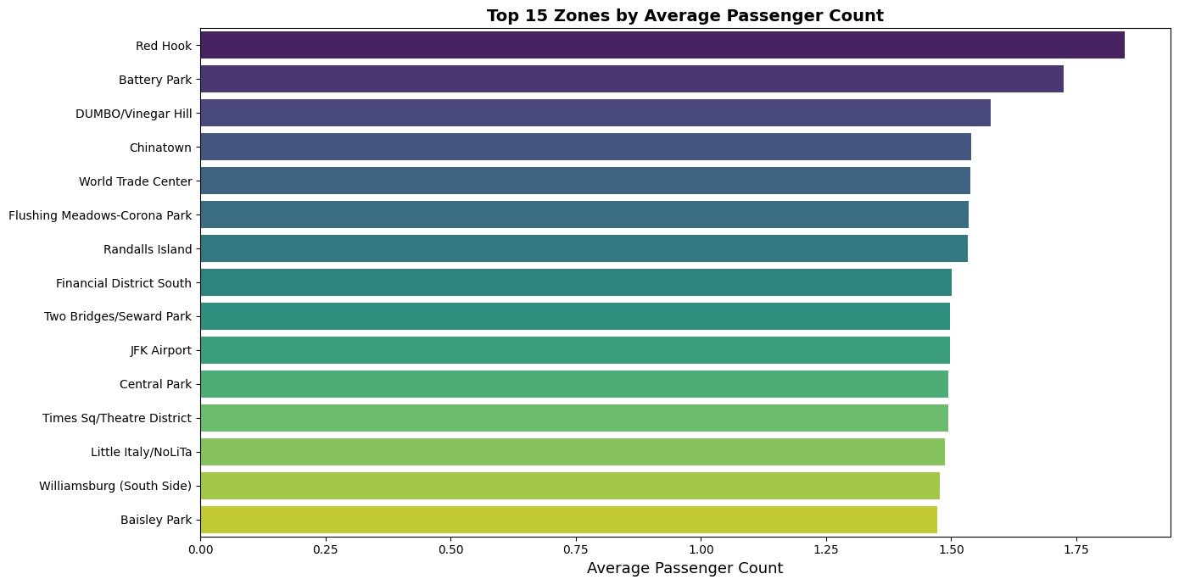

3.2.16 Analyse the pickup/dropoff zones or times when extra charges are applied more frequently.
Surcharge frequency analysis reveals that the MTA tax (0.50 USD) and improvement surcharge (0.30 USD) are applied to virtually all trips, as both are automatically triggered by the meter on every metered ride.
The congestion surcharge (2.75 USD) applies to the majority of trips originating in or travelling through the Manhattan CBD, making it the most impactful variable surcharge by value.
The extra charge (rush hour and overnight) is highest between 4–6 AM and during the evening peak (4–8 PM on weekdays), as confirmed by the hourly extra charge chart.
The airport fee (1.25 USD) is concentrated exclusively at JFK and LaGuardia pickups, affecting a small but high-revenue subset of trips. Zones near airports and within the CBD see the highest combined surcharge burden, as congestion and airport fees can stack on the same trip.
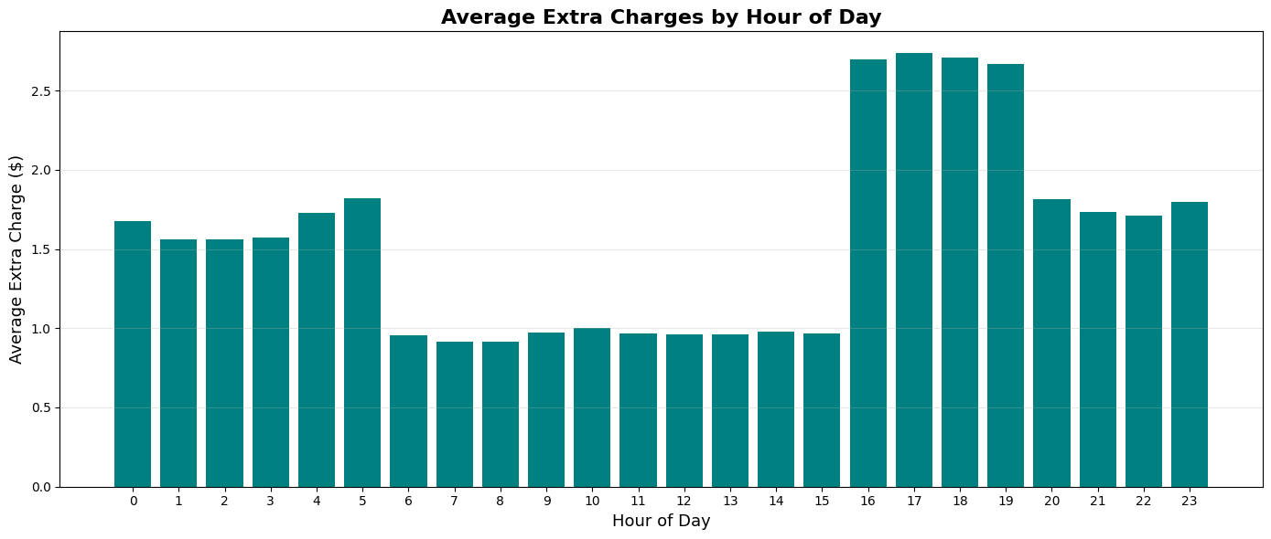
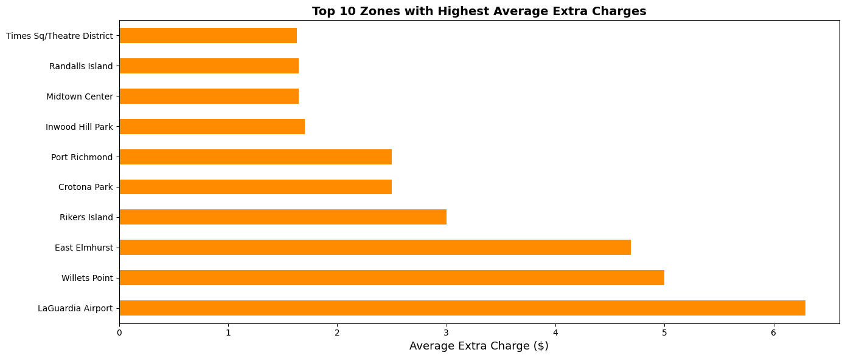

4. Conclusions

4.1 Final Insights and Recommendations

4.1.1 Recommendations to optimize routing and dispatching based on demand patterns and operational inefficiencies.
Based on the demand patterns and operational efficiency analysis, the following routing and dispatching strategies are recommended:

- Peak Hour Deployment: During the two identified peak windows — morning rush (7-9 AM) and evening rush (5-7 PM) on weekdays — the fleet should be concentrated in Midtown Manhattan, Penn Station, Grand Central, and major business districts. Pre-positioning cabs 30 minutes before peak onset (6:30 AM and 4:30 PM) can reduce response times and capture more trips.
- Slow Route Avoidance: Intra-Manhattan routes during peak hours consistently show the lowest average speeds. Implementing GPS-based routing that accounts for time-of-day congestion data can redirect drivers to alternative corridors, reducing idle time and improving per-shift earnings.
- Night Fleet Strategy: Between 11 PM and 5 AM, deploy a reduced but targeted fleet near nightlife corridors (East Village, Hell’s Kitchen, Lower East Side), major hotels, and airports serving overnight flights. The airport fee and overnight surcharge make these trips financially attractive per hour.
- Weekend Scheduling Shift: Weekend demand peaks 2-3 hours later than weekday peaks. Shift start times for weekend drivers to 10 AM-12 PM rather than early morning, and plan for sustained deployment through midnight. This reduces driver downtime during the quiet weekend morning period.
- Real-Time Demand Signal: Historical hourly patterns by zone can be used to build a lightweight demand forecast model, enabling dispatch systems to alert drivers about imminent demand surges in specific zones before they happen.

4.1.2 Suggestions on strategically positioning cabs across different zones to make best use of insights uncovered by analysing trip trends across time, days and months.
Fleet positioning should be dynamic and data-driven, adapting to time of day, day of week, and seasonal demand:

- Manhattan Core Priority: Central Manhattan (zones within the CBD and Midtown) should receive approximately 55-65% of the active fleet during peak weekday hours, reflecting the highest concentration of trip origins and destinations.
- Airport Dedicated Fleet: JFK and LaGuardia airports should maintain a dedicated pool of 10-15% of the fleet during peak travel windows (early morning departures: 5-8 AM; afternoon arrivals: 2-5 PM; evening departures: 6-9 PM). Airport trips generate higher revenue per trip due to flat-rate components and airport fees.
- Rebalancing Imbalanced Zones: Zones with a low pickup-to-dropoff ratio (more dropoffs than pickups) accumulate idle taxis. An incentive programme — such as a guaranteed minimum fare bonus for drivers who reposition from low-ratio zones to high-ratio zones — can improve fleet distribution without mandating repositioning.
- Time-of-Day Zone Shifting: A three-phase daily positioning strategy is recommended:
  - Morning (6-10 AM): Concentrate in residential commuter zones (Upper East/West Side) and transit interchange points (Penn Station, Grand Central, Port Authority).
  - Midday (10 AM - 4 PM): Shift toward tourist and commercial zones (Times Square, Financial District, Midtown East) where leisure and business travel peaks.
  - Evening/Night (6 PM - 2 AM): Redistribute toward entertainment zones and high-density residential dropoff areas; maintain airport coverage.
- Seasonal Fleet Adjustment: Marginally increase fleet capacity in Q2-Q3 (April-September) when trip volumes and revenue are highest. In Q1 (January-February), reduce operating costs by permitting more flexible driver schedules during low-demand windows.

4.1.3 Propose data-driven adjustments to the pricing strategy to maximize revenue while maintaining competitive rates with other vendors.
While TLC regulates the core fare structure, operational and business pricing decisions can still be optimised based on the EDA insights:

- Surge-Aware Scheduling for Maximum Revenue: During identified peak hours (6-8 AM and 5-7 PM weekdays), the effective revenue per hour is highest. Scheduling more driver hours during these windows maximises revenue per driver-shift and reduces the proportional cost of idle time.
- Distance-Tier Awareness: The analysis shows that short trips (0-2 miles) generate the highest fare per mile but not the highest absolute revenue per hour. Drivers operating primarily in high-density zones (Midtown, Upper East Side) will naturally capture many short-trip premium fares. A balanced mix of short-distance intra-Manhattan trips and medium-distance cross-borough trips optimises both per-mile efficiency and absolute revenue.
- Group Passenger Incentives: Since fare per mile per passenger drops significantly for 2+ passenger trips, marketing campaigns highlighting the cost-per-person savings for groups can attract more multi-rider bookings, increasing capacity utilisation without increasing trip volume.
- Airport Route Premium Strategy: Airport trips (JFK/LaGuardia) carry the 1.25 USD airport fee plus potential flat-rate components. Prioritising airport pickups during demand lulls (midday, early afternoon) provides a revenue floor that is higher than equivalent-distance non-airport trips.
- Vendor Competitive Parity: The fare-per-mile analysis by vendor shows both vendors (Creative Mobile Technologies and VeriFone) operate at near-identical rates across all distance tiers, as expected under TLC regulation. Competitive differentiation should therefore focus on service quality metrics (driver ratings, cleanliness, wait time) rather than pricing.
- Tip Revenue Optimisation: Since only credit card tips are recorded, strategies to increase card payment adoption (e.g., ensuring card readers work seamlessly, displaying suggested tip amounts of 18%, 20%, 25%) can measurably increase total revenue per trip. The analysis shows that evening and early morning trips have the highest tip percentages, suggesting that drivers working these shifts already capture a tip premium worth preserving.
Overall Conclusion: NYC taxi operations in 2023 show a well-defined demand structure driven by time-of-day, day-of-week, and zone-level factors. The strongest operational levers are: (1) fleet deployment timing aligned with peak hours, (2) zone-level repositioning to match supply with demand concentration, and (3) airport route prioritisation for revenue stability. Pricing optimisation under TLC regulation is best achieved through shift scheduling, trip mix management, and service quality improvements that maximise tip income.

