**Major Project Report On**

###### “Online Voting System”

Submitted in partial fulfillment of the requirement for the degree of

**Bachelor’s of Technology Session 2019-2023**

SUBMITTED BY NAME:-RAHUL JHA

**SEM :- 8'th**

Enrollment N0 :- 1916658

**SUBMITTED TO**

**DR. AMIT GUPTA**

#### IK GUJRAL PUNJAB TECHNICAL UNIVERSITY

**Approved by Ass. Professor Dr. Amit Gupta**

CERTIFICATE

This is to certify that the project titled **“ONLINE VOTING SYSTEM”** is the bonafide work carried out by **RAHUL KUMAR JHA,** student of **ELECTRONIC AND COMMUNICATION ENGINEERING** of **I K GUJRAL PUNJAB TECHNICAL UNIVERSITY** in fulfillment of the requirements for the award of the degree of **BACHELOR OF TECHNOLGY**.

The report submitted by the student is the work of student himself and he has fulfilled the requirements of completing his work during the training. His conduct was good during the entire training period. He were sincere towards his work and did all the study with thorough understanding and dedication.

(----------------------) (Prof )

**Director Internal Guide**

DECLARATION

I beg **RAHUL KUMAR JHA** hereby declare that the Project Report entitled **“ONLINE VOTING SYSTEM”** submitted by me to **I K GUJRAL PUNJAB TECHNICAL UNIVERSITY** is record of an original work done by me under the guidance of **Mr. MANOJ**.

This Project report has been submitted in partial fulfillment of the requirement for the award of degree of **BACHELOR OF TECHNOLOGY**. This is my original work and the conclusions drawn therein are based on the material collected by myself. This project report has not been submitted to any other university or institute for the award of any degree or diploma.

**Under the Guidance of: Signature of the Student**

DR. AMIT GUPTA RAHUL KUMAR JHA

Uni. Roll no.- 1916658 Class: - ECE & 8'th sem

……………………. (Project Supervisor)

ACKNOWLEDGEMENT

*Heartfelt thanks to the following people…*

A Few typewritten words of thanks can-not really express the sincerity of my gratitude. But I am trying to put into words my gratefulness towards all who have helped & encourage me in carrying out the project.

I would like to thank my trainer **Mr. MANOJ** Who helped me throughout the project.

I would then like to thank my faculty guide, **Dr. Amit Gupta**, for all his valuable inputs and constant support towards me throughout my project and providing me an opportunity to learn outside the class room. It was a truly wonderful learning experience.

I would like to dedicate this project to my parents. Without their help and constant support this project would not have been possible. I would like to thank all my friends who did their valuable suggestions and support.

Last but not the least I would like to thank all the respondents who offered their opinions and suggestions and sometimes critical views throughout the survey which made me constantly update myself come out with a successful project.

**Roll No: 1916658 Student Name:RAHUL JHA**

**INDEX**

|  |  |
| --- | --- |
| **S.no** | **Topic** |
| 1. | Introduction To Online Voting System |
| 2. | Abstract of The Project |
| 3. | Objective of The Project |
| 4. | Scope of The Project |
| 5. | METHOLODOGY |
| 6. | Topics Used IN Project |
| 7. | Code and Project Screenshots |
| 8. | References |

**Introduction to Student Result Management System**

Voting is a fundamental aspect of democratic societies, allowing citizens to exercise their right to choose representatives and shape the future of their nation. Traditional voting systems often require physical presence at polling stations, leading to logistical challenges, long queues, and limited accessibility for certain groups. An online voting system addresses these issues by providing a digital platform for casting votes remotely, bringing convenience, accessibility, and efficiency to the electoral process.

In these day, most the party are doing many unlawful activity to get an advantage in the election. And a pure election is the pillar for the Strong democracy. A free election is still a big challenge for the government.

The application is reduced as much as possible to avoid errors while voting by the voter. It also provides error message while entering invalid data and or if any one who is not eligible to vote. No formal knowledge is needed for the user to use this system. Thus by this all it proves it is user-friendly. The main goal of Online voting system, is to provide secure, error free, reliable and fast voting system. It can assist the user to concentrate on their other activities rather to concentrate on the record keeping. Thus it will help organization in better utilization of resources.

The Online Voting System incorporates several key features, including:

**User Registration and Authentication:** Users create accounts and undergo identity verification processes to ensure eligibility to vote.

**Candidate Information**: Comprehensive profiles of candidates, including background, party affiliation, and agenda, are provided to enable informed decision-making.

**Electronic Ballots**: Voters can access and complete their ballots online, selecting preferred candidates or voting on specific issues.

**Security Measures:** Encryption techniques, digital signatures, and other security measures are employed to protect the integrity and confidentiality of votes and prevent tampering.

**Real-time Results:** The system generates real-time results, allowing users to track the progress of the election.

**Accessibility:** The platform adheres to web accessibility standards, accommodating individuals with disabilities.

**Voter Support**: User support and assistance are provided to address technical issues or concerns faced by voters.

#### Abstract of the Project Student Result Management System

The Online Voting System is a groundbreaking digital platform designed to transform the voting process by providing a secure, convenient, and inclusive platform for citizens to cast their votes remotely. This abstract provides a concise overview of the objectives, features, implementation, and impact of the Online Voting System.

The primary objective of the Online Voting System is to enhance accessibility and efficiency in the voting process while ensuring the integrity and confidentiality of votes. By leveraging advanced technology and robust security measures, this system aims to overcome the limitations of traditional voting methods and offer a user-friendly and intuitive interface for voters.

Key features of the Online Voting System include user registration and authentication, comprehensive candidate information, electronic ballots, security measures, real-time results, accessibility considerations, and voter support. Users can create accounts, verify their identities, and access candidate profiles to make informed decisions. Electronic ballots are generated dynamically, enabling voters to securely cast their votes online. The system employs encryption techniques, digital signatures, and secure authentication mechanisms to protect the integrity and confidentiality of votes. Real-time result generation allows users to track the progress of the election, promoting transparency. Accessibility standards are adhered to, ensuring the system is inclusive and accommodating for individuals with disabilities. User support is provided to address any technical issues or concerns faced by voters.

The implementation of the Online Voting System involves the use of front-end technologies such as java Swing for GUI, along with back-end technologies like Java and DSA. The system utilizes MySQL and jdbc for database management, ensuring efficient data storage and retrieval.

The Online Voting System has the potential to revolutionize the democratic process by simplifying voting procedures, reducing logistical challenges, and increasing voter participation. By providing a convenient and secure platform, citizens can exercise their democratic rights from anywhere, overcoming barriers such as physical presence and long queues. Additionally, the system promotes transparency, with real-time result generation and monitoring capabilities.

In conclusion, the Online Voting System offers a modern and efficient approach to voting, fostering inclusivity and enhancing the democratic experience. With its user-friendly interface, robust security measures, and real-time result generation, this system has the potential to reshape democratic processes and strengthen citizen engagement in electoral activities.

**Objective of Project Online voting System**

The objectives of the Online Voting System project revolve around enhancing accessibility, convenience, efficiency, integrity, transparency, and voter engagement while accommodating diverse user demographics and streamlining election administration.

**Enhance Accessibility:** The primary objective of the project is to increase the accessibility of the voting process. By providing an online platform, citizens can cast their votes remotely, eliminating geographical barriers and enabling individuals with limited mobility or other constraints to participate in the voting process.

**Improve Efficiency:** The Online Voting System project seeks to improve the efficiency of the voting process. Through digital ballots and automated result generation, the system eliminates manual counting and reduces the time and effort required for result tabulation.

**Ensure Integrity and Security:** One of the crucial objectives is to ensure the integrity and security of the voting process. The project aims to implement robust security measures, such as encryption techniques, digital signatures, and secure authentication mechanisms, to protect against unauthorized access, tampering, or manipulation of votes.

**Enhance Transparency:** Transparency is a key objective of the Online Voting System project. By providing real-time monitoring and auditing capabilities, the system enables administrators and stakeholders to track the progress of the election, ensuring transparency and accountability in the entire voting process.

**Foster Voter Engagement:** The project aims to foster increased voter engagement. By providing comprehensive candidate information and facilitating informed decision-making, the system encourages voters to actively participate in the electoral process and make well-informed choices.

**Streamline Election Administration**: The project aims to streamline election administration processes. By automating tasks such as voter registration, ballot creation, and result generation, the system reduces administrative burden and allows election officials to focus on other critical aspects of the electoral process.

# Scope of the Project Online Voting System

It's important to note that the scope may vary based on the project's specific requirements, resources, and constraints. Regular stakeholder consultation and risk assessments are crucial to defining and managing the project's scope effectively.

* + - * + User Registration and Authentication:
        + The system will provide a user registration process where individuals can create accounts and undergo authentication to ensure eligibility to vote. This includes verifying user identities and implementing secure authentication mechanisms to prevent unauthorized access.
        + Candidate Information:

The Online Voting System will provide comprehensive profiles of candidates, including their background, party affiliation, and agenda. The system will allow voters to access this information to make informed decisions during the voting process.

* + - * + Electronic Ballots:

The project will develop a user-friendly interface for voters to access and complete their electronic ballots. The system will generate dynamic ballots that accurately represent the available candidates and issues to be voted upon.

* + - * + Security Measures:

The Online Voting System will implement robust security measures to protect the integrity and confidentiality of the voting process. This includes employing encryption techniques, digital signatures, secure data transmission protocols, and secure authentication mechanisms to prevent tampering, fraud, and unauthorized access.

* + - * + Real-time Results and Monitoring:

The system will generate real-time results, enabling voters and administrators to track the progress of the election. Real-time monitoring and auditing capabilities will be implemented to ensure transparency and accountability throughout the voting process.

* + - * + Accessibility:

The project will prioritize accessibility by adhering to web accessibility standards. The Online Voting System will be designed to accommodate users with disabilities, ensuring equal participation for all citizens.

* + - * + Voter Support:

User support and assistance will be provided to address any technical issues or concerns faced by voters. The system will have provisions for user feedback, inquiries, and support channels to ensure a smooth voting experience.

* + - * + Scalability and Performance:

The Online Voting System will be designed to handle a large volume of concurrent users efficiently. The system will be scalable to accommodate increasing user demands during peak voting periods while maintaining optimal performance.

* + - * + Integration with Existing Election Processes:

The project will consider the integration of the Online Voting System with existing election processes and systems. This may include coordination with election authorities, data synchronization, and adherence to legal and regulatory requirements.

* + - * + System Administration:

The Online Voting System will have an administrative interface to manage user registrations, candidate information, system settings, and overall system administration. The administrative interface will have appropriate access controls and functionality to ensure efficient management of the voting system.

**METHODLOGY**

###### Software Development Life Cycle:

SDLC is a process followed for a software project, within a software organization. It consists of a detailed plan describing how to develop, maintain, replace and alter or enhance specific software. The life cycle defines a methodology for improving the quality of software and the overall development process.

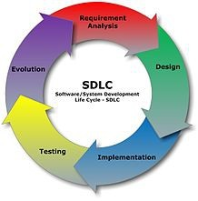

Different stages of SDLC:

The Software Development Life Cycle (SDLC) of an Online Voting System typically consists of several stages, each playing a crucial role in the development and deployment of the system. Here are the common stages of the SDLC for an Online Voting System:

**Requirement Gathering:**

In this stage, project stakeholders identify and gather the requirements for the Online Voting System. This involves understanding the needs of the users, election authorities, and other stakeholders. Requirements are documented, and the scope of the project is defined.

**System Analysis and Design:**

During this stage, the requirements are analyzed, and the system's architecture and design are formulated. System components, modules, and data structures are identified. Design decisions are made regarding the user interface, security measures, database structure, and integration with external systems.

**Development:**

The development stage involves the actual coding and implementation of the Online Voting System. The development team follows the design specifications to build the system components, implement security measures, create the user interface, and integrate the various modules. Coding standards and best practices are followed during this stage.

**Testing:**

Once the development is complete, the system undergoes rigorous testing. This includes unit testing, integration testing, and system testing. The testing process aims to identify and rectify any defects or issues in the system. Functional testing, performance testing, security testing, and user acceptance testing are carried out to ensure that the system meets the defined requirements and functions correctly.

**Deployment:**

After successful testing and resolving any identified issues, the Online Voting System is ready for deployment. It is installed and configured on the appropriate servers and infrastructure. Data migration and setup procedures are carried out, ensuring a smooth transition from the development environment to the production environment.

**Maintenance and Support:**

Once the system is deployed, the maintenance and support stage begins. It involves monitoring the system's performance, addressing user feedback and issues, and making necessary updates and enhancements. Regular maintenance tasks, including bug fixes, security patches, and database backups, are performed to ensure the system's ongoing reliability and functionality.

Throughout the SDLC stages, it is essential to follow industry best practices, adhere to security standards, and engage in regular communication and collaboration with stakeholders to ensure the successful development, deployment, and maintenance of the Online Voting System.

**Flowchart**

Flow chart is a graphical representation of an algorithm. Programmers often use it as a program-planning tool to solve a problem. It makes use of symbols which are connected among them to indicate the flow of information and processing. The process of drawing a flowchart for an algorithm is known as “flowcharting”.

The flowchart shows the steps as boxes of various kinds, and their order by connecting the boxes with arrows. This diagrammatic representation illustrates a solution model to a given [problem](https://en.wikipedia.org/wiki/Problem_solving). Flowcharts are used in analyzing, designing, documenting or managing a process or program in various fields.

**Basic Symbols used in Flowchart Designs**

* 1. **Terminal:** The oval symbol indicates Start, Stop and Halt in a program’s logic flow. A pause/halt is generally used in program logic under some error

conditions. Terminal is the first and last symbols in the flowchart.



* 1. **Input/Output:** A parallelogram denotes any function of input/output type. Program instructions that take input from input devices and display output on output devices are indicated with parallelogram in a flowchart.



* 1. **Processing:** A box represents arithmetic instructions. All arithmetic processes such as adding, subtracting, multiplication and division are indicated by action or process symbol.



* 1. **Decision:** Diamond symbol represents a decision point. Decision based operations such as yes/no question or true/false are indicated by diamond in flowchart.



* 1. 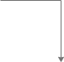**Connectors & Flow lines:** Whenever flowchart becomes complex or it spreads over more than one page, it is useful to use connectors to avoid any confusions. It is represented by a circle. Flow lines indicate the exact sequence in which instructions are executed. Arrows represent the direction of flow of control and relationship among different symbols of flowchart.

The graphics above represent different part of a flowchart. The process in a flowchart can be expressed through boxes and arrows with different sizes and colors. In a flowchart, we can easily highlight a certain element and the relationships between each part

**Introduction To Topic Used In Project**

**Java:-**

Java’s history began in the early 1990s when Sun Microsystems was developing a version of C++ that was more portable, equipped with automated memory management, and more suitable for modern multimedia. Today, the logo of an orange, steaming coffee cup is a widely recognizable symbol in the field of custom software development across the world.

Java in its core is an open-source and free-to-use programming language. It is object-oriented programming (OOP) which is one of the reasons for its remarkable popularity throughout the years. Because it is an OOP programming language, it offers developers a clever modular structure that greatly simplifies advanced problem-solving tasks.

## What is Java used for?

Java, unlike some other programming languages, is used in a multitude of different scenarios from ordinary GUI applications, to advanced back-end systems and game development. Here, we have listed some of the most notable use cases of the Java programming language:

### ****Desktop GUI Applications****

One of the main ways that developers use Java is to create a graphical user interface for desktop applications. There are numerous Java Frameworks available, significantly improving the speed of developing GUI Applications such as Swing, AWT, or JavaFX.

### ****Web-based Applications****

The main thing that set Java apart from other programming languages back in the day were its applets that could run in a web browser. Even though now, applets are a thing of the past, creating web apps is still one of Java’s strong suites as technologies like Struts, JSP, or Servlets enable the creation of advanced web applications. After all, Java is known for being a proven server-side programming language.

### ****Game Development****

Even though most of the modern game engines such as Unity and Unreal Engine run on C++, there are still a couple of notable examples of games based on the Java environment – most importantly Minecraft Java edition. There are numerous frameworks, tools, and libraries available, such as LibGDX and OpenGL API that allow developers to create titles for game consoles and mobile devices.

### ****Big Data Technology****

A very popular and widely used open framework associated with Big data called Hadoop is entirely written in Java. Considering its features like memory distribution, advanced automatic garbage collection, and stack provision system, Java is a very tempting choice when building robust BigData enterprise applications.

### ****IoT devices****

IoT, or the internet of things, is consistently gaining popularity with the introduction of devices like Amazon Alexa. Software engineers often regard Java as one of the best languages for IoT device development. It results from the fact that Java code has the ability to run on a wide variety of devices, reducing the overall workload.

### ****Cloud-Based Applications****

Cloud-native has been one of the biggest trends in software development for quite a while, and Java programming language has been a vital part of its progress throughout the years. Because of its low cost and popularity, many companies use Java to develop SaaS and PaaS services in the cloud. What’s more, its unique functionalities like containers, JVM optimizations, multi-purpose frameworks, and native image technology offer further advantages when it comes to cloud-based development.

### ****Mobile applications****

You might not have known that Java has also had a significant influence on the mobile market as well. Even with the emergence of Kotlin as the new preferred language for Android app development in 2019, Java is still widely used today. The Android development community fancies this programming language, mainly thanks to its wide range of tools and libraries. It is also worth noting that some of the most popular android apps like **Spotify** and **Twitter** are developed mainly in Java.

## Benefits of Java

Java holds one of the top spots in popularity indexes for a good reason. There are some very clear advantages of Java over other programming languages which make it a preferred choice for software developers and organizations worldwide:

### ****Easy to learn****

Java is considered to be a fairly easy to learn programming language. It is appreciated for its speed in coding, compiling, or debugging.

### ****Object-oriented****

The main characteristic of Java, as well as its biggest advantage, is the fact that it is fundamentally object-oriented. Because Java is an object-oriented programming language, it thus allows for the creation of more modular software and reusable code.

### ****Platform-independent****

Developers can run their software on many different systems with relative ease.

### ****Versatility of use****

Java is a general-purpose programming language that found its uses in almost all parts of the IT market from developing Android apps, web applications, and GUI functionalities to helping create enterprise-grade software, and analyzing large volumes of unstructured data.

### ****Highly-optimized Java IDE****

There are numerous Java Development Environments ([**Java IDE**](https://stratoflow.com/top-java-ide/)) available to its programmers. Such an integrated development environment helps develop applications faster and more efficiently by combining various development tools into one universal package.

The said Environments maximize Java developer’s productivity, allow for better Java database connectivity and provide a wide variety of libraries, all packed into an intuitive GUI interface.

## Drawbacks of Java

### ****Memory consumption****

Compared to other languages like C and C++ Java may require more system memory. During the execution of garbage collection, due to high memory needs, the performance of the system can degrade when not monitored.

### ****Cost****

Increased memory consumption leads to potential cost increases, as you would need better hardware to efficiently run Java software.

### ****Less machine interactive****

Java is inherently a high-level programming language and therefore lacks with regard to interacting directly with machines. Thus, there is limited support for low-level programming.

**Java Swing**

Java Swing is a lightweight Java graphical user interface (GUI) widget toolkit that includes a rich set of widgets. It is part of the Java Foundation Classes (JFC) and includes several packages for developing rich desktop applications in Java. Swing includes built-in controls such as trees, image buttons, tabbed panes, sliders, toolbars, color choosers, tables, and text areas to display HTTP or rich text format (RTF). Swing components are written entirely in Java and thus are platform-independent.

Swing offers customization of the look and feel of every component in an application without making significant changes to the application code. It also includes a pluggable look and feel feature, which allows it to emulate the appearance of native components while still having the advantage of platform independence. This particular feature makes writing applications in Swing easy and distinguishes it from other native programs.

Swing was distributed as a downloadable library and has been included as a part of Java standard edition 1.2. Originally, the graphics library for Java, developed by Netscape Communication Corporation, was called Internet Foundation Classes (IFC). The first release of IFC was on December 16, 1996. The evolution of JFC can be traced back to 1997, when Sun Microsystems and Netscape Communication Corporation came up with the idea of merging IFC with other technologies.

**Java Database Connectivity(JDBC)**

Java database connectivity (JDBC) is the Java Soft specification of a standard application programming interface (API) that allows Java programs to access database management systems. The JDBC API consists of a set of interfaces and classes written in the Java programming language.

Using these standard interfaces and classes, programmers can write applications that connect to databases, send queries written in structured query language (SQL), and process the results.

Since JDBC is a standard specification, one Java program that uses the JDBC API can connect to any database management system (DBMS), as long as a driver exists for that particular DBMS.

**NetBeans IDE**

IntelliJ IDEA is an Integrated Development Environment (IDE) specifically designed for Java development. It is developed by Jet Brains and provides a comprehensive set of tools and features to facilitate efficient coding, debugging, and testing of Java applications.

**MySQL DataBase**

Databases are the essential data repository for all software applications. For example, whenever someone conducts a web search, logs in to an account, or completes a transaction, a database system is storing the information so it can be accessed in the future.

A relational database stores data in separate tables rather than putting all the data in one big storeroom. The database structure is organized into physical files optimized for speed. The logical data model, with objects such as data tables, views, rows, and columns, offers a flexible programming environment. You set up rules governing the relationships between different data fields, such as one to one, one to many, unique, required, or optional, and “pointers” between different tables. The database enforces these rules so that with a well-designed database your application never sees data that’s inconsistent, duplicated, orphaned, out of date, or missing.

The “SQL” part of “MySQL” stands for “Structured Query Language.” SQL is the most common standardized language used to access databases. Depending on your programming environment, you might enter SQL directly (for example, to generate reports), embed SQL statements into code written in another language, or use a language-specific API that hides the SQL syntax.

**Screen shorts Of Code**

Head:-

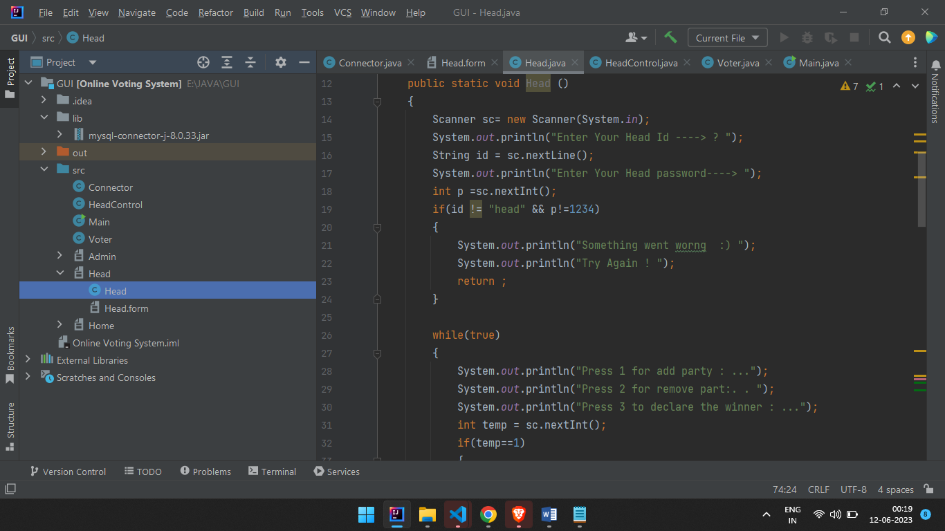

Head have three functions :

1. AddParty
2. RemoveParty
3. Declear the Winner

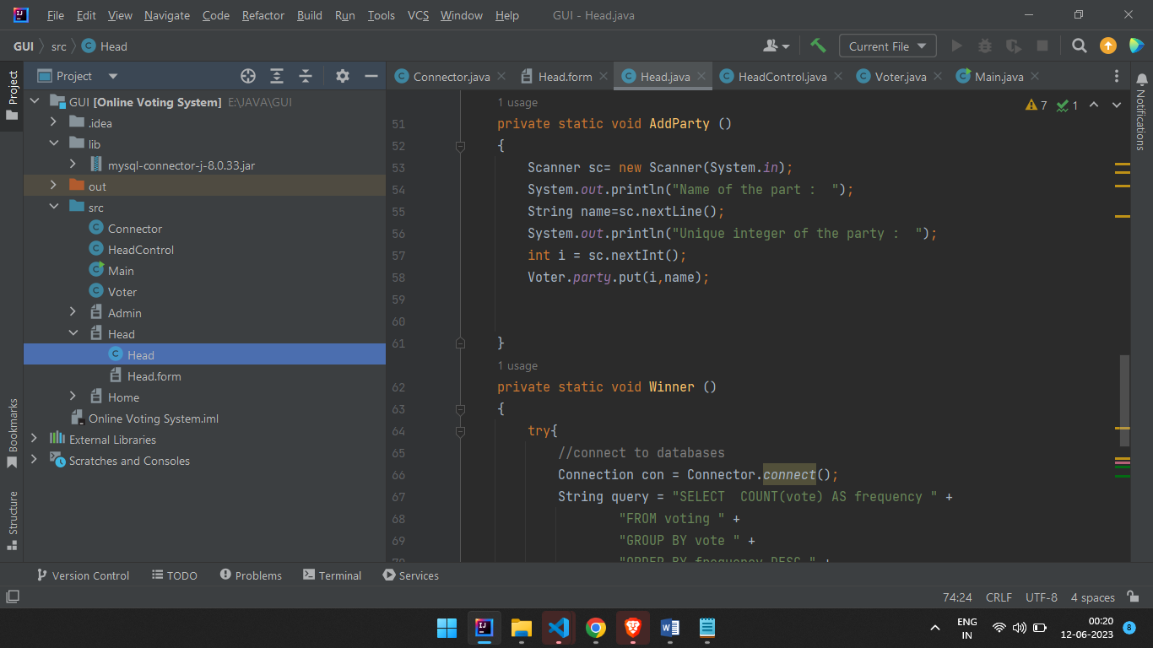

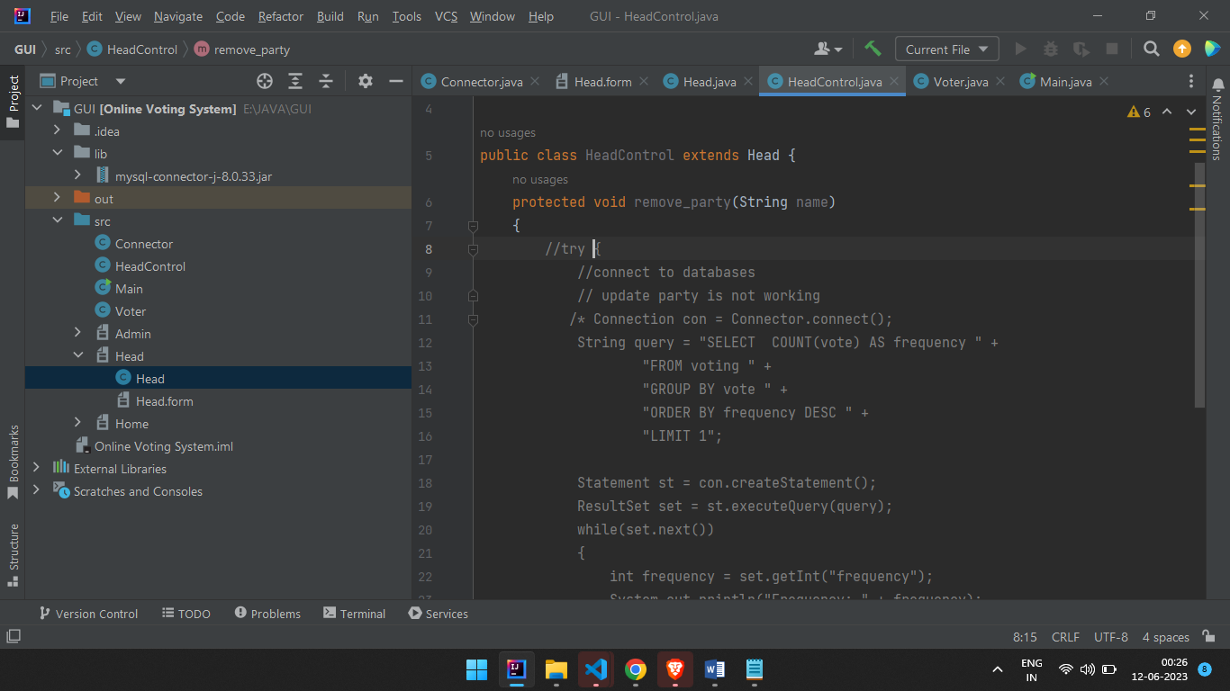

2nd member of the Project is “Admin” : - Authentication is needed

1. Add a new Voter

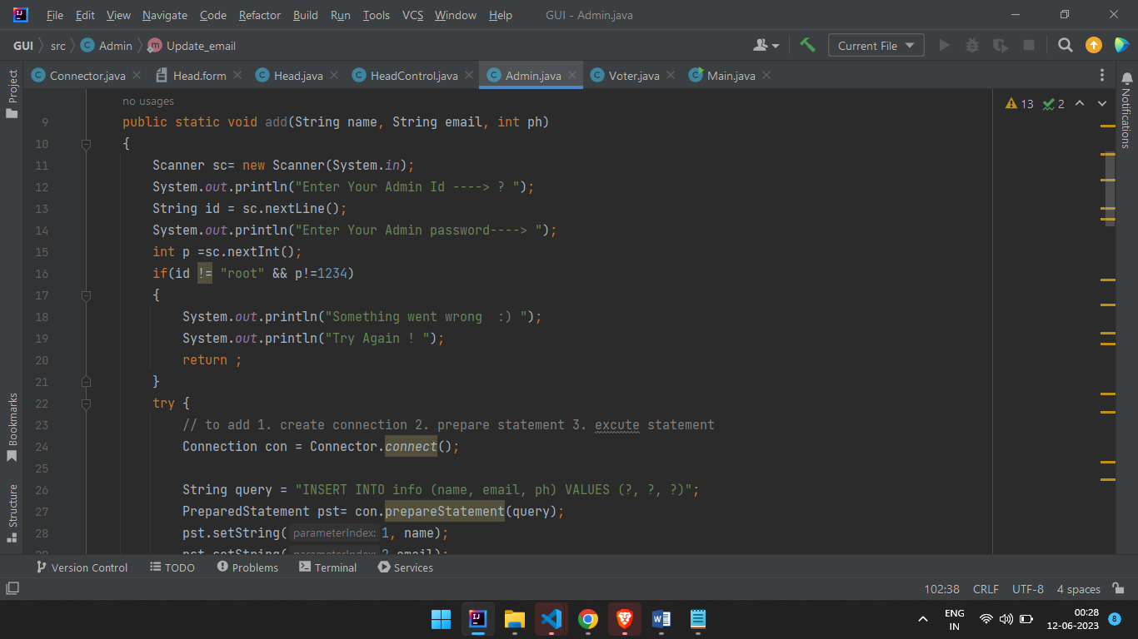

1. Remove the voter Voter-list

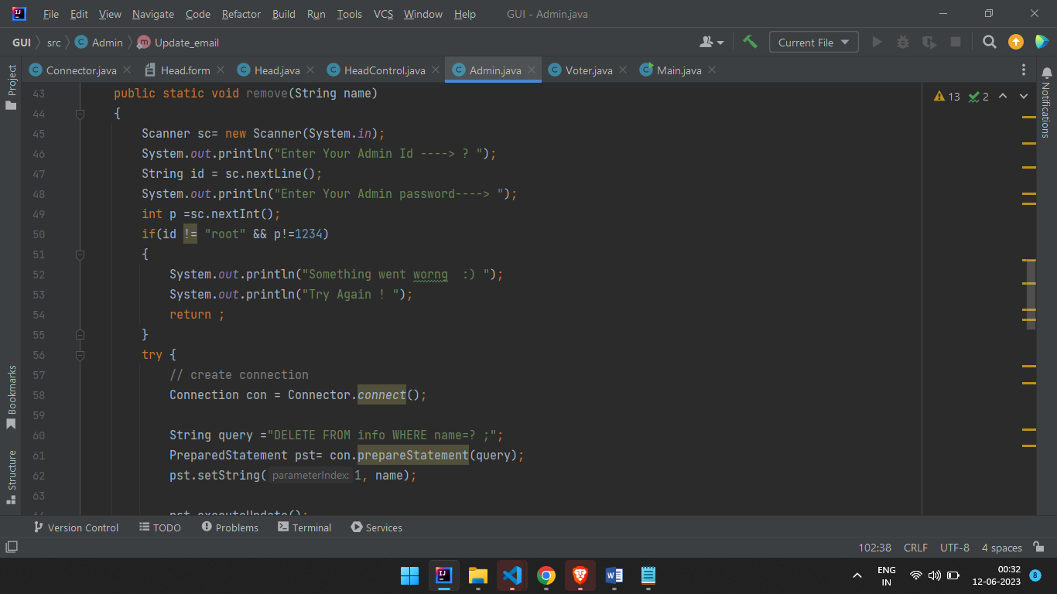

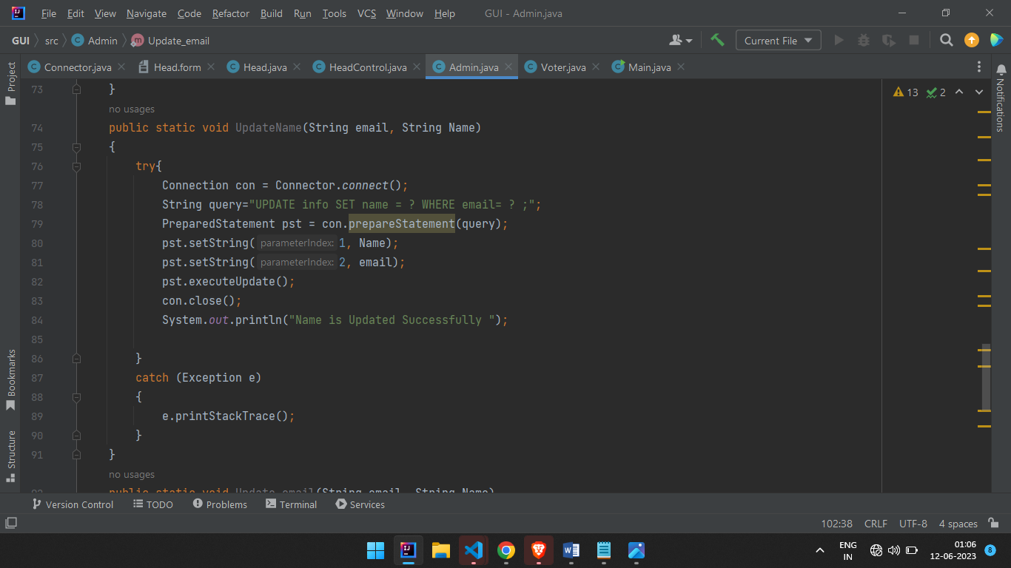

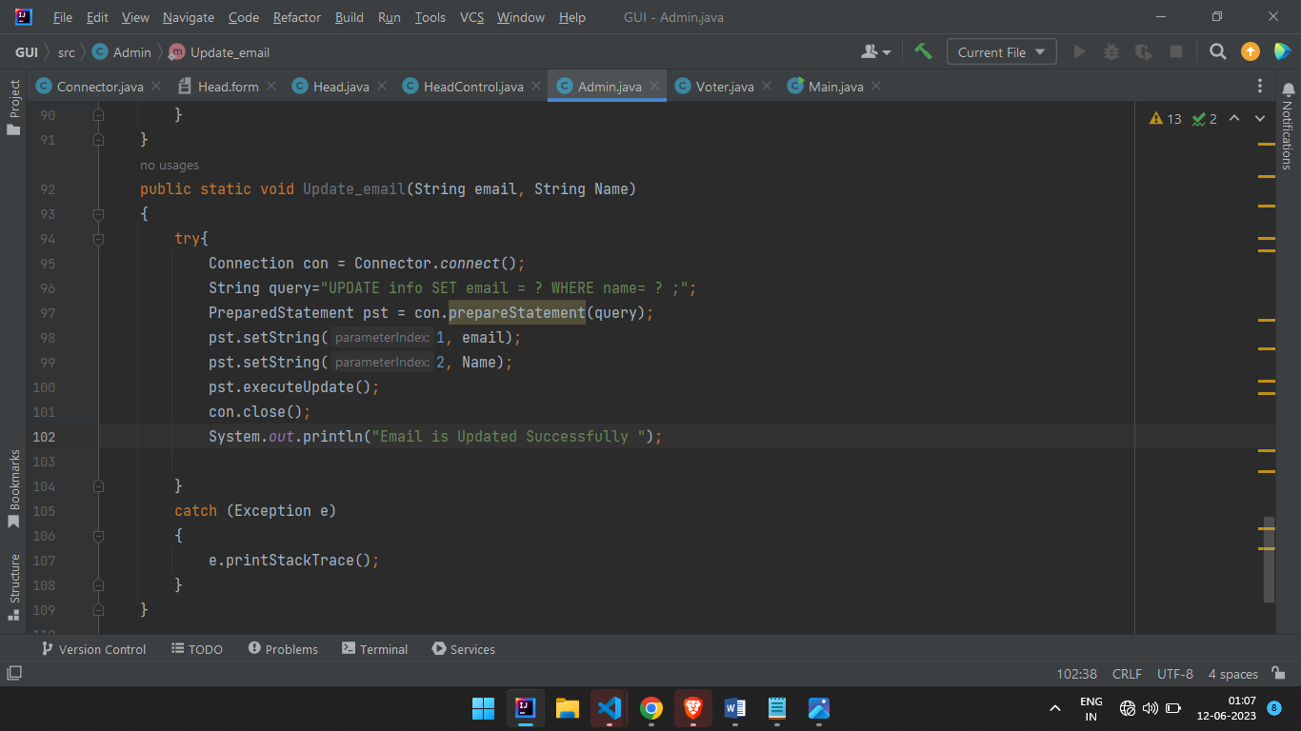

Project Screenshot of Console Screen

