**WEEK-3**

**AIM:** Develop a simple data link layer that performs the flow control using the sliding window protocol, and loss recovery using the Go-Back-N mechanism.

1. **SLIDING WINDOW PROTOCOL**

**THEORY:**

**Sliding Window Protocol** is a flow control mechanism used in reliable data transmission. It allows the sender to transmit multiple frames before needing an acknowledgment (ACK), ensuring efficient use of the network.

The "window" refers to a set of frames that the sender can transmit without waiting for an ACK. As ACKs are received, the window "slides" forward, allowing the sender to send new frames. Both sender and receiver maintain a window size, controlling how much data can be in transit at once. This protocol helps optimize throughput while avoiding congestion or overwhelming the receiver.

**PROGRAM:**

#include<stdio.h>

int main()

{

int w,i,f,frames[50];

printf("Enter window size: ");

scanf("%d",&w);

printf("\nEnter number of frames to transmit: ");

scanf("%d",&f);

printf("\nEnter %d frames: ",f);

for(i=1;i<=f;i++)

scanf("%d",&frames[i]);

printf("\nWith sliding window protocol the frames will be sent in the following manner (assuming no corruption of frames)\n\n");

printf("After sending %d frames at each stage sender waits for acknowledgement sent by the receiver\n\n",w);

for(i=1;i<=f;i++)

{

if(i%w==0)

{

printf("%d\n",frames[i]);

printf("Acknowledgement of above frames sent is received by sender\n\n");

}

else

printf("%d ",frames[i]);

}

if(f%w!=0)

printf("\nAcknowledgement of above frames sent is received by sender\n");

return 0;

}

**OUTPUT**

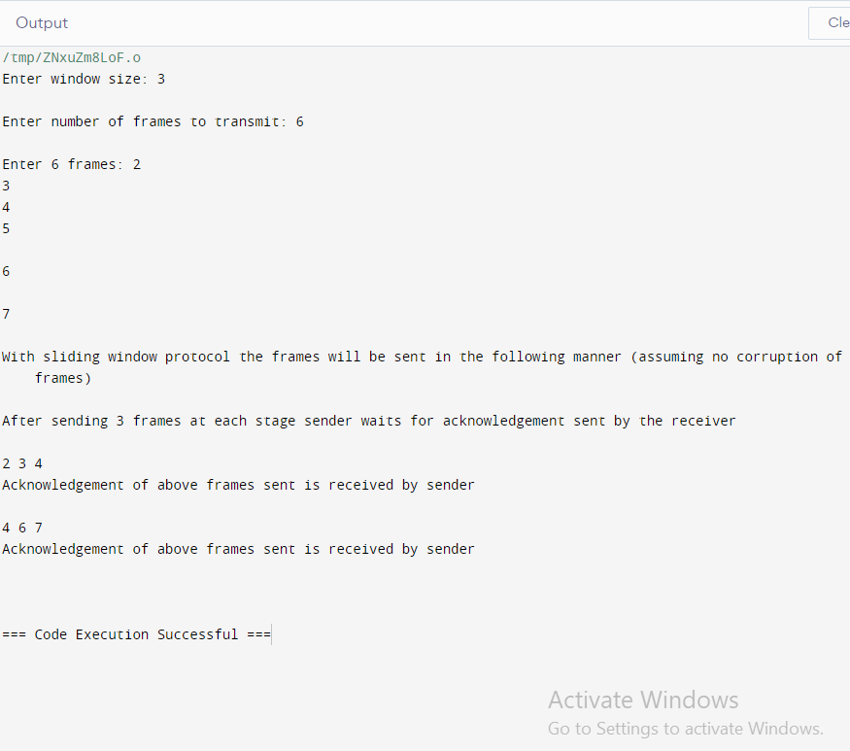

**ii) LOSS RECOVERY USING GO BACK N MECHANISM**

**THEORY:**

**Go-Back-N (GBN) Mechanism** is a sliding window protocol used for reliable data transmission. The sender can send up to **N** frames without waiting for an acknowledgment (ACK) but must re-transmit all frames from a lost or erroneous frame onwards. The receiver only accepts in-order frames, discarding any out-of-order ones and acknowledging only the last correctly received frame.

If a frame is lost or an error is detected, the sender goes back to re-transmit that frame and all subsequent frames. While efficient compared to Stop-and-Wait, GBN can lead to redundant re-transmissions.

**PROGRAM:**

#include<stdio.h>

int main()

{

int windowsize,sent=0,ack,i;

printf("enter window size\n");

scanf("%d",&windowsize);

while(1)

{

for( i = 0; i < windowsize; i++)

{

printf("Frame %d has been transmitted.\n",sent); sent++;

if(sent == windowsize)

break;

}

printf("\nPlease enter the last Acknowledgement received.\n");

scanf("%d",&ack);

if(ack == windowsize)

break;

else

sent = ack;

}

return 0;

}

**OUTPUT:**

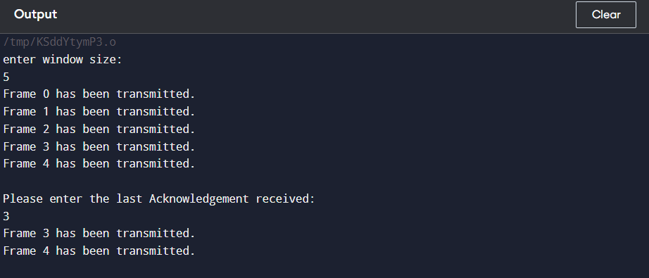

**Questions for Discussions(Viva)**

1. **What is the Sliding Window Protocol?**

**Answer :**It’s a flow control protocol used in data transmission that manages the number of frames a sender can send before waiting for an acknowledgment.

1. **What is a "window size" in Sliding Window Protocols?**

**Answer:** It’s the number of frames that can be sent without waiting for an acknowledgment.

1. **Why is the Sliding Window Protocol useful?**

**Answer:** It improves efficiency by allowing continuous transmission of frames and managing flow control and error recovery.

1. **What are the two types of Sliding Window Protocols?**

**Answer:** **Go-Back-N** and **Selective Repeat.**

1. **How does Selective Repeat differ from Go-Back-N?**

**Answer:** In **Selective Repeat**, only the lost frames are re-transmitted, whereas in **Go-Back-N**, all frames after the lost frame are re-transmitted.