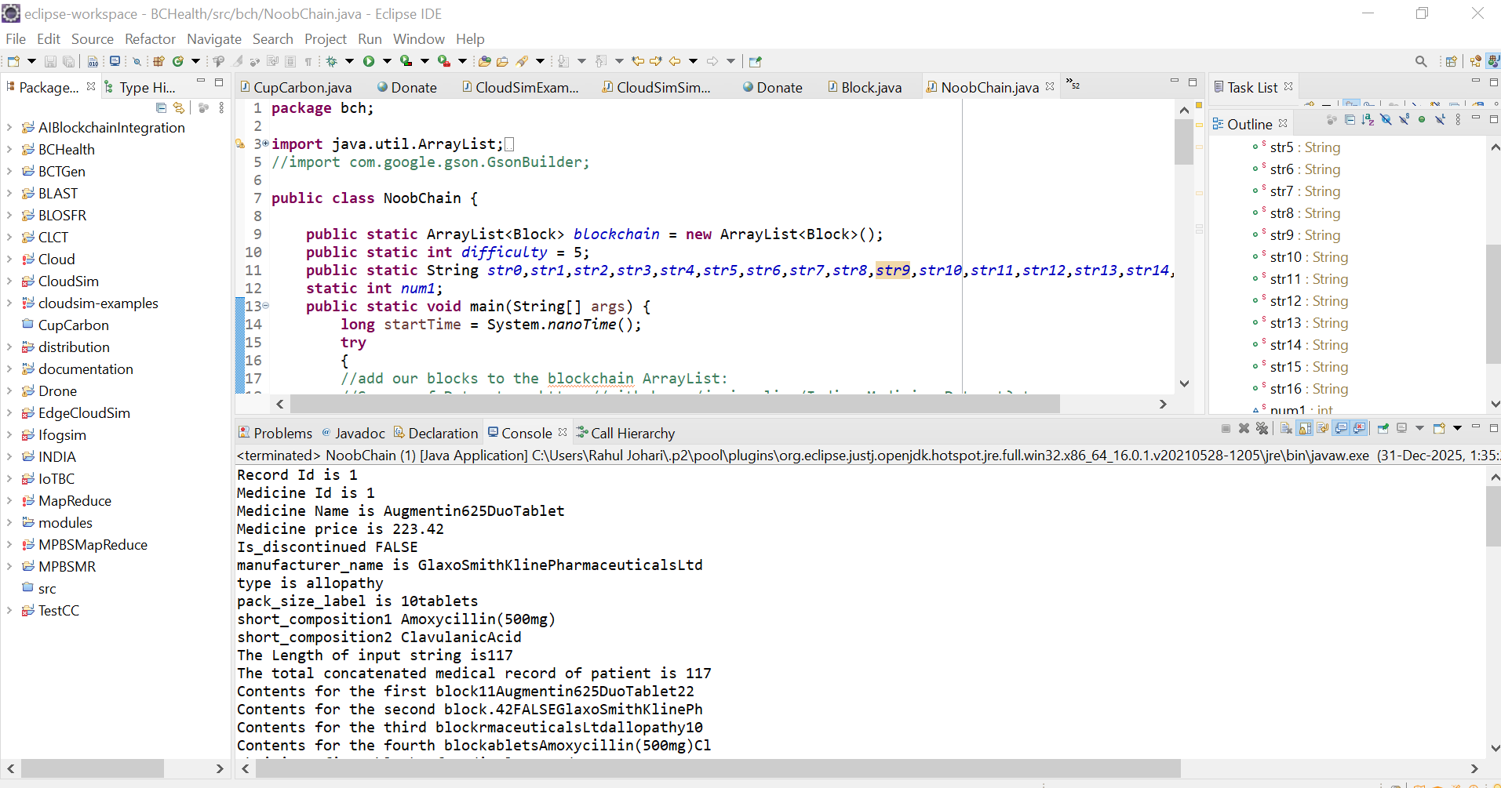
Simulation Snapshot of the BlockChain Code in ECLIPSE IDE using Java Programming Language [18]

