**INFORMATICS & COMPUTATIONAL SCIENCES**

UNIVERSITY COLLEGE OF SCIENCE

VIGYAN BHAWAN BLOCK-A

MOHANLAL SUKHADIA UNIVERSITY,UDAIPUR

BACHELOR OF COMPUTER APPLICATION

(A Choice Based Credit System)



BCA VIth Semester

(Session 2023-24)

Final Project Synopsis

On

**“Food-Delivery Website”**

Submitted To:- Submitted By:-

**Dr.Avinash Panwar**  Suraj Menaria

**TITLE:-**

**“** Food Delivery-Website”

**LOGO:-**



**Group Member:-**

* Varun Menariya
* Rahul Joshi
* Suraj Menaria
* Vishal Kumar Suthar

**INTRODUCTION:-**

Welcome to our food delivery website, your new go-to place for ordering delicious meals from your favorite local restaurants. We've made it super simple and convenient to enjoy great food without leaving your home.

Our website lets you easily browse through a wide variety of restaurants and cuisines. Whether you're craving pizza, sushi, burgers, or something else, you'll find plenty of options to choose from. Each restaurant has a detailed menu with pictures and descriptions, so you know exactly what you're getting.

Ordering is quick and easy. Just select your dishes, add them to your cart, and check out. You can pay online securely, and we'll handle the rest. You'll receive updates on your order status, so you know exactly when your food will arrive.

For restaurant owners, our platform makes it easy to manage orders and menus. You'll reach more customers and keep them happy with reliable service.

Our goal is to make food delivery simple, fast, and enjoyable for everyone. Whether you're a busy professional, a family looking for an easy dinner, or someone who just loves trying new foods, our website is here to make your dining experience better. Enjoy delicious meals delivered right to your door with just a few clicks!

**Objective Of The Project:-**

The objective of our food delivery website project is to create a user-friendly, efficient, and reliable platform that connects customers with a diverse range of local restaurants, enhancing the dining experience through convenient online ordering and delivery services. Our specific goals include:

1. **Convenience:** Provide a seamless and intuitive online ordering system that allows users to browse menus, select dishes, and place orders quickly and easily from their devices.

2. **Variety:** Offer a wide selection of cuisines and restaurants, catering to diverse tastes and dietary preferences, ensuring that every user can find something they love.

3. **Quality Service:** Ensure timely and accurate deliveries with real-time tracking and updates, enhancing customer satisfaction and trust.

4. **Support for Restaurant:** Equip restaurant partners with a robust backend system for managing orders, menus, and customer interactions, helping them to expand their reach and grow their business.

5. **User Experience:** Prioritize a smooth, enjoyable user experience with features like personalized recommendations, secure payment options, and responsive customer support.

6**. Community Engagement:** Foster connections within the local community by highlighting local eateries and promoting special deals, events, and promotions.

Through these objectives, our project aims to revolutionize the food delivery landscape, making it easier, faster, and more enjoyable for customers to enjoy great food at home.

**Features of the Project:-**

Our food delivery website project comes with a wide range of features designed to provide a seamless and enjoyable experience for both customers and restaurant owner. Here are some key features:

**For Customers:**

1. **User-Friendly Interface:**

Simple, intuitive design for easy navigation.

Search and filter options to quickly find favorite dishes and restaurants.

3**. Order Customization:**

Options to customize orders according to dietary preferences and specific requests.

4. **Secure Payment:**

Multiple payment options including credit/debit cards, digital wallets, and cash on delivery. Secure payment gateway for safe transactions.

6**. Customer Reviews and Ratings:**

Honest reviews and ratings from other customers to help make informed choices.

Option to leave feedback on the service and food quality.

7. **Promotions and Discounts:**

Access to special deals, discounts, and promo codes. Loyalty programs and rewards for frequent users

**For Restaurant Owner:**

**Comprehensive Dashboard:**

Easy-to-use dashboard for managing orders, menus, and customer interactions.

Analytics and reporting tools to track sales and performance.

**Menu Management:**

Simple interface for updating menu items, prices, and availability.

Option to highlight special dishes and promotions.

**Order Management:**

Efficient order processing system with real-time updates.

Tools to handle peak times and manage delivery schedules.

**Customer Engagement:**

Features to send personalized offers and promotions to customers.

Option to respond to customer reviews and feedback.

**Integration and Support :**

Easy integration with existing POS systems.

Dedicated support team for technical assistance and troubleshooting.

**Project Modules:-**

Creating a food delivery website involves several modules to ensure a seamless and efficient experience for users, delivery personnel, and restaurant partners. Here's a breakdown of the essential modules:

1**. User Module**

User Registration/Login

Email/phone number registration

User Profile Management

Edit personal information

Add/manage delivery addresses

View order history

2.**Admin Module**

Dashboard

Monitor user activity, orders, and revenue.

**Technical Specification :-**

**Hardware:-**

* Processor: i3,i5
* Ram: Minimum 4gb
* Storage: SSD (Solid State Drive) for data access. Storage capacity based on anticipated data volume.

**Software:-**

* Windows 7,8,9,10,11 (ultimate, enterprise)
* Mongo DB Compass
* Visual Studio Code

**Technical Used:-**

**Frontend Development:**

* **React.js:**

React JS is a powerful JavaScript library developed by Facebook for building fast and interactive user interfaces, particularly for single-page applications. It allows developers to create reusable UI components, simplifying code maintenance and enhancing scalability. React utilizes a virtual DOM for efficient updates and rendering, ensuring high performance. Its component-based architecture promotes a modular development approach, enabling better management of complex applications. React's flexibility and extensive ecosystem make it a popular choice for modern web development.

* **HTML:**

HTML (HyperText Markup Language) is the foundational markup language for creating and structuring web pages, using tags to define elements like headings, paragraphs, and images. It is essential for building and designing websites, enabling browsers to display content correctly.

* **CSS:**

CSS (Cascading Style Sheets) is used to style and layout web pages by controlling elements like colors, fonts, spacing, and positioning. It enhances the visual presentation of HTML content, making websites more attractive and user-friendly.

**Backend Development :**

* **Express.js:** Express.js is a minimal and flexible Node.js web application framework that provides a robust set of features to develop web and mobile applications. It is designed to make the process of building web applications simpler and more efficient by offering a plethora of built-in functionalities and middleware support.
* **Node.js:**

Node.js is a powerful, open-source runtime environment that allows developers to run JavaScript on the server-side. It is built on Chrome's V8 JavaScript engine, enabling fast and efficient execution of code. Node.js is designed for building scalable network applications, particularly useful for real-time applications like chat servers and APIs. Its non-blocking, event-driven architecture makes it capable of handling multiple simultaneous connections efficiently. With a vast ecosystem of modules available via npm (Node Package Manager), Node.js streamlines the development process for a wide range of applications.

* **Mongo db:**

MongoDB Compass is a graphical user interface (GUI) for MongoDB that simplifies database management and visualization. It allows users to explore their data, run queries, and analyze schema, making it easier to understand the structure and content of their databases. With Compass, users can perform CRUD operations (Create, Read, Update, Delete) through an intuitive interface without needing extensive command-line knowledge. It also provides real-time performance metrics and insights to optimize database performance. MongoDB Compass is an essential tool for developers and database administrators working with MongoDB.

**Database – ScreenShots:-**

* Admin-panel:-

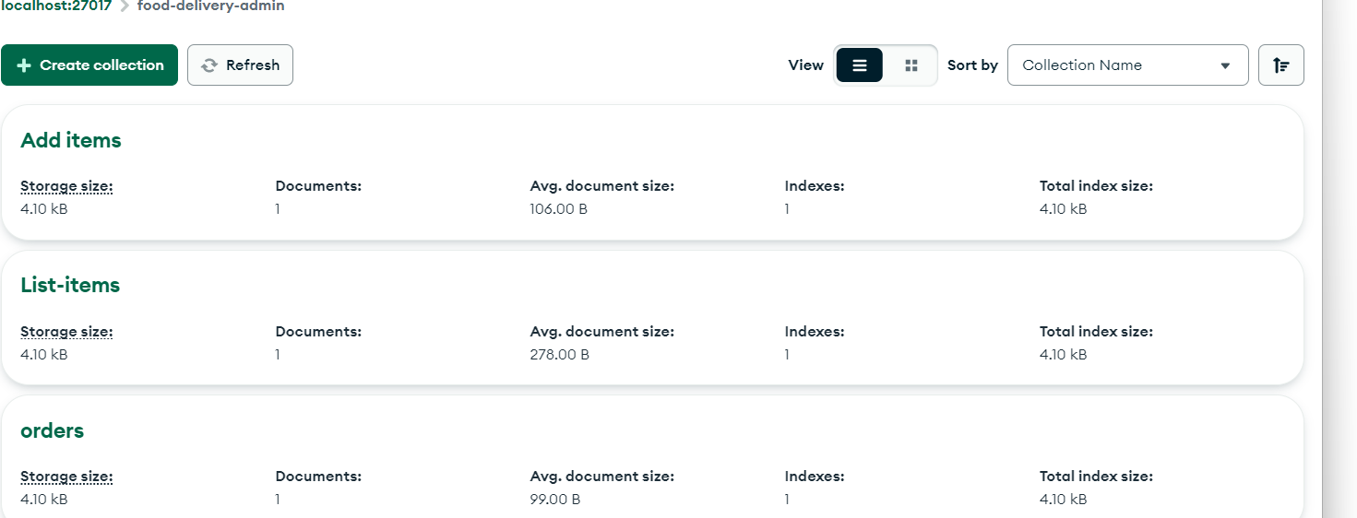

* Add-Items:-

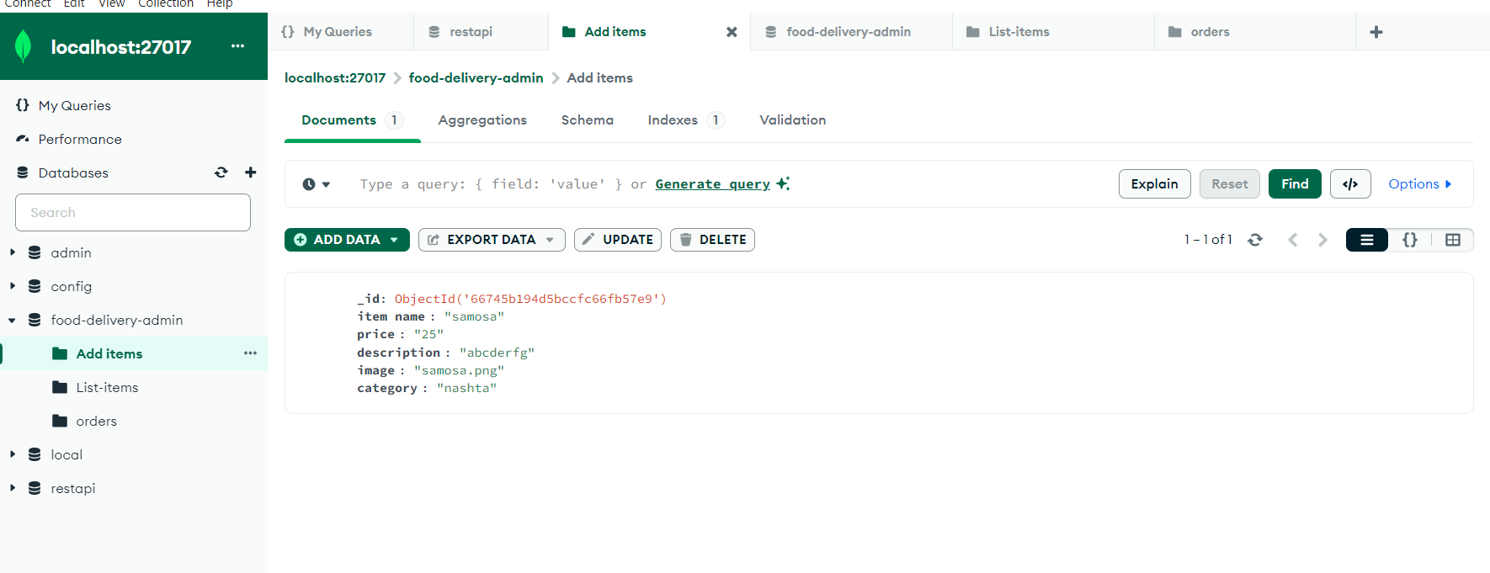

* List-Items:-

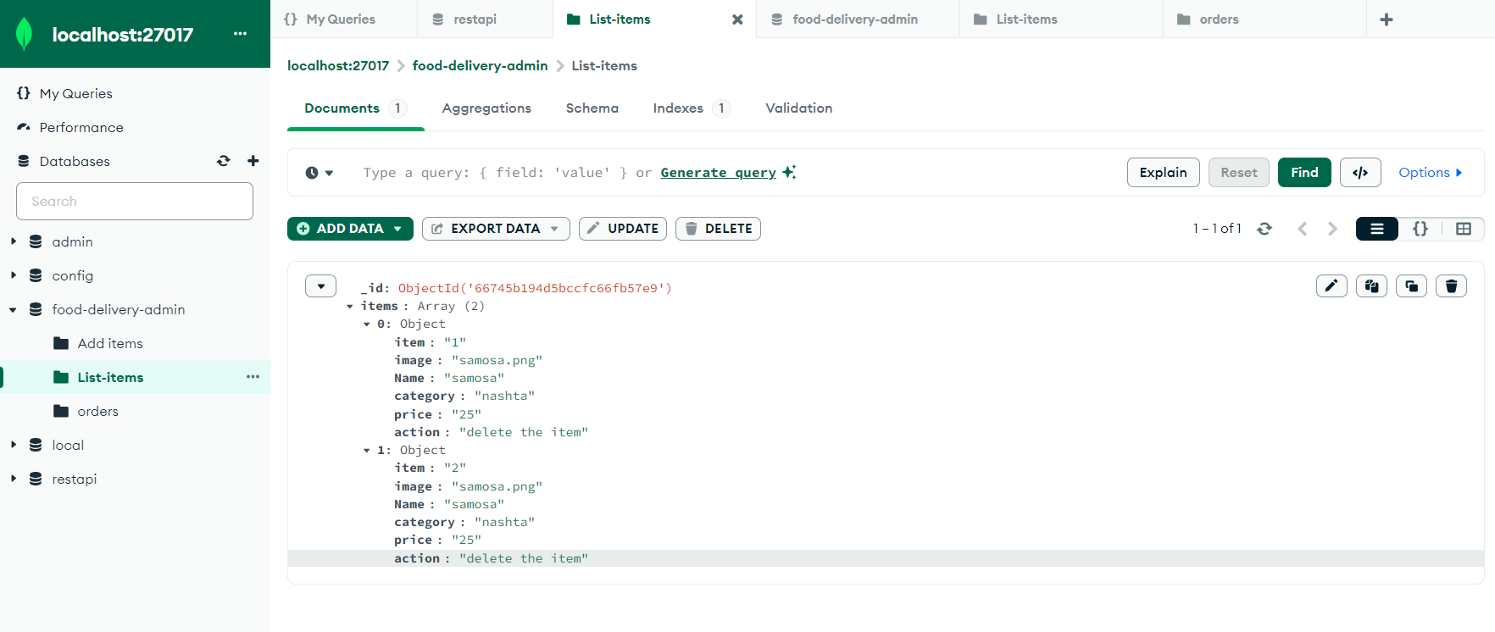

* Orders:-

