Steps for making a Peanut-Butter Jelly Sandwich

1. Ingredients required
   1. Sliced bread loafs.
   2. Peanut-butter
   3. Jelly (whichever flavour you prefer)
   4. Butter knife
2. Take any 2 adjacent loafs. I would recommend that you skip the end slices since they are not uniform. Place them on a plate such that the adjoining sides are facing upwards – these are the sides on which you would be applying the peanut butter and jelly.

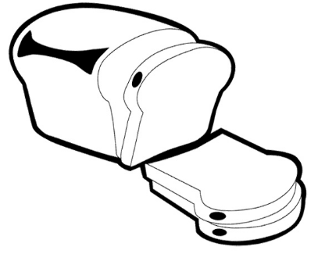

*Creative commons licence*

Keep these faces facing upwards on a plate.

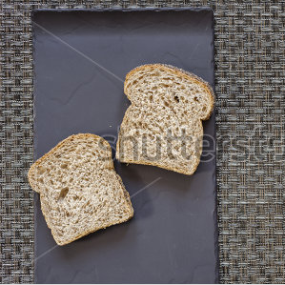*© shutterstock.com*

1. Heat the butter knife mildly over a flame or stove (a minute on a medium flame). I found that this makes it easier for the peanut butter to spread over the bread surfaces, especially on cold days.
2. Hold the bread slice with one hand supporting it with your palm. Scoop some peanut-butter with the heated knife and apply it on one of the bread surfaces. Apply a thin uniform layer on the bread surface.

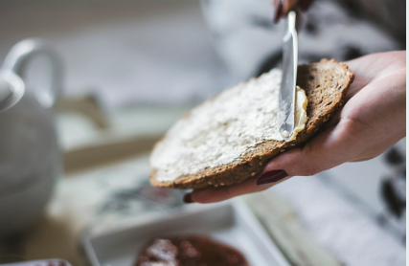*© istockphoto.com*

1. Repeat the above process with the second slice.
2. You can now apply jelly following the same process as you did for applying peanut butter. I would recommend that you apply jelly on only one of the slices, unless you want it oozing from the edges of the sandwich while eating. Note that, in this case, you should NOT heat the knife.
3. Now just press both the pieces together with the sides on which you applied the peanut butter and jelly facing each other. Press them mildly. Press the slices too hard and you would make the sandwich soggy.

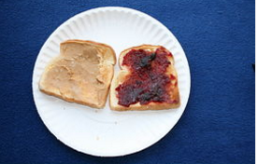 *©canstockphoto.com*

Flip one on the other and mildly press them.

1. That’s it, your sandwich is ready to be devoured.

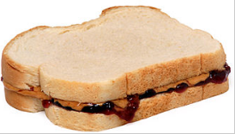 *Wikimedia commons image*

Word count : 287