NETWORK PERFORMANCE ANALYSIS
Final Project Report | Python • MySQL • Power BI

Prepared from the supplied task sheet, Python notebook, and SQL script

Log records | Network nodes | Average latency | Average packet loss
43,200 | 5 | 38.87 ms | 0.443%

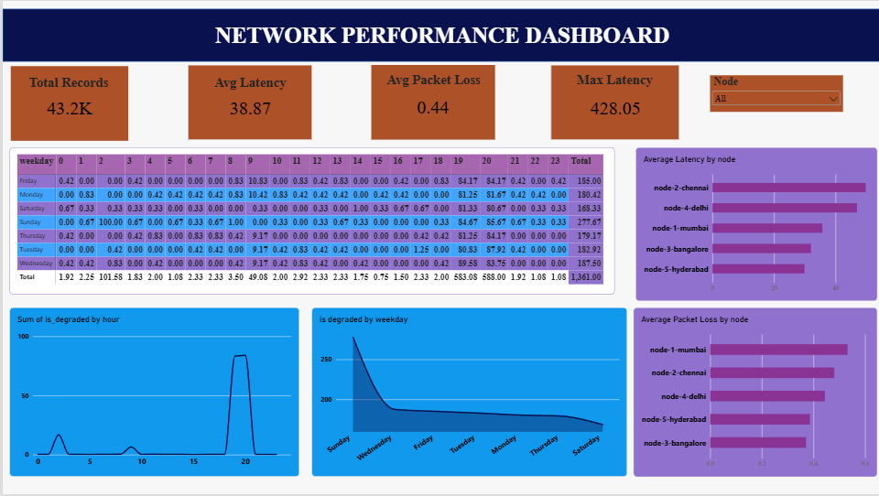
sss

1. Executive Summary
This project analyzes network log data to identify latency, packet loss, and recurring network-performance degradation across five network nodes. Python is used for data inspection, cleaning, time-based feature preparation, statistical analysis, and summary generation. MySQL stores the detailed logs and summary tables and supports SQL-based comparisons. Power BI is the reporting layer for KPI cards, trends, node comparisons, heatmaps, slicers, and interactive monitoring.
The supplied notebook contains 43,200 network-log records, with 8,640 records for each of five nodes. The recorded average latency is approximately 38.87 ms, median latency is 31.62 ms, and maximum latency is 428.05 ms. Average packet loss is approximately 0.443%, with a maximum recorded packet loss of 17.59%. The strongest hourly degradation signals occur at 20:00 and 19:00.

2. Problem Statement
Network performance can vary by node and time of day. High latency can delay communication, while packet loss can interrupt or degrade data transmission. The project examines network logs to locate poor-performing nodes and recurring performance-degradation windows so that monitoring and troubleshooting can be prioritized.

3. Objectives
- Inspect and clean network log data.
- Prepare timestamp-derived fields such as date, hour, weekday, day of week, month, and year.
- Calculate latency and packet-loss statistics.
- Create hourly, weekday-hour, and node-hour degradation summaries.
- Store detailed and summarized data in MySQL.
- Use SQL to compare nodes and identify peak degradation periods.
- Build an interactive Power BI dashboard for network monitoring.
- Present actionable findings and recommendations.

4. Tools and Technologies
Python: pandas, NumPy, and Matplotlib for data preparation, analysis, and plots.
MySQL: database and tables for network logs and summary data; SQL aggregation and sorting for performance analysis.
Power BI: KPI cards, hourly trend visuals, node comparisons, weekday-hour heatmap, slicers, filters, and dashboard reporting.
Primary dataset: network_logs.csv. Supporting summaries: summary_hourly.csv, summary_weekday_hour.csv, and summary_node_hour.csv.

5. Dataset Overview
The notebook output reports 43,200 rows and four core columns in the network log: timestamp, node, latency_ms, and packet_loss_pct. Five nodes are represented: node-1-mumbai, node-2-chennai, node-3-bangalore, node-4-delhi, and node-5-hyderabad. Each node has 8,640 records.
The supporting hourly summary has 24 rows, the weekday-hour summary has 168 rows, and the node-hour summary has 120 rows. These summaries support time-of-day, weekday/time, and node/time comparisons.

6. Methodology
Step 1 — Data inspection: load the log and summary CSV files with pandas; inspect dimensions, column names, data types, descriptive statistics, missing values, and duplicate rows.
Step 2 — Cleaning: fill missing latency and packet-loss values with their respective medians; convert metric columns to numeric values and parse timestamp values as datetimes. The notebook checks duplicate counts and missingness.
Step 3 — Time feature engineering: derive date, hour, weekday name, numeric day of week, month, and year from timestamp.
Step 4 — Metric analysis: calculate average, median, minimum, and maximum latency; calculate average and maximum packet loss; aggregate record count, average latency, average packet loss, and maximum latency by node.
Step 5 — Time-based summaries: examine degradation by hour, weekday-hour, and node-hour, then sort the summaries to identify the highest values.
Step 6 — Database and dashboard: create MySQL tables for network logs and summaries; query node-level performance and peak periods; connect the cleaned and summarized data to Power BI for interactive analysis.

7. SQL Database Design
The SQL script creates a database named network. The network_logs table contains timestamp, node, latency_ms, and packet_loss_pct. Three summary tables are defined: summary_hourly (hour, is_degraded), summary_weekday_hour (weekday, hour, is_degraded), and summary_node_hour (node, hour, is_degraded).
Queries in the supplied SQL script count log rows, preview records, calculate per-node record counts and average metrics, list the highest latency and packet-loss records, rank nodes by degradation, and find the top hourly and weekday-hour degradation values.

8. Key Results
Overall latency: average 38.87 ms; median 31.62 ms; minimum 12.38 ms; maximum 428.05 ms.
Packet loss: average 0.443%; maximum 17.59%.
Node with highest average latency: node-2-chennai at approximately 49.80 ms, followed by node-4-delhi at approximately 46.96 ms.
Node with lowest average latency: node-5-hyderabad at approximately 29.90 ms, followed by node-3-bangalore at approximately 32.00 ms.
Highest average packet loss by node: node-1-mumbai at approximately 0.532%.
Peak hourly degradation summary: hour 20 has a reported value of 83.944, followed by hour 19 at 83.278. The next highest reported hour is 02:00 at 16.889.
Highest weekday-hour summary entries: Sunday at hour 02 reports 100.0; Wednesday at 19:00 reports 89.583; Tuesday at 20:00 reports 87.917.
Highest node-hour summary entries: node-2-chennai at 19:00 reports 0.9556 and at 20:00 reports 0.9444; node-4-delhi at 20:00 reports 0.9250 and at 19:00 reports 0.9222.

9. Interpretation and Important Data-Quality Note
The results point to node-2-chennai and node-4-delhi as priorities for latency investigation. Node-1-mumbai deserves packet-loss investigation because it has the highest average packet-loss value among the five nodes. The hourly summaries consistently flag 19:00–20:00 as important monitoring windows.
Important validation note: the notebook's degradation summaries show different apparent scales: hourly values include 83.944, weekday-hour values include 100.0, while node-hour values include values such as 0.9556. Before comparing these summary tables directly or labeling all values as percentages, confirm how is_degraded was calculated and whether each table stores a fraction or a percentage. The report preserves the values as displayed in the notebook rather than silently converting them.

10. Power BI Dashboard Design
The task sheet marks the Power BI connection, KPI cards, hourly trend, node comparison, weekday-hour heatmap, interactive dashboard, and key-insight tasks as completed. A clear dashboard can include:
- KPI cards: Total Records, Average Latency (ms), Average Packet Loss (%), Maximum Latency (ms), and Maximum Packet Loss (%).
- Hourly trend: degradation by hour, with 19:00 and 20:00 highlighted for investigation.
- Node comparison: average latency and average packet loss by node.
- Weekday-hour heatmap: identify combinations of weekday and hour with higher degradation.
- Node-hour heatmap: compare the time-based degradation pattern for each node.
- Slicers: node, weekday, date, and hour where those fields are available.

11. Recommendations
- Investigate node-2-chennai first for high average latency and its elevated 19:00–20:00 degradation values.
- Review node-4-delhi during 19:00–20:00 because its node-hour degradation values are also high.
- Inspect node-1-mumbai network paths, interfaces, and traffic around packet-loss spikes.
- Add alerts for sustained latency spikes and packet loss, using thresholds agreed with the network operations team.
- Compare weekday-hour patterns over additional periods to determine whether the observed peaks repeat consistently.
- Standardize the is_degraded definition and scale across all summary outputs before publishing percentage-based KPIs.
- Validate data refresh, timestamp time zone, missing-value handling, and row counts after loading data into MySQL and Power BI.

12. Conclusion
The Network Performance Analysis project demonstrates an end-to-end analytics workflow using Python, MySQL, and Power BI. It converts raw network logs into performance metrics and time-based summaries, enabling comparisons across nodes and time windows. The available results highlight node-2-chennai and node-4-delhi for latency follow-up, node-1-mumbai for packet-loss follow-up, and 19:00–20:00 as a key monitoring period. Standardizing the degradation metric is an important final validation step before treating all degradation values as directly comparable percentages.

13. Project Deliverables
- Python notebook: data inspection, cleaning, feature engineering, metric analysis, and degradation summaries.
- MySQL script: database/table definitions and analytical queries.
- Power BI file: network monitoring dashboard (as supplied).
- Final report: methodology, findings, recommendations, and conclusion.

