FINAL PROJECT REPORT
NETFLIX DATA ANALYSIS USING POWER BI
Customer Engagement, Content Performance, Ratings & Country Analysis
Domain: Entertainment, Media, and OTT Analytics
Project Created by Mr. Gaurav Kumar
Vinsup Skill Academy, Coimbatore

1. Executive Summary
This project analyzes Netflix content and customer viewing behavior using Excel for data preparation and Power BI for analysis and visualization. The focus is on customer engagement, content popularity, ratings, subscription behavior, demographics, and country-level patterns. The final dashboard combines interactive visuals and filters to support business-oriented analysis.

2. Problem Statement
Analyze Netflix's content and customer viewing behavior to derive meaningful business insights. The goal is to clean and visualize the data to understand customer engagement, content popularity, and subscription trends.

3. Objectives
• Identify the most popular movies and TV shows based on watch time and ratings.
• Analyze customer demographics and target-audience preferences.
• Understand the impact of Basic, Standard and Premium subscriptions on watch time and engagement.
• Explore content ratings and their effect on viewer behavior.
• Analyze content release patterns and recent additions.
• Support content strategy using genre popularity and user ratings.
• Compare engagement and retention patterns across countries.

4. Methodology
Data Cleaning & Transformation: Identify missing values, standardize date formats and ensure rating values are properly categorized.
Customer Demographics: Group customers by age range and analyze their distribution.
Subscription Analysis: Compare subscription type with total watch time and engagement.
Content Analysis: Identify top content by watch time and compare Movies with TV Shows.
Rating & Geographic Analysis: Analyze ratings by genre, country, show rating, director and cast, along with country-level patterns.
Power BI Dashboard: Present KPIs, charts, slicers and navigation sections for interactive analysis.

5. Dataset Description
The project specification identifies two CSV datasets.
Dataset | Format | Key Variables
Netflix Shows Dataset | CSV | show_id, type, title, director, cast, country, date_added, release_year, rating, duration, genre
Netflix Customer Ratings Dataset | CSV | customer_id, show_id, customer_name, age, gender, country, subscription_type, watch_time_minutes, rating

6. Dashboard Structure
• Customers – customer engagement KPIs, top content, genre ratings, subscription type and age-group analysis.
• Content – release-year watch time, subscription-type watch time, title counts by country and rating by cast.
• Rating – show-rating distribution, director ratings, country/watch-time relationship and genre ratings.
• Country – country/type/rating composition and title distribution by country and rating.

7. Key Dashboard Results
KPI | Dashboard value
Total Titles Watched | 19.049K
Average Rating | 3.01
Total Watch Time | 50M
Total Customers | 20K
Note: KPI values are transcribed from the supplied screenshots and were not independently recalculated.

8. Dashboard Screenshots

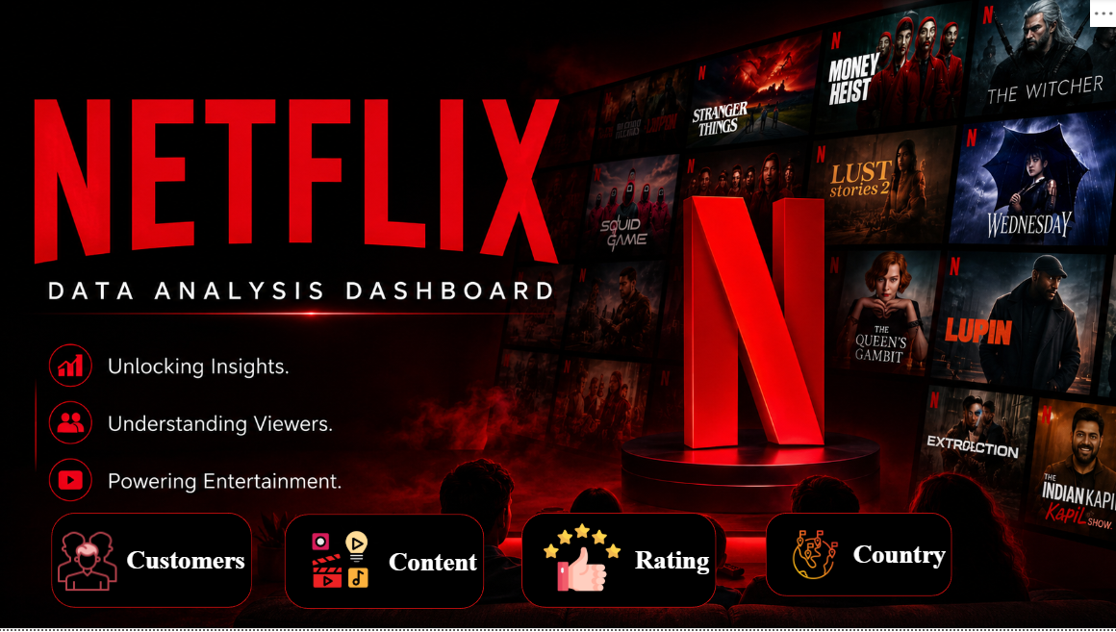

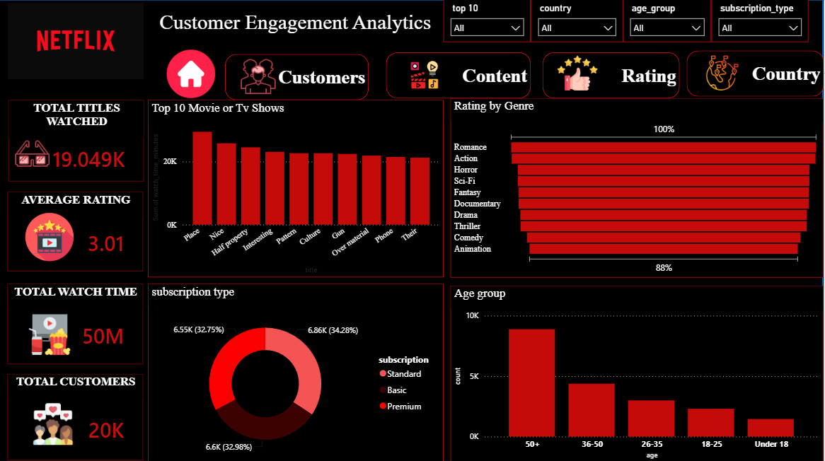
Figure 2 – Customer Engagement Analytics: KPIs, top content, genre ratings, subscriptions and age group.
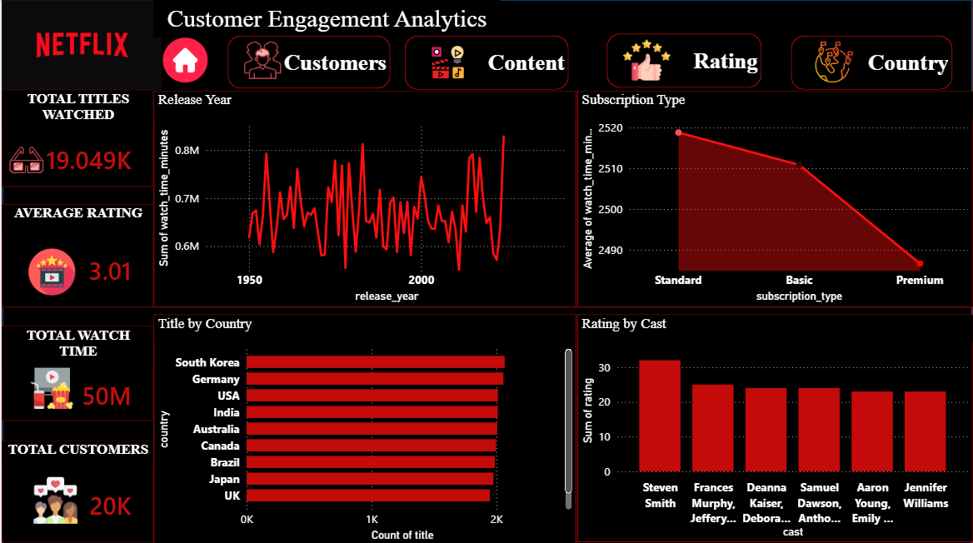

Figure 3 – Content analysis: release year, subscription type, country and cast-level rating views.

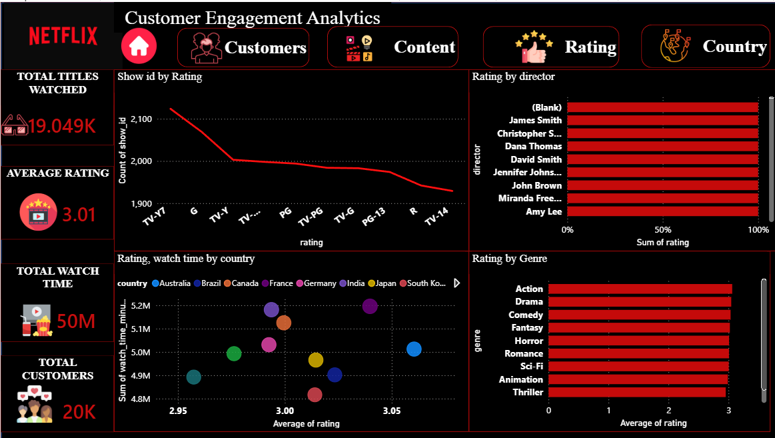
Figure 4 – Rating analysis: show ratings, directors, country/watch-time relationship and genres.

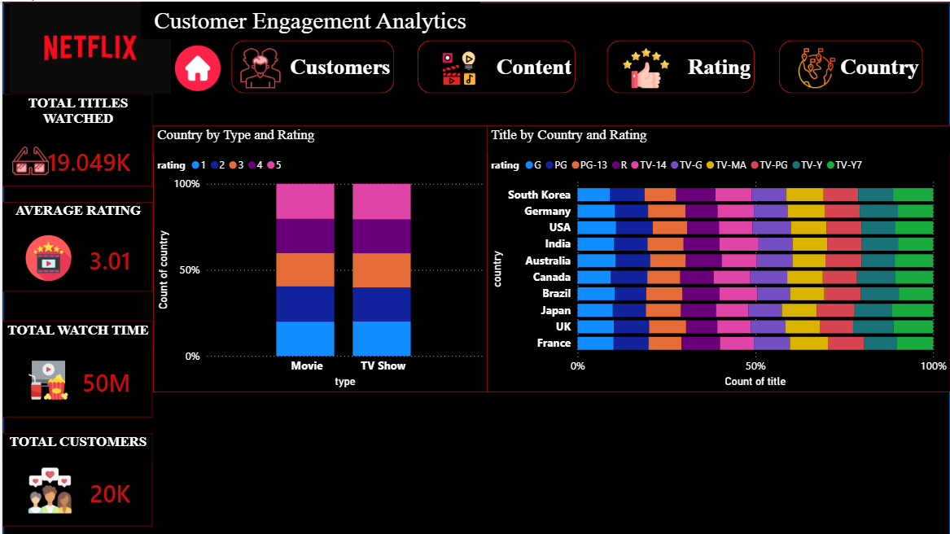

Figure 5 – Country analysis: content type/rating composition and title distribution by country.

s

9. Findings
• The dashboard provides a consolidated view of customer engagement, content performance, ratings, subscriptions, age groups and countries.
• The headline KPIs shown are 19.049K total titles watched, 3.01 average rating, 50M total watch time and 20K total customers.
• The Customer page shows the 50+ category as the largest age group in the supplied screenshot.
• The subscription donut chart shows Basic, Standard and Premium with broadly similar shares, with Standard displayed as the largest segment.
• The Content page includes a Top 10 watch-time visual and a release-year watch-time trend.
• The Rating page provides show-rating, director, genre and country/watch-time perspectives.
• The Country page compares title distribution across countries and content types/ratings.

10. Business Recommendations
• Use age-group and subscription patterns to support audience-focused engagement strategies.
• Use watch time, ratings and genre performance together when evaluating content.
• Compare country-level performance to identify opportunities for localized content strategy.
• Use director/cast and rating analysis as supporting evidence for content evaluation.
• Use release trends to inform future content planning.
• Use Power BI slicers for country, age group and subscription type when presenting management insights.

11. Limitations
This report is based on the supplied project specification and five supplied Power BI dashboard screenshots. The underlying CSV files and Power BI data model were not supplied here, so calculations and data quality were not independently validated.

12. Conclusion
The Netflix Data Analysis project demonstrates how cleaned datasets and Power BI visualizations can be used to study customer engagement and content performance in an OTT environment. The final dashboard brings together customer, content, rating and country perspectives and provides a practical foundation for business decision-making.

13. Source Basis
Primary source: PowerBI - Netflix Analysis project specification supplied by the user. Visual evidence: five Power BI dashboard screenshots supplied by the user.

