BUILD MANUAL
RONIN + CAT
ANIMATION RIG
A shape-by-shape Figma guide for building a simple, mobile-app mascot that is ready to animate in Rive.
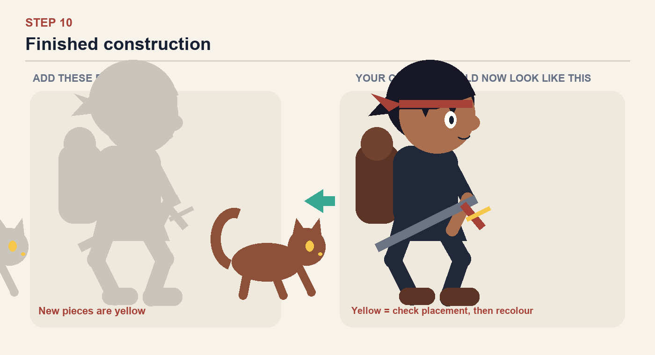
Build rule: simple silhouettes first. Details come only after every moving part exists as its own named layer.

Tools — learn these once
You will reuse the same small set of Figma tools throughout the manual.
V — Move / Select | Click a shape to select it. Drag to move. Hold Shift while selecting to choose several shapes.

O — Ellipse | Press O, then drag. Hold Shift for a perfect circle. Use this for the head, eyes and rounded joints.

R — Rectangle | Press R and drag. Increase Corner radius in the right panel to make torsos, feet and bags.

P — Pen | Press P and click around a custom silhouette. Click the first point again to close the shape.

⌘D — Duplicate | Duplicates the selected shape. Useful for making matching legs, arms and eyes.

⌘G — Group | Select related pieces and group them. Name groups Ronin, Cat, Sword and Backpack.

Rename | Double-click a layer name in the left panel. Name it immediately before drawing the next piece.

Opacity + Lock | Select the reference, set Opacity to 30% in the right panel, then press ⇧⌘L to lock it.

Step 1 — Set up the tracing frame
Create a 600 × 600 frame. Place the Canva artwork inside, set it to 30% opacity, then lock it.
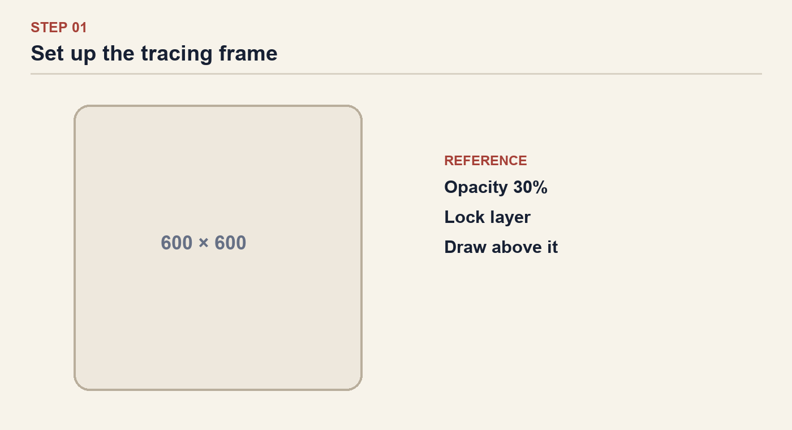
Checkpoint: The reference is locked and cannot be selected accidentally.

Step 2 — Build the rear silhouette
Use simple shapes. Extend each leg segment beneath the joint by about 10–15 px.
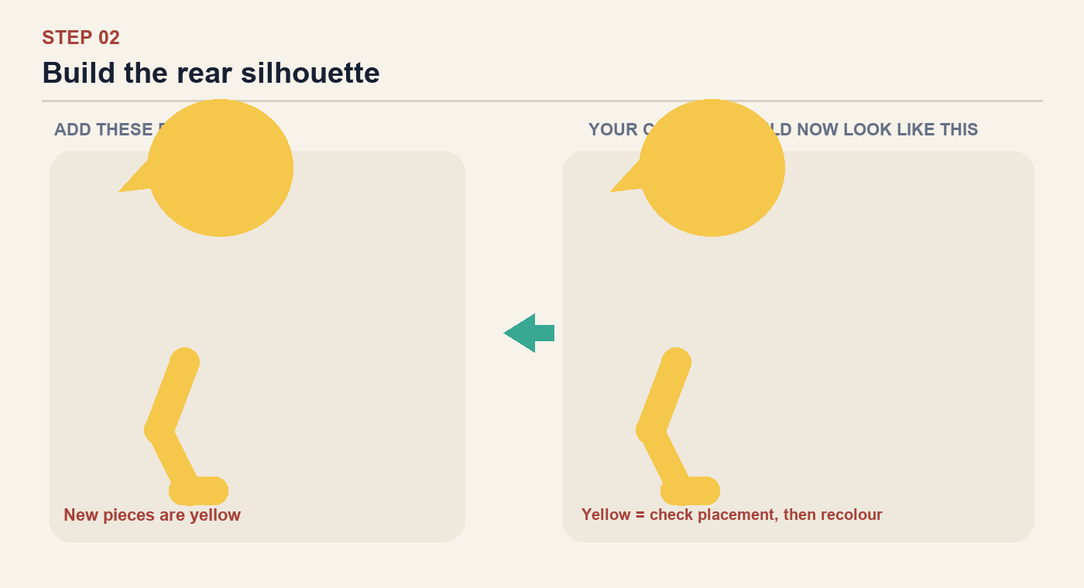
Checkpoint: Every yellow piece exists as a separate, clearly named layer. Nothing has been flattened.

Step 3 — Add the back arm and backpack
Keep the back arm behind the torso. The backpack may overlap the shoulder.
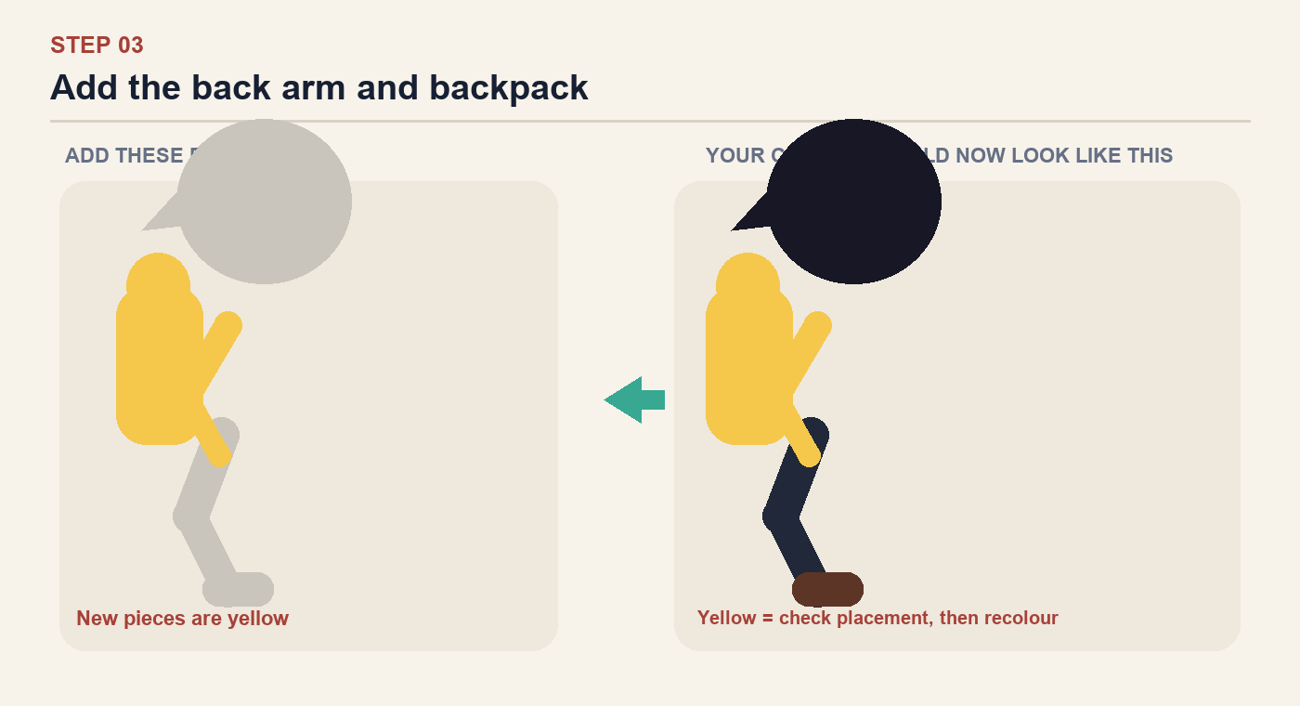
Checkpoint: Every yellow piece exists as a separate, clearly named layer. Nothing has been flattened.

Step 4 — Add the torso and head
Use one rounded torso shape and one large head ellipse. Keep the head oversized and app-like.
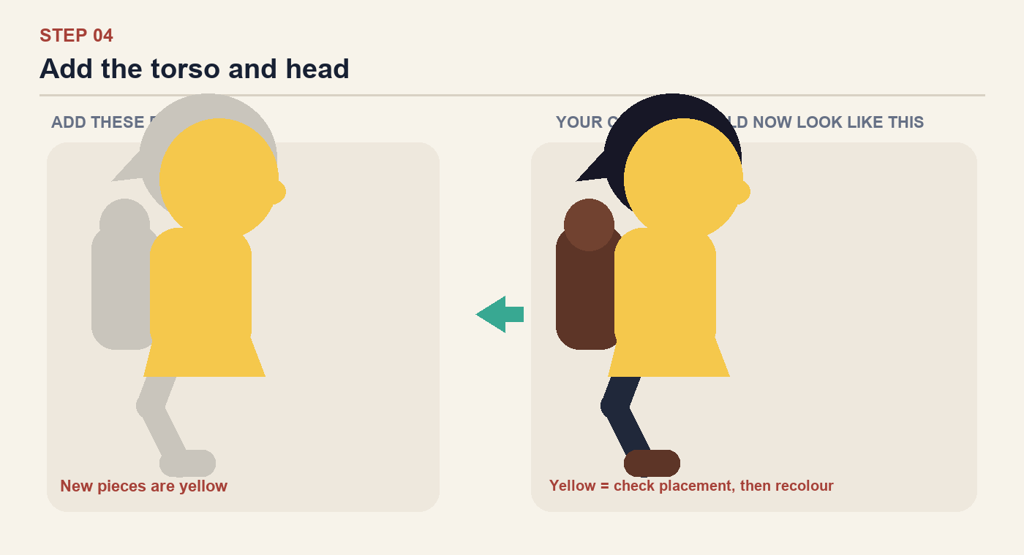
Checkpoint: Every yellow piece exists as a separate, clearly named layer. Nothing has been flattened.

Step 5 — Build the front leg
Make thigh, shin and foot separate layers. Hide the top of the thigh beneath the torso.
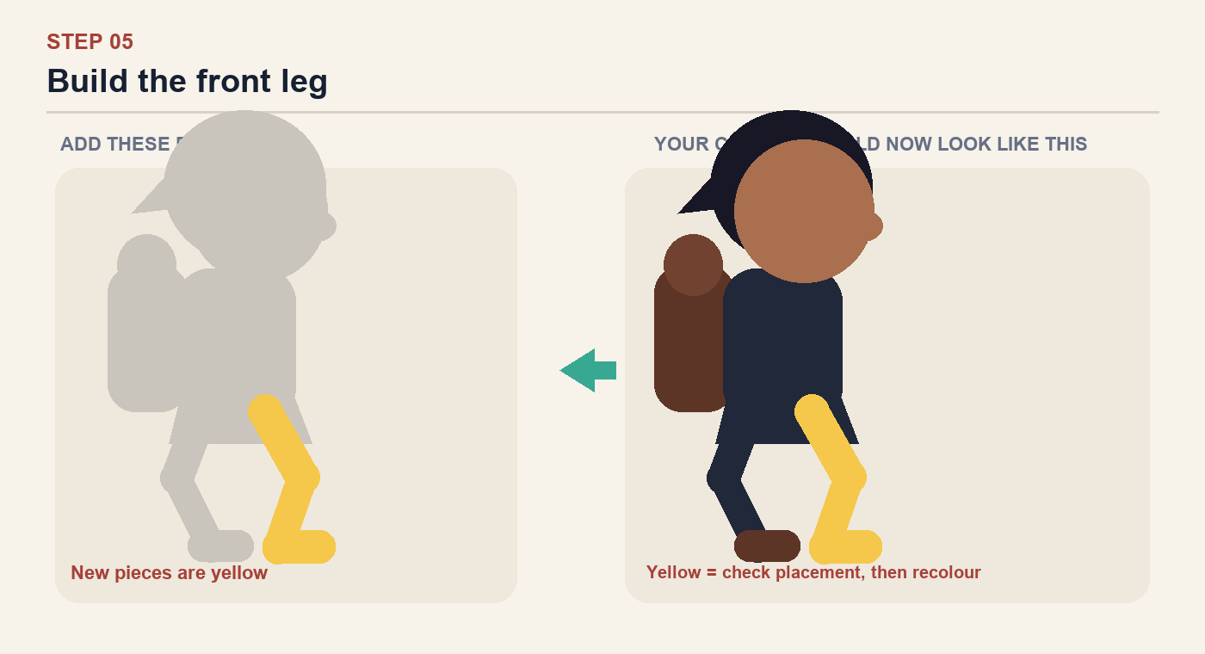
Checkpoint: Every yellow piece exists as a separate, clearly named layer. Nothing has been flattened.

Step 6 — Build the front arm
Make upper arm and forearm separate. Overlap them at the elbow.
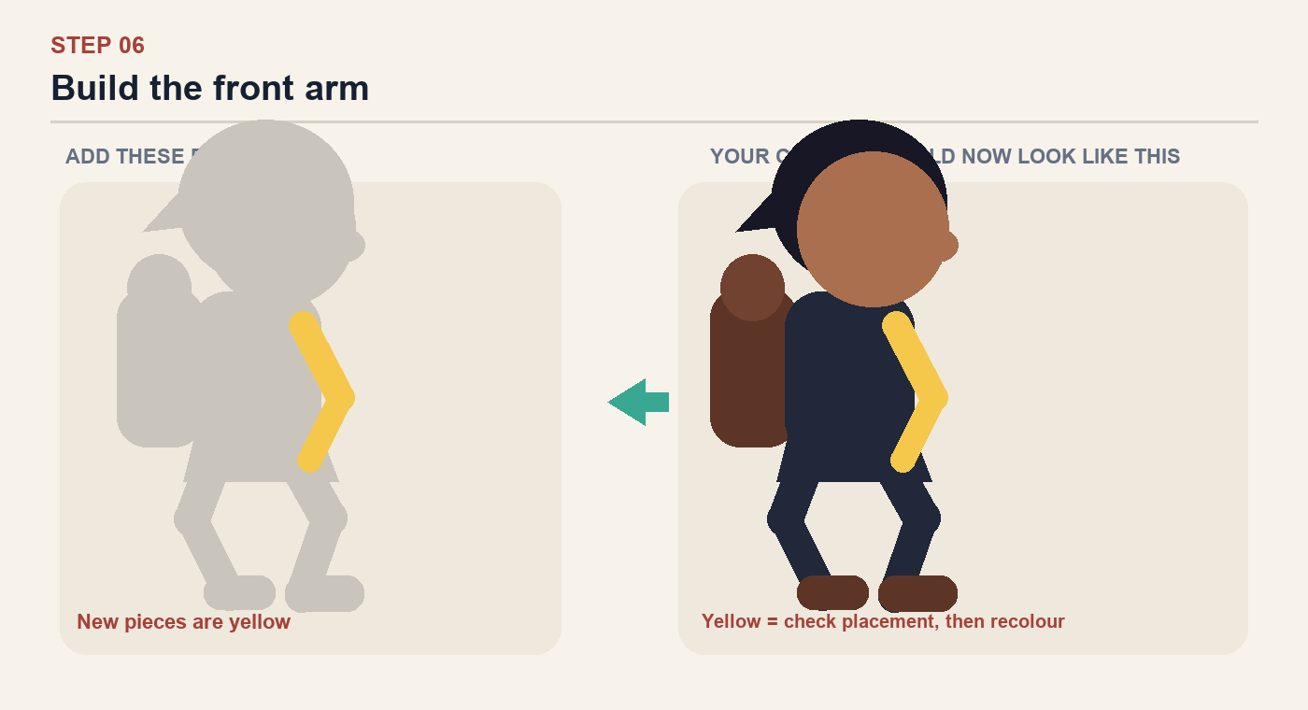
Checkpoint: Every yellow piece exists as a separate, clearly named layer. Nothing has been flattened.

Step 7 — Add the character details
Use only a few bold shapes. Avoid individual hair strands, textures and realistic shading.
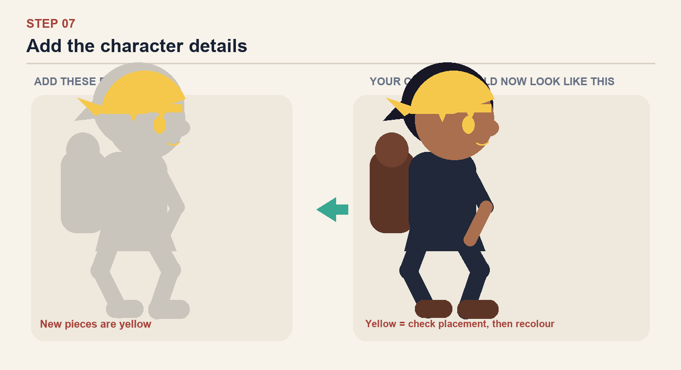
Checkpoint: Every yellow piece exists as a separate, clearly named layer. Nothing has been flattened.

Step 8 — Add the sword
Keep the complete sword in one group so it can move with the torso or hand.
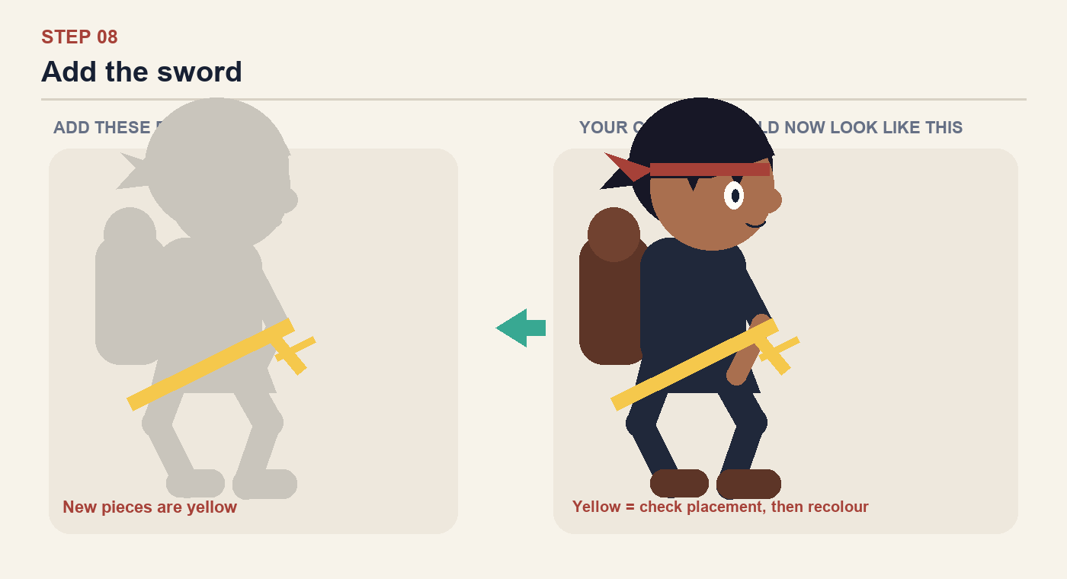
Checkpoint: Every yellow piece exists as a separate, clearly named layer. Nothing has been flattened.

Step 9 — Build the cat silhouette
Keep the cat in its own group. Separate the tail and legs so they can move.
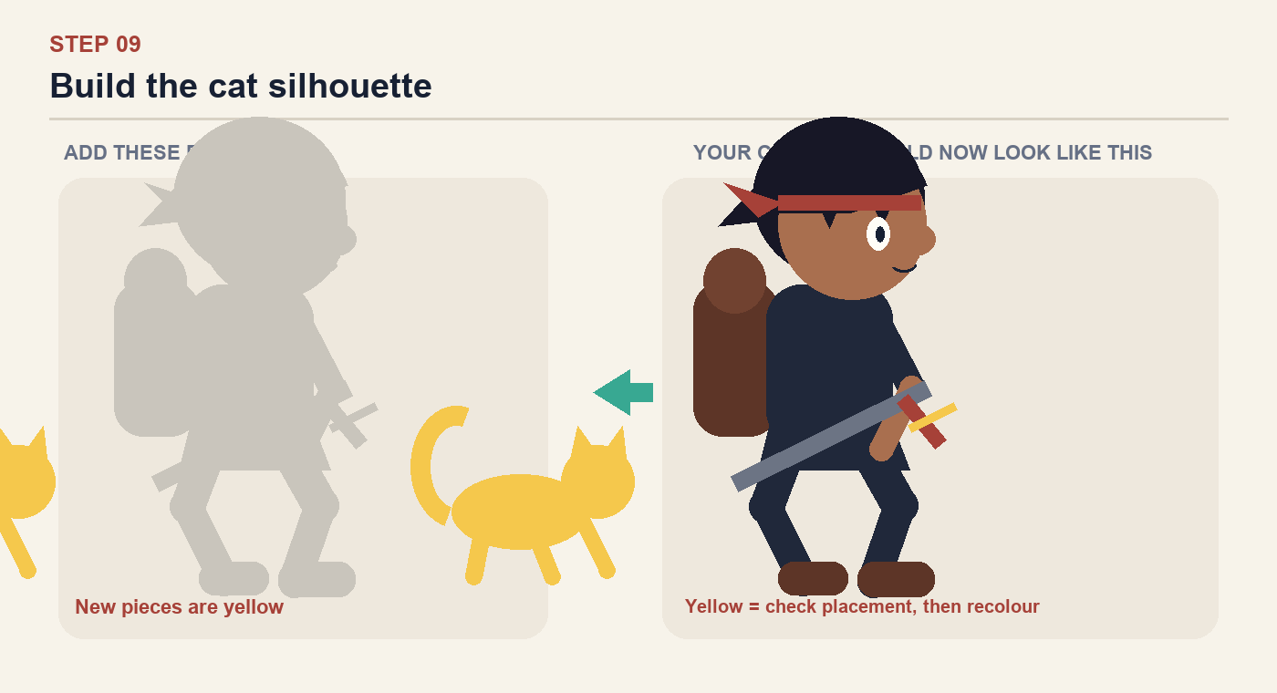
Checkpoint: Every yellow piece exists as a separate, clearly named layer. Nothing has been flattened.

Step 10 — Add the cat face
Use only an eye and tiny nose. Readability at phone size matters more than detail.
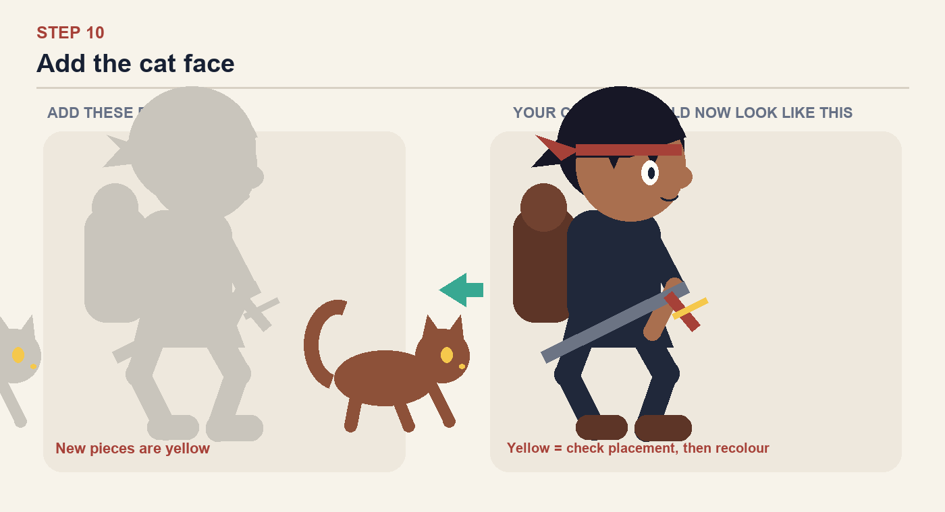
Checkpoint: Every yellow piece exists as a separate, clearly named layer. Nothing has been flattened.

Final check — prepare for Rive
Do not export until every box below is true.
1 | The Ronin and cat are separate top-level groups.

2 | Upper and lower arms are separate layers.

3 | Upper and lower legs are separate layers.

4 | Each joint overlaps by roughly 10–15 px, so rotation cannot reveal gaps.

5 | Back limbs sit behind the torso; front limbs sit in front.

6 | The reference image is hidden before export.

7 | Every layer has a useful name; no important layer is still called Vector or Rectangle.

8 | The character remains readable when viewed at approximately 120 px tall.

Recommended layer order
Hair Back → Back Leg → Back Arm → Backpack → Torso → Head → Front Leg → Front Arm → Hair Front → Headband → Face → Sword
Cat: Tail → Back Legs → Body → Front Legs → Head → Face
When you reach this page, send a screenshot of your Layers panel and canvas. We can correct the structure before you begin animating.

