ADVANCED BUILD MANUAL
RONIN + CAT
VECTOR RIG
Trace the real artwork closely while rebuilding every moving part as a clean, editable Figma path.
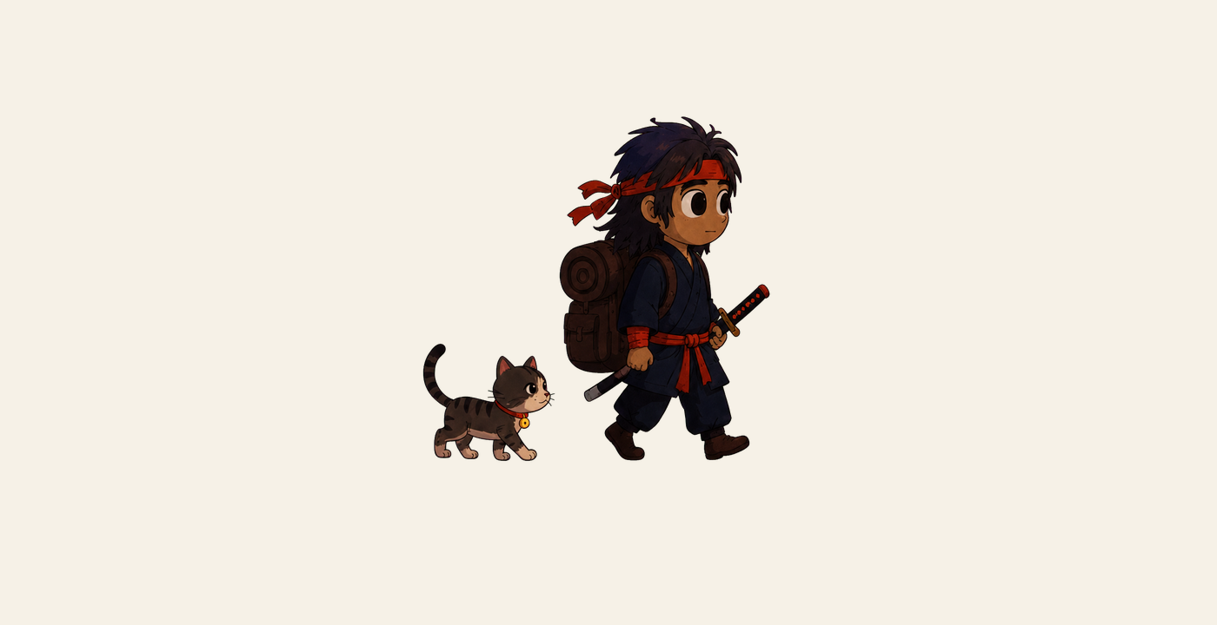
OUTCOME A recognisable version of the supplied PNG—not a generic substitute—structured for Rive animation.

Advanced tools — paths and curves
Learn these once. Every construction page then tells you only which tool to use.
P — Pen: straight points | Click once for a corner. Use corners only where the silhouette genuinely changes direction.

P — Pen: curved points | Click and drag while placing a point to pull Bézier handles. Longer handles create smoother curves.

Enter — Edit object | Select a vector and press Enter. Drag anchors or handles. Double-click an anchor to switch between corner and smooth.

Delete an anchor | While editing a path, select an unnecessary point and press Delete. Fewer anchors usually produce a cleaner result.

Close a path | With Pen active, click the first anchor again. Closed paths can receive fills and import reliably into Rive.

I — Eyedropper | Select a shape, press I and sample the reference. Use sampled colours as a starting point, then simplify them.

ANCHOR RULE Start with one point at each major change in direction. Adjust handles before adding another point.

Advanced tools — construction and depth
⌘D — Duplicate then edit | Duplicate a related limb or detail, then reshape its anchors. Do not mirror blindly; the PNG uses perspective.

Boolean Union | Select overlapping shapes and choose Union from the toolbar when they should become one silhouette.

Use as Mask | Place a detail over its parent, select both and choose Use as Mask. Prefer keeping masks simple for the Rive handoff.

Rotation test | Move the transform origin mentally to the joint, rotate a limb 20–30°, check for gaps, then Undo.

Outline view: ⇧O | Toggle outline view to spot accidental open paths, duplicate points and overly complicated silhouettes.

Scale check | Zoom out until the combined character is about 120 px tall. Remove any detail that becomes visual noise.

Fidelity target
Preserve: silhouette, proportions, large hair masses, robe crossover, red headband/sash, backpack roll, sword angle, cat silhouette and expressive eyes.
Simplify: fabric grain, tiny scratches, freckles, hair strand texture, repeated stitching and photographic shading.
DEPTH RULE Use at most three tones per major material: base, shadow and a restrained highlight.

Step 01 — Prepare an exact tracing workspace
Use a 1000 × 1000 frame. Fit the PNG inside without stretching, set it to 45% opacity and lock it. Create top-level groups named RONIN, CAT and REFERENCE.
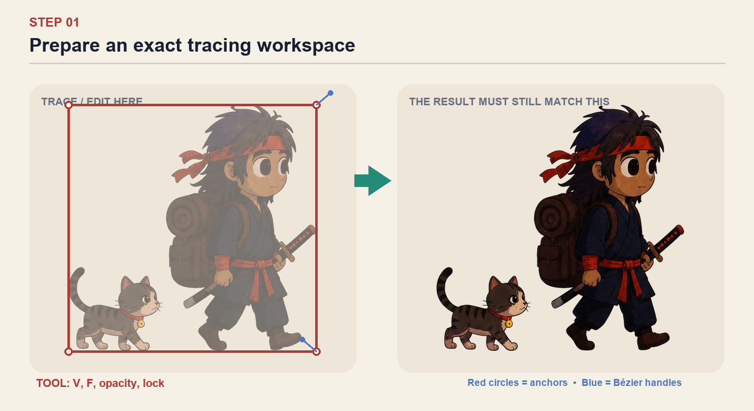
CHECK BEFORE CONTINUING The reference is locked; RONIN and CAT groups are empty and ready above it.

Step 02 — Trace the rear silhouette first
Trace Hair Back, Rear Arm, Rear Leg and the backpack silhouette as separate closed paths. These sit behind the body, so finish their hidden overlap beneath the torso.
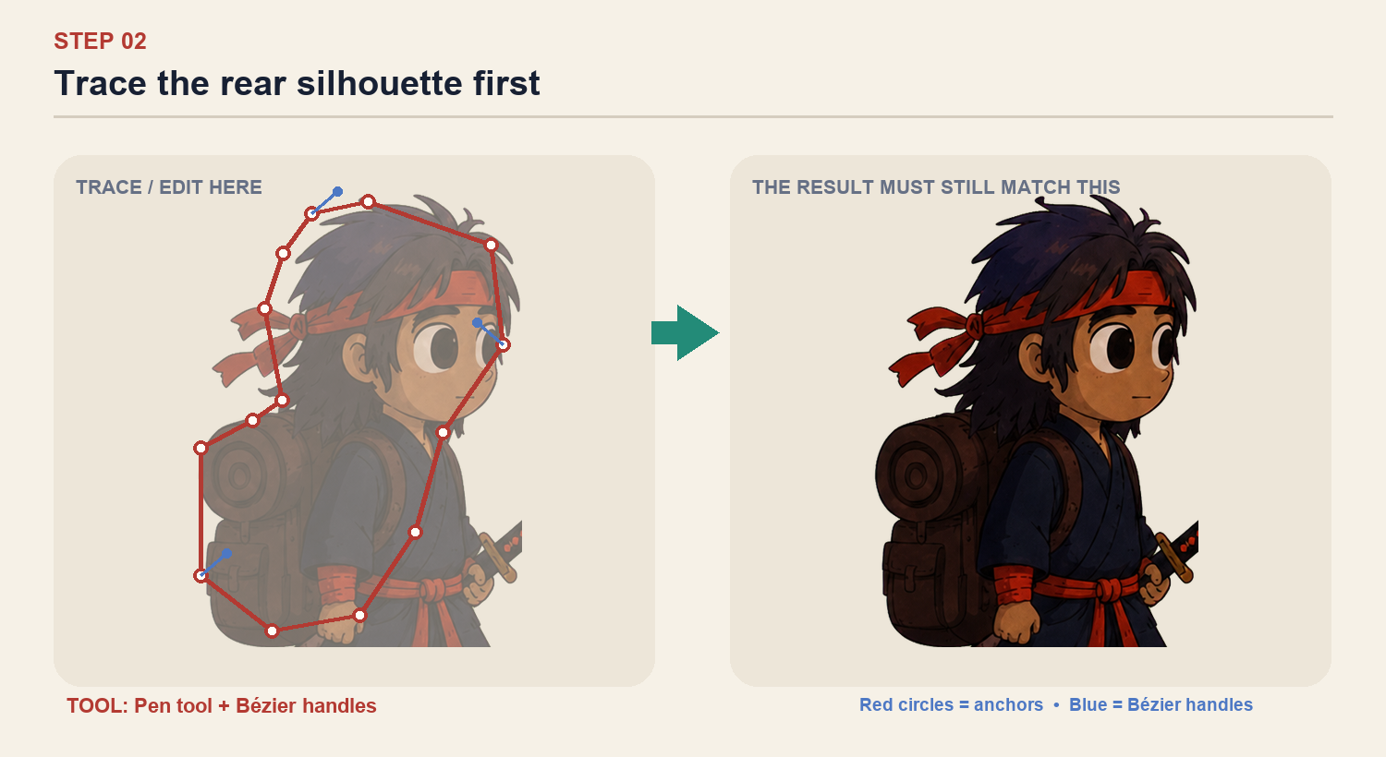
CHECK BEFORE CONTINUING Rear pieces extend behind future torso shapes, with no visible gaps at the shoulder or hip.

Step 03 — Build the face as a clean skin shape
Trace one smooth head/ear silhouette. Use 8–12 anchors and long handles. Add the two eyes as ellipses; do not trace the painted texture or freckles yet.
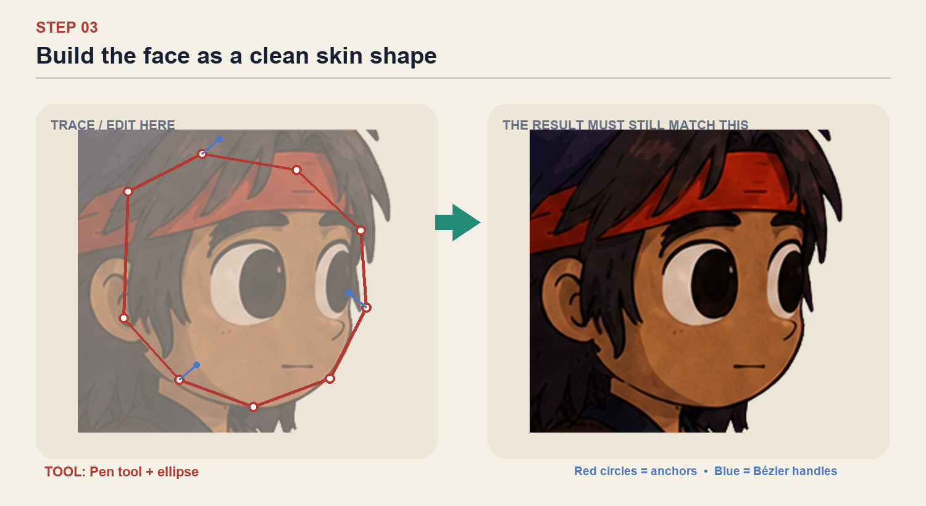
CHECK BEFORE CONTINUING The face silhouette matches the PNG at 100% zoom and remains smooth in outline view.

Step 04 — Construct hair and headband
Trace Hair Front in 5–7 large locks rather than every strand. Make the headband, knot and two tails separate paths so the tails can sway independently.
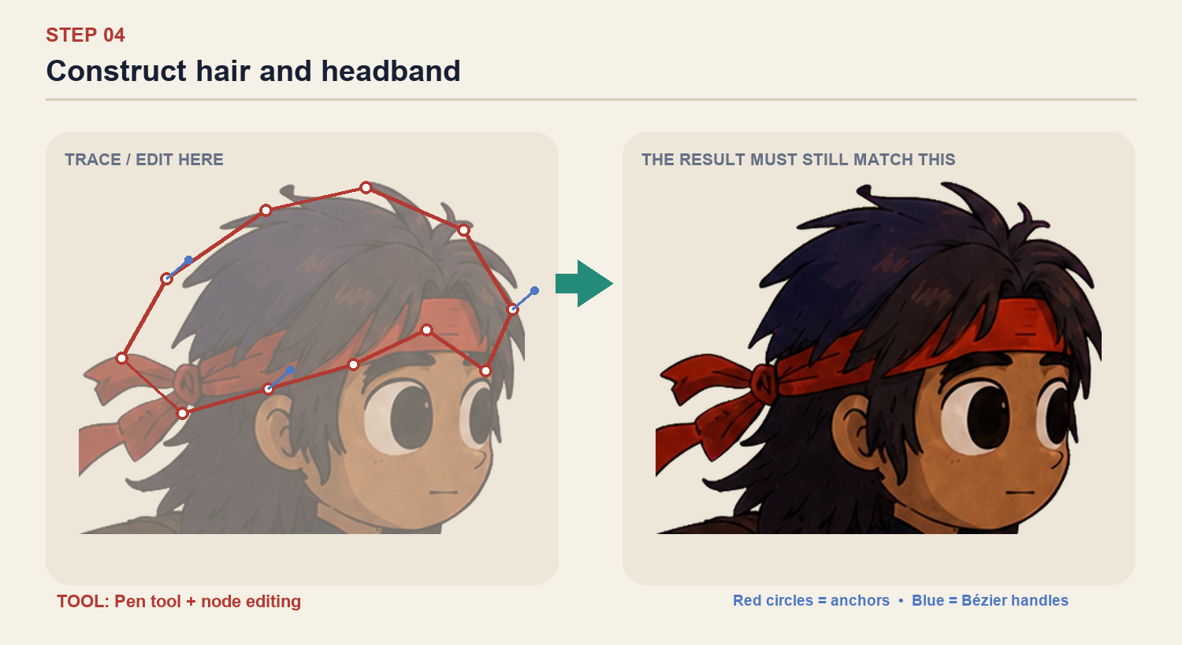
CHECK BEFORE CONTINUING Headband tails, hair back and hair front are independent layers.

Step 05 — Trace the robe in large panels
Build Torso Base, Front Lapel, Rear Lapel, Tunic Skirt and Sash as separate shapes. Preserve the crossed robe silhouette; omit fabric grain.
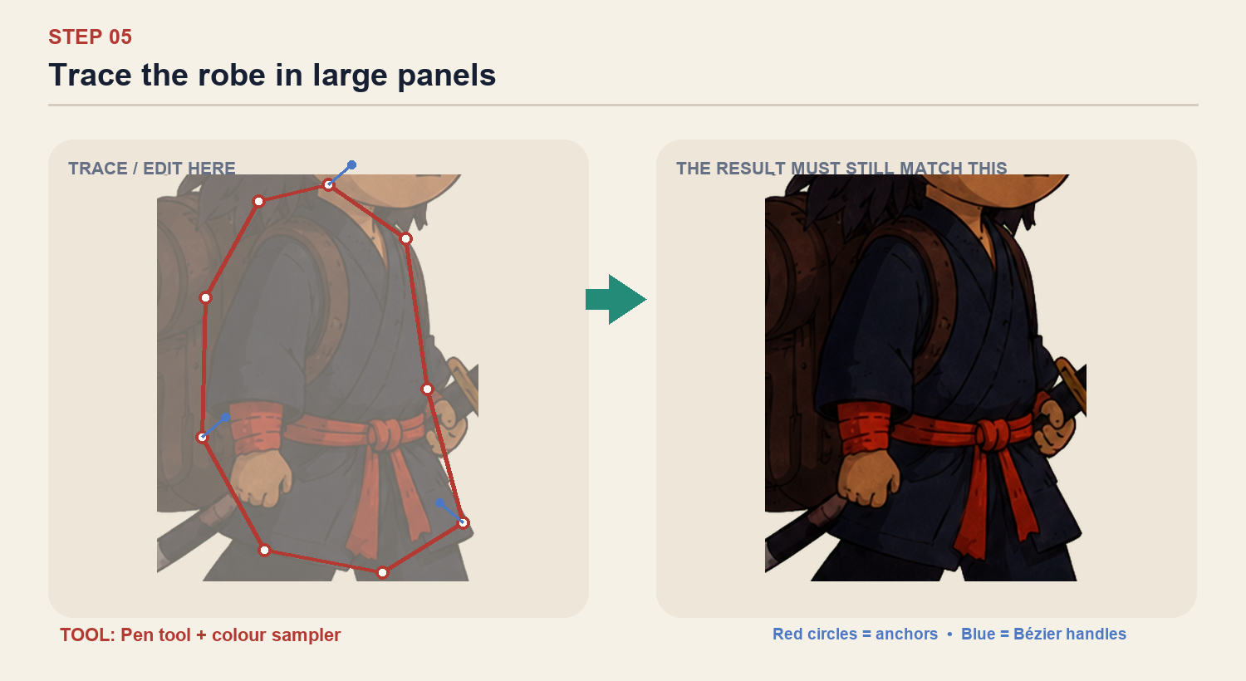
CHECK BEFORE CONTINUING The robe crossover remains clearly recognisable when all texture is hidden.

Step 06 — Separate both arms at the elbow
Create upper arm, forearm and hand layers. Extend each piece 10–15 px underneath its neighbour. Temporarily rotate the forearm 25° to prove the elbow stays covered.
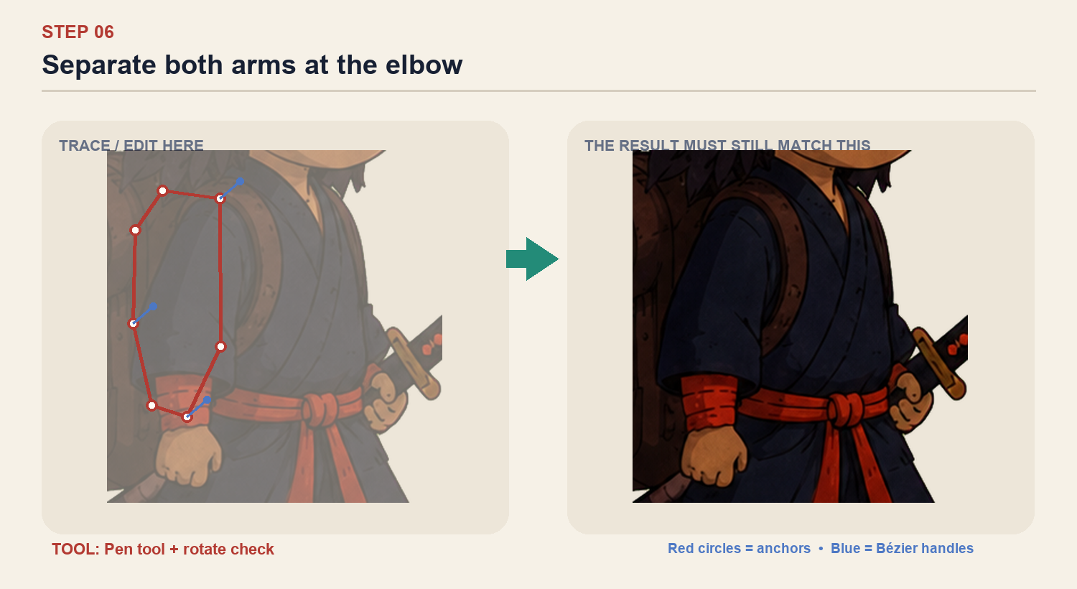
CHECK BEFORE CONTINUING Both forearms can rotate 25° without opening a hole at either elbow.

Step 07 — Separate thighs, shins and boots
Trace six moving pieces: front/rear thigh, front/rear shin and two boots. Keep the wide trousers, but use rounded hidden ends at the knee and ankle.
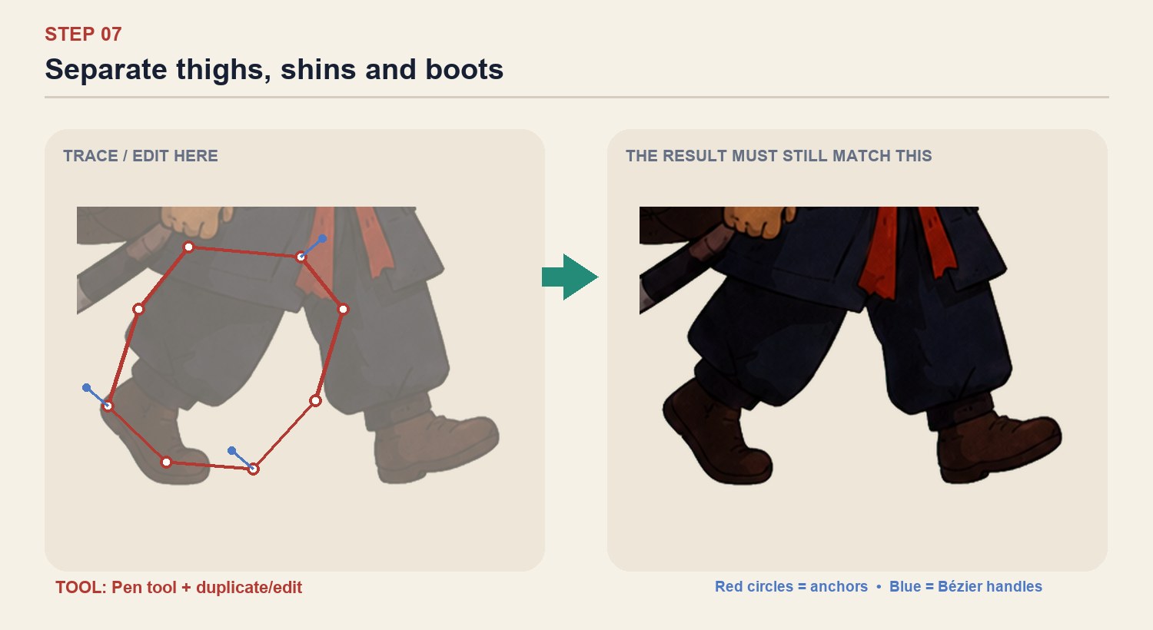
CHECK BEFORE CONTINUING Thighs, shins and boots rotate independently without losing the baggy-trouser silhouette.

Step 08 — Rebuild the backpack with controlled depth
Use one pack silhouette, one bedroll ellipse/spiral group, two straps and two pockets. Keep the rich brown depth with only a base, shadow and highlight—not the PNG texture.
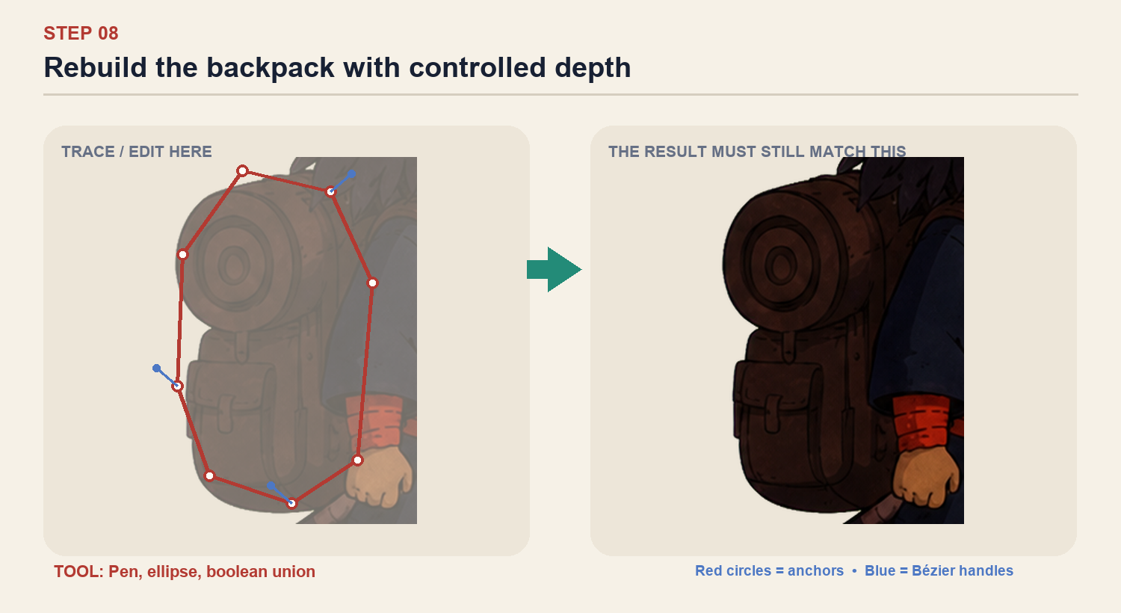
CHECK BEFORE CONTINUING The backpack reads as deep brown leather with no more than three tonal levels.

Step 09 — Make the sword independently movable
Trace sheath, handle, guard and end cap separately, then group them as SWORD. Keep the diagonal angle from the PNG and place it between the back arm and torso.
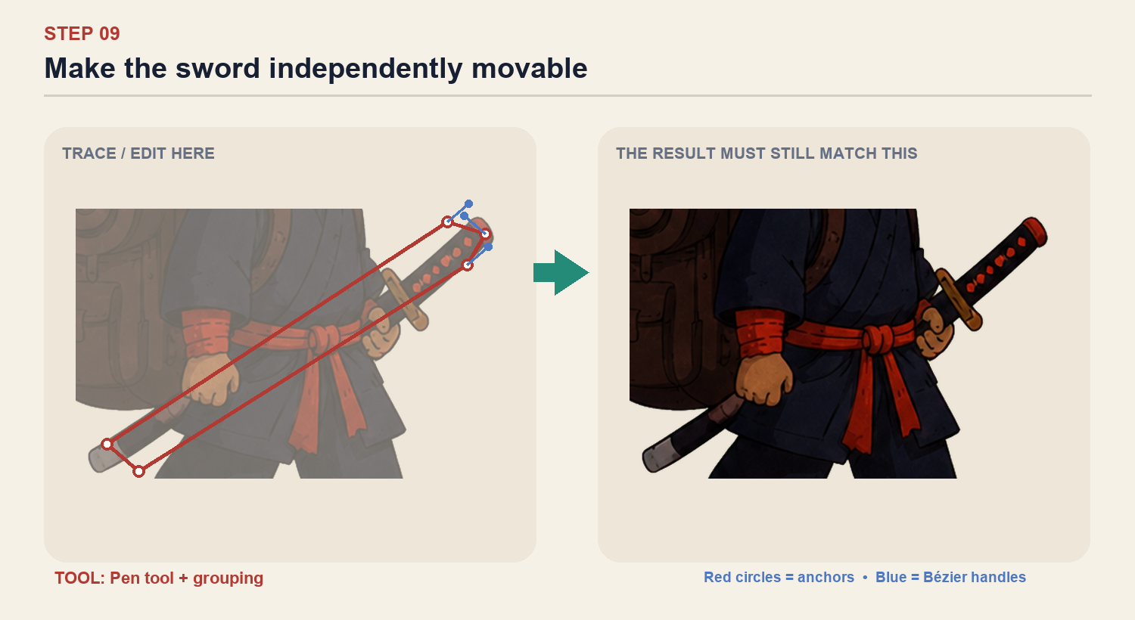
CHECK BEFORE CONTINUING SWORD is one named group and does not share vector points with the hand or torso.

Step 10 — Build the cat as its own small rig
Trace Body, Head, Muzzle, Tail, four legs and collar separately. Use the PNG silhouette closely; simplify the stripes into five bold shapes.
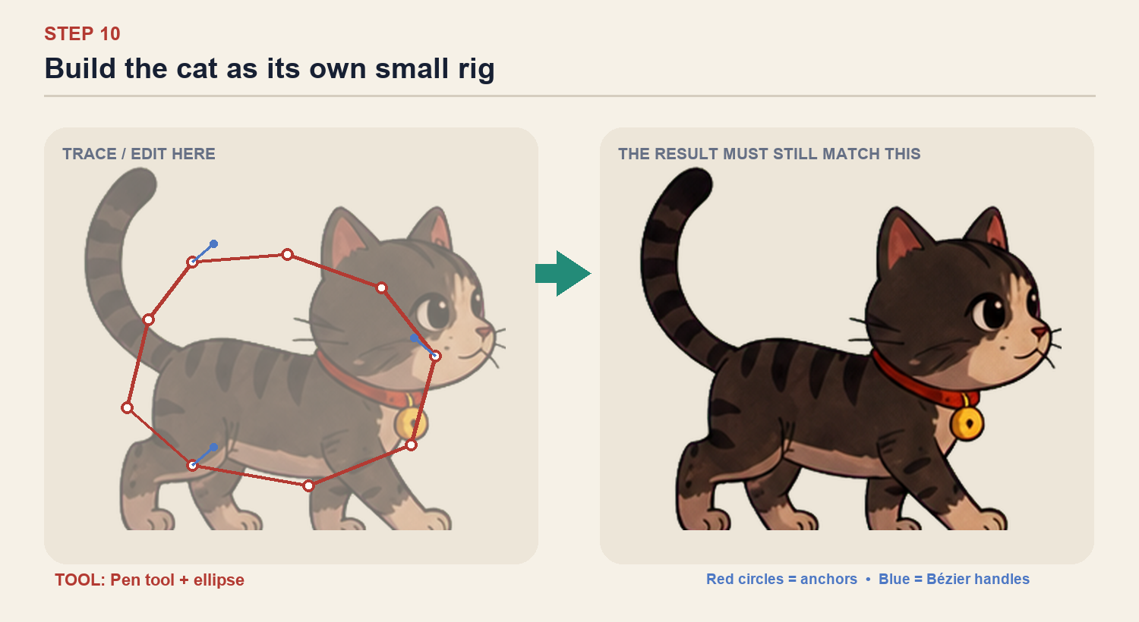
CHECK BEFORE CONTINUING The cat reads correctly as a silhouette before stripes or face details are visible.

Step 11 — Refine cat legs, tail and face
Give each visible leg a rounded hidden root beneath the body. Keep the tail as one tapered path. Add two eye shapes, muzzle, nose and bell only after the silhouette works.
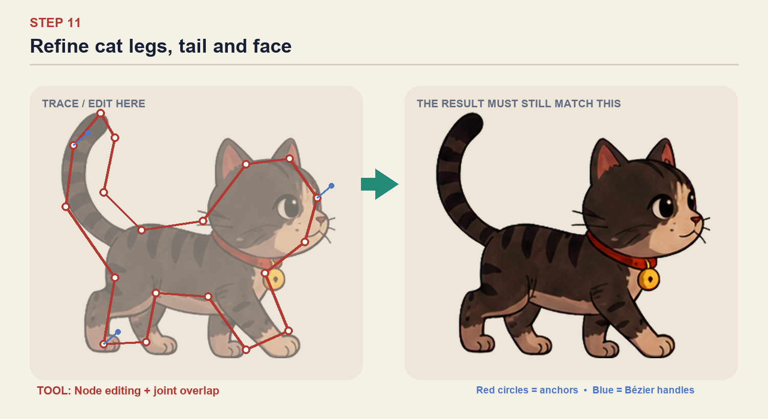
CHECK BEFORE CONTINUING Tail and legs move independently; face details remain legible at phone size.

Step 12 — Add depth without returning to raster detail
For major pieces, add one shadow shape and one small highlight clipped inside the parent group. Avoid noise, grain and tiny strokes; every detail must remain readable at 120 px tall.
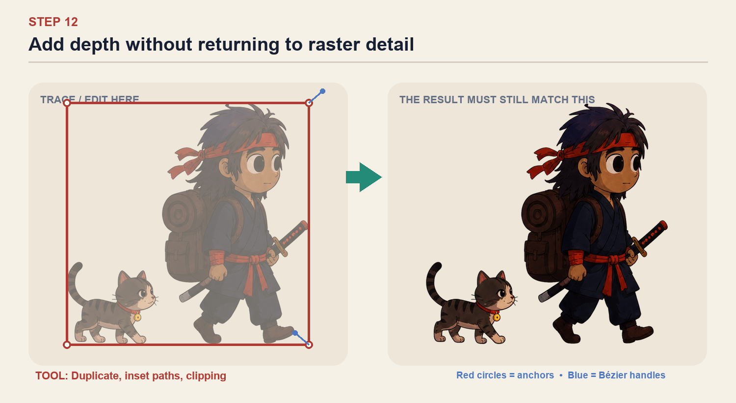
CHECK BEFORE CONTINUING At 120 px tall the design still resembles the supplied PNG, with no noisy micro-detail.

Final layer structure and Rive gate
Match this organisation before exporting. The exact number of decorative shapes may differ; moving parts must remain separate.
RONIN — behind torso
Hair Back • Rear Upper Arm • Rear Forearm • Rear Hand • Rear Thigh • Rear Shin • Rear Boot • Backpack • Sword / Sheath
RONIN — body/front
Torso Base • Robe Panels • Head / Skin • Hair Front • Headband + Tails • Front Upper Arm • Front Forearm • Front Hand • Front Thigh • Front Shin • Front Boot • Face Details • Sash
CAT
Tail • Rear Legs • Body • Front Legs • Head • Muzzle • Eyes + Nose • Collar + Bell • Stripes
1 | All visible paths are closed

2 | No moving limb shares a path with the torso

3 | Every elbow, knee, shoulder and hip has hidden overlap

4 | Reference PNG is hidden

5 | No unnamed Vector layers remain

6 | Character passes the 120 px scale check

7 | A duplicate Figma frame is kept as a backup before Rive import

NEXT Send a screenshot of the canvas plus the complete Layers panel before importing into Rive. Structural mistakes are much easier to fix in Figma.

