**Movie Rating And Review App**

**A PROJECT REPORT**

***Submitted by***

**Kacha Rahul Bharatbhai**

**190200107052**

***In partial fulfillment for the award of the degree of***

**BACHELOR OF ENGINEERING**

***in***

**Computer Engineering**

**Government Engineering College, Rajkot**



**Gujarat Technological University, Ahmedabad**

**[July, 2022]**



**Government Engineering College, Rajkot**

**Mavadi-Kankot Road, Rajkot, Gujarat**

**CERTIFICATE**

This is to certify that the project report submitted along with the project entitled **Movie Rating And Review App** has been carried out by **Kacha Rahul Bharatbhai** under my guidance in partial fulfillment for the degree of Bachelorof Engineering in Computer Engineering, 7th Semester of Gujarat Technological University, Ahmadabad during the academic year 2022-23.

Prof (Dr.) Mahesh D. Titiya

Internal Guide

Prof (Dr.) S. M. Shah

Head of the Department



**Government Engineering College, Rajkot**

**Mavadi-Kankot Road, Rajkot, Gujarat**

**DECLARATION**

We hereby declare that the Internship / Project report submitted along with the Internship / Project entitled **Movie Rating And Review App** submitted in partial fulfillment for the degree of Bachelor of Engineering in Computer Engineering to Gujarat Technological University, Ahmedabad, is a bonafide record of original project work carried out by me at Government Engineering College, Rajkot under the supervision of Prof (Dr.) Mahesh D. Titiya and that no part of this report has been directly copied from any students’ reports or taken from any other source, without providing due reference.

Name of the Student Sign of Student

Kacha Rahul Bharatbhai



i

**ACKNOWLEDGEMENT**

Every work that is completes successfully in time stands on the encouragement, goodwill and support of people around. Through this, I would like to express our gratitude to all those who have contributed support and valuable guidelines during the period of project.

I would like to thank my guide **Prof (Dr.) Mahesh D. Titiya** for their guidelines and for being a constant source of inspiration to do something creative, innovative and encouragement in carrying out this project work.

I would like to express my gratitude towards staff members of Computer Engineering Department, Government Engineering College - Rajkot for their kind co-operation and encouragement which helped us in completion of this project.

ii

**ABSTRACT**

*"****Movie Rating And Review App"*** *is a fun project where anyone can add their favourite movies, write a review about them, and rate them as they like. I have used the "themoviedb" API in my app. First, the index page renders all the movies users add from the database, and the "Add Movie" button redirects to a page with a single input element.*

*Next, the user inputs a movie he wants to add, and then the submit button renders all the possible matches from the API. Then the user selects the movie he wants to add, and then the app redirects him to the edit page, where he can add the rating and review of the movie.*

*The app is developed using HTML, CSS and Bootstrap. The backend consists of ExpressJS - a NodeJS framework, MongoDB for the database, and EJS as the templating engine. The project is deployed on Heroku, a PasS, where you can deploy some limited numbers of apps for free.*

iii

**List of Figures**

Fig 3 (a) File Structure 05

Fig 3 (b) ER Diagram 06

Fig 3 (c) Use Case Diagram 07

Fig 3 (d) Movie Model Screenshot 08

Fig 3 (e) Routes Screenshot 09

Fig 4 (a) Index/Home Page Screenshot 10

Fig 4 (b) Back of Card Screenshot 10

Fig 4 (c) Add Page Screenshot 11

Fig 4 (d) Select Page Screenshot 11

Fig 4 (e) Edit Page Screenshot 12

iv

**Abbreviations**



**HTML**

**CSS**

**JS**

**EJS**

**E-R Diagram**

**UI/UX**

**Hypertext Markup Language**

**Cascading Style Sheets**

**JavaScript**

**Embedded JavaScript Templating**

**Entity Relationship Diagram**

**User Interface / User Experience**

v

**Table of Contents**

Acknowledgement ..................................................................................................…….…...ii

Abstract.....................................................................................................................………..iii

List of Figures.........................................................................................................………... iv

List of Abbreviations ..............................................................................................….……. .v

Table of Contents......................................................................................................……….vii

**1.0 Introduction ……………..………………………………………………………..…….1**

1.1 Summary………………………………………………………….………..…….1

1.2 Purpose …………………………………………………………….…………….1

1.3 Objective ………………………………………………………….……….…….1

1.4 Scope (what it can do and can’t do) ……………………………….…………….2

1.5 Technology and Tools ……………………………………………….……….….2

**2.0 Literature Review ………………………………………………………………...…….3**

2.1 Observations……...……………………………………………………...……….3

2.1.1 User Friendliness……………………………………………………………3

2.1.2 Auth wall / Login system…………………………………………………..3

2.1.3 Privacy Issues………………………………………………………………3

2.1.4 Targeted Ads………………………………………………………………..3

2.1.5 Misleading Popups………………………………………………………….3

**3.0 Methodology……………………….…………………..………………………………..4**

3.1 Process……………………………………………………………..…...……..…4

3.2 Technologies Used.……………………………………………………………....5

3.3 File Structure………………………………………………………………….….5

3.4 ER Diagram………………………..……………………………………………..6

3.5 Use Case Diagram………………………………………………………………..7

3.6 Snapshots of Code………………………………………………………………..7

3.6.1 Movie Model (Database Model) …………...………………………….8

vi

3.6.2 Routes…………………………..…………...………………………….9

**4.0 Result…………..………………………….……………………………….……………10**

4.1 Index/Home Page……………………………………….…..…………………...10

4.2 Back of Card…………………………………………….…..………………...…10

4.3 Add Page………………………………………………….………………….…..11

4.4 Select Page…………………………………..………….……..…………………11

4.5 Edit Page…………………………………..…………...……...…………………11

**5.0 Conclusion and Discussion………………..……………………………..……………..13**

5.1 Summary……………………..………………….……………………………….13

**References.……………………………………………………………………….14**

**Demo.……………………….…………………………………………………….15**

vii

241761 Introduction

**1. Introduction**

**1.1 Summary:**

This project is developed for film enthusiasts. It's available for everyone. People can add new movies and write reviews about them, rate them, or they can just read others' thoughts. There is no authentication wall, i.e., you don't need an account to post your reviews. So people can express their thoughts on their favorite movies without worrying about their data being stolen.

Rate each film on a 10-star scale (with halves) to record and share your reaction. Write and share reviews, and follow friends and other members to read theirs. Write and share thoughts. Share your life in film.

**1.2 Purpose:**

This website holds the database in which information about movies is stored.

This website aims to allow users to express their views and thoughts on popular films. People from all around the world can use this app.

**1.3 Objective:**

This website aims to allow users to express their views and thoughts on popular films. People from all around the world should be able to use this app.

Gujarat Technological University 1 Government Engineering College-Rajkot

241761 Introduction

**1.4 Scope:**

**User:**

Users can add a movie.

Users can delete a movie.

Users can add reviews and ratings.

Users can edit reviews and ratings.

**Admin:**

Admin can see the entire movie database.

Admin can delete a movie from the database.

Admin have full accessibility of the website & manages the website.

Admin can edit a review or rating from the database.

**1.5 Tools and technology Used:**

**Technologies used:**

* ExpressJS
* MongoDB
* EJS
* Bootstrap

**Tools used:**

* VS Code
* Mongo Shell
* EJS
* Git and Github

Gujarat Technological University 2 Government Engineering College-Rajkot

241761 Literature Review

1. **Literature Review:**

**2.1 Observations:**

Various case studies have highlighted the problems faced while setting up a review app.

Some of the issues found during the survey in the existing system are listed below:

**2.1.1 User Friendliness:**

Web apps or Websites are very hard to interact with because of the UI-UX design problems.

Users find it difficult to navigate even when the app is relatively simple.

**2.1.2 Auth wall / Login system:**

Apps make you register first to use the app, which quickly loses the users' interest.

**2.1.3 Privacy issues:**

People don't trust sites and apps with their data nowadays. More people are now aware of how the site can use their data.

**2.1.4 Targeted ads:**

People don't like to have ads on their favorite websites! Primarily if they are targeted ads-which most users find creepy and invasive.

**2.1.5 Misleading popups:**

Users don't like popups that download malicious files and can corrupt their devices.

Gujarat Technological University 3 Government Engineering College-Rajkot

241761 Methodology

asdddddddddddddddddddddddddddddddddddddddddddddddddddddddddddddddddddddddddddddddddddd hhhhhhhhhhhhhhhhhhhhhhhhhhhhhhhhhhhhhhhhhhhhhhhhhhhhhhhhhhhh

1. **Methodology:**

**3.1 Process:**

The process starts when the user clicks the *"Add Movie"* button. Then the user is taken to the *"add"* page, where he finds an input element where he enters the movie's name. This clicktriggers an API call and renders the options similar to the keyword. All the options are generated with the release date after the title. (format: "*<MOVIE NAME> - <RELEASE DATE>*".)

The user selects his desired title and gets redirected to the *"edit"* page, where he adds his review and rating. And then, he saves the rating and review, and the movie gets added to the home page.

The simulation mentioned above flow is from the user's point of view. the technical aspect of what happens is given below:

First, the index page gets rendered by querying all the movies from the database. Then, if a user wants to add a new film, he clicks on the *"Add movie"* button. Next, the app redirects him to the *"/add"* path, where he finds a form of an input field and a submit button.

Next, the user enters a movie name and hits *"Add movie."* It triggers an API call *(GET)* which fetches all the possible matches and renders the movie titles and their release date in the format of *"<MOVIE TITLE> - <RELEASE DATE>,"* which are hyperlinks that point to the URL which leads to the edit page which makes another API call *(GET)* with the movie ID and gets the data of the movie.

Finally, the user adds the rating and review of the movie he just added, which triggers a database insertion of the film, and the movie gets stored in the database.

llllllllllllllllllllllllllllllllllllllllllllllllllllllllllllllllllllllllllllllllllllllllllllllllllllllllllllllllllllllllllllllllllllllllllllllllllllllllllllllllll 444444444444444444444444444444444444444444444444444444444444444444444444444444444444444444

456546456546666666666666666666666666666666666666666666666666666666666666666666666645444444

Gujarat Technological University 4 Government Engineering College-Rajkot 4566666666666666666666666644444444444444444444444444444444444444444444444444444444444444

llllllllllllllllllllllllllllllllllllllllllllllllllllllllllllllllllllllllllllllllllllllllllllllllllllllllllllllllllllllllllllllllllllllllllllllllllllll

241761 Methodology

**3.2 Technologies used:**

* ExpressJS (a node framework)
* MongoDB
* EJS (templating Engine)
* Bootstrap

**3.3 File Structure:**

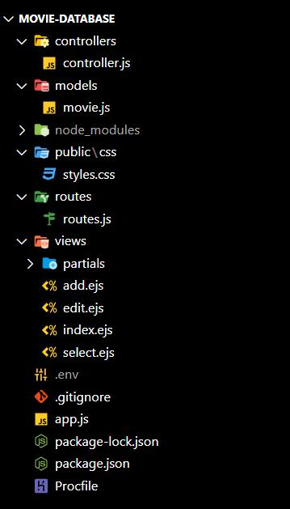

*Fig 3(a). The file structure of the app*

llllllllllllllllllllllllllllllllllllllllllllllllllllllllllllllllllllllllllllllllllllllllllllllllllllllllllllllllllllllllllllllllllllllllllll

Gujarat Technological University 5 Government Engineering College-Rajkot

kllllllllllllllllllllllllllllllllllllllllllllllllllllllllllllllllllllllllllllllllllllllllllllllllllllllllllllllllllllllllllllllllllllllllllllllll

241761 Methodology

**3.4 ER Diagram:**

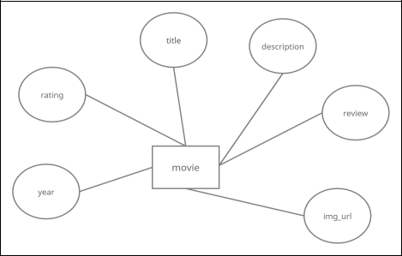

*Fig 3(b). The ER Diagram of the Movie rating and review app*

llllllllllllllllllllllll

Gujarat Technological University 6 Government Engineering College-Rajkot L;;;;;;;;;;;;;;;;;jhlkkkkkkkkkkkkkkkkkkkkkkkkkkkkkkkkkkkkkkkkkkkkkkkkkkkkkkkjjjjjjjjjjjjjjjjjjjjjjjjjjjjjjjjjj jjjjjjjjjjjjjjjjjjjjjjjjjjjjjjjjjjjjjjjjjjjjjjjjjjjjjjjjjjjjjjjjjjjjjjjjjjjjjjjjjjjjjjjjjjjjjjjjjjjjjjjjjjjjjjjjjjjjjjjjjjjjjjjjjjjjjjjj

241761 Methodology hjjjjjjjjjjjjjjjjjjjjjjjjjjjjjjjjjjjjjjjjjjjjjjjjjjhhhhhhhhhhhhhhhhhhhhhhhhhhhhhhhhhhhhhhh

**3.5 Use Case Diagram:**

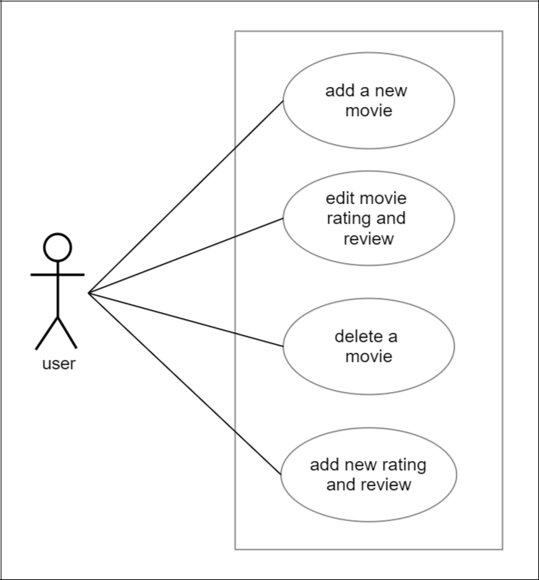

*Fig 3(c). The Use Case Diagram of the Movie rating and review app*

jjjjjjjjjjjjjjjjjjjjjjjjjjjjjjjjjjjjjjjjjjjjjjjjjjjjjjjjjjjjjjjjjjjjjjjjjjjjjjjjjjjjjjjjjjjjjjjjjjjjjjjjjjjjjjjjjjjjjjjjjjjjjjjjjjjjjjjjjjjjjjjjjjjjjjjjj kkkkkkkkkkkkkkdfjdsfshlgjfgfkjgfdksfdlgjfdkgjfdgkjkjsfldgjkfdlghkf

Gujarat Technological University 7 Government Engineering College, Rajkot

241761 Methodology

**3.6 Snapshots of Code:**

**3.6.1 Movie Model (Database Model):**

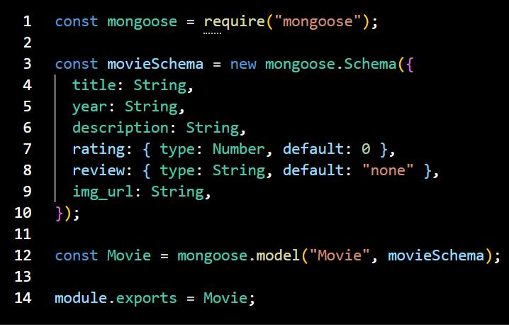

*Fig 3(d). Snapshot of the Movie Model*

Gujarat Technological University 8 Government Engineering College, Rajkot

241761 Methodology

**3.6.2 Routes:**

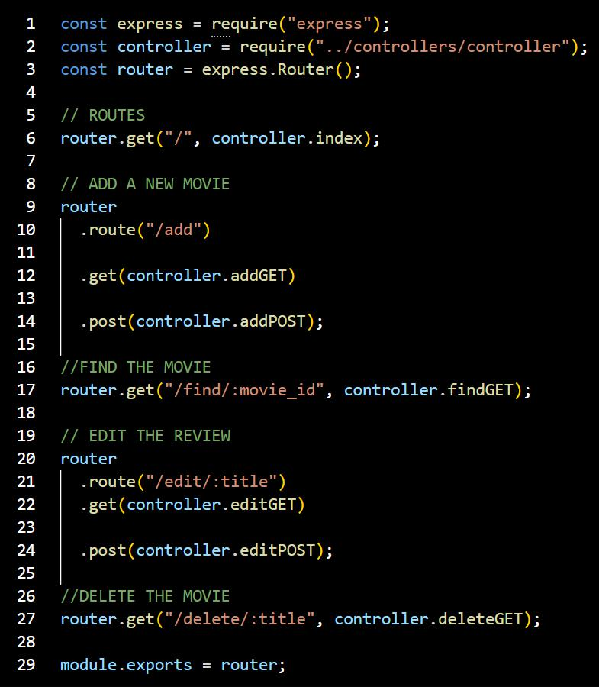

*Fig 3(e). Snapshot of the Routes*

Gujarat Technological University 9 Government Engineering College, Rajkot

241761 Result

**4. Result:**

**4.1 Index/Home Page:**

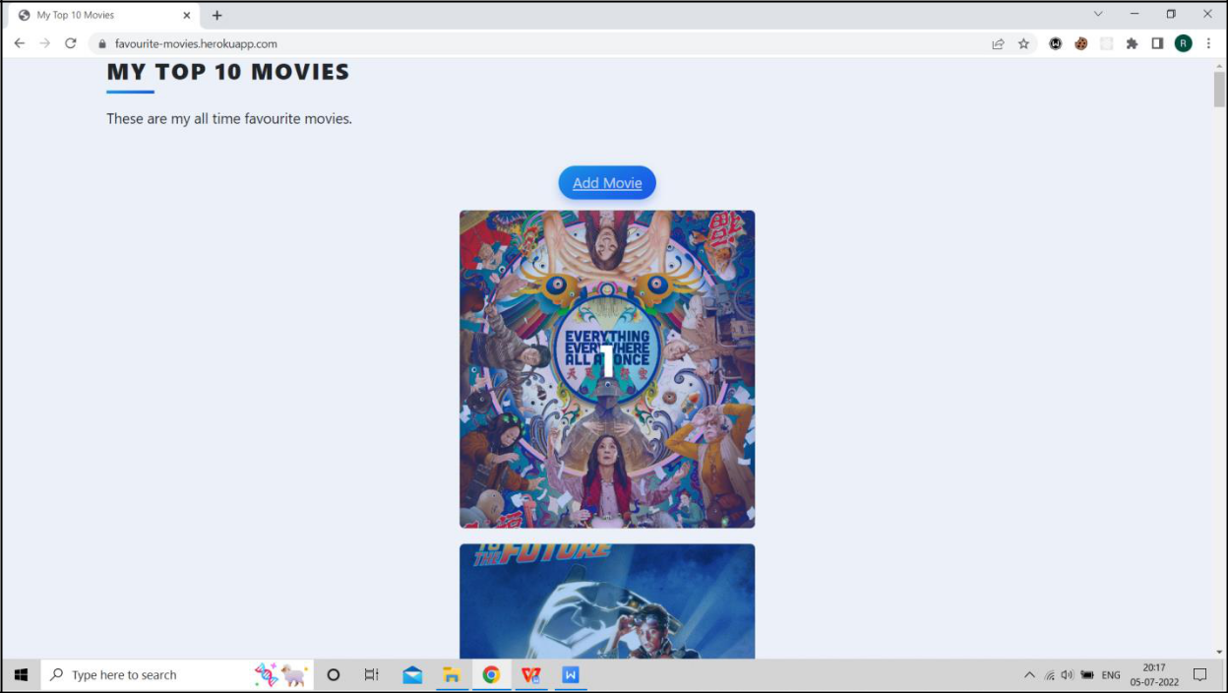

*Fig 4(a). Index Page*

**4.2 Back of Card:**

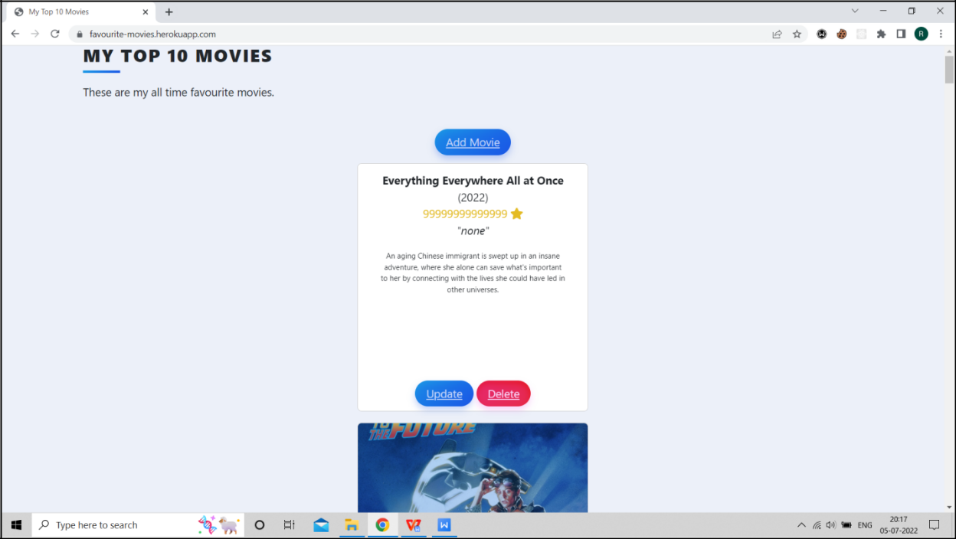

*Fig 4(b). Back Of The Movie Card*

Gujarat Technological University 10 Government Engineering College, Rajkot

241761 Result

**4.3 Add Page:**

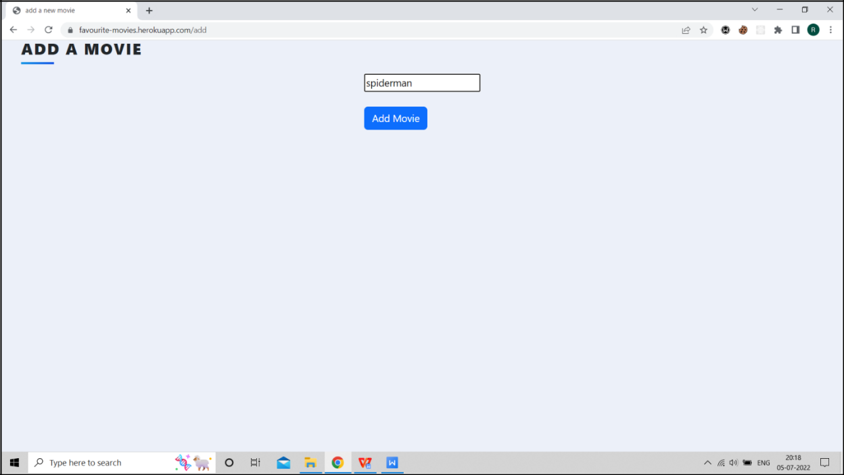

*Fig 4(c). Add Page*

**4.4 Select Page:**

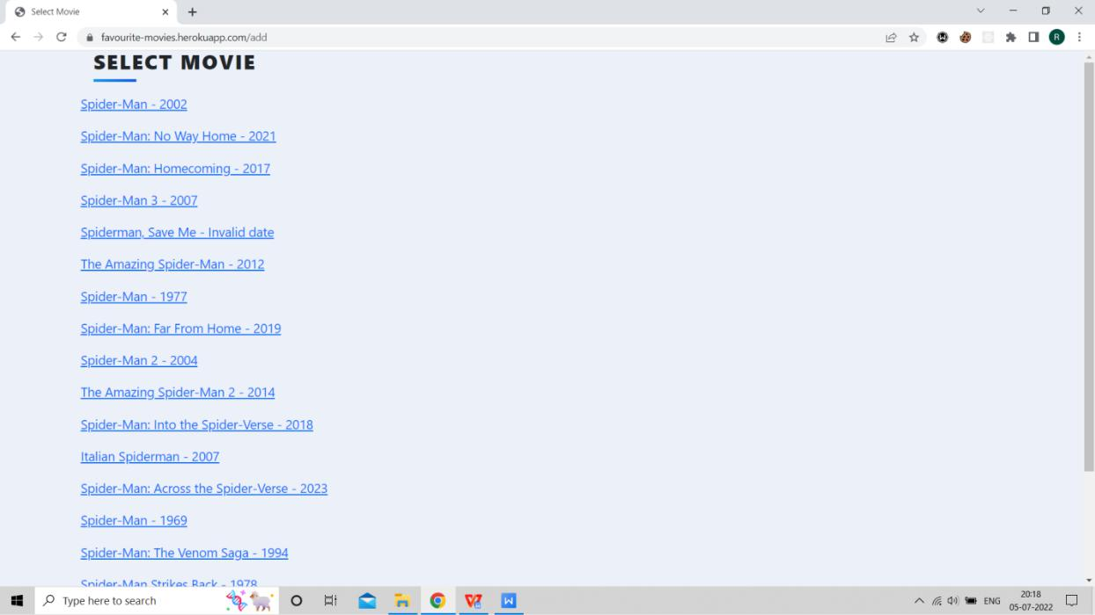

*Fig 4(d). Select Page*

Gujarat Technological University 11 Government Engineering College, Rajkot

241761 Result

**4.5 Edit Page:**

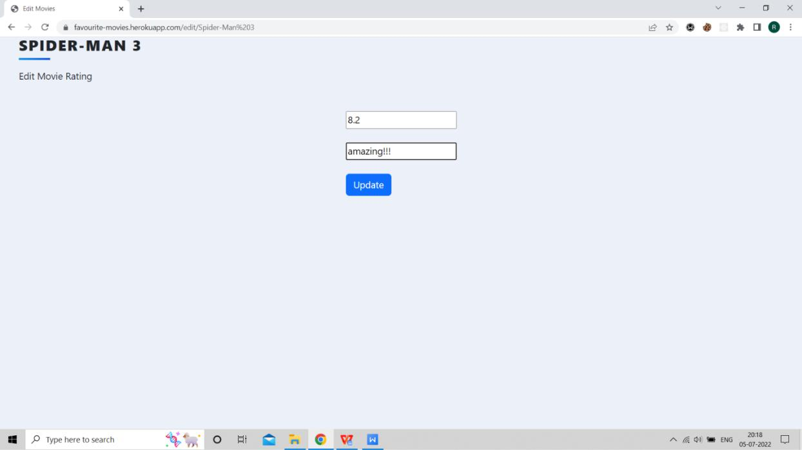

*Fig 4(e). Edit Page*

Gujarat Technological University 12 Government Engineering College, Rajkot

241761 Conclusion and Discussion

**5.0 Conclusion and Discussion**

**5.1 Summary:**

Thus, I conclude that from this project, under the guidance of Prof (Dr.) Mahesh D. Titiya, I have reached this stage of my project work.

In this project, I built a movie review website, letting people express their thoughts to the world on their favorite movies. This app helps build a community of people with the same interest: films. I had a lot of fun building this project, and I hope the users will have to while using it.

I learned a lot while doing this project, including MongoDB ODM Mongoose, version control and how to deploy an app to the cloud. I am very grateful to Prof (Dr.) Mahesh D. Titiya, who was my mentor during this project and guided me throughout this assignment.

Gujarat Technological University 13 Government Engineering College, Rajkot

241761 References

**References:**

* Stackoverflow *(<https://stackoverflow.com/>)*
* Bootstrap *(<https://getbootstrap.com/>)*
* “The Complete 2022 Web Development Bootcamp - Udemy”

*(<https://www.udemy.com/course/the-complete-web-development-bootcamp/>)*

- “100 Days of Code: The Complete Python Pro Bootcamp for 2022 - Udemy” *(<https://www.udemy.com/course/100-days-of-code/>)*

Gujarat Technological University 14 Government Engineering College, Rajkot

241761 Demo

**Demo:**

**Code Repo And Deployment:**

**Code:** *<https://github.com/rahulkacha/movie-database>*

**QR code:**



**Deployment:** *<https://favourite-movies.herokuapp.com/>*

**QR code:**



Gujarat Technological University 15 Government Engineering College, Rajkot