# MOVIE RATING AND REVIEW APP

**A PROJECT REPORT**

**Submitted by**

## RAHUL KACHA

*in partial fulfillment for the award of the degree of*

## BACHELOR OF ENGINEERING

*in*

**COMPUTER ENGINEERING**



**GOVERNMENT ENGINEERING COLLEGE RAJKOT GUJARAT TECHNOLOGICAL UNIVERSITY MAY- JUNE 2022**

# CERTIFICATE

**Certified that this project report “MOVIE RATING AND REVIEW APP” is the bonafide work of “RAHUL KACHA” who carried out the project work under my**

**supervision.**

|  |  |  |
| --- | --- | --- |
| **M. D. TITIYA**  **Guide** | **<HOD>**  **Head of the Department** | **<PRINCIPAL>**  **Principal** |

**COMPUTER DEPARTMENT**

**GOVERNMENT ENGINEERING COLLEGE RAJKOT**

**GUJARAT TECHNOLOGICAL UNIVERSITY**

# ACKNOWLEDGEMENT

I would like to express my special thanks to my project guide M. D. Titiya Sir as well as our principal <principal> who gave me the golden opportunity to do this wonderful project on the topic of the MOVIE RATING AND REVIEW APP, which also helped me in doing a lot of research and I came to know about so many new things. I am really thankful to them.

Secondly I would also like to thank my parents and friends who helped me a lot in finalizing this project within the limited time frame.

|  |  |
| --- | --- |
| Date : 08/07/2022 | RAHUL KACHA |
| Place : Rajkot | 190200107052 |
|  | E |

**TABLE OF CONTENTS**

Acknowledgement i

Abstract ii

List of Figures iii

Table of Contents iv

**Chapter 1 Introduction** **07**

**Chapter 2 Literature Review** **08**

**Chapter 3 Methodology** ...**09**

**Chapter 4 Result** …**12**

**Chapter 5 Conclusion** ....**14**

**References** ….**15**

**Demo** ….**16**

**ABSTRACT**

"Movie Rating And Review App" is a fun project where anyone can add their favourite movies, write a review about them, and rate them as they like. I have used the "themoviedb" API in my app. First, the index page renders all the movies users add from the database, and the "Add Movie" button redirects to a page with a single input element. Next, the user inputs a movie he wants to add, and then the submit button renders all the possible matches from the API. Then the user selects the movie he wants to add, and then the app redirects him to the edit page, where he can add the rating and review of the movie.

**LIST OF FIGURES**

Fig 1 (a) File Structure 06

Fig 1 (b) ER Diagram .07

Fig 2 (a) Index Page Screenshot ...08

Fig 2 (b) Add Page Screenshot ...08

Fig 2 (c) Select Page Screenshot ...09

Fig 2 (d) Review Page Screenshot ...09

# **INTRODUCTION**

This project is developed for film enthusiasts. It's available for everyone. People can add new movies and write reviews about them, rate them, or they can just read others' thoughts. There is no authentication wall, i.e., you don't need an account to post your reviews. So people can express their thoughts on their favorite movies without worrying about their data being stolen.

**LITERATURE REVIEW**

Various case studies have highlighted the problems faced while setting up a restaurant [1 – 5]. Some of the problems found during the survey in the existing system are listed below:

* **User-friendliness:** Web apps or Websites are very hard to interact with because of the UI-UX design problems. Users find it difficult to navigate even when the app is relatively simple.
* **Auth-wall/Login-system:** Apps make you register first to use the app, which quickly loses the users' interest.
* **Privacy issues:** People don't trust sites and apps with their data nowadays. More people are now aware of how the site can use their data.

# **METHODOLOGY**

The process starts when the user clicks the "Add Movie" button. Then the user is taken to the "add" page, where he finds an input element where he enters the movie's name. This click triggers an API call and results in rendering the options similar to the keyword. All the options are generated with the release date after the title. (format: "*<MOVIE NAME> - <RELEASE DATE>*".)

The user selects his desired title and gets redirected to the "edit" page, where he adds his review and rating. And then, he saves the rating and review, and the movie gets added to the home page.

The simulation mentioned above flow is from the user's point of view. the technical aspect of what happens is given below:

First, the index page gets rendered by querying all the movies from the database. Then, if a user wants to add a new film, he clicks on the "Add movie" button. Next, the app redirects him to the "/add" path, where he finds a form of an input field and a submit button. Next, the user enters a movie name and hits "Add movie." It triggers an API call (GET) which fetches all the possible matches and renders the movie titles and their release date in the format of "*<MOVIE TITLE> - <RELEASE DATE>,*" which are hyperlinks that point to the URL which leads to the edit page which makes another API call (GET) with the movie ID and gets the data of the movie. Finally, the user adds the rating and review of the movie he just added, which triggers a database insertion of the movie, and the movie gets stored in the database.

* **Technologies used:**

1. ExpressJS (a node framework)
2. MongoDB
3. EJS (templating engine)
4. Bootstrap

* **File structure:**

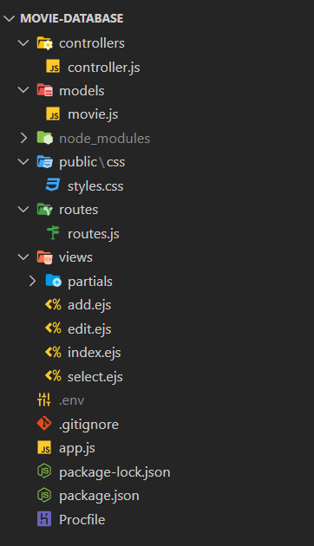

## *Fig 1 (a). The File Structure of the app*

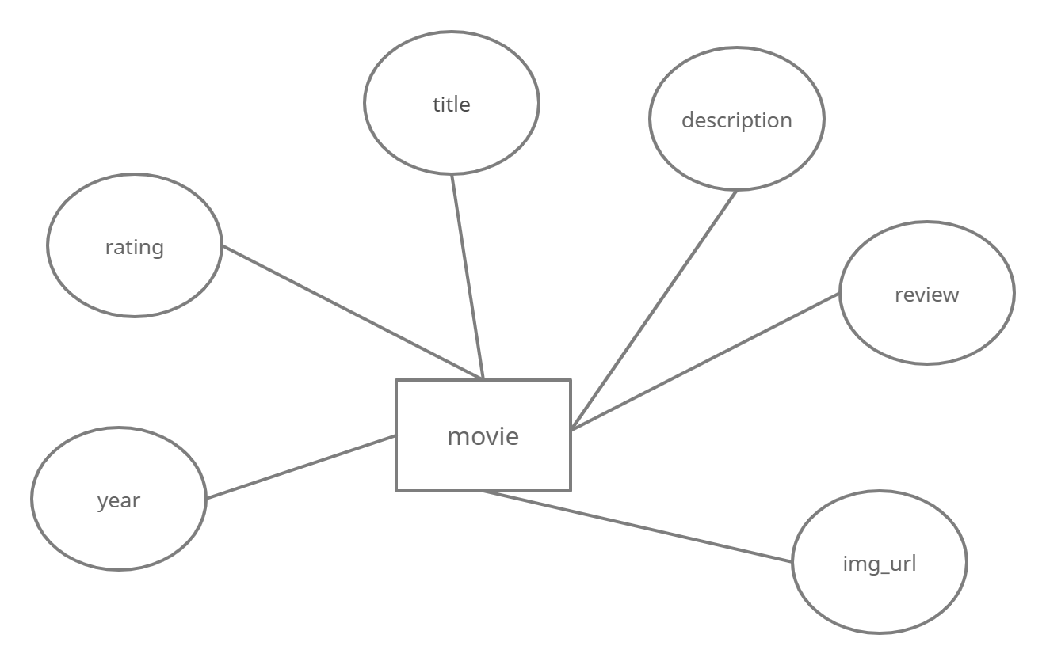

## *Fig 3 (b). The ER Diagram of the Movie rating and review app*

**RESULT**

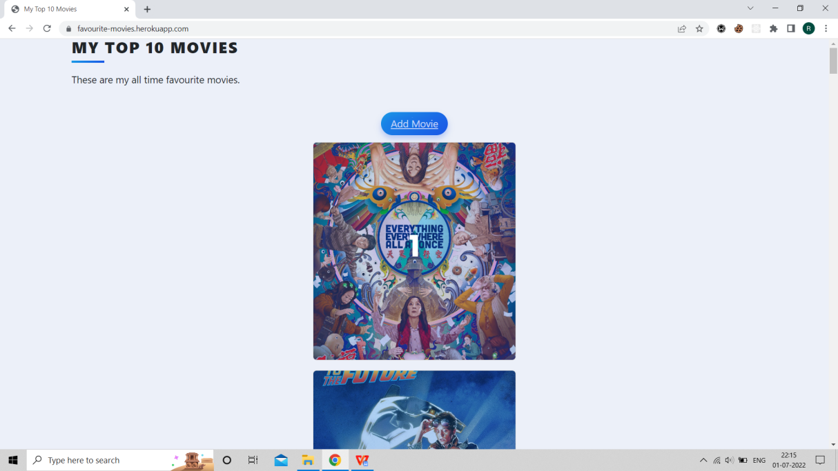

## *Fig 2 (a). The above snapshot shows the index page of Movie rating and review app.*

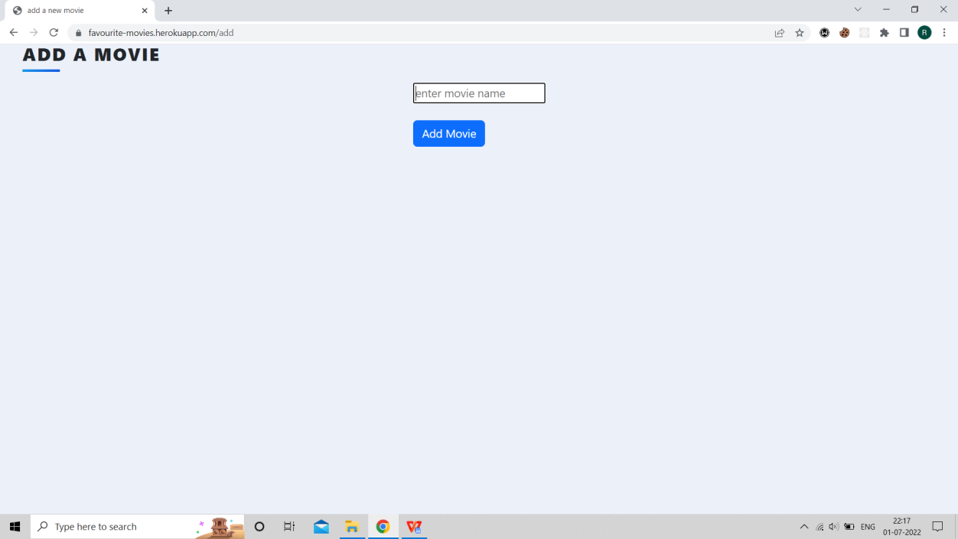

*Fig 2 (b). The above snapshot shows the add page which consists of an input element and a submit button.*

.

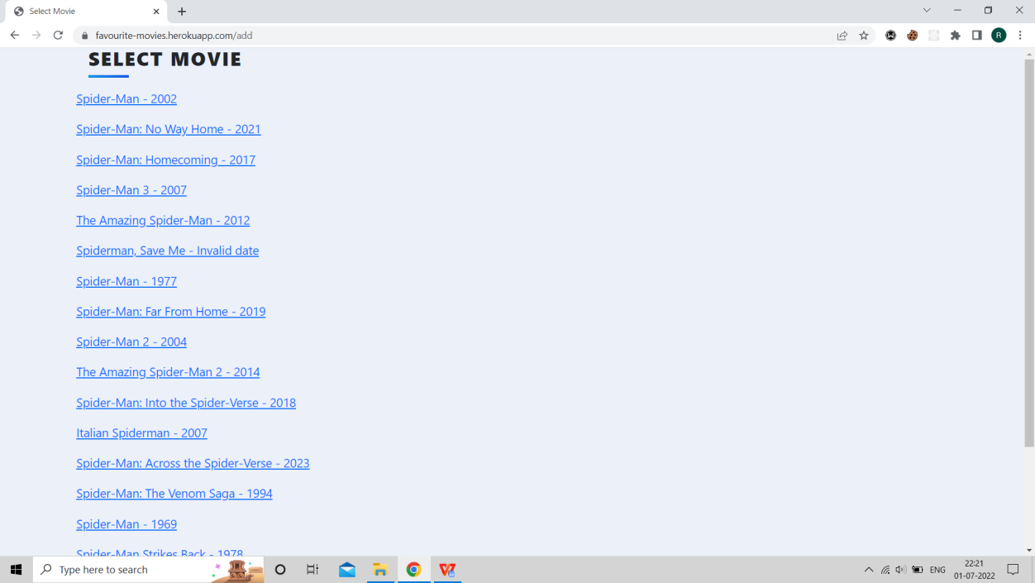

*Fig 2 (c). This is the snapshot of the select page through which user can select the desired movie.*

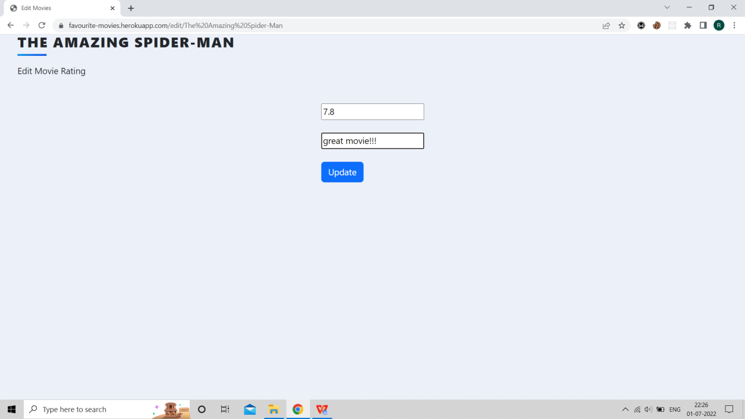

*Fig 2 (d). This is the snapshot of the edit page through which user can add/edit the review and rating of a particular movie.*

# **CONCLUSION**

The movie review app is developed with users' experience in mind. No unnecessary registrations or logins, very easy to use, etc. Using this app, users can add a movie, rate them and review them as they like. They can also read others' reviews and opinions on the same film. It brings like-minded people together who love movies.

# **REFERENCES**

* 1. [www.stackoverflow.com](http://www.stackoverflow.com/)
  2. https://getbootstrap.com/
  3. <https://www.udemy.com/course/the-complete-web-development-bootcamp/>
  4. https://www.udemy.com/course/100-days-of-code/

**DEMO**

# **Code repo and deployment**

**Code:**<https://github.com/rahulkacha/movie-database>

Or scan the following qr code:



**deployment:** https://favourite-movies.herokuapp.com/

Or scan the following qr code:

