**Command line args:**

start CppCli-WPF-App.exe localhost:8081 localhost:8080 C:\CodePublisher\

Client Details : localhost:8081

Server Details : localhost:8080

Virtual Path: C:\CodePublisher\

**Demonstration:**

**Note:** Please create CodePublisher folder as per path “C:\CodePublisher\” for Demo purposes**.**

On loading the GUI, the javascript and css files will be downloaded in the virtual path folder provided at the command line args of the GUI - CppCli-WPF-App.exe

Eg: start CppCli-WPF-App.exe localhost:8081 localhost:8080 C:\CodePublisher\

Javascript , css and other utililies will be downloaded at “C:\CodePublisher\”.

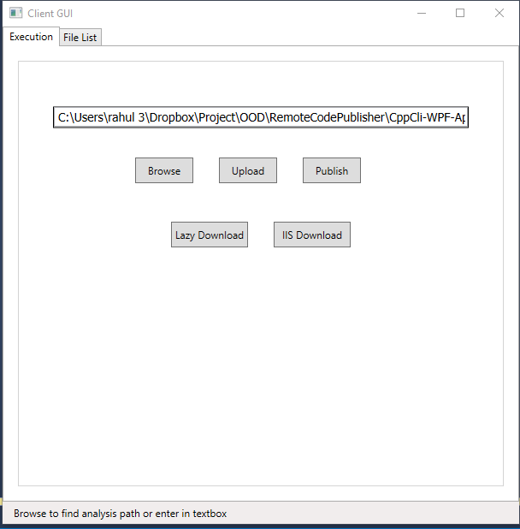

**Demo:**

**“Execution Tab”**

* **Browse** button

Selects Folder Path to be analyzed.

Eg: ../ CppCli-WPF-App/ Path Selected in snippet above

* **Upload** button

Uploads all the .h and .cpp files present in folder selected above to path “../Repository_Server/”

* **Publish** button

Publishes all the .h and .cpp files present in folder “../Repository_Server/” into folder

“../Repository_Code_Publish/” with the corresponding folders as “Categories”:

“../Repository_Code_Publish/CppFiles” -> Category stores all html Cpp Files

“../Repository_Code_Publish/HeaderFiles” -> Category stores all html Header Files

* **For Lazy Download:**

**Lazy Download** button

Downloads Published html files from folder “../Repository_Code_Publish/” into folder “../Repository_Client/” with the corresponding folders as “Categories”:

“../Repository_Client/CppFiles” -> Category stores all html Cpp Files

“../Repository_Client/HeaderFiles” -> Category stores all html Header Files

* **For IIS Download:**

**IIS Download** button:

Downloads Published html files from folder “../Repository_Code_Publish/” into folder

Virtual path mentioned in the command line args of GUI earlier.

Eg: “C:\CodePublisher\”with the corresponding folders as “Categories”:

“C:\CodePublisher\CppFiles\” -> Category stores all html Cpp Files

“C:\CodePublisher\HeaderFiles” -> Category stores all html Header Files

**“File List Tab”**

Assuming ../ CppCli-WPF-App/ as folder selected earlier and Upload , Publish , Lazy Download and IIS Download buttons are used.

“Window.h” and “Window.cpp” files are uploaded and published to server plus downloaded to Client Repository (“../Repository_Client/”) and IIS Repository (“C:\CodePublisher\”).

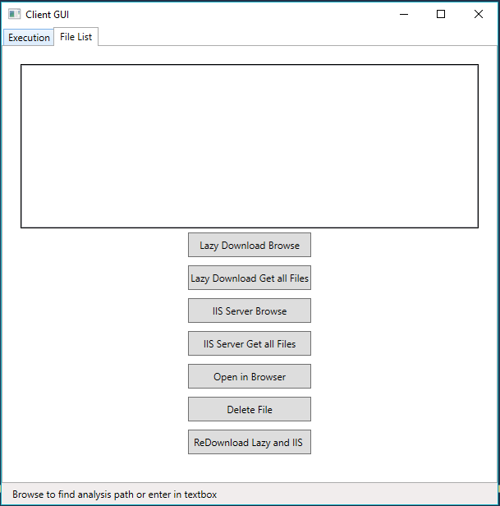

**Lazy Download Demo:**

* **Lazy Download Browse** button

Displays Categories plus the files present in each category

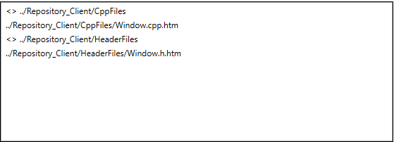

* **Lazy Download Get all Files** button

Display all Published Files in the repository plus with no parents

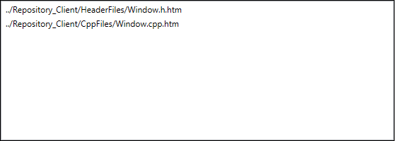

**IIS Download Demo:**

* **IIS Download Browse** button

Displays Categories plus the files present in each category

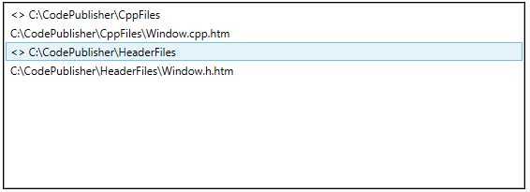

* **IIS Download Get all Files** button

Display all Published Files in the repository plus with no parents

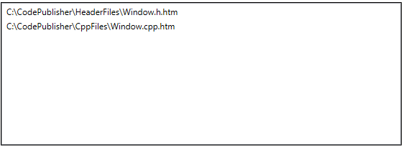

**General Use Buttons:**

* **Open in Browser Browse** button

Opens selected files in Browser. Can be used for both Lazy Download and IIS Download Repositories.

* **Delete File** button

Deletes selected published files, plus also republishes the undeleted (remaining) files.

Can be used for both Lazy Download and IIS Download Repositories.

* **ReDownload Lazy and IIS** button

After Deleting and republishing above files we can Redownload current files in our Lazy and IIS Repositories using this button.