**Mini Home Work -2**

* **Instance created programmatically using Java SDK for Amazon Web Service and Eclipse Mars IDE**

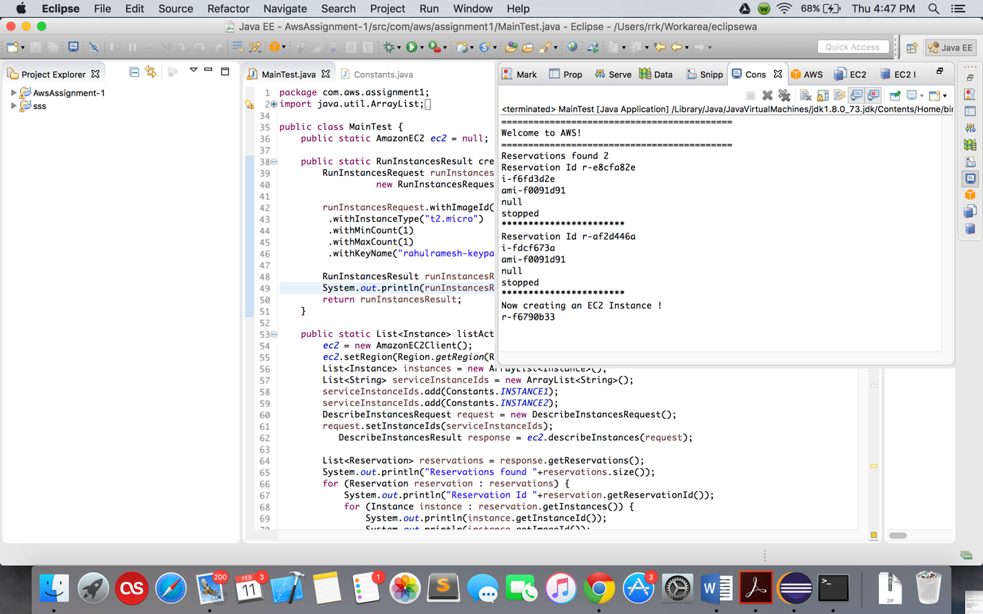

**Fig 1** - Eclipse Console Screen Shot

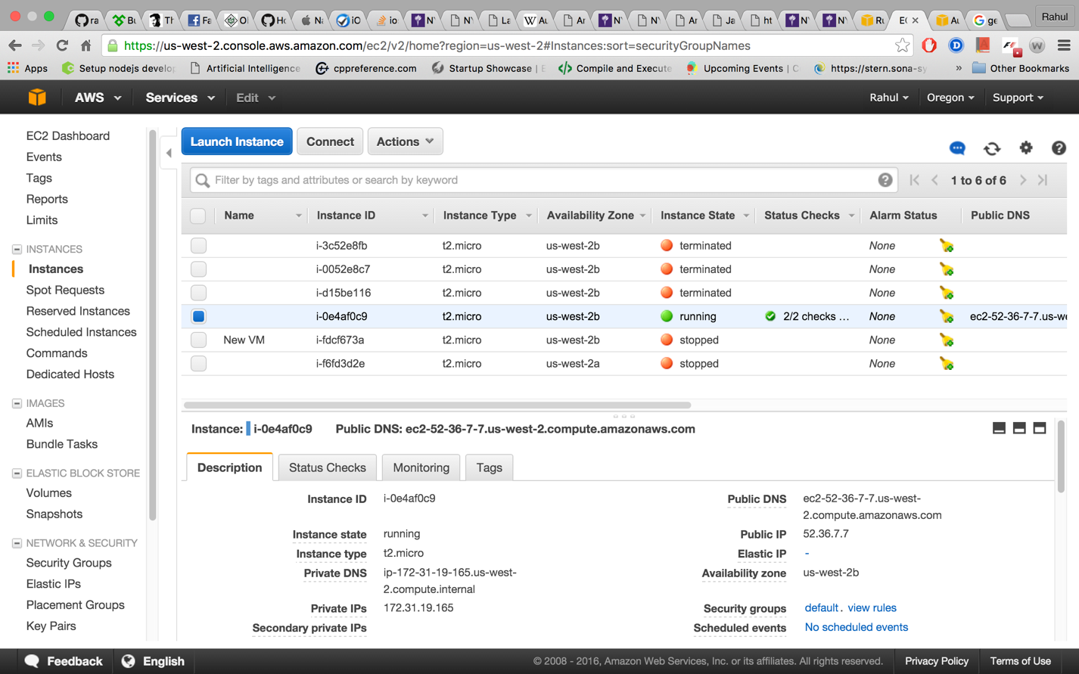

**Fig 2** – Instance Running in AWS Console

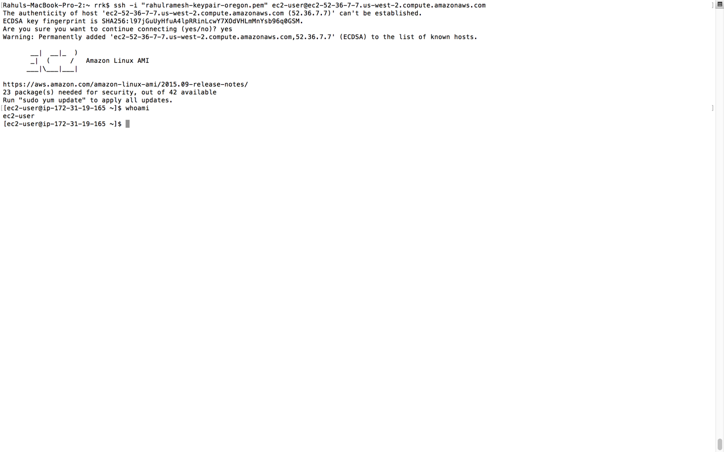

**Fig 3** – SSH to Program created EC2 Instance

* **Instance created using AWS Command Line Tool**

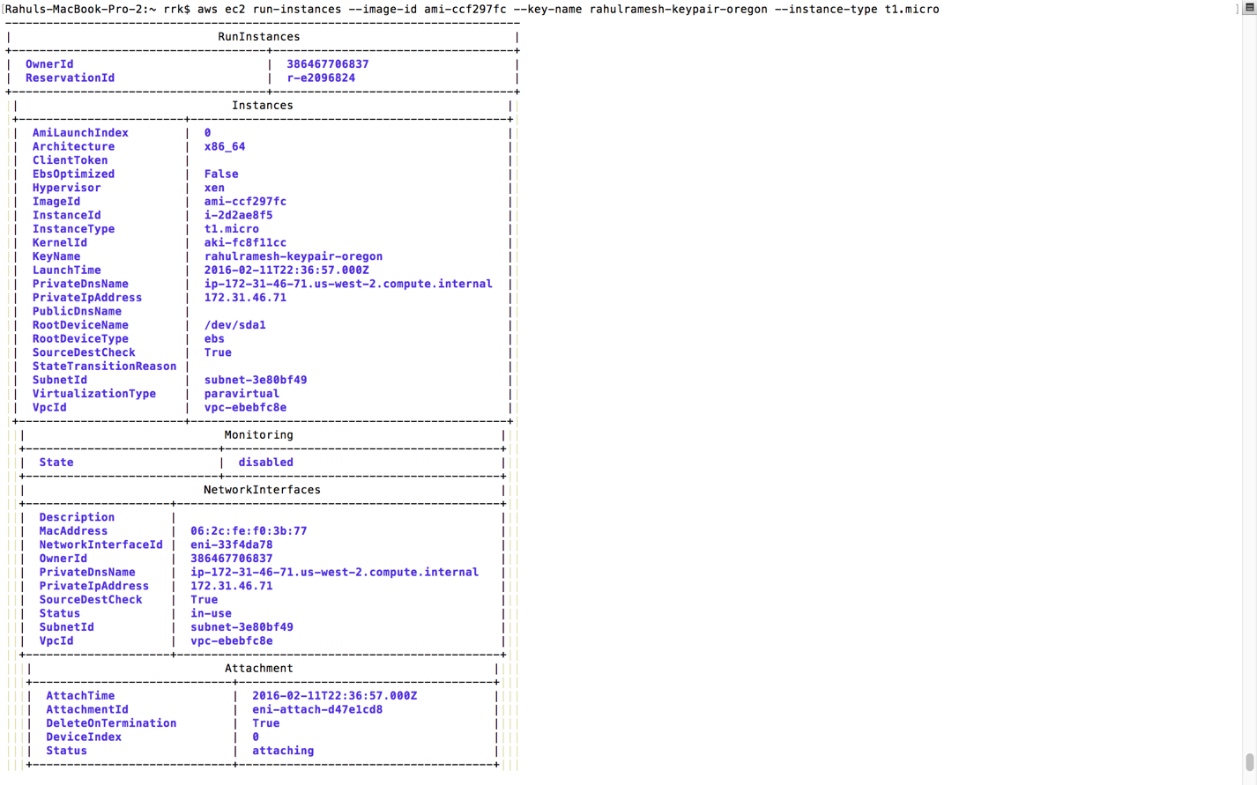

**Fig 4** – Shell Command

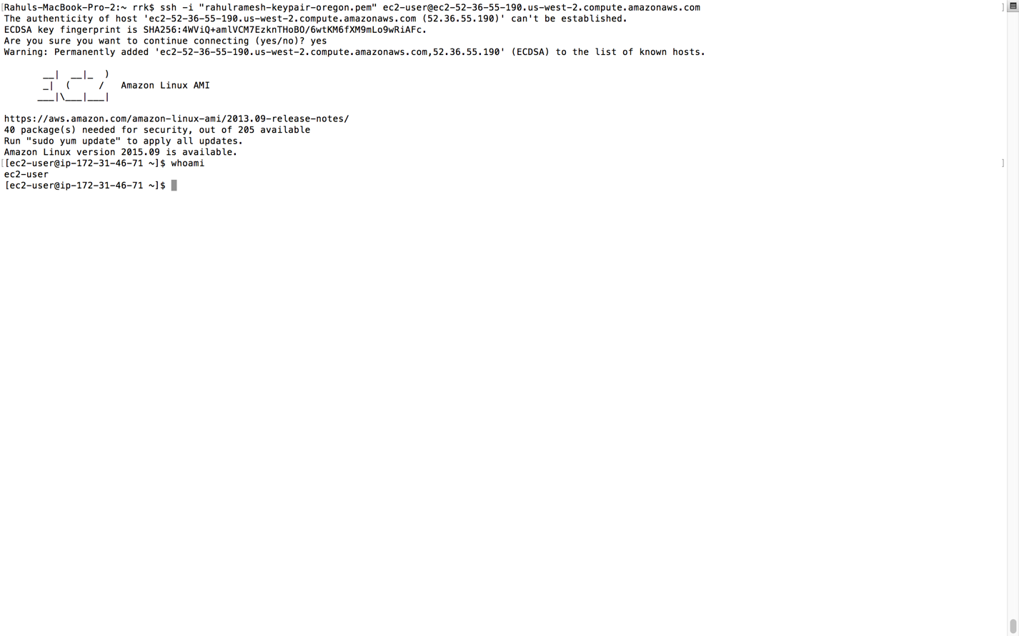

**Fig 5** – SSH to Command Line created EC2 Instance

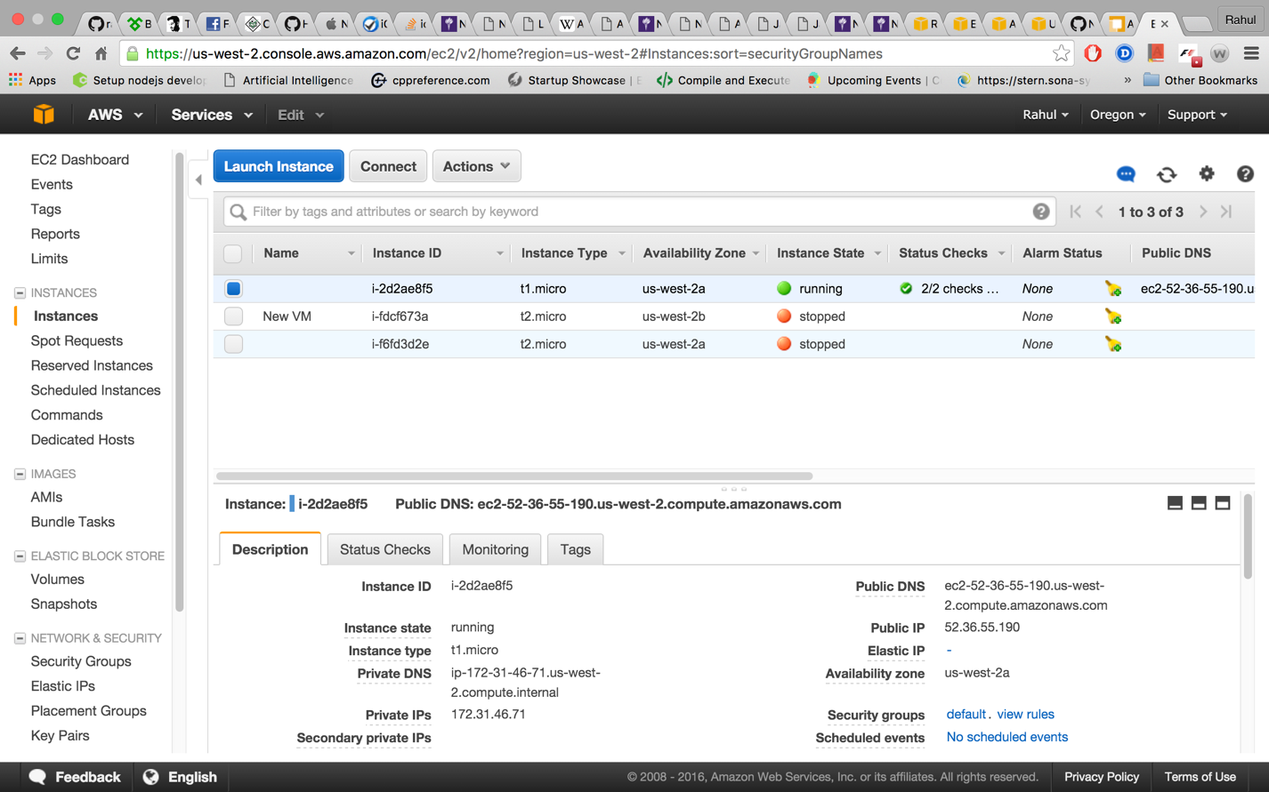

**Fig 6** – Amazon EC2 instance running Shell created Instance.

**Code Added separately in Zip File**