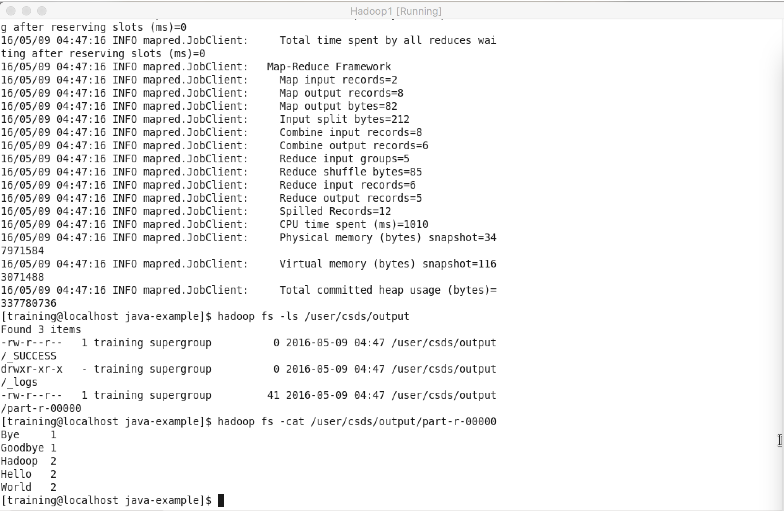

**SNAPSHOTS**

Figure 1- Map Reduce job in Java

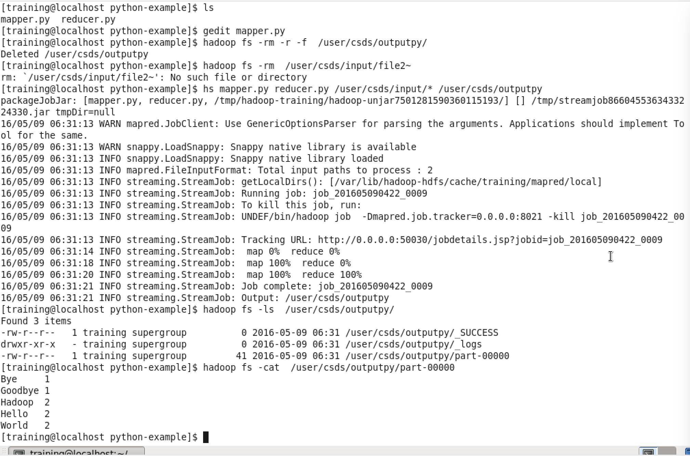

Figure 2- Map reduce output in Python using Hadoop Streaming

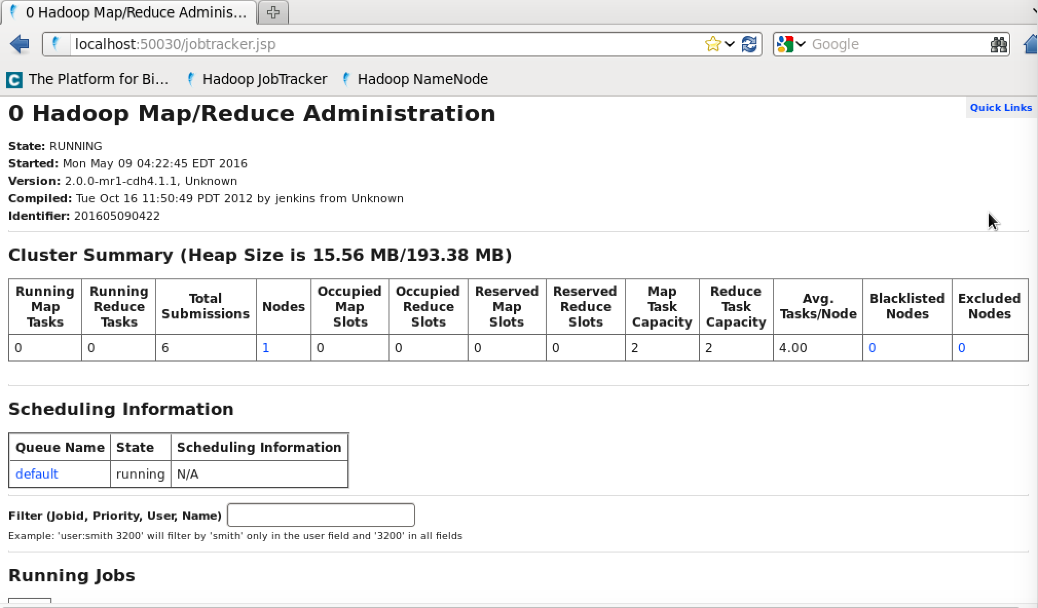

Figure 3- Map Reduce Administration Page

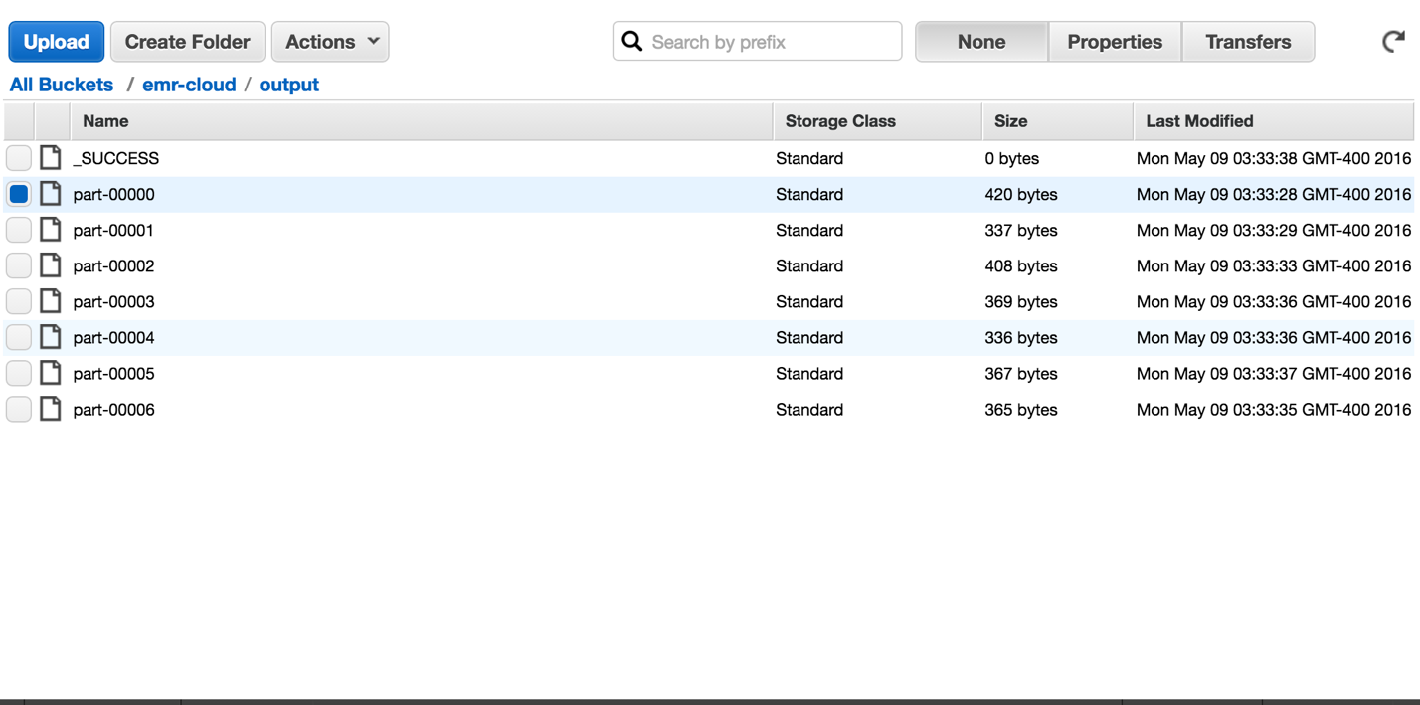

Figure 4- Output of Map reduce job on Amazon EMR

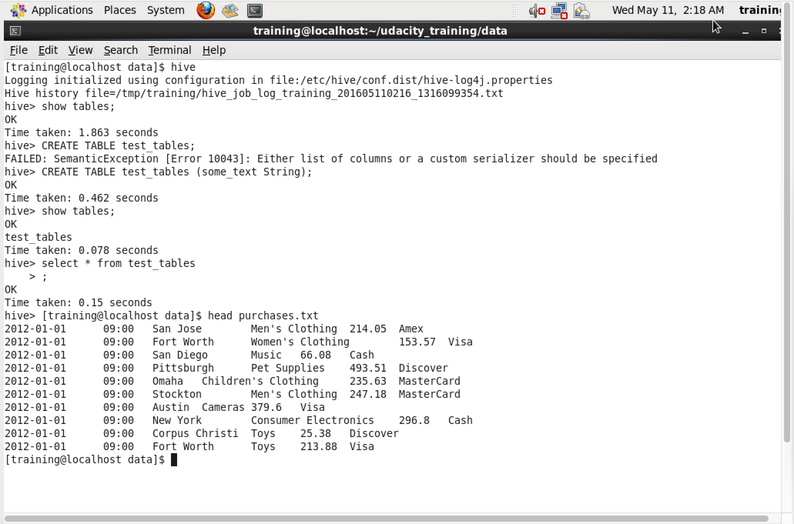

Figure 5- Starting up hive on Cloudera vm

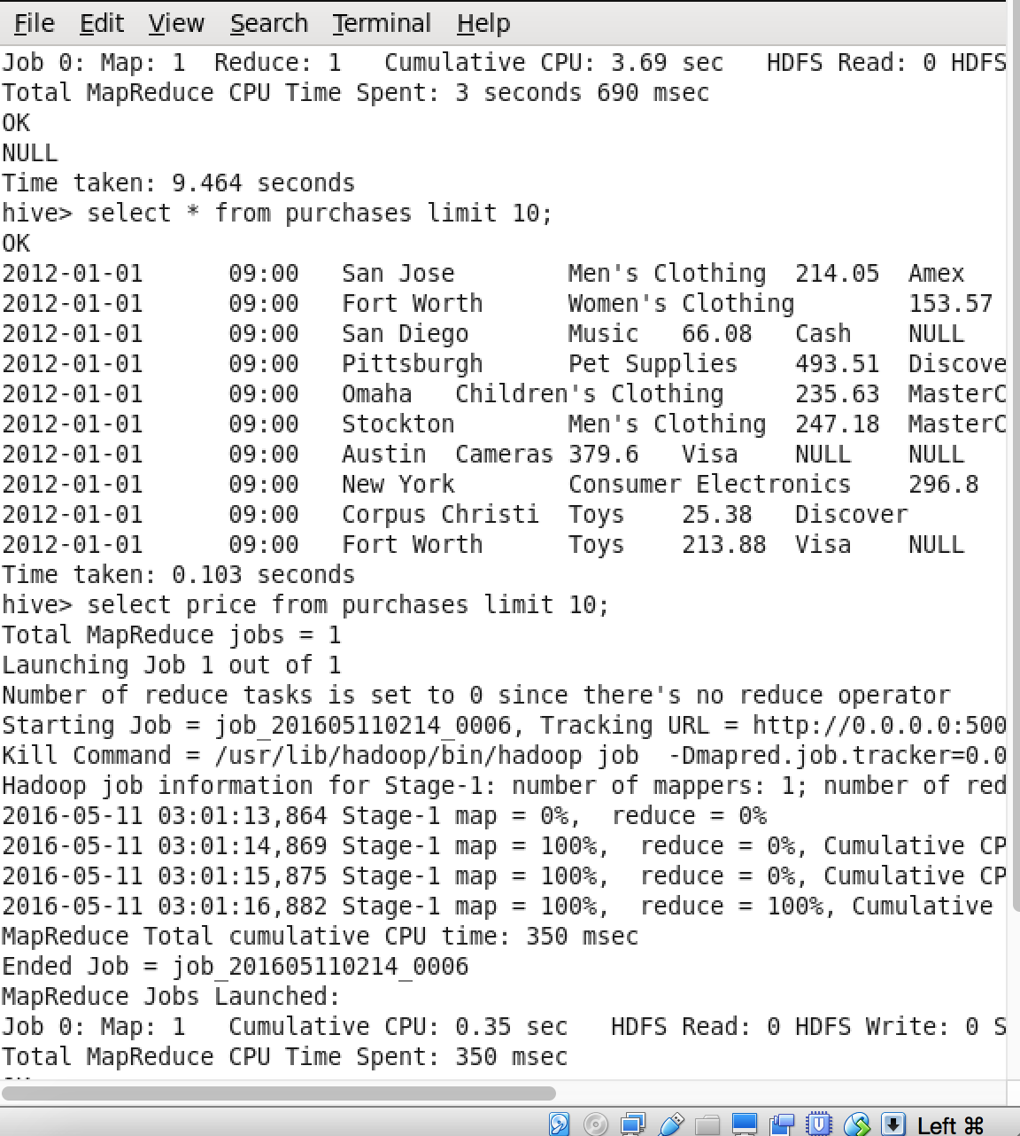

Figure 5- Hive jobs running in Cloudera VM and purchases table filled