Twitter Verbal Abuse

Rahul Ramesh Kumar

[rrk310@nyu.edu](mailto:rrk310@nyu.edu) ,rrk310

**Problem Statement**

The rising abuses on twitter against women have reached crisis levels as per the Women, Action, & the Media (WAM!) group. This includes women of color, queer women, transgender women, disabled women and other oppressed groups.

In order better understand the nature of these abusive tweets and gain more understanding on the trends of these abuses, a tool is required that can help visualize real time tweets that helps to gain new insights into this issue and also help organizations like WAM! to generate better reports to provide Twitter as evidences.

**Mockup -1**

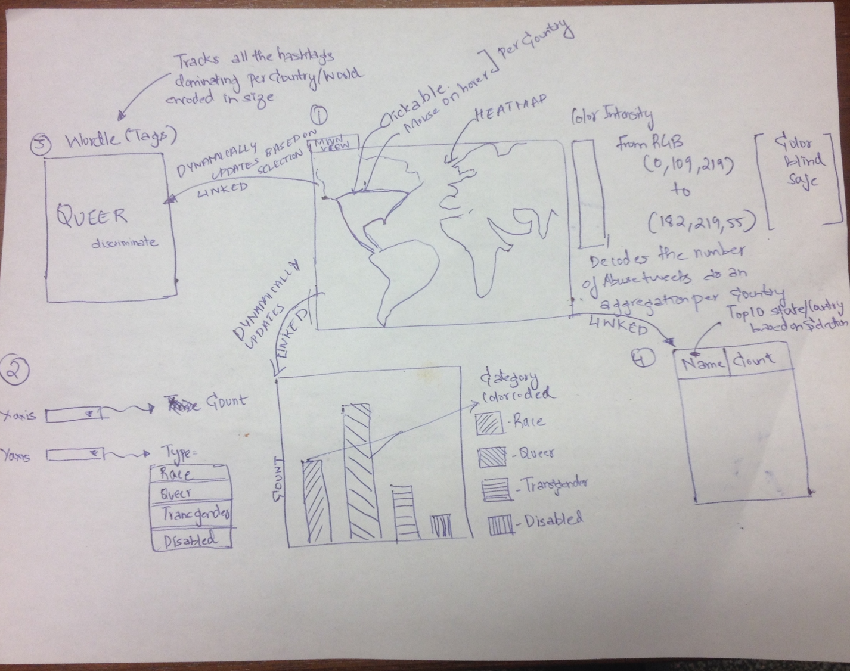

**Figure 1**

**How to read the sketch?**

The Mockup in Figure 1 represents the sketch of the visualization. This visualization is composed of a Main View (1) and Two Linked Views (2 & 4). There is also a word cloud (3) on top left that is linked to the main view

1. Main View – The main view consists of the entire world map that encodes the twitter that are flagged as abusive tweets geo graphically using Coordinates as well as the intensity of the tweets emerging as a heat map. The main view also has an on mouse hover component where each country on mouse hover will show certain statistics based on the location clicked and its name. The clickable component on the map is a country where the linked views are updated based on the component clicked. The data in the periodically fetched and the linked views are updated accordingly. The linked views are explained below.
2. Linked Views – The Linked View 2 provides a Bar chart that is populated based on the country clicked on the main map. It encodes a bar chart where X axis represents the count (Aggregation) of abusive tweets and Y axis just represents each bar as a category. Also each bar is color coded to represent these abuse types/category. An example of types/category is provided in the figure. The linked View 2 is dynamically updated a new data arrives. The Linked View 3 provides a list display that shows Name and Count that provides top 10 Abusive tweets based on Country/State that’s selected on the Map. When the map is loaded, it automatically displays the top 10 trending tweeting countries. When the country is clicked, it displays the top 10 states in that country based on tweet count.
3. Word cloud – Every tweet internally contains an array of tags that it is associated it and tweets that share same tags fall into one set. Such a multi set contains 1 to N sets of different sizes. The view will populate a UI based word cloud based on this multi set displaying the trending hashtags that occur in Abusive tweets.

**How the interaction Works?**

On Load -

The main view (1) is automatically loaded from the backend service with real time tweets. Once loaded the linked Views (2, 4, 5) are populated accordingly. Linked View 2 will have all results for the entire world as the user has not selected any from the list. Linked View 4 will automatically calculate all the top 10 countries that have highest Abusive tweets in descending order. Linked View 5 will start generating the trend chart based on category. The word cloud is constantly updating now based on the popular hash tags in the entire world.

On Click Map(1)-

When the map is clicked, any country that is in the path is automatically highlighted on the map. The corresponding country information is sent across to all the linked views and word cloud. They automatically start populating the data now for the selected country instead of the world. Linked View 4 will not start populating top 10 states that have the highest Abusive tweets from the country in descending order. The word cloud is updated now to display popular hash tags trending in that country selected.

**How the design helps answering questions?**

1. How are the verbally abusive tweets distributed?

Following question is answered from the main area which is the heat map. The heat map helps determine from a high level perspective how the tweets are distributed across the different countries. This data is crucial to understand where the data of interest lies and to begin first level of exploration.

1. What are the dominating keywords (hash tags) in that country/state?

Every state shows up interesting patterns on its views about abuses and the dominating keywords shows what are main abuse topics (hash tags) used by twitter abusers from that country/state.

1. Tracking of Child abuse in a certain region?

The heat map provides interactive display and also helps visualize using related views if there are any child abuses happening in a certain region. This is supplemented by the Linked View 2 that provides this same data with more detail. This data is important to the social activist group or non profits like WAM! to pin point locations of abuse.

**Mockup-2**

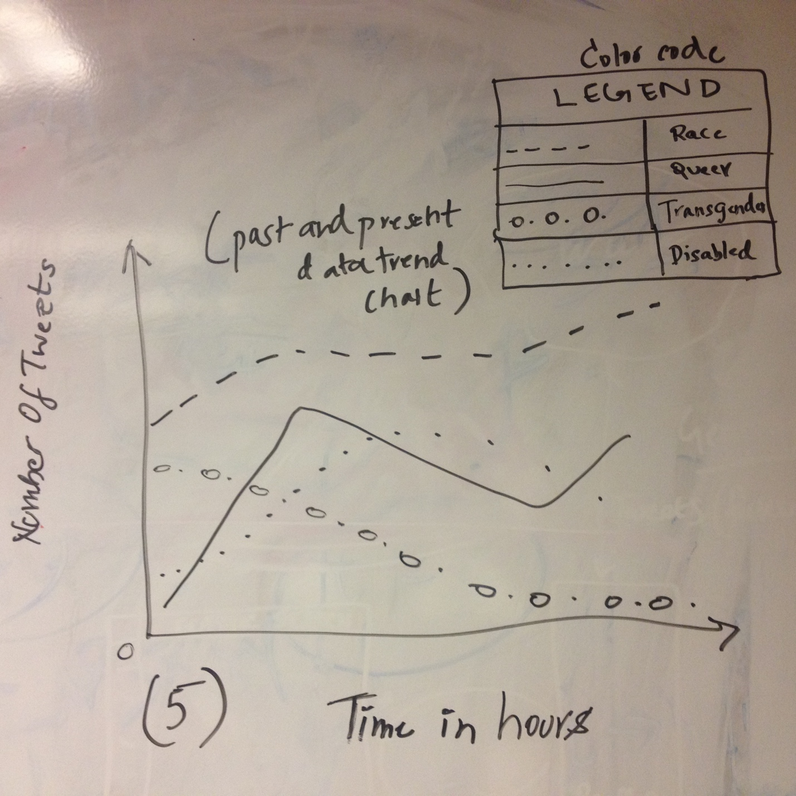

**Figure 2**

**How to read the sketch?**

The following graph is a trend graph that shows trending abuses based on types from a country that is selected on the main map (1). This shows trends using the past data and also the current data and aggregates them to plot as individual line graphs where X axis represents the Count of the tweets and Y axis is Time in hours. Each line graph is also color coded based on the abuse category.

**How the interaction Works?**

On every load and change of country of the map (1), the Linked View (5) is changed to depict the trend for the country/world. When ever a country is selected, it fetched last 1 hour of data and uses existing data in the frontend to visualize the trend for that country.

**How the design helps answering questions?**

What category of abuses are trending across the world?

The View (5) helps determine the current trends per country. Since it’s a linked view, it automatically loads the visualization when a country of interest is selected on the map (1) by the user. This information helps uncover the most dominant vs least dominant trending abuses in each country. Also its juxtaposition with various other abuse types helps compare them relative to other abuse types.