**Assignment 2 – Socket Programming Assignment - Webserver**

* Assignment Includes both the optional exercises
* Following server provides a multithreaded environment for TCP requests and provides responses without blocking the port.
* It listens for requests in port 81
* It also serves requests from a client program and a web based client program(browser)
* Client program can resolve host address by host name
* IP of the web server is 127.0.0.1 and host name is “localhost”

1. **sock_server.py**

**import** socket  
**from** threading **import** Thread  
  
notFoundResponse = **"""HTTP/1.1 404 Not Found\r\n Content-type: text/html\r\n \n  
<html>\r\n  
<body>\r\n  
 <h1>404 Not Found</h1>\r\n  
 <p>The requested URL was not found on this server.</p>\r\n  
 </body>\r\n  
</html>\r\n"""**foundResponse = **"""HTTP/1.1 200 OK\r\n Content-type: text/html\r\n  
"""***# Once Server accepts connection it post's to worker thread to  
# provide response of HTML File.***def** worker(connectionSocket,addr):  
 print(**'Received'**+str(addr))  
 **try**:  
 message = connectionSocket.recv(1024)  
 filename = str(message,**"utf-8"**).split()[1]  
 f = open(filename[1:])  
 content = f.read()  
 outputdata = bytearray()  
 outputdata.extend(map(ord, content))  
  
 *#Send one HTTP header line into socket* connectionSocket.send(foundResponse.encode(**'utf-8'**))  
  
 *#Send the content of the requested file to the client* connectionSocket.send(outputdata)  
  
 *#Close client socket* connectionSocket.close()  
 f.close()  
  
 **except** (IOError,IndexError):  
 *#Send response message for file not found* connectionSocket.send(notFoundResponse.encode(**'utf-8'**))  
 *#Close client socket* connectionSocket.close()

**def** serverMain():  
 serverSocket = socket.socket(socket.AF_INET,socket.SOCK_STREAM)  
 serverSocket.bind((**'localhost'**,81))  
 print(**'Main Server Started !'**)  
 **while True**:  
 serverSocket.listen(5)  
 print(**'Ready to serve ..'**)  
 connectionSocket, addr = serverSocket.accept()  
  
 *#Post it to worker thread to unblock this thread* w = Thread(target=worker, args=(connectionSocket,addr))  
 w.start()  
 serverSocket.close()  
  
**if** __name__ == **'__main__'**:  
 serverMain()

Following client can send a HTTP request to the web server at port 81 and print response header and content

1. **sock_client.py**

**import** sys  
**import** socket  
**from** sys **import** argv  
  
*#Supports only IPv4 for now***def** getHost(hostAddr):  
 **return** socket.gethostbyname(hostAddr)  
  
**def** clientMain(argv):  
 print(**'Entered Client process !'**)  
 **if**(len(argv) == 4):  
 print(**'server host : '**+argv[1] + **' server port : '**+argv[2] + **' filename = '**+argv[3])  
 hostAddr = getHost(argv[1])  
 hostPort = argv[2]  
 file = argv[3]  
 print(**'Host is = '**+hostAddr)  
 clientSock = socket.socket(socket.AF_INET, socket.SOCK_STREAM)  
 clientSock.connect((hostAddr, int(hostPort)))  
 reqString = **'GET '**+file +**' HTTP/1.1\r\nHost:'** + hostAddr +**":"**+hostPort+**'\r\nConnection: keep-alive\r\n \r\n\r\n'** clientSock.sendall(str.encode(reqString))  
 data = clientSock.recv(1024)  
 print(str(data))  
 clientSock.close()  
 **else**:  
 print(**'Wrong Usage! , please input format sock_client.py [server_host] [server_port] [filename]'**)  
  
**if** __name__ == **'__main__'**:  
 clientMain(argv)

1. **HelloWorld.html**

<**html**>  
<**title**> Welcome to Python Server !</**title**>  
<**body**>  
<**h1**>Hello World !!<**h1**>  
</**body**>  
</**html**>

**Screen Shots:**

1. Welcome page shown on successful HTTP Request for HelloWorld.html

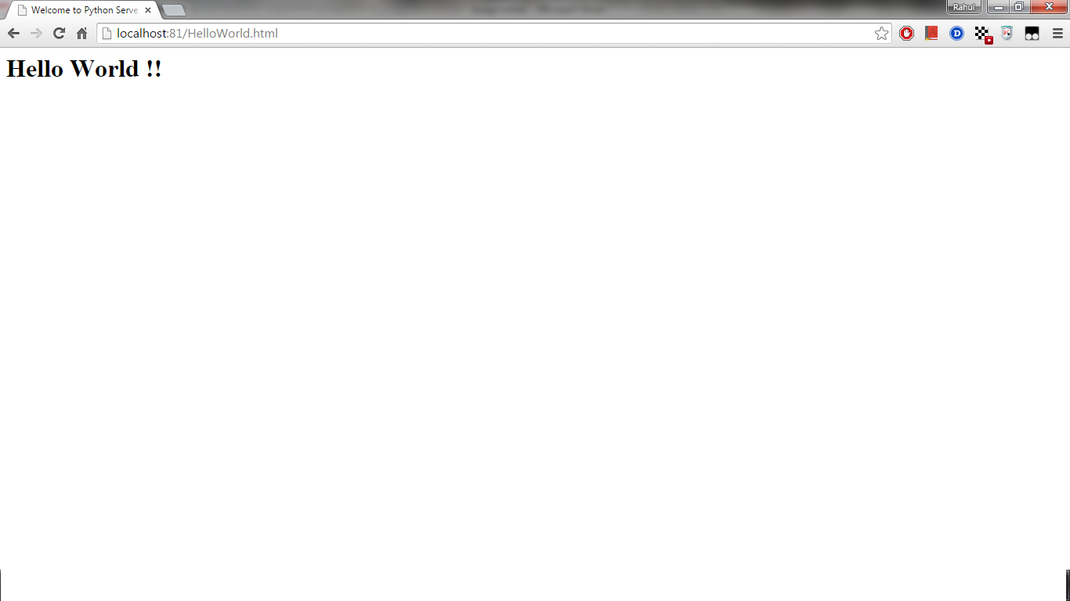

1. 404 Not Found shown for Invalid page HelloWorld1.html

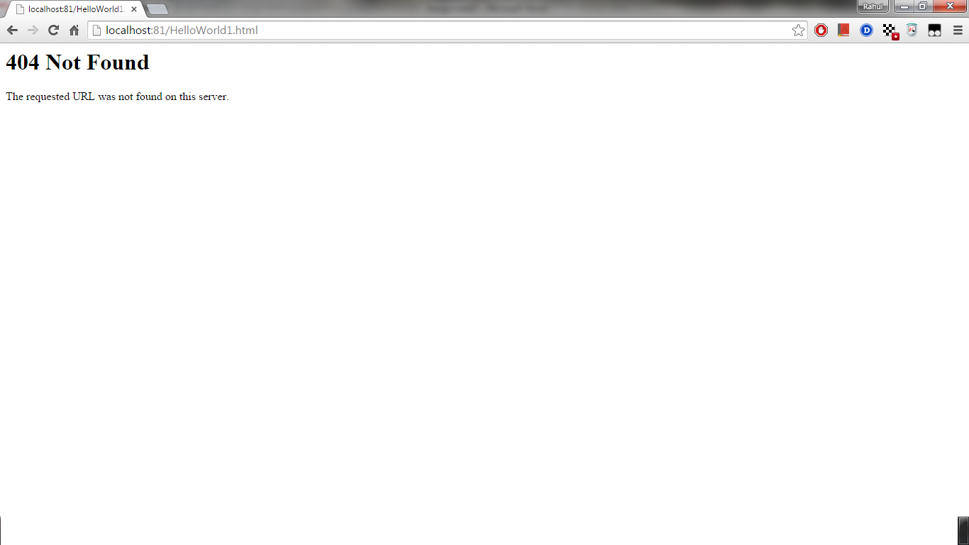

1. Command Line prints successful HTTP Response field and Content

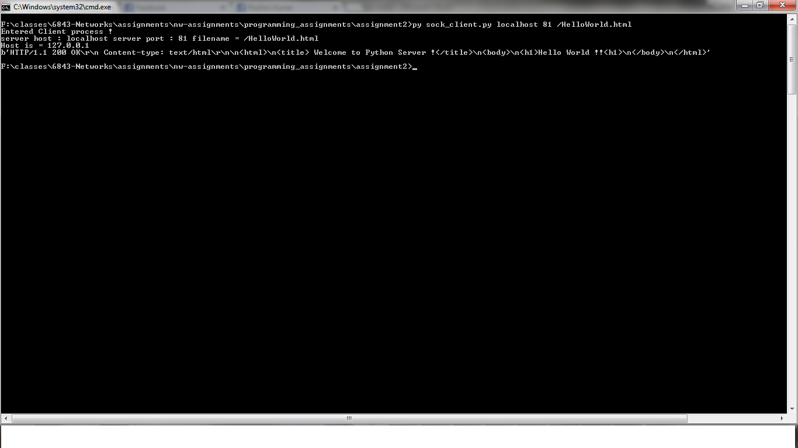

1. Command Line prints 404 Not found response message and Content

