**Assignment 3 – Socket Programming Assignment – SMTP**

* Mail server – **smtp-pulse.com** port - **2525**

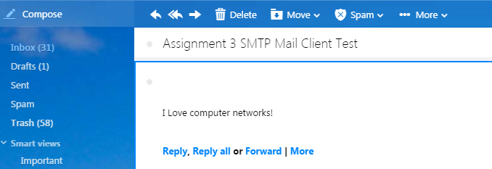

Fig 1.1 **Mail received at Yahoo**

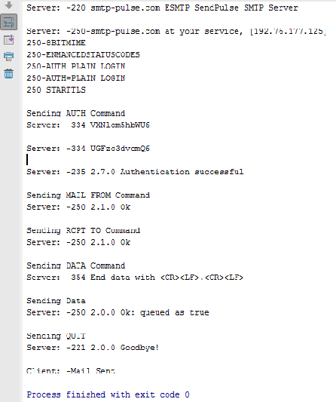

Fig 1.2 **Console Log**

Code- **smtpclient.py**

**from** socket **import** *  
msg = **"I Love computer networks!"**endmsg = **"\r\n.\r\n"**nyu_usn = **"cnJrMzEwQG55dS5lZHU=\r\n"**nyu_pass = **"ZGJETEd0VFJXTlRzbUY=\r\n"**pulsesmtpserver = **"smtp-pulse.com"**pulsesmtpport = 2525  
  
clientSocket = socket(AF_INET,SOCK_STREAM) *#TCP*clientSocket.connect((pulsesmtpserver,pulsesmtpport))  
  
print(**'Client: -connect done !'**)  
recve = clientSocket.recv(1024)  
recv = recve.decode(**'utf-8'**)  
print (**'Server: -'**+recv)  
**if** recv.split(**' '**,1)[0] != **'220'**:  
 print (**'Client: -220 reply not received from server.'**)  
  
*# Send HELO command and print server response.*heloCommand = **'EHLO rahul\r\n'**clientSocket.send(bytes(heloCommand,**'UTF-8'**))  
recv1 = clientSocket.recv(1024)  
recv = recv1.decode(**'utf-8'**)  
print (**'Server: -'**+recv)  
  
*#Send AUTH command and print server response.*print (**"Sending AUTH Command"**)  
*#AUTH with base64 encoded user name password*clientSocket.send(bytes(**"AUTH LOGIN\r\n"**,**'ascii'**))  
recv2 = clientSocket.recv(1024)  
recv = recv2.decode(**'utf-8'**)  
print (**'Server: -'**+recv)  
**if** recv.split(**' '**,1)[0] != **'334'**:  
 print (**'Client: -334 reply not received from server.'**)  
  
clientSocket.send(bytes(nyu_usn,**'utf-8'**))  
recv3 = clientSocket.recv(1024)  
recv = recv3.decode(**'utf-8'**)  
print (**'Server: -'**+recv)  
**if** recv.split(**' '**,1)[0] != **'334'**:  
 print (**'Client: -334 reply not received from server.'**)  
  
clientSocket.send(bytes(nyu_pass,**'utf-8'**))  
recv4 = clientSocket.recv(1024)  
recv = recv4.decode(**'ascii'**)  
print (**'Server: -'**+recv)  
**if** recv.split(**' '**,1)[0] != **'235'**:  
 print (**'Client: -334 reply not received from server.'**)  
  
*#Send MAIL FROM command and print server response.*print (**"Sending MAIL FROM Command"**)  
clientSocket.send(bytes(**"MAIL FROM:<rrk310@nyu.edu>\r\n"**,**'UTF-8'**))  
recv5 = clientSocket.recv(1024)  
recv = recv5.decode(**'utf-8'**)  
print (**'Server: -'**+recv)  
**if** recv.split(**' '**,1)[0] != **'250'**:  
 print (**'Client: -250 MAIL FROM failed.'**)  
  
  
*#Send RCPT TO command and print server response.*print (**"Sending RCPT TO Command"**)  
clientSocket.send(bytes(**"RCPT TO:<rahul.ramesh89@yahoo.co.in>\r\n"**,**'UTF-8'**))  
recv6 = clientSocket.recv(1024)  
recv = recv6.decode(**'utf-8'**)  
print (**'Server: -'**+recv)  
**if** recv.split(**' '**,1)[0] != **'250'**:  
 print (**'Client: -250 RCPT TO Failed.'**)  
  
  
*#Send DATA command and print server response.*print (**"Sending DATA Command"**)  
clientSocket.send(bytes(**"DATA\r\n"**,**'UTF-8'**))  
recv7 = clientSocket.recv(1024)  
recv = recv7.decode(**'utf-8'**)  
print (**'Server: -'**+recv)  
**if** recv.split(**' '**,1)[0] != **'354'**:  
 print (**'Client: --354 DATA Ready failed.'**)  
  
  
*#Send Data and print server response.*print (**"Sending Data"**)  
clientSocket.send(bytes(**"SUBJECT: Assignment 3 SMTP Mail Client Test\n"**+msg+endmsg,**'UTF-8'**))  
recv8 = clientSocket.recv(1024)  
recv = recv8.decode(**'utf-8'**)  
print (**'Server: -'**+recv)  
  
*#Send QUIT and print server response.*print (**"Sending QUIT"**)  
clientSocket.send(bytes(**"QUIT\r\n"**,**'UTF-8'**))  
recv9 = clientSocket.recv(1024)  
recv = recv9.decode(**'utf-8'**)  
print (**'Server: -'**+recv)  
  
print (**"Client: -Mail Sent"**)  
clientSocket.close()