Firmware Security Compliance Document
DGCA UAS Type Certification — Certification Scheme Section 7.1 (Level 1)

Manufacturer (Flight Module firmware provider) | Inofly
Product | CubePilot CubeOrange+ (STM32H743), PX4-based firmware (inoflyPilot fork)
Ground station | inoflyGCU (QGroundControl fork)
Role | Firmware Manufacturer — not the Certification Body
Document date | 2026-07-10
Draft for Certification Body review

Contents
Contents 2
Executive Summary 6
What this document is 6
Who we are 6
What is being certified 6
What Section 7.1 requires, in plain terms 6
Compliance at a glance 6
The single idea behind the whole design 7
How to read this document 7
What we ask of the Certification Body 7
Glossary — terms and acronyms 8
Roles and parties 8
Hardware and software 8
Cryptography (the security building blocks) 8
Firmware integrity concepts 9
Runtime and update concepts 9
Flight-parameter protection 10
Physical protection 10
Internal identifiers (appear in evidence) 10
Certificate of Compliance 11
DGCA UAS Type Certification — Certification Scheme Section 7.1 (Level 1) 11
Document control 11
1. Declaration 11
2. Conditions and conformance summary 11
3. Signing-Key Provenance statement (read together with the Certification Body) 13
4. Physical and operational controls (context) 14
5. Open items for the Certification Body 14
Firmware Security Architecture — Auditor Overview 15
Inofly UAS — DGCA Level 1 (Firmware Manufacturer) 15
1. System components 15
2. The single-keypair trust model 15
3. Chain of trust (secure boot) 16
4. Boot sequence — Power On Self-Test (POST) 16
5. Firmware update paths — both gated 18
6. Compliance parameter protection 18
7. Audit log signing (additional requirement) 19
8. Hardware platform and validation status 19
9. Design choices and deviations from common industry practice (and why they are equal or stronger) 19
DGCA Certification Scheme §7.1 — Compliance Mapping 21
Inofly UAS Firmware Security — Level 1 (Firmware Manufacturer) 21
0. Reference summary of compliance 21
1. Verification of Secure Boot — Flight Module Security Implementation (§7.1 a.i) 22
1.1 Level 0 / Level 1 compliance (Annexure E) 22
1.2 Communication requirement (Annexure E, if applicable) 22
1.3 Root of trust mechanism (TPM or TEE for Level 1) used to sign Flight-Module-generated data 22
1.4 Verification key of the root of trust recorded and retained 23
2. Calculation of Checksums (§7.1 a.ii) 23
2.1 Registered checksums submitted to the Certification Body 23
2.2 Code part and data part checksums calculated separately 24
2.3 Secure Hash Algorithm (SHA2 or SHA3) 24
2.4 Registered checksums stored securely — not updatable without manufacturer authorization 24
2.5 Registered checksums digitally signed by the Certification Body and retained 25
3. Power On Self-Test (§7.1 a.iii) 25
3.1 POST implemented 25
3.2 POST compares calculated checksums with registered checksums 25
3.3 POST result logged 26
3.4 Mismatch prevents the UAS from functioning, and is logged 26
4. Testing of firmware protection (§7.1 a.iv) 27
5. Safety and security of firmware update (§7.1 b — Secure Upgrade Test) 27
5.1 Update permitted only if signed by the manufacturer's digital certificate 27
5.2 UAS verifies authenticity with the manufacturer's public key 28
5.3 Firmware change recorded in the logs 28
5.4 Registered checksum updated securely in the Flight Module after upgrade 28
5.5 Checksums of updated firmware signed by the Certification Body and retained 29
6. Secure change of flight parameters (§7.1 c — Testing of Parameter Update) 29
6.1 Authenticity of parameter update 30
6.2 Change recorded in the logs 30
6.3 / 6.4 Registered checksum updated after upgrade; Certification Body signs checksums 30
6.5 Parameter update via standard operating procedure — parameter remains unaffected 30
6.6 Parameter update with invalid digital signature — update fails 30
7. Log file signing — additional requirement 30
8. Traceability — requirement → tests → hardware evidence 31
Annexure E Conformance Statement 33
Flight Module security level — DGCA Certification Scheme for UAS 33
1. Security-level determination 33
2. Point-by-point conformance 33
E.1 — Security level (Level 0 / Level 1) 33
E.2 — Root of trust for Level 1 ("using, for example, TPM or TEE") 33
E.3 — Verification key recorded and retained 34
E.4 — Communication requirement (multi-module / 128-bit symmetric key) 34
E.5 — Key management within the module 34
3. Summary 35
4. Items for Certification Body confirmation 35
Certified Build Identity Sheet 36
The exact firmware artifact this certification applies to 36
1. Firmware image identity 36
2. Registered checksums (in the signed manifest) 36
3. Binary manifest (provisioned to the flight module) 36
4. Bootloader 37
5. Signing key (root of trust) 37
6. Compliance parameters baked into this build (.compliance_params, covered by data_hash) 37
7. How to reproduce these values 37
8. Sign-off 38
Test Evidence Pack — DGCA §7.1 39
Captured evidence per compliance test (CubeOrange+ hardware) 39
E-D3 — POST passes on boot; integrity published (§7.1 a.iii.a/b) 39
E-D4 — Tamper → POST fails → arming blocked → logged (§7.1 a.iii.d, a.iv) 39
E-D4-b — Organic code/data hash mismatch (reason 4/5) — the hardware-only proof (§7.1 a.iii.b) 40
E-D6 — Unauthorized update rejected at three layers (§7.1 a.iv, b.i) 40
E-D7 — Compliance parameters cannot be changed (§7.1 c.v/c.vi) 40
E-D9 — Signed audit log: violations logged + offline verification (§7.1 a.iii.c, b.iii, c.ii; additional log-signing requirement) 41
E-summary — automated evidence (§7.1 all) 42
Evidence index (test → clause → source) 42

Executive Summary

What this document is
This is the firmware-security compliance submission for DGCA UAS Type Certification, Level 1, against Section 7.1 of the Certification Scheme for UAS. It shows, requirement by requirement, how our drone's flight-control firmware meets each condition, and provides the evidence.

Who we are
We are the Firmware Manufacturer — we build and cryptographically sign the flight-control firmware, generate its checksums, and enforce integrity on the drone. We are not the Certification Body; the Certification Body is a separate party that witnesses the tests and may counter-sign our checksums.

What is being certified
Flight controller | CubePilot CubeOrange+ (STM32H743 microcontroller)
Firmware | PX4-based (our secured fork)
Ground control software | QGroundControl (our secured fork)
Exact build under certification | recorded in Part 5 — Certified Build Identity

What Section 7.1 requires, in plain terms
Section 7.1 asks a manufacturer to prove four things:
- Firmware tamper avoidance (7.1 a) — the drone must refuse to operate if its firmware has been changed by anything other than an authorized, signed update. It self-checks at every power-on and blocks arming on any mismatch.
- Safe and secure firmware update (7.1 b) — a firmware update is accepted only if it carries the manufacturer's digital signature; the drone verifies it, and the change is logged.
- Secure change of flight parameters (7.1 c) — safety-critical settings (altitude, speed, fence, airframe) cannot be changed to unsafe values by an operator; only a signed firmware release can change the certified values.
- Log file signing (additional) — the drone's security log is signed so any tampering is detectable offline.

Compliance at a glance
Section 7.1 area | Status | How it is achieved (plain) | Proof
a — Firmware tamper avoidance | Conforms | Every boot re-computes the firmware's checksums and verifies the manufacturer signature; any mismatch blocks arming and is logged. | Part 3 §1–4; Part 6
b — Secure firmware update | Conforms | Updates are accepted only if signed by the manufacturer; verified at the ground station, on the drone, and again at boot. | Part 3 §5; Part 6
c — Secure flight parameters | Conforms | Certified limits are compiled into the signed firmware; operators cannot exceed them; every attempt is logged. | Part 3 §6; Part 6
Log signing | Conforms | The security log is signed with the manufacturer key; tampering is detectable offline. | Part 3 §7; Part 6
Overall: all Section 7.1 controls are implemented and validated on real hardware (CubeOrange+). An automated test suite of 358 checks passes. The formal declaration is in Part 1 — Certificate of Compliance.

The single idea behind the whole design
One manufacturer signing key is the root of trust. Its secret half never leaves the manufacturer; its public half is built into the drone. The drone trusts only what that key has signed — firmware, checksums, updates, and its own log. Everything in this document is an application of that one idea.

How to read this document
The document is organized in parts. An auditor can read them in order, or jump to Part 3:
Part | Contents | For
1 — Certificate of Compliance | The formal signed declaration + a conformance summary table + open items for the Certification Body | The headline: what we declare and where each item is evidenced
2 — System Architecture | How the security works, with diagrams (trust model, boot sequence, update paths) | Context to understand Part 3
3 — §7.1 Compliance Mapping | Each Section 7.1 clause quoted, then how we satisfy it, with evidence | The heart of the submission
4 — Annexure E Conformance | Security-level (Level 1) determination, point by point | The security-level determination, cross-checked against the Annexure E criteria
5 — Certified Build Identity | The exact firmware this certificate applies to (versions, checksums, key fingerprint) | Pins the certificate to one specific build
6 — Test Evidence | Captured results from the hardware tests, per clause | The proof behind the "Conforms" claims
A Glossary of terms and acronyms follows this summary. Every technical term used in the parts is defined there in plain language.

What we ask of the Certification Body
A short list of items are the Certification Body's to confirm or perform (detailed in Part 1 §5): confirm the signing-key provenance approach (we adopt a CCA certificate for production), counter-sign the registered checksums, and witness the live test session (Part 6 / the test runbook).

Glossary — terms and acronyms
Plain-language definitions of every technical term used in this document. Nothing here is needed to understand the Executive Summary; use it while reading Parts 2–6.

Roles and parties
Term | Meaning
FM (Flight Module / Firmware Manufacturer) | Us — the party that builds and signs the flight-control firmware and enforces integrity on the drone.
CB (Certification Body) | The independent party that witnesses the tests and may counter-sign the checksums. Not us.
Operator | The end user who flies the drone. Can fly and set mission values, but cannot alter certified firmware or limits.
DGCA | Directorate General of Civil Aviation — the Indian regulator whose Certification Scheme this submission addresses.

Hardware and software
Term | Meaning
CubeOrange+ | The flight-controller hardware being certified. Contains the STM32H743 microcontroller.
STM32H743 | The microcontroller (the "brain" chip) on the CubeOrange+. All security checks run here.
Flight controller (FC) | The CubeOrange+ board running the firmware.
PX4 | The open-source flight-control firmware platform our firmware is based on.
QGroundControl (QGC) | The ground-station software (runs on a laptop) used to load firmware and monitor the drone.
MCU | Microcontroller unit — the STM32H743 chip.
SD card | Removable storage on the flight controller; holds the manifest, the MAVLink link-signing key, and the audit log. (The manufacturer's private signing key is never on the drone.)

Cryptography (the security building blocks)
Term | Meaning
Root of trust | The one trusted anchor the whole system is built on — here, the manufacturer's signing key.
Key pair (public / private) | Two matching keys. The private key signs (kept secret by the manufacturer); the public key verifies signatures (built into the drone). What one signs, only the other can verify.
RSA-2048 | The specific public-key cryptography and key size used. 2048-bit is a standard, widely certified strength.
RSA-PSS | The specific, modern RSA signature scheme used for every signature in the system.
SHA-256 | The secure hashing algorithm (SHA-2 family) used for all checksums. Turns any file into a fixed 256-bit fingerprint; changing one bit changes the fingerprint.
Signature | A cryptographic seal made with the private key that proves "the manufacturer produced this, unaltered." Verified with the public key.
Hash / checksum | A SHA-256 fingerprint of some data. Used to detect any change.
Fingerprint (of a key) | A short SHA-256 hash identifying a specific key, so two parties can confirm they hold the same key.
CCA certificate | A document-signing digital certificate issued by India's Controller of Certifying Authorities. The intended production source of the manufacturer key.
libtomcrypt / OpenSSL | The cryptography software libraries. libtomcrypt runs the checks on the drone; OpenSSL does the signing on the manufacturer's computer. They interoperate.

Firmware integrity concepts
Term | Meaning
Manifest | A small signed file on the drone holding the registered checksums (code + data), the board ID, and the manufacturer signature. The drone checks against this at boot.
Registered checksum | The official SHA-256 checksum of the certified firmware, submitted to the CB and stored in the manifest.
Code hash | The SHA-256 checksum of the firmware code section.
Data hash | The SHA-256 checksum of the firmware data section — the table holding the certified flight-parameter values. Kept separate from the code hash so parameters can be revised independently.
POST (Power-On Self-Test) | The integrity self-check the drone runs automatically at every power-on: it re-computes the checksums from live memory and verifies the signature, then decides whether the drone may arm.
Arming | Enabling the motors so the drone can fly. A failed POST blocks arming — the drone cannot take off.
Board ID | A number identifying the hardware model (CubeOrange+ = 1063). Prevents firmware for one board running on another.
Bootloader / verifying bootloader | The first code that runs at power-on. Ours verifies the firmware's signature before launching it — an unsigned firmware won't run.
bl_update | The controlled mechanism used to install/update the bootloader; it verifies a signature before writing.

Runtime and update concepts
Term | Meaning
Update bundle (.fwbundle) | The single signed file the operator loads in the ground station to update firmware. Contains the firmware plus its signed manifest.
verify_update | The on-drone check that inspects a staged update and accepts it only if the manufacturer signature (and board ID) are valid.
Reason code | A number the drone reports saying why a check failed. POST: 1 = manifest missing, 2 = checksum/CRC, 3 = signature, 4 = code changed, 5 = data/parameters changed, 6 = wrong board. Update staging uses its own shorter list (2 = corrupt, 3 = signature, 4 = wrong board), so an update rejection with reason 4 means wrong board, not changed code. These make each test result unambiguous.
CRC (CRC32) | A quick corruption check on a file. A broken CRC (reason 2) means the file was damaged or altered.
Audit log | The drone's security event log (SD card): every POST result, update attempt, and blocked parameter change. Signed so tampering is detectable. Different from the flight telemetry log.
uORB | PX4's internal messaging system; how the POST result is published to the arming logic. (Implementation detail.)

Flight-parameter protection
Term | Meaning
Compliance parameter | A safety-critical setting the certificate controls (max altitude, max speed, fence range, airframe type, signing mode). Its certified value is compiled into the signed firmware.
CAPPED parameter | A tunable mission limit (e.g. max altitude 120 m). The operator may set any value up to the certified ceiling for a flight, but never above it; the setting does not persist across reboots.
LOCKED parameter | A fixed configuration (e.g. airframe type). The operator cannot change it at all; only a signed firmware release can.
MAVLink signing | Authentication of the link between the ground station and the drone. Only a ground station that knows the drone's passphrase (which derives the key) can command it.

Physical protection
Term | Meaning
Tamper-evident seal | A serialized physical seal on the airframe and enclosure. Reaching the debug port to bypass software protection requires visibly breaking it; broken seals are caught on return inspection.
TPM / TEE | Dedicated hardware security modules (a Trusted Platform Module or Trusted Execution Environment). The STM32H743 has neither; we achieve Level 1 in software plus the verifying bootloader and seal — see Part 4.

Internal identifiers (appear in evidence)
Requirement and decision IDs such as POST001–004, UPD001, PAR001, PAIR001, LOG001, ROT001/002, BOOT001–008, ADR-nnn are our internal traceability labels linking a requirement to its code and tests. An auditor does not need to memorize them; each is explained where it first appears, and the full list is in the traceability table at the end of Part 3.

PART 1

Certificate of Compliance

DGCA UAS Type Certification — Certification Scheme Section 7.1 (Level 1)
Required by §7.1(a): *"Manufacturer to produce a certificate of compliance indicating compliance with all conditions mentioned."* This document is that certificate.

Document control
Document title | Certificate of Compliance — Firmware Security (DGCA §7.1, Level 1)
Manufacturer (Flight Module provider) | Inofly
Role | Firmware Manufacturer — signs firmware, stores registered checksums, enforces integrity. Not the Certification Body.
Product / flight module | CubePilot CubeOrange+ flight controller (STM32H743), PX4-based firmware (inoflyPilot fork)
Ground control software | inoflyGCU (QGroundControl fork)
Certified build identity | See the Build Identity section — pins this certificate to a specific firmware artifact (version, git hash, code/data checksums, board_id, public-key fingerprint)
Version history
Rev | Date | Description | Prepared by | Approved by
Draft A | 2026-07-10 | Initial certificate for Certification Body review | _________ | _________
Sign-off
 | Name | Title | Signature | Date
Prepared by
Approved by
⚠️ Pre-issue conditions (must be closed before this certificate is signed for a production unit): (1) the firmware must be signed with the production manufacturer key, not the current test key — see the Signing-Key Provenance statement below and the Build Identity section; (2) the Certified Build Identity fields must be filled for the exact production build; (3) items marked "Certification Body to confirm" below must be resolved with the Certification Body.

1. Declaration
The Manufacturer declares that the flight-module firmware identified in the Build Identity section has been designed, implemented, and tested to meet the conditions of Section 7.1 of the DGCA Certification Scheme for UAS at Level 1, as summarized in the conformance table below and evidenced in the referenced documents.

2. Conditions and conformance summary
§7.1 clause | Condition | Conformance | Evidence
a.i (a) | Flight module Level 0/1 compliance | Conforms — Level 1. All secure execution on the flight-module microcontroller; single module (no companion computer). | the Annexure E Conformance section; mapping §1.1
a.i (b) | Communication requirement (Annexure E) | Conforms / N.A. Single module ⇒ no inter-module link. Ground Control Station ↔ Flight Module link authenticated by MAVLink signing (PAIR001). | Annexure E §2; mapping §1.2
a.i (c) | Root of trust used to sign Flight Module data | Conforms. RSA-2048 root of trust; audit log bound to it. See Signing-Key Provenance (§3). | mapping §1.3; TEST_EVIDENCE §D1
a.i (d) | Verification key recorded and retained | Conforms. Public key retained (manufacturer_public.pem); used to verify log origin. | mapping §1.4
a.ii (a) | Registered checksums submitted to Certification Body | Conforms. Pipeline emits signed manifest (code + data checksums). | mapping §2.1; BUILD_IDENTITY
a.ii (b) | Code and data checksums separate | Conforms. Independent SHA-256 over code range and data range. | mapping §2.2
a.ii (c) | Secure Hash Algorithm (SHA2/SHA3) | Conforms. SHA-256 throughout; no MD5/SHA-1. | mapping §2.3
a.ii (d) | Registered checksums stored securely, not updatable without manufacturer | Conforms. RSA-PSS-signed manifest; only a manufacturer-signed update replaces it. | mapping §2.4; TEST_EVIDENCE §D4/D6
a.ii (e) | Checksums may be Certification Body-signed and retained | Supported. Checksums furnished to Certification Body for signing/retention (Certification Body action). | mapping §2.5
a.iii (a) | POST implemented | Conforms. POST autostarts every boot. | mapping §3.1; TEST_EVIDENCE §D3
a.iii (b) | POST matches calculated vs registered checksums | Conforms. Live code/data hashes compared to signed manifest. | mapping §3.2; TEST_EVIDENCE §D3
a.iii (c) | POST result logged | Conforms. PASS and FAIL both logged (signed audit log). | mapping §3.3; TEST_EVIDENCE §D9
a.iii (d) | Mismatch prevents operation and is logged | Conforms. Arming blocked on any POST failure; logged with reason code. | mapping §3.4; TEST_EVIDENCE §D4
a.iv | Firmware protection testing (unauthorized change fails / fails POST) | Conforms. Demonstrated at 3 layers (Ground Control Station, Flight Module gate, boot). | mapping §4; TEST_EVIDENCE §D4/D6
b (i) | Update permitted only if manufacturer-signed | Conforms. Ground Control Station + Flight Module + bootloader all verify signature. | mapping §5.1; TEST_EVIDENCE §D5/D6
b (ii) | UAS verifies authenticity with public key | Conforms. libtomcrypt RSA-PSS against embedded public key. | mapping §5.2
b (iii) | Firmware change recorded in logs | Conforms. UPDATE_ATTEMPT entries (success/fail). | mapping §5.3; TEST_EVIDENCE §D9
b (iv) | Registered checksum updated securely after upgrade | Conforms (staged); auto-promotion in progress. New signed manifest replaces old only after signature verify. | mapping §5.4 (status note)
b (v) | Updated checksums Certification Body-signed and retained | Supported (Certification Body action). | mapping §5.5
c (i) | Parameter update authenticity via manufacturer process | Conforms. Compliance params compiled into signed firmware (data_hash). | mapping §6.1; TEST_EVIDENCE §D7
c (ii) | Parameter change recorded in logs | Conforms. COMPLIANCE_PARAM_VIOLATION entries. | mapping §6.2; TEST_EVIDENCE §D9
c (iii/iv) | Registered checksum updated / Certification Body-signed | Conforms / Supported. Same mechanism as b(iv)/b(v). | mapping §6.3
c (v) | SOP parameter update leaves parameter unaffected | Conforms. CAPPED/LOCKED enforcement; demonstrated live. | mapping §6.5; TEST_EVIDENCE §D7
c (vi) | Invalid-signature parameter update fails | Conforms. Rejected at Ground Control Station/Flight Module/POST. | mapping §6.6; TEST_EVIDENCE §D4/D6
Additional (log file signing) | Log file signing | Conforms. Per-file RSA public-key encryption of log hash; offline-verifiable. | mapping §7; TEST_EVIDENCE §D9
Overall: all Section 7.1 conditions are met, subject to the pre-issue conditions above. Automated test suite: 358/358 pass; POST002/003/004 validated on CubeOrange+ hardware (see build/test evidence).

3. Signing-Key Provenance statement (read together with the Certification Body)
The root of trust is a single self-managed RSA-2048 keypair:
- The public key is embedded in the bootloader and application firmware and is retained for the Certification Body. DER SHA-256 fingerprint of the current (test) key: f52ab7731ca86ea15aa152b605a87369da236b76ce99e7bd09b381b7af928dd5.
- The private key is held offline by the Manufacturer and never leaves that environment.
- The signature scheme is RSA-PSS (SHA-256, MGF1-SHA256, salt length 32).
Signing-key provenance — for Certification Body confirmation. A common industry approach roots the signing key in a CCA-issued document-signing certificate (.PFX, purchased from India's Controller of Certifying Authorities). Our current root of trust is instead a self-managed raw RSA-2048 keypair — there is no CA/CCA certificate behind it yet. We assess this satisfies the §7.1 "root of trust … used to sign the data generated inside the Flight Module" requirement (the property required is authenticity/integrity of firmware, checksums, and logs, which the RSA-2048 chain provides).
Production decision (2026-07-10): adopt a CCA certificate for production. For production units the manufacturer signing key will be adopted from a CCA-issued document-signing certificate (RSA-2048), in line with common industry practice. The bench/reference builds documented here use a self-generated test key; the production cut-over procedure — how the key is extracted from the CCA .PFX and wired into the (unchanged) RSA-PSS signing pipeline — is documented step-by-step in the Production Key Provisioning section. The migration is localized to the two PEM files in pki/manufacturer/ plus a firmware/bootloader rebuild; it does not change the architecture or the signing scheme.
Production key condition. The key currently in the tree is a test/development key (its private key is present as an unencrypted PEM on the build machine). Before this certificate is issued for a production unit, the firmware must be re-signed with the production CCA-derived manufacturer key per the Production Key Provisioning section, and the fingerprint above (and in the Build Identity section) updated accordingly.

4. Physical and operational controls (context)
- Verifying bootloader (BOOT001) checks the app-firmware signature on every boot; signed `bl_update` (BOOT008) verifies a bootloader image before erasing sector 0.
- Tamper-evident sealing (BOOT007) on airframe + Cube enclosure, with STM32 96-bit UID + seal-serial recorded per unit, is the compensating control for physical SWD/JTAG access. Procedure: the Manufacturing Runbook.

5. Open items for the Certification Body
- CCA certificate for production — production units will be signed with a CCA-issued RSA-2048 document-signing certificate (decided 2026-07-10; procedure in the Production Key Provisioning section). Certification Body to confirm this satisfies the root-of-trust provenance expectation and to receive the retained X.509 certificate chain.
- Certification Body counter-signing of registered checksums — §7.1 a.ii(e)/b(v): Certification Body to sign and retain the checksums we furnish.
- Witnessed test session — §7.1 a.iv requires the firmware-protection test "in presence of Certification Body"; run per the Test Runbook section.
- Auto-promotion of staged update manifest (§7.1 b.iv) — final implementation item (ADR-023 A-6) in progress; equivalent end state demonstrable via manufacturer provisioning today.

PART 2

Firmware Security Architecture — Auditor Overview

Inofly UAS — DGCA Level 1 (Firmware Manufacturer)
Purpose. A self-contained architecture walkthrough for the Certification Body, with the block/flow diagrams called out in the reference documents. For requirement-by-requirement mapping see the §7.1 Compliance Mapping; for the canonical internal reference (full decision log) see the Architecture Reference.

1. System components
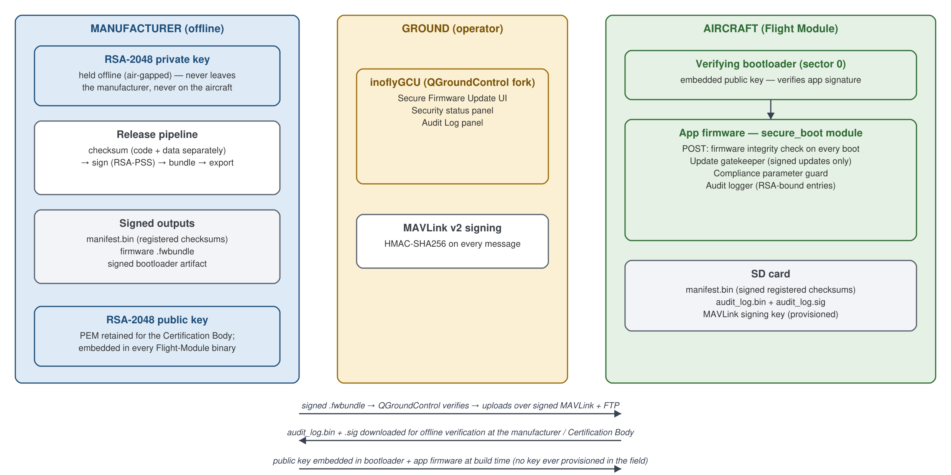
Figure 1 — System components and trust boundaries
Roles. We are the Firmware Manufacturer: we hold the signing key, sign firmware and manifests, and enforce integrity on the module. The Certification Body is a separate party that witnesses the tests and may counter-sign the registered checksums. The operator flashes and flies but cannot alter compliance-critical firmware or parameters.

2. The single-keypair trust model
One RSA-2048 keypair is the root of trust for everything (firmware signing, manifest signing, update-bundle signing, and audit-log hash encryption). RSA-2048 is a widely certified choice for this class of flight controller, and a single keypair keeps key management minimal.
Key | Location | Used for
Private | Manufacturer, offline (never leaves) | Signing firmware images, manifests, update bundles; opening (decrypting) audit-log signatures during verification
Public | Embedded in bootloader binary and application firmware; retained as PEM for the Certification Body | Verifying all signatures on-device; encrypting the audit-log hash
- Signature scheme: RSA-PSS (SHA-256, MGF1-SHA256, salt length 32), applied uniformly by every signer and verifier.
- Hash: SHA-256 everywhere (SHA-2, FIPS 180-4). No MD5/SHA-1 anywhere.
- On-device crypto: libtomcrypt (already part of NuttX/PX4 — no new dependency). Host/SITL crypto: OpenSSL. The two interoperate; a passing POST on real hardware is the proof.

3. Chain of trust (secure boot)
Each layer is verified by the layer above it; the chain is anchored by (a) cryptography and (b) a tamper-evident physical seal.
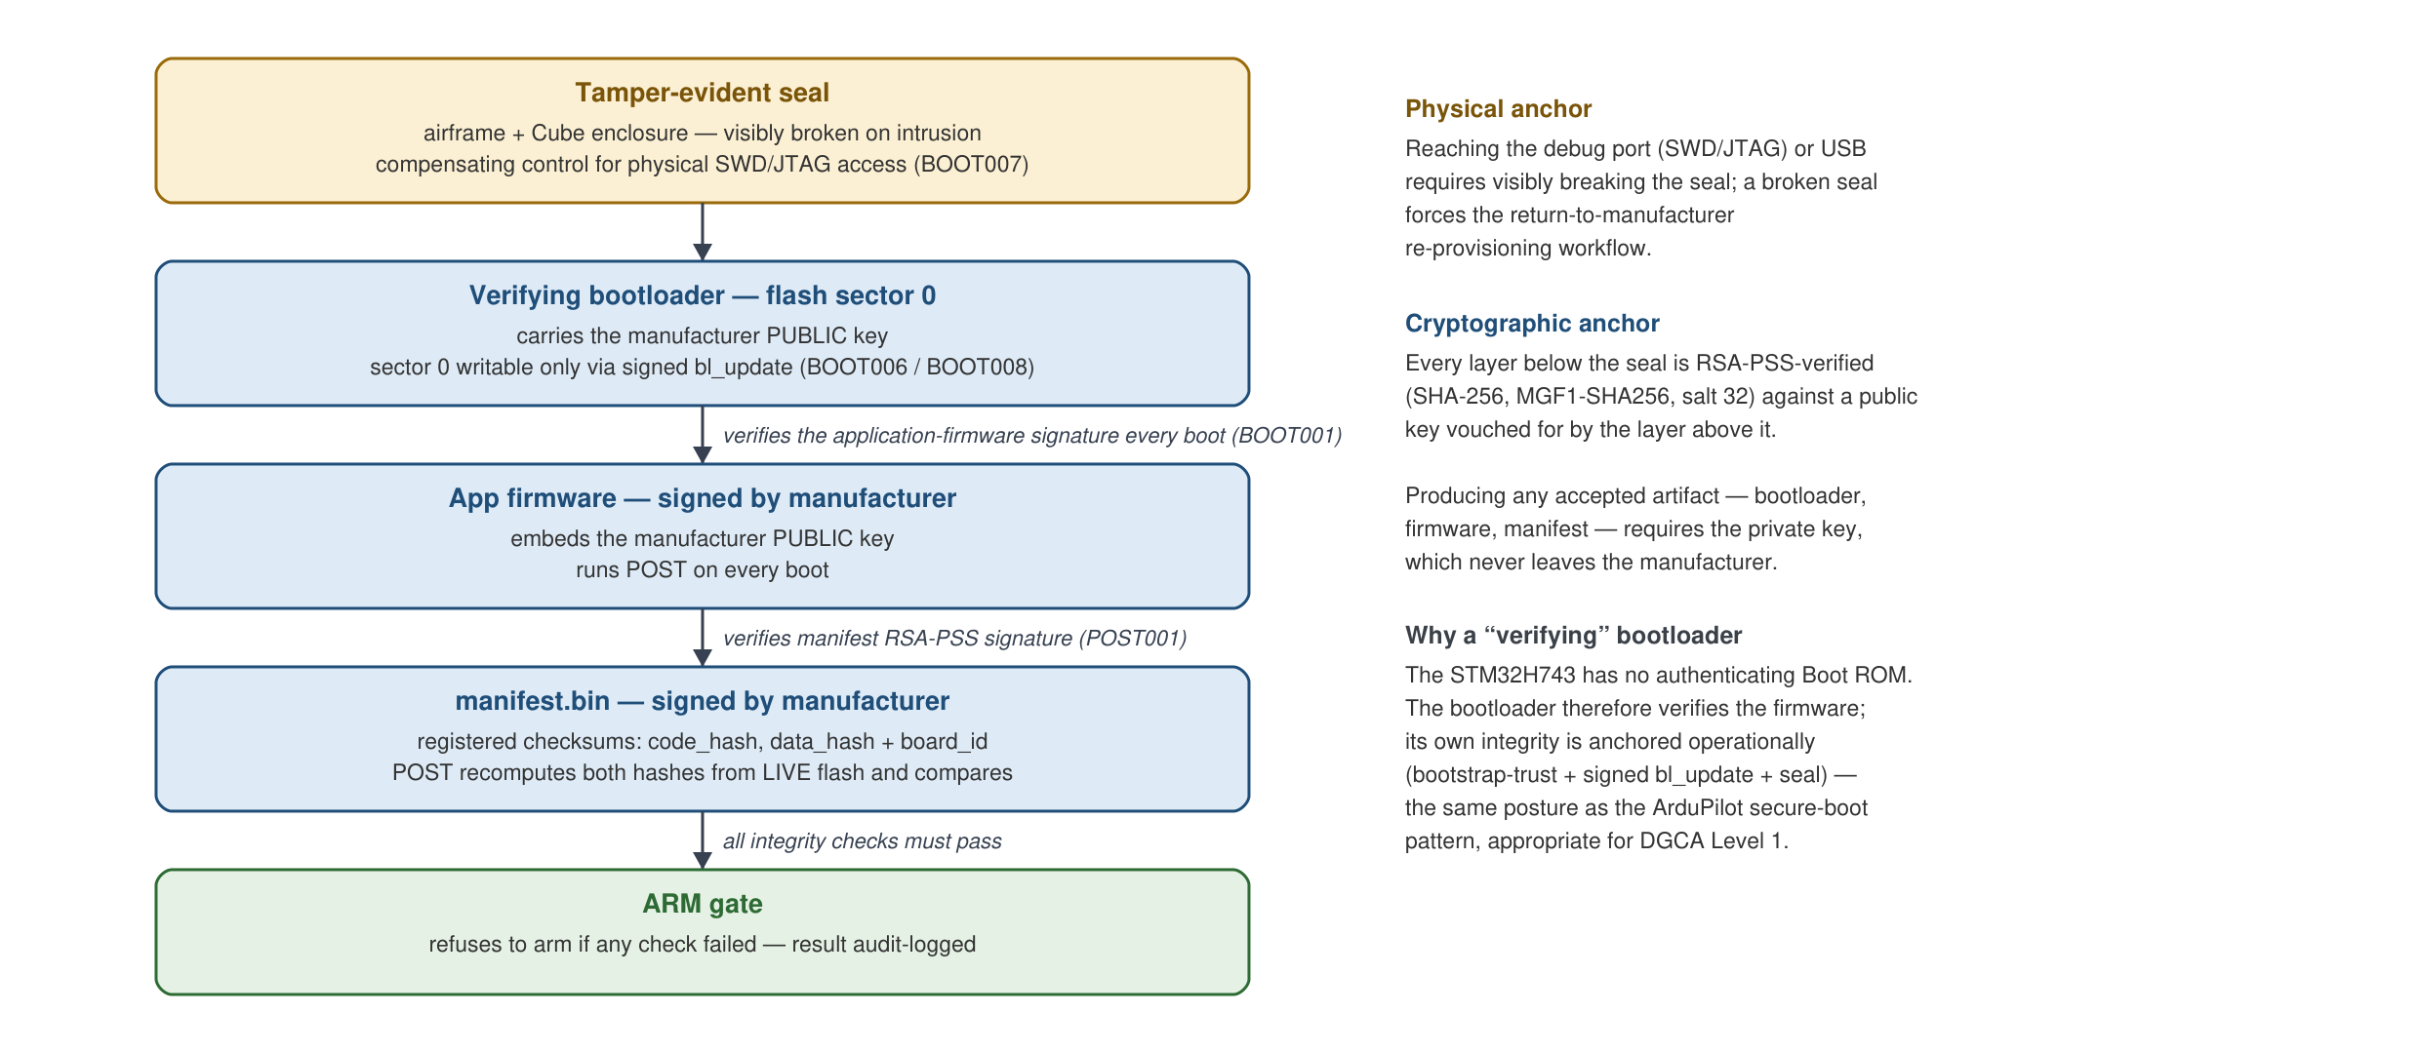
Figure 2 — Chain of trust: every layer verified by the layer above it
Trust transitivity. Break the seal and you are visible; without it, sector 0 can only be rewritten by a manufacturer-signed application firmware pushing a manufacturer-signed bootloader — which requires the private key. From the bootloader down, every layer is RSA-PSS-verified against a public key that the layer above has already vouched for. An attacker who cannot produce a manufacturer signature cannot get unauthorized code or checksums to run.
Terminology note for the auditor. The STM32H743 has no authenticating Boot ROM (unlike phones or STM32H5/U5). Ours is therefore a verifying bootloader — it verifies the *firmware's* signature. The bootloader's own integrity is provided operationally (bootstrap-trust + seal), not by silicon. This is the same posture as the ArduPilot secure-boot pattern and is appropriate for DGCA Level 1, which requires authenticity/integrity of updates, not confidentiality.

4. Boot sequence — Power On Self-Test (POST)
This is the flow behind the reference documents' "Secure firmware booting procedure" and "POST workflow" figures.
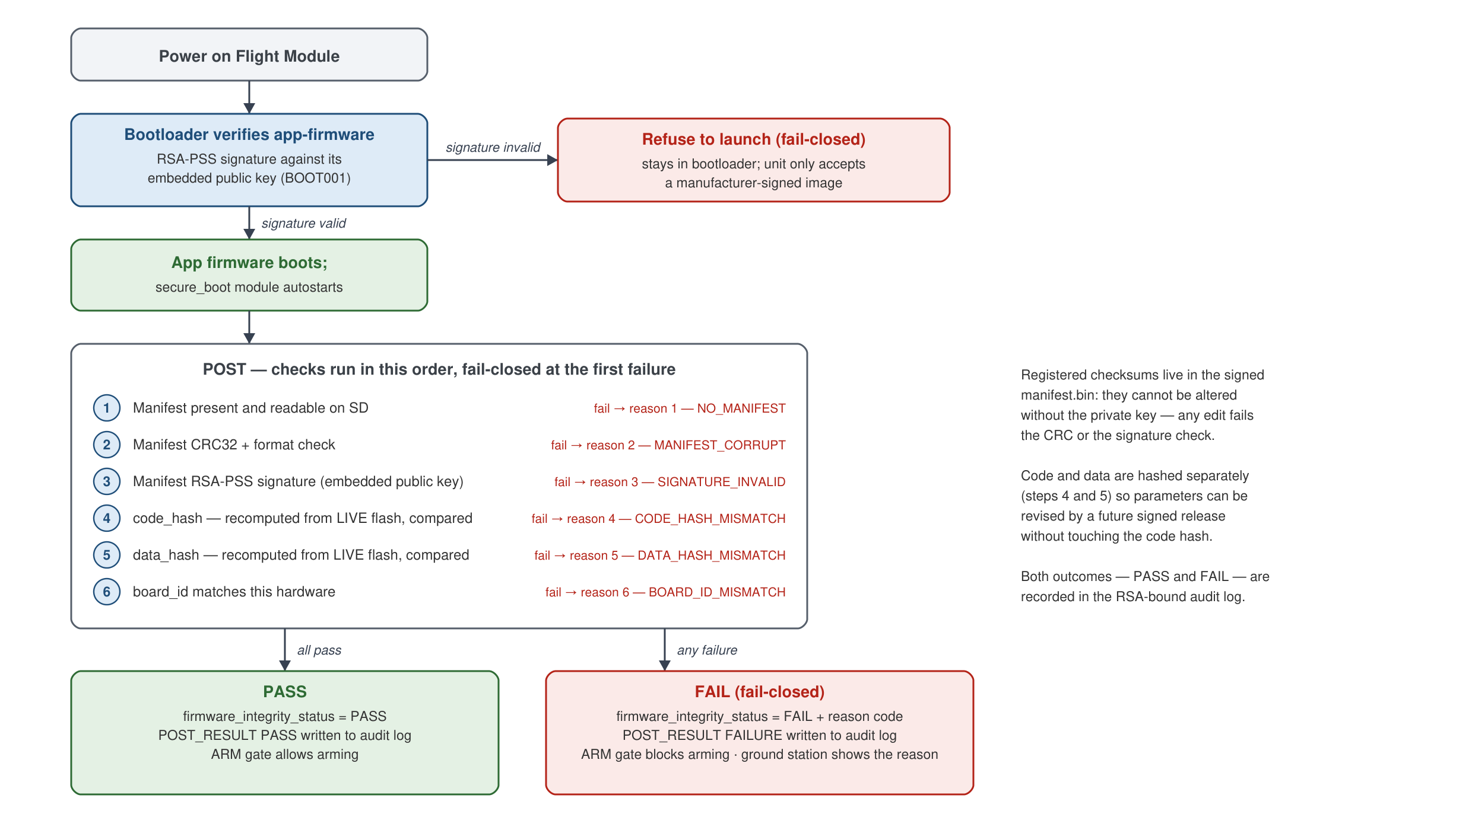
Figure 3 — Boot sequence and Power-On Self-Test (POST), fail-closed
- Registered checksums live in the signed manifest.bin on the SD card; they cannot be altered without the private key (any edit fails CRC or signature).
- Code vs data are hashed separately (steps 4 and 5) so parameters/data can be revised in a future signed release independently of code.
- Both outcomes logged — PASS and FAIL — to the RSA-signed audit log.

5. Firmware update paths — both gated
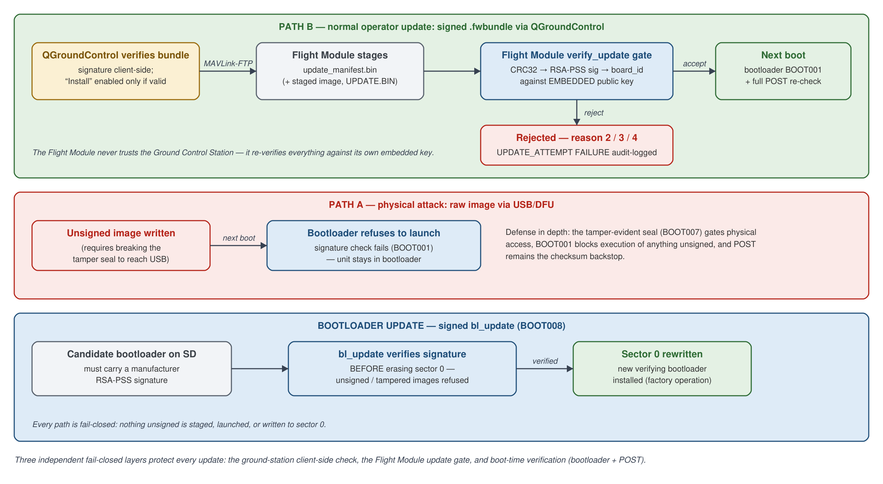
Figure 4 — Firmware update paths; all three are independently gated
Three independent fail-closed layers protect an update: Ground Control Station client-side, Flight Module update gate, and boot-time (bootloader + POST). The Flight Module never trusts the Ground Control Station's verdict — it re-verifies against its own embedded public key.

6. Compliance parameter protection
Compliance-critical parameter values are compiled into the firmware in a dedicated flash table (.compliance_params) that is covered by the registered data_hash. They cannot be changed from any Ground Control Station — a change requires a new manufacturer-signed release.
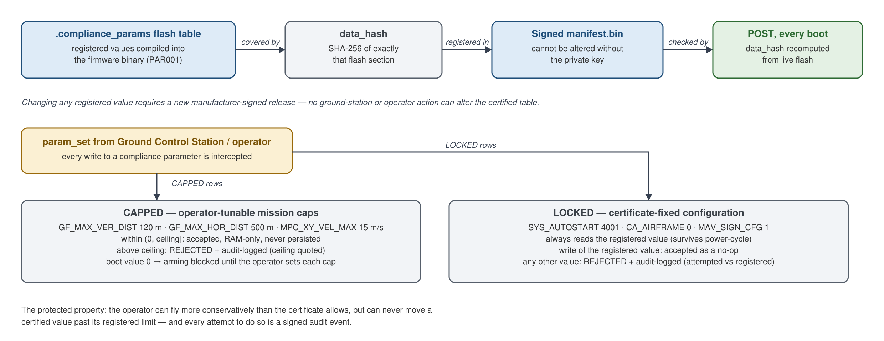
Figure 5 — Compliance parameter protection (PAR001): CAPPED and LOCKED kinds
Parameter | Kind | Registered | Compliance meaning
GF_MAX_VER_DIST | CAPPED | 120 m | Max altitude AGL ceiling
GF_MAX_HOR_DIST | CAPPED | 500 m | Fence range ceiling
MPC_XY_VEL_MAX | CAPPED | 15 m/s | Max speed ceiling
SYS_AUTOSTART | LOCKED | 4001 | Certified airframe model
CA_AIRFRAME | LOCKED | 0 | Frame configuration
MAV_SIGN_CFG | LOCKED | 1 | MAVLink signing required

7. Audit log signing (additional requirement)
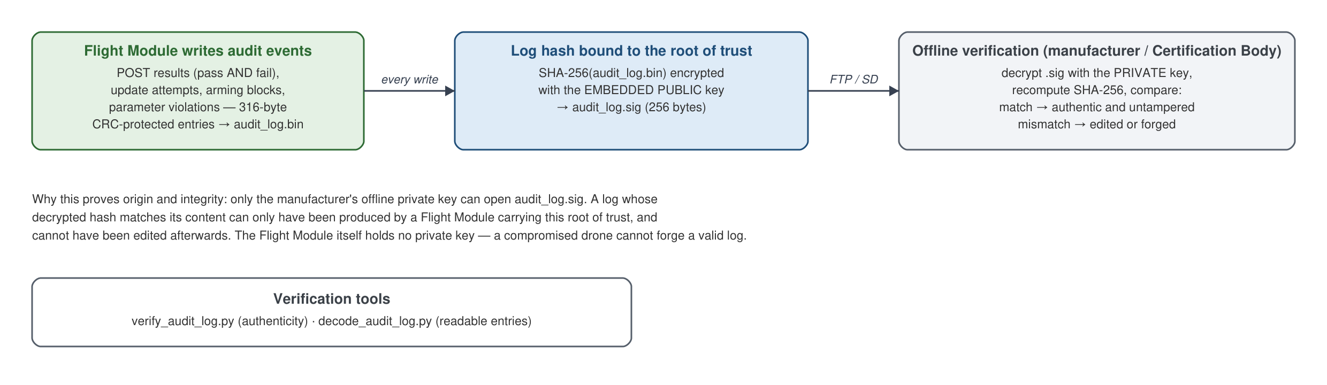
Figure 6 — Audit log signing and offline verification (LOG001)
Only the manufacturer's private key can open the signature, so the log's origin (produced by a Flight Module carrying this root of trust) and integrity (no post-hoc edits) are provable offline. Tools: verify_audit_log.py, decode_audit_log.py.

8. Hardware platform and validation status
- Target: CubePilot CubeOrange+, STM32H743 (2 MB flash, no authenticating Boot ROM, no accessible BOOT0 on the shipped carrier).
- Bench acceptance (Tier 1, H0–H15): complete on real hardware — POST on real flash, tamper/arming block, PAR001 against real NVM, signed audit log persisted on SD, update accept/reject, attacker-key and organic hash-mismatch cases. See the Hardware Acceptance record.
- Secure bootloader chain (B1–B9): complete — BOOT001 positive/negative, signed bl_update (BOOT008), staged SD update matrix. See the Bootloader Bring-up record.
- Physical control (BOOT007): tamper-evident seal + UID/seal-serial tracking; procedure in the Manufacturing Runbook.
- Automated tests: 358 compliance tests pass (Docs/compliance_report.txt).

9. Design choices and deviations from common industry practice (and why they are equal or stronger)
Topic | Common industry approach | Our approach | Why acceptable for Level 1
Root of trust | RSA-2048, keys in Flight Module | RSA-2048, single keypair, public key embedded in bootloader + firmware | Same key strength; keys never in transit
Ground Control Station ↔ Flight Module lock | Custom 8-byte UID | MAVLink v2 signing, 32-byte key = SHA256(passphrase) | Strictly stronger (HMAC-SHA256 vs 8-byte UID); uses native PX4/QGroundControl infra
Bootloader trust | Reliance on the flashing procedure | Verifying bootloader + bootstrap-trust + signed bl_update + tamper seal | Cryptographic + operational anchor; no reliance on procedure alone
Flash encryption (AES) | Sometimes present | Deferred (BOOT004) | Level 1 requires authenticity/integrity of updates, not confidentiality; our signed chain delivers that. Reserved for Level 2/3 / productization
Log signing | Per-file RSA, public-key hash encryption | Identical scheme | A well-established, audited-acceptable approach
Full rationale and decision log: the Architecture Reference §10–§12.

PART 3

DGCA Certification Scheme §7.1 — Compliance Mapping

Inofly UAS Firmware Security — Level 1 (Firmware Manufacturer)
Document | Compliance mapping — Gazette Certification Scheme for UAS, Section 7.1
Scope | Firmware tamper avoidance, safety/security of firmware update, secure change of flight parameters, log file signing
Platform | PX4 (inoflyPilot fork) on CubePilot CubeOrange+ (STM32H743), QGroundControl (inoflyGCU fork)
Role | Firmware Manufacturer — provider of the Flight Module firmware. We are not the Certification Body.

0. Reference summary of compliance
Sr. No | Parameter | Compliance criteria | Where satisfied | Demo
7.1 (a) | Firmware tamper avoidance | UAS should not function if firmware is changed by any procedure other than the authorized update procedure | §1 (Secure boot), §2 (Checksums), §3 (POST), §4 (Firmware protection testing) | D3, D4, D5, D6
7.1 (b) | Safety and security of firmware update | Update permitted only if signed by manufacturer; UAS verifies authenticity; changes logged; registered checksums updated | §5 (Secure upgrade) | D5, D6
7.1 (c) | Secure change of flight parameters | Compliance-affecting parameters cannot be changed except by the manufacturer's authorized process | §6 (Parameter protection) | D7
Additional | Log file signing | Binary logs signed; tamper detectable offline | §7 (LOG001) | D9
Annexure E | Flight module security level | Level 1 — secure execution inside the flight module | §1.1 | D1
Overall implementation status: all Section 7.1 controls are implemented and validated on real hardware (CubeOrange+, bench acceptance Tier 1 H0–H15 complete 2026-06-05; secure-bootloader chain B1–B9 complete 2026-07-09). The automated compliance test suite (358 tests) passes; see Docs/compliance_report.txt (regenerate with python tools/generate_compliance_report.py --run-tests).

1. Verification of Secure Boot — Flight Module Security Implementation (§7.1 a.i)

1.1 Level 0 / Level 1 compliance (Annexure E)
*"Check if the flight module has 'Level 0 or Level 1' compliance as defined in Annexure E."*
Satisfied — Level 1. All secure execution occurs inside the Flight Module, on the STM32H743 microcontroller of the CubeOrange+ flight controller:
- Signature verification (boot-time and update-time) runs on the microcontroller using libtomcrypt (RSA-PSS / SHA-256).
- Checksum computation (POST) runs on the microcontroller over the live flash contents.
- Audit-log hash encryption runs on the microcontroller.
- There is no separate companion computer — the Flight Module is a single module, so the Annexure E inter-module 128-bit encryption requirement is not applicable (a common single-module architecture position).
Evidence: src/modules/secure_boot/ (PX4 fork), the Architecture section §2.

1.2 Communication requirement (Annexure E, if applicable)
*"Check that the flight module follows the communication requirement (if applicable) as defined in Annexure E."*
Not applicable / exceeded. Single-module Flight Module ⇒ no inter-module link to protect. Additionally, the Ground Control Station ↔ Flight Module link is authenticated with MAVLink v2 message signing (PAIR001): a per-drone 32-byte key derived as SHA256(passphrase), provisioned to the Flight Module at manufacture. A Ground Control Station without the key cannot command the drone — its messages fail HMAC-SHA256 verification and are dropped by the Flight Module. MAV_SIGN_CFG = 1 (signing required on all non-USB links) is a LOCKED compliance parameter (§6) and cannot be disabled at runtime.
How this works, briefly. The ground station and the flight module each derive the same 32-byte key from the pairing passphrase. Every command message then carries an authentication tag (HMAC-SHA256) computed with that key; the flight module recomputes the tag on receipt and silently drops any message whose tag does not match. A ground station that never received the key cannot produce valid tags, so it cannot command the aircraft.
Evidence: tools/provisioning/provision_signing_key.py, PX4 MAVLink signing, tests tests/compliance/test_PAIR001_gcs_pairing.py. Demo: D8.

1.3 Root of trust mechanism (TPM or TEE for Level 1) used to sign Flight-Module-generated data
*"Check that the flight module has a root of trust mechanism implemented … which is used to sign the data generated inside the FM."*
Satisfied — RSA-2048 root of trust. A single manufacturer RSA-2048 keypair is the root of trust for the entire system (a widely certified key size and pattern for this class of hardware):
- The private key never leaves the manufacturer's offline signing environment.
- The public key is embedded in two places on the Flight Module: (1) compiled into the verifying bootloader binary, and (2) compiled into the application firmware (manufacturer_pubkey.h, DER SubjectPublicKeyInfo, ~294 bytes).
- All Flight-Module-generated compliance data (the security audit log) is cryptographically bound to this root of trust: the Flight Module encrypts the SHA-256 hash of the log with the embedded public key (§7), which only the manufacturer's private key can open.
- All signing/verification executes within the Flight Module's microcontroller — keys are never exchanged in transit at runtime.
How this works, briefly. The two halves of the keypair have asymmetric powers: the public key can only *check* signatures, never *create* them. So the flight module can verify with full confidence that an artifact came from the manufacturer, while carrying nothing an attacker could steal to forge one — even a fully compromised aircraft cannot sign anything on the manufacturer's behalf, because no private key exists outside the manufacturer's offline environment.
Evidence: pki/manufacturer/public/manufacturer_public.pem (single source of truth), firmware/include/manufacturer_pubkey.h, bootloader keystore (PX4 fork), tests test_ROT001_keygen.py, test_ROT002_embed_pubkey.py. Demo: D1.

1.4 Verification key of the root of trust recorded and retained
*"The verification key of the root of trust may be recorded and retained. (This key will also be used for verifying the origin of logs generated by FM.)"*
Satisfied. The RSA-2048 public key (PEM) is retained at pki/manufacturer/public/manufacturer_public.pem and can be provided to the Certification Body for record. The same keypair verifies the origin of Flight-Module-generated logs: the offline tool tools/verify_audit_log.py decrypts the log signature and proves the log was produced by a Flight Module carrying this root of trust (§7).
Demo: D1, D9.

2. Calculation of Checksums (§7.1 a.ii)

2.1 Registered checksums submitted to the Certification Body
*"Manufacturer to submit checksums of the firmware to the CB and these checksums may be called 'registered checksums'."*
Satisfied. Every firmware release is processed by the release pipeline (tools/pipeline.py), which produces a manifest carrying the registered checksums:
- release/<target>_manifest.json — human-readable, for Certification Body submission,
- release/<target>_signed.json — the same manifest wrapped with the manufacturer RSA-PSS signature,
- release/<target>_manifest.bin — the 373-byte binary manifest provisioned onto the flight module (magic INOFLY03, format v3: hashes + board_id + version + RSA-PSS signature + CRC32).
Demo: D2 (pipeline run in front of the auditor; checksums displayed).

2.2 Code part and data part checksums calculated separately
*"Code part and data part checksums to be calculated separately to enable updating of data/parameters in the future."*
Satisfied. Two independent SHA-256 checksums:
- `code_hash` — over the firmware code flash range [_stext … _compliance_params_start),
- `data_hash` — over the compliance-parameter data table [_compliance_params_start … _compliance_params_end) (the .compliance_params flash section holding the registered parameter values, §6).
The host pipeline (--elf mode) hashes exactly the same flash ranges the Flight Module re-hashes at POST, so host-computed and device-computed values are directly comparable. Registered parameter values can be revised in a future release by re-signing with a new data_hash without conflating code and data integrity.
Evidence: tools/checksum/checksum.py, ADR-018 in the Architecture Reference §12; tests test_CHK001_checksum.py (23 tests). Demo: D2, D3.

2.3 Secure Hash Algorithm (SHA2 or SHA3)
*"All the checksums should be calculated using a Secure Hash Algorithm (SHA2 or SHA3)."*
Satisfied. SHA-256 (SHA-2 family, NIST FIPS 180-4) is used for every hash in the system — firmware checksums, signature digests, audit-log hashing, MAVLink signing-key derivation. MD5/SHA-1 are not used anywhere in the chain (enforced by code review policy and tests).

2.4 Registered checksums stored securely — not updatable without manufacturer authorization
*"Registered checksums should be stored securely in the flight module such that they cannot be updated without the authorization of the manufacturer."*
Satisfied — by cryptography, not by obscurity. The registered checksums live inside the binary manifest on the flight module. The manifest is protected by:
- RSA-PSS signature over the manifest payload, made with the manufacturer's offline private key. Any modification of the stored checksums invalidates the signature; POST then fails (reason=3) and the UAS cannot be armed.
- CRC32 for corruption detection (fails POST with reason=2).
- The only accepted path to replace the manifest is a manufacturer-signed firmware update (§5): the update bundle carries a new signed manifest, and the Flight Module verifies its signature against the embedded public key before accepting it.
An attacker cannot forge a manifest without the private key, which never leaves the manufacturer.
How this works, briefly. The manifest's signature covers exactly the fields that matter: the code checksum, the data checksum, the hardware identifier (board_id) and the firmware version, concatenated in a fixed order and signed offline with the private key. At boot, the flight module rebuilds that same byte sequence from the stored manifest fields, computes its SHA-256 digest, and runs the RSA-PSS verification against the embedded public key. Editing any protected field breaks the verification; replacing the whole manifest with one signed by a different key also fails, because the flight module only trusts its embedded key. Replaying an *old, genuinely signed* manifest passes the signature check but then fails the checksum comparison (§3.2), because its checksums describe different firmware than what is actually in flash — so there is no combination of tampered manifest and tampered firmware that can agree.
Demo: D4 (tampered manifest ⇒ POST fail, arming blocked), D6 (attacker-signed manifest ⇒ rejected).

2.5 Registered checksums digitally signed by the Certification Body and retained
*"These registered checksums may be digitally signed by the CB and retained."*
Supported. The pipeline outputs (*_manifest.json / *_signed.json, containing the code and data checksums in hex) are provided to the Certification Body as files; the Certification Body may digitally sign and retain them under its own process. This step is performed by the Certification Body — as the manufacturer we supply the artifacts.

3. Power On Self-Test (§7.1 a.iii)

3.1 POST implemented
*"Manufacturers should implement Power On Self-Test (POST)."*
Satisfied. POST runs automatically on every boot (the secure_boot module is autostarted from the board init script — no operator action). Sequence on each power-on:
- Bootloader (BOOT001) verifies the RSA-PSS signature of the application firmware image against the embedded manufacturer public key before launching it — fail-closed.
- App firmware POST loads the binary manifest and verifies, in order: CRC32 → RSA-PSS manifest signature → code_hash → data_hash → board_id (the code/data hashes are recomputed live from the actual flash contents using libtomcrypt SHA-256).
- Result is published (firmware_integrity_status internal status message), logged to the audit log, and consumed by the arming gate.
Evidence: FirmwareIntegrityChecker.cpp (PX4 fork), tests test_POST001_power_on_self_test.py (22 tests). Demo: D3.

3.2 POST compares calculated checksums with registered checksums
*"It should include calculation of checksums of the firmware (code and data part) and the checksum should be matched with the registered checksum stored in the flight module which was supplied at the time of certification."*
Satisfied. At boot the Flight Module re-computes SHA-256 over the live flash code range and the live compliance-parameter data range, and compares each against the registered code_hash / data_hash in the signed manifest. This is real on-device hashing of real flash (validated on CubeOrange+ hardware, acceptance step H14 — a validly-signed manifest carrying a wrong hash is detected organically, with no test stub).
How this works, briefly. The microcontroller's flash is memory-mapped, so "the firmware" is simply a range of readable addresses. The linker places three markers in the binary: the start of the code, and the start and end of the compliance-parameter table. On every boot the flight module runs SHA-256 directly over [code start … parameter-table start) to get the calculated code checksum, and over the parameter-table range to get the calculated data checksum — then compares each, byte for byte, against the registered values from the signature-verified manifest. Two distinct operations therefore protect the boot: a *cryptographic signature verification* proves the registered checksums are authentic (only the manufacturer could have produced them), and a *plain byte comparison* proves the flash contents match them. The flight module never creates signatures — it holds no private key — it only verifies.
Demo: D3 (match ⇒ pass), optional D4-b (hash mismatch ⇒ reason 4/5).

3.3 POST result logged
*"The result of the POST should be logged."*
Satisfied — both outcomes. Every POST writes a POST_RESULT entry to the security audit log on the SD card (/fs/microsd/inofly/audit_log.bin): PASS entries as well as FAIL entries (we deliberately log both, not only failures). Entries carry a wall-clock timestamp, monotonic sequence number, result code and failure reason, are CRC32-protected individually, and the whole file is RSA-signed after every write (§7).
Demo: D3, D4, D9.

3.4 Mismatch prevents the UAS from functioning, and is logged
*"Mismatch of checksum should prevent the UAS from booting and be logged."*
Satisfied. On any POST failure the UAS is made non-functional: arming is blocked by the commander health gate (Preflight Fail: Firmware integrity check failed), so the aircraft cannot arm, take off, or fly. The failure (with distinct reason code — 2 CRC, 3 signature, 4 code-hash, 5 data-hash, 6 board-id) is written to the audit log and displayed in the Ground Control Station Security panel.
Design position: the Flight Module intentionally boots far enough to *report and log* the failure — a module that halted silently could neither log the mismatch (required by this same clause) nor tell the operator why. "Prevent from booting" is implemented as "prevent from operating/arming," which is the interpretation commonly accepted in certification. Additionally, if the firmware image itself is tampered, the verifying bootloader refuses to launch it at all (BOOT001) — that case genuinely does not boot.
Demo: D4.

4. Testing of firmware protection (§7.1 a.iv)
*"Attempt modifying the firmware (code and data) in an unauthorized manner. The firmware update should fail. In case the firmware gets updated in an unauthorized manner, then verify that the UAS fails the POST. Test to be conducted in presence of CB."*
Satisfied — demonstrated live in front of the Certification Body (Demo steps D4–D6). Layers of the demonstration:
Attack attempted | Blocking layer | Observed result
Load a tampered .fwbundle in the Ground Control Station | Ground Control Station client-side RSA-PSS verify | Signature FAILED (red); install button disabled; nothing sent to Flight Module
Push a tampered/corrupted update manifest onto the Flight Module (SD tamper) | Flight Module verify_update gate | UPD001: update REJECTED (reason=2) + FAILURE audit entry
Update artifact signed by a non-manufacturer key (valid CRC, valid structure) | Flight Module RSA-PSS verify against embedded public key | REJECTED (reason=3) + FAILURE audit entry
Tamper the registered manifest on the Flight Module | POST | POST FAILED (reason=2/3), arming blocked, FAILURE logged
Firmware got modified anyway (simulated: validly-signed manifest with wrong hash vs. live flash) | POST code/data hash compare | POST FAILED (reason=4/5), arming blocked, logged
Unsigned/tampered firmware image flashed to the Flight Module | Verifying bootloader (BOOT001) | Bootloader refuses to launch the image — fail-closed
Unsigned bootloader replacement attempt via bl_update | BOOT008 signed-bootloader gate | bl_update refuses before erasing sector 0
The Ground-Control-Station side hash+signature check before flashing and the Flight-Module side verification against the embedded public key together implement exactly the mechanism described in the reference remarks: *"Flight Module verifies the hash and signature using the public key it has; if they match then only firmware flashing is permitted."*
Evidence: hardware acceptance the Hardware Acceptance record H5, H12, H13, H14 (all PASS on CubeOrange+); bootloader bring-up the Bootloader Bring-up record B4, B8 (PASS).

5. Safety and security of firmware update (§7.1 b — Secure Upgrade Test)

5.1 Update permitted only if signed by the manufacturer's digital certificate
*"The update should be permitted only if it is signed by the manufacturer's digital certificate."*
Satisfied — verified at three independent layers, all fail-closed:
- Ground Control Station client-side (inoflyGCU / QGroundControl Secure Firmware Update page): verifies the bundle's RSA-PSS signature before allowing "Install on Drone". Unsigned/tampered bundles show red FAILED and cannot be installed.
- Flight Module drone-side (UPD001): the Flight Module independently verifies the staged update manifest — CRC32, RSA-PSS signature against the *embedded* public key, and board_id — before authorizing. The Flight Module does not trust the Ground Control Station's verdict.
- Boot-time (BOOT001): even if both prior layers were bypassed, the verifying bootloader checks the flashed image's RSA-PSS signature on every boot and refuses to launch unsigned firmware; POST then provides the checksum backstop.
The bootloader itself can only be replaced through the same discipline: bl_update verifies a manufacturer RSA-PSS signature on the candidate bootloader image before touching sector 0 (BOOT008 / ADR-025).
Demo: D5 (signed accepted), D6 (unsigned/tampered/attacker-signed rejected).

5.2 UAS verifies authenticity with the manufacturer's public key
*"UAS should be able to verify the authenticity of the update by verifying it with the public key of the manufacturer."*
Satisfied. All Flight-Module side verification uses the RSA-2048 public key compiled into the firmware/bootloader (§1.3). RSA-PSS (SHA-256, MGF1-SHA256, salt length 32) via libtomcrypt on the microcontroller. Interoperability with the manufacturer's OpenSSL signing side is proven on hardware (acceptance H3, H13).
How this works, briefly. Verification is not a comparison of two secrets — it is a one-way mathematical check. The flight module computes the SHA-256 digest of the artifact it received, then applies the public-key operation to the 256-byte signature; the RSA-PSS scheme confirms whether that signature binds exactly this digest. A passing check proves two things at once: the artifact is byte-identical to what was signed, and the signer held the manufacturer's private key. One shared verification routine implements this for every check in the system — manifest, staged update image, and candidate bootloader — so there is a single implementation to review and test.

5.3 Firmware change recorded in the logs
*"Firmware change should be recorded in the logs."*
Satisfied. Every update attempt — accepted or rejected — writes an UPDATE_ATTEMPT entry (result SUCCESS/FAILURE, with reject reason) to the Flight Module audit log on SD, which is itself RSA-signed (§7). The Ground Control Station additionally shows the install state machine outcome and the live audit event stream in the Audit Log panel.
Demo: D5/D6 followed by D9 (decode of the log showing the entries).

5.4 Registered checksum updated securely in the Flight Module after upgrade
*"After the UAS is upgraded, the registered checksum should be updated in the flight module securely."*
Satisfied. Each signed release carries its own signed manifest with the new registered checksums (generated by the same pipeline, §2.1). On update, the new signed manifest replaces the registered manifest on the Flight Module — the Flight Module only accepts it after verifying its RSA-PSS signature, so the registered checksums can never be updated by an unauthorized party. On the next boot, POST verifies the updated firmware against the updated registered checksums.
How this works, briefly. Before authorizing an update, the flight module *binds* the new manifest to the new firmware image: it streams the staged image from storage, recomputes the code and data checksums over exactly the byte ranges the new manifest describes, and requires both to match the new manifest's registered values (plus a signature check on the image itself). This prevents a mix-and-match attack — a genuine manifest cannot be paired with a different image, or vice versa. An update whose manifest is older than the currently registered one is refused (anti-rollback).
*Status note for the auditor:* today the new manifest is verified and staged by the Flight Module (verify_update/apply_update — hash-bound to the new image, with anti-rollback on the manifest creation timestamp); automatic first-boot promotion of the staged manifest is the final work item of the staged-update workstream (ADR-023 A-6, in progress). The equivalent end state is demonstrable now via the manufacturer provisioning flow (pipeline → signed manifest → Flight Module).

5.5 Checksums of updated firmware signed by the Certification Body and retained
*"The checksums of the updated firmware (code and data) to be digitally signed by the CB and retained."*
Supported. As §2.5 — for every release, the pipeline emits the code/data checksums in Certification-Body-consumable form; signing/retention is performed by the Certification Body.

6. Secure change of flight parameters (§7.1 c — Testing of Parameter Update)
Mechanism. Compliance-critical parameters have their registered values compiled into the firmware binary in a dedicated flash table (.compliance_params) that is covered by the registered data_hash. They cannot be modified from any Ground Control Station by any method — changing a registered value requires a new manufacturer-signed firmware release (which is exactly the authorized process the Gazette requires). Two enforcement kinds:
Parameter | Kind | Registered value | Meaning
GF_MAX_VER_DIST | CAPPED | 120 m | Max altitude AGL — registered value is a ceiling
GF_MAX_HOR_DIST | CAPPED | 500 m | Fence range — ceiling
MPC_XY_VEL_MAX | CAPPED | 15 m/s | Max speed — ceiling
SYS_AUTOSTART | LOCKED | 4001 | Certified airframe model — fixed by type certificate
CA_AIRFRAME | LOCKED | 0 (Multirotor) | Frame configuration — fixed
MAV_SIGN_CFG | LOCKED | 1 | MAVLink signing required — fixed
- CAPPED: operator may set a *mission value* within (0, ceiling] for the current flight only (RAM-only, never persisted). Any attempt above the ceiling is rejected with the ceiling named in the error, and audit-logged. Boot value is 0 and arming is blocked until each CAPPED parameter is deliberately set — so the certified ceiling can never be silently exceeded.
- LOCKED: the parameter always reads the registered value. Any write of a different value is rejected (attempted=X registered=Y (LOCKED)) and audit-logged. The certified configuration cannot be moved.

6.1 Authenticity of parameter update
*"UAS should be able to verify the authenticity of the manufacturer citing the process for instituting a change in any given parameter."*
Satisfied. The only way to change a *registered* value is a manufacturer-signed firmware release: the new value changes the .compliance_params flash bytes ⇒ new data_hash ⇒ new signed manifest ⇒ verified by the Flight Module with the embedded public key (§5). Anything else fails POST on the next boot.

6.2 Change recorded in the logs
*"Change should be recorded in the logs."*
Satisfied. Every rejected attempt to move a compliance parameter fires a COMPLIANCE_PARAM_VIOLATION audit entry (parameter name recorded; log RSA-signed). Legitimate mission values actually flown are captured in the flight telemetry log, which is the authoritative operational record at audit time.

6.3 / 6.4 Registered checksum updated after upgrade; Certification Body signs checksums
Satisfied / supported. Identical mechanism to §5.4/§5.5 — parameter data lives under data_hash, so a parameter revision is a firmware update with a new signed manifest; checksums furnished to the Certification Body per release.

6.5 Parameter update via standard operating procedure — parameter remains unaffected
*"Try to update the parameters that affect compliance conditions using the manufacturer's standard operating procedure. The parameter should remain unaffected."*
Satisfied — demonstrated live. From the Ground Control Station / console, param set on a LOCKED parameter to any non-registered value is rejected and the parameter still reads the registered value; param set above a CAPPED ceiling is rejected with the ceiling named. A param save + power-cycle demonstrates nothing persists (CAPPED returns to 0; LOCKED still pinned to registered value).
Demo: D7.

6.6 Parameter update with invalid digital signature — update fails
*"Try to update the parameters in the firmware that affect compliance conditions using an invalid digital signature. The update should fail."*
Satisfied — demonstrated live. A firmware/manifest carrying modified parameter data but an invalid (or non-manufacturer) signature is rejected: at the Ground Control Station (bundle FAILED), at the Flight Module update gate (reason=3), and at POST (reason=3, or reason=5 if the data table were modified with the signature somehow intact). Arming stays blocked.
Demo: D6, D4.

7. Log file signing — additional requirement
*"All binary logs should be signed using public key and they should get validated using private key when required."*
Satisfied — per-file RSA signing of the security audit log (LOG001), same scheme as the audited reference:
- Flight Module writes fixed-size binary entries (each CRC32-protected) to /fs/microsd/inofly/audit_log.bin. Events logged: POST result (pass and fail), firmware update attempts, arming blocks, compliance-parameter violations.
- After every write, the Flight Module computes SHA-256 of the whole file and encrypts the hash with the embedded RSA-2048 public key, storing the 256-byte result as audit_log.sig.
- Offline, the manufacturer (or Certification Body witness) decrypts .sig with the private key and compares hashes: tools/verify_audit_log.py prints PASS: audit log signature is authentic. Any edit/tamper of the log makes the comparison fail.
- tools/decode_audit_log.py renders the binary log human-readable (timestamped IST/UTC) and can run the signature check in the same invocation.
Both files are downloadable from the Ground Control Station Audit Log panel (MAVLink-FTP) or directly from the SD card.
Why this proves origin and integrity, briefly. Encryption with the public key can only be undone with the private key. So when the manufacturer's private key successfully opens audit_log.sig and the recovered hash matches the log file, two facts are established at once: the log was produced by a flight module carrying this root of trust (origin), and not a byte of it has changed since the flight module last sealed it (integrity). Because the flight module holds no private key, a compromised aircraft — or anyone who obtains the SD card — cannot re-seal an edited log.
Evidence: SecurityAuditLogger.cpp (PX4 fork), tests test_LOG001_audit_log.py (26 tests); hardware acceptance H7, H9, H10 (PASS). Demo: D9.

8. Traceability — requirement → tests → hardware evidence
Req ID | Description | Automated tests | Hardware evidence
ROT001/ROT002 | RSA-2048 keypair; public key embedded in Flight Module | test_ROT001_*, test_ROT002_* | H3 (libtomcrypt verify on silicon)
CHK001 | SHA-256 code+data checksums, separate | test_CHK001_* | H2/H3 (host vs device hash equality)
SIG001/PKG001 | Signed manifest; signed update bundle | test_SIG001_*, test_PKG001_* | H11
PRV001 | Manifest provisioned to Flight Module | test_PRV001_* | H2
POST001–004 | POST: CRC, signature, code/data hash, board_id | test_POST001_* | H3, H4, H5, H13, H14, H15
ARM001 | Arming blocked on POST failure | arming-gate tests | H5, H13, H14
PAR001 | Compliance parameter protection | test_PAR001_* | H6, H7
LOG001 | Signed audit log | test_LOG001_* | H7, H9, H10
UPD001 | Flight Module rejects unsigned update | test_UPD001_* | H11, H12, H13, H15
PAIR001 | Ground Control Station ↔ Flight Module authentication | test_PAIR001_* | H8
BOOT001 | Verifying bootloader | test_BOOT001_* | B3, B4
BOOT006/BOOT008 | Bootloader install path; signed bl_update | sign_bootloader host tests | B2, B6, B8
BOOT007 | Tamper-evident sealing (physical SWD path) | — (procedural) | the Manufacturing Runbook
Full test-to-requirement matrix: Docs/compliance_report.txt / .json (generated by tools/generate_compliance_report.py).

PART 4

Annexure E Conformance Statement

Flight Module security level — DGCA Certification Scheme for UAS
Purpose. The §7.1 compliance criteria repeatedly reference *"Level 0 or Level 1 compliance as defined in Annexure E"* and *"the communication requirement (if applicable) as defined in Annexure E."* This statement addresses Annexure E point-by-point and records our determination: Level 1.
Source-text note. The authoritative definitions are in Annexure E of the DGCA Certification Scheme itself. The requirements addressed below are reproduced from the §7.1 criteria. The Certification Body is asked to cross-check each item against the current authoritative Annexure E text.

1. Security-level determination
Flight module architecture | Single module. Flight controller and (no) companion computer are one physical module — the CubeOrange+ / STM32H743. There is no second processing element.
Determined level | Level 1
Basis | All secure execution (signature verification, checksum computation, log-hash encryption) occurs inside the flight-module microcontroller. Public-key management is entirely within the flight-module firmware.

2. Point-by-point conformance

E.1 — Security level (Level 0 / Level 1)
*Requirement (§7.1 a.i.a):* the flight module shall have Level 0 or Level 1 compliance.
Conforms — Level 1. The flight module performs firmware signature verification, POST checksum verification, and audit-log signing on-device. No security-relevant operation is delegated off-module.

E.2 — Root of trust for Level 1 ("using, for example, TPM or TEE")
*Requirement (§7.1 a.i.c):* the FM shall have a root-of-trust mechanism implemented (using, for example, TPM or TEE for Level 1 compliance) used to sign the data generated inside the FM.
Conforms — with a hardware nuance for Certification Body confirmation. Our root of trust is an RSA-2048 keypair whose public half is embedded in the verifying bootloader and application firmware, and whose private half is held offline by the manufacturer. All Flight-Module-generated compliance data (the audit log) is bound to this root (the log hash is encrypted with the embedded public key).
- The criteria phrase TPM/TEE as "for example" — i.e., illustrative mechanisms, not a mandate. Our mechanism provides the required property (authenticity/integrity of firmware, registered checksums, and logs) via cryptography + a verifying bootloader + tamper-evident sealing.
- Hardware note (for Certification Body confirmation): the STM32H743 on CubeOrange+ has no TrustZone TEE and no on-chip TPM (and no authenticating Boot ROM). This is a common hardware position for this class of flight controller — Level 1 is realized without a discrete TPM/TEE by managing the key within the flight-controller software and protecting the boot chain by other means. We ask the Certification Body to confirm this interpretation of "for example, TPM or TEE" is acceptable at Level 1 (industry precedent on comparable hardware indicates it is).
- Compensating controls for the absence of a hardware TEE: verifying bootloader (BOOT001), signed bl_update (BOOT008), bootstrap-trust (sector 0 writable only from signed app fw), and tamper-evident sealing of the SWD/JTAG path (BOOT007).

E.3 — Verification key recorded and retained
*Requirement (§7.1 a.i.d):* the verification key of the root of trust may be recorded and retained (also used to verify the origin of FM logs).
Conforms. The RSA-2048 public key is retained at pki/manufacturer/public/manufacturer_public.pem (DER SHA-256 fingerprint in the Build Identity section §5) and is the key used to verify the origin/integrity of Flight-Module-generated logs (tools/verify_audit_log.py).

E.4 — Communication requirement (multi-module / 128-bit symmetric key)
*Requirement (§7.1 a.i.b / Annexure E):* if the flight module is realized as multiple chips/modules (e.g. flight controller + companion computer), the inter-module communication must be secured using (or equivalent of) 128-bit symmetric key encryption (minimum).
Not applicable — single module. There is no companion computer and no inter-module security boundary to protect, so the 128-bit inter-module encryption requirement does not apply.
Beyond the requirement: the Ground Control Station ↔ Flight Module link (which *is* present) is authenticated with MAVLink v2 message signing — a 32-byte key derived as SHA256(passphrase), HMAC-SHA256 per message (PAIR001). This exceeds a 128-bit symmetric requirement in key length and is enforced on all non-USB links (MAV_SIGN_CFG=1, a LOCKED compliance parameter).

E.5 — Key management within the module
*Requirement (Annexure E, Level 1):* management of the public key needs to be fully within the module; host processes/users must not be able to obtain the private key or inject fraudulent logs.
Conforms.
- The private key is never on the module — it is held offline by the manufacturer. There is therefore no device-resident private key for a host process or user to extract (a stronger position than a device-resident-key design).
- The public key is compiled into the firmware/bootloader (not user-writable without re-flashing signed firmware).
- Fraudulent-log injection is prevented by the per-file signing scheme: the log hash is encrypted with the embedded public key and can only be validated/opened with the manufacturer's offline private key, so a forged or edited log is detectable offline (§7 of the mapping).

3. Summary
Annexure E item | Determination
Security level | Level 1
Root of trust | RSA-2048; TPM/TEE read as illustrative — Certification Body to confirm (reference precedent supports)
Verification key retained | Yes
Communication requirement (128-bit inter-module) | N.A. — single module; Ground Control Station link exceeds via MAVLink signing
Key management within module | Yes; no device-resident private key

4. Items for Certification Body confirmation
- Acceptance of a non-TPM/non-TEE root of trust at Level 1 (E.2), consistent with the reference precedent.
- Confirmation that single-module architecture makes the inter-module communication requirement inapplicable (E.4).
- Cross-check of every item above against the authoritative Annexure E text.

PART 5

Certified Build Identity Sheet

The exact firmware artifact this certification applies to
Purpose. A Certificate of Compliance certifies *a specific firmware build*, not "the firmware" in general. This sheet pins the certificate to a single, reproducible artifact by recording its version, source revision, checksums, target board, bootloader, and signing-key fingerprint. If any of these values changes, it is a different build and requires its own identity sheet.
⚠️ This sheet currently records the latest BENCH build (test key). It is a *template populated with real reference values* so the format and provenance are clear. For the production certification, regenerate every value from the production build signed with the production manufacturer key, and replace the "test key" fingerprint. Fields that must be finalized for production are marked [FINALIZE].

1. Firmware image identity
Field | Value (reference bench build — B9, 2026-07-09)
Product | CubePilot CubeOrange+ flight controller
Board ID | 1063 (CubeOrange+; compiled SECURE_BOOT_BOARD_ID=1063)
Firmware family | PX4 (inoflyPilot fork) with secure_boot module
Firmware version string | 0.1-class dev build [FINALIZE — set production version, e.g. `1.0.0`]
PX4 source git hash | c4aa2811ebdb2ccad105334411ed1751ed5ed40f
App firmware .px4 SHA-256 | db5d6f9e0f36ad6c10d16baf65b16a03cf9ab964fe6c922e634cda78550078f4

2. Registered checksums (in the signed manifest)
Field | Value
code_hash (SHA-256, flash [_stext .. _compliance_params_start)) | 2078492570ee1e195279828dc42244f4ce697b0de2c968adeed5b8e964c02c5d
data_hash (SHA-256, flash [_compliance_params_start .. _compliance_params_end)) | a3e97baed053cd2c55528397c0c3d97df2524fb2929ff23e896c08f040c1dffb
Hash algorithm | SHA-256 (FIPS 180-4)
These are the values POST re-computes from live flash on every boot and compares against the manifest. They are furnished to the Certification Body as the registered checksums (§7.1 a.ii).

3. Binary manifest (provisioned to the flight module)
Field | Value
File | /fs/microsd/inofly/manifest.bin
Magic | INOFLY03
Format version | 3
Size | 373 bytes
SHA-256 (this build's manifest.bin) | 130f415b87acaca63165201a1ff2134d23c6bcf8e01f526dd56023fd62791e51
Integrity | CRC32 + RSA-PSS signature over the payload

4. Bootloader
Field | Value
Secure bootloader image — SHA-256 of the release artifact file | 66bf50f6542acc71c726c94a8a811be013d4be245b8abeca01289779d8ac1333
On-device reported bootloader hash (bench unit; covers the boot region, so it differs from the file hash above by measurement range) | 3a404d9a… (short) — record full hash from the target at production [FINALIZE]
Install / update path | signed bl_update (BOOT008 — verifies RSA-PSS signature before erasing sector 0)
Size | 108,160 B (≈105.6 KB of the 128 KB sector-0 budget)

5. Signing key (root of trust)
Field | Value
Key type | RSA-2048, self-managed (see provenance note below)
Public key (retained for Certification Body) | pki/manufacturer/public/manufacturer_public.pem
Public key encoding on device | DER SubjectPublicKeyInfo (~294 bytes), compiled into bootloader + app fw
DER SHA-256 fingerprint (current TEST key) | f52ab7731ca86ea15aa152b605a87369da236b76ce99e7bd09b381b7af928dd5
Signature scheme | RSA-PSS (SHA-256, MGF1-SHA256, salt length 32)
Signature size | 256 bytes
Production key fingerprint | [FINALIZE — regenerate production key, insert its DER SHA-256]
Provenance: the value above is the bench/test key — a self-generated raw RSA keypair, not a certificate (verified 2026-07-10: the public PEM parses as a bare PUBLIC KEY, not an X.509 cert; private half is an unencrypted PEM on the build machine). For production the key is adopted from a CCA-issued RSA-2048 document-signing certificate (decided 2026-07-10). Extraction + cut-over procedure: the Production Key Provisioning section. Replace the fingerprint above with the CCA-derived production key's fingerprint at cut-over. See also the Certificate of Compliance §3.

6. Compliance parameters baked into this build (.compliance_params, covered by data_hash)
Parameter | Kind | Registered value
GF_MAX_VER_DIST | CAPPED | 120 m
GF_MAX_HOR_DIST | CAPPED | 500 m
MPC_XY_VEL_MAX | CAPPED | 15 m/s
SYS_AUTOSTART | LOCKED | 4001
CA_AIRFRAME | LOCKED | 0 (Multirotor)
MAV_SIGN_CFG | LOCKED | 1 (signing required)

7. How to reproduce these values
# App fw / manifest hashes:
sha256sum <build>/cubepilot_cubeorangeplus_default.px4
sha256sum <build>/cubepilot_cubeorangeplus_default_manifest.bin
# code_hash / data_hash / board_id / git_hash (from the signed manifest):
cat <build>/cubepilot_cubeorangeplus_default_manifest.json
# Public-key DER fingerprint:
openssl pkey -pubin -in pki/manufacturer/public/manufacturer_public.pem -outform DER | openssl dgst -sha256
# Bootloader hash:
sha256sum <build>/cubepilot_cubeorangeplus_bootloader.bin

8. Sign-off
 | Name | Signature | Date
Build produced by
Verified against target by
Approved for certification by

PART 6

Test Evidence Pack — DGCA §7.1

Captured evidence per compliance test (CubeOrange+ hardware)
Purpose. The §7.1(a.iv) firmware-protection test is conducted "in presence of Certification Body," and a formal compliance submission presents captured evidence (screenshots / console output) for each test. This pack collects the actual recorded outputs from the CubeOrange+ bench acceptance sessions, mapped to the demo steps (Dn) in the Test Runbook section and the clauses in the §7.1 Compliance Mapping.
Source: the Hardware Acceptance record bench sessions (2026-05 → 2026-06), PX4 fork noted per item.
How to use during the Certification Body witness session. These are the *reference* captures proving each test passed on hardware. During the witnessed session you will re-run the same steps live (per the demo script) and the auditor compares the live output to these captures. For the formal submission, add a screenshot of each QGroundControl-side result (Security panel, Secure Update page, Audit Log panel) alongside the console captures below — placeholders are marked [SCREENSHOT].

E-D3 — POST passes on boot; integrity published (§7.1 a.iii.a/b)
Captured (H4, PX4 fork `a7ed0be789`):
nsh> listener firmware_integrity_status
TOPIC: firmware_integrity_status
check_passed: True
failure_reason: 0
code_hash: [55, 191, 183, 193, 52, 241, 26, 52, ...] → 37 bf b7 c1 34 f1 1a 34
data_hash: [238, 95, 147, 247, 13, 139, 44, 26, ...] → ee 5f 93 f7 0d 8b 2c 1a
board_id: 39 (display-only truncation of 1063 & 0xFF; gate uses compiled 1063)
Result: the on-device libtomcrypt hash of live flash matched, byte-for-byte, what tools/pipeline.py --elf computed at provisioning — first end-to-end proof of real-flash hashing + OpenSSL→libtomcrypt interop on multi-megabyte ranges. [SCREENSHOT: QGroundControl Security panel showing "Firmware Verified / green"]

E-D4 — Tamper → POST fails → arming blocked → logged (§7.1 a.iii.d, a.iv)
Captured (H5): one byte flipped at offset 100 in /fs/microsd/inofly/manifest.bin (CRC-covered region), reboot, secure_boot start:
ERROR [secure_boot] Firmware manifest is corrupt - checksum mismatch
(stored=0x84CEAB36 computed=0xAE12E80B)
WARN [secure_boot] Pre-operational self-test FAILED - firmware did not
pass the integrity check; arming is blocked
INFO [secure_boot] Audit event recorded (type=1 result=1, #2)
INFO [secure_boot] Audit signature updated (256 bytes, covering 3 entries)
nsh> listener firmware_integrity_status
check_passed: False
failure_reason: 2
nsh> commander check → Preflight check: FAILED
nsh> commander arm → denied
Result: CRC mismatch caught before signature/hash checks (correct ordering); arming blocked; FAILURE logged. Restoring the good manifest returns POST to PASS (gate is data-driven, not sticky). [SCREENSHOT: QGroundControl "Firmware checksum verification failed" popup]

E-D4-b — Organic code/data hash mismatch (reason 4/5) — the hardware-only proof (§7.1 a.iii.b)
Captured (H14, 2026-06-04):
Case | Captured output | Reason
H14.A code | Firmware code check FAILED - code changed since signing (1870700 bytes), failure_reason: 4, arm blocked (audit #24) | 4
H14.B data | Flight-parameter check FAILED - parameters changed since signing (96 bytes), failure_reason: 5; listener showed correct code_hash + wrong data_hash → confirms code→data ordering | 5
Result: a validly-signed manifest carrying a deliberately wrong hash is caught against the real 1.87 MB flash hash — the on-silicon hash-compute correctness, which SITL structurally cannot demonstrate.

E-D6 — Unauthorized update rejected at three layers (§7.1 a.iv, b.i)
Layer | Case | Captured result
Ground Control Station client-side | tampered .fwbundle loaded | Signature red FAILED; Install disabled; nothing sent to Flight Module (H12.A) [SCREENSHOT: QGroundControl Secure Update page, red FAILED]
Flight Module drone-side (CRC) | one byte flipped in staged update_manifest.bin | CRC mismatch …, UPD001: update REJECTED (reason=2), one UPDATE_ATTEMPT FAILURE entry (H12.B)
Flight Module drone-side (signature) | attacker-key-signed manifest (valid CRC) | signature is not from the manufacturer → Staged update REJECTED (reason=3) — proves the signature branch is live on real libtomcrypt (H13). reason=3 is the authoritative assertion.
Update board_id | manifest with board_id 1064 | board_id 1064 does not match this hardware (1063), REJECTED reason=4; board_id 1063 → ACCEPTED (H15)

E-D7 — Compliance parameters cannot be changed (§7.1 c.v/c.vi)
Captured (H6, nsh console):
param set GF_MAX_VER_DIST 200 → REJECT attempted=200.000 ceiling=120.000
param set GF_MAX_VER_DIST 120 → accepted (at ceiling, RAM-only)
param set SYS_AUTOSTART 4002 → REJECT attempted=4002 registered=4001 (LOCKED)
param set SYS_AUTOSTART 4001 → accepted (no-op)
param set MAV_SIGN_CFG 0 → REJECT registered=1 (LOCKED)
secure_boot param_status → Violations rejected : 2
pre-arm gate → BLOCKED (first unset: GF_MAX_VER_DIST)
Also captured (H6, QGroundControl path): over-cap write via QGroundControl Parameters editor (PARAM_SET) → *"Parameter write failed: GF_MAX_VER_DIST"* — confirms the guard sits in param_set_internal and fires regardless of caller (nsh or MAVLink). [SCREENSHOT: QGroundControl parameter write-failed toast]
Result: CAPPED over-ceiling and LOCKED non-registered writes both rejected; caps enforced in SI units; nothing persists across reboot.

E-D9 — Signed audit log: violations logged + offline verification (§7.1 a.iii.c, b.iii, c.ii; additional log-signing requirement)
Captured (H7): after the H6 rejections —
#9 EVENT_PARAM_CHANGE / FAILURE "Attempted to change GF_MAX_VER_DIST - rejected (protected flight parameter) [PAR001]"
#10 EVENT_PARAM_CHANGE / FAILURE "Attempted to change SYS_AUTOSTART - rejected (protected flight parameter) [PAR001]"
#7 arming gate audited: "Arming was blocked by a security check / compliance unset: GF_MAX_VER_DI" [POST001 arming gate]
Captured (H5/H10 — offline verification of the on-device log):
$ py tools/verify_audit_log.py --log release/sd/audit_log.bin \
--sig release/sd/audit_log.sig \
--key pki/manufacturer/private/manufacturer_private.pem
log file: release\sd\audit_log.bin (948 bytes, 3 entries)
expected SHA-256: 698c76f9c6b07558ed3b6b962942708290c1e7b36c9b449671247ace784f4608
decrypted hash: 698c76f9c6b07558ed3b6b962942708290c1e7b36c9b449671247ace784f4608
PASS: audit log signature is authentic
$ py tools/decode_audit_log.py release/sd/audit_log.bin
#0 28 May 2026, 10:02:40 AM IST POST FAILED - code hash mismatch [POST002]
#1 29 May 2026, 02:03:07 AM IST POST passed - firmware verified [POST001/002/003]
#2 29 May 2026, 02:17:31 AM IST POST FAILED - manifest CRC failed [POST001]
Status: OK - every entry parsed and passed CRC.
Result: the on-device log — mixed PASS/FAIL, multi-event — verifies byte-for-byte offline with the manufacturer key; both outcomes (pass and fail) are recorded and rendered in plain English (IST/UTC). [SCREENSHOT: QGroundControl Audit Log panel, entries listed]
Regenerated live (host, 2026-07-10) on the staged bench log confirms the tool chain still passes:
$ py tools/verify_audit_log.py --log release/sd/audit_log.bin --sig release/sd/audit_log.sig --key .../manufacturer_private.pem
→ PASS: audit log signature is authentic (11 entries, 3476 bytes)

E-summary — automated evidence (§7.1 all)
Captured (host, 2026-07-10): python tools/generate_compliance_report.py --run-tests
Total tests: 358 Passed: 358 Failed: 0
Requirements: 13 PASS (host tests) + 3 HARDWARE_VALIDATED (POST002/003/004) + 0 FAIL
OVERALL VERDICT: PASS
Full matrix: ../compliance_report.txt.

Evidence index (test → clause → source)
Evidence | Demo | §7.1 clause | Hardware step | PX4 fork
E-D3 POST pass + real hashes | D3 | a.iii.a/b | H3/H4 | a7ed0be789
E-D4 tamper → block → log | D4 | a.iii.d, a.iv | H5 | a7ed0be789
E-D4-b organic hash mismatch | D4-b | a.iii.b | H14.A/B | f3408a16e5→bench
E-D6 update rejects (3 layers) | D6 | a.iv, b.i | H12/H13/H15 | bench
E-D7 param protection | D7 | c.v/c.vi | H6 | bench
E-D9 signed log + offline verify | D9 | a.iii.c, b.iii, c.ii, log signing | H5/H7/H10 | a7ed0be789
E-summary automated suite | D0 | all | — | host
Screenshots to attach for the formal pack: QGC Security panel (verified/failed), Secure Firmware Update page (green VERIFIED and red FAILED), Audit Log panel (entry list + download buttons), parameter write-failed toast, and the checksum-failed popup. These are the standard evidence figures for a §7.1 submission. Live captures can be taken during the witnessed session per the Test Runbook section.

