Inofly
DGCA UAS Type Certification — Certification Scheme Section 7.1 (Level 1)

Firmware Security Compliance Document | Doc No.: | 12 - Software - INF
Firmware Security Compliance Document | Issue | 01

Version History Table
Revision No.: | Revision Date: | Description
1 | 26/08/2026 | Initial Release

Prepared by: | Approved by:

CONTENTS
Right-click and choose “Update Field” to build the table of contents.

1 REFERENCE SUMMARY OF COMPLIANCE
The table below lists every condition of Section 7.1 of the DGCA Certification Scheme for UAS and points to the section of this document where our implementation is described.
Sr. No | Parameters | Compliance Criteria | Method of Evaluation | Document Reference
7.1 | Firmware tamper avoidance | a) Protection of onboard computer firmware from tampering (software). UAS should not function if firmware is changed by any procedure other than authorized update procedure. | Stage 1: Verify the documents submitted by the manufacturer. Stage 2: Witness the test of verification as per below compliance. A. Verification of Secure Boot: Manufacturer to produce a certificate of compliance indicating compliance with all conditions mentioned below: | Section 3
 |  |  | i) Flight Module Security Implementation | Section 3.2
 |  |  | a) Flight Module should have 'Level 0' or 'Level 1' compliance as defined in Annexure E. | Section 3.2
 |  |  | b) Flight modules should follow the communication requirement (if applicable) as defined in Annexure E. | Section 3.2.4
 |  |  | c) FM should have a root of trust mechanism implemented (using, for example, TPM or TEE for Level 1 compliance) which is used to sign the data generated inside the FM. | Section 3.2.5
 |  |  | d) The verification key of the root of trust may be recorded and retained. (This key will also be used for verifying the origin of logs generated by the FM). | Section 3.2.6
 |  |  | ii) Calculation of Checksums | Section 4
 |  |  | a) Manufacturer to submit checksums of the firmware to the CB and these checksums may be called 'registered checksums'. | Section 4
 |  |  | b) Code part and data part checksums to be calculated separately to enable updating of data/parameters in the future easily. | Section 4.1
 |  |  | c) All checksums should be calculated using a Secure Hash Algorithm (SHA2 or SHA3). | Section 4.1.1
 |  |  | d) Registered checksums should be stored securely in the flight module such that they cannot be updated without the authorization of the manufacturer. | Section 4.1.2
 |  |  | e) These registered checksums may be digitally signed by the CB and retained. | Section 4.1.3
 |  |  | iii) Power on Self-Test (POST) | Section 5
 |  |  | a) Manufacturers should implement a Power On Self-Test (POST). | Section 5.1
 |  |  | b) It should include calculation of checksums of the firmware (code and data part) and the checksum should be matched with the registered checksum stored in the flight module which was supplied at the time of certification. | Section 5.1.1
 |  |  | c) The result of the POST should be logged. | Section 5.1.2
 |  |  | d) Mismatch of checksum should prevent the UAS from booting and be logged. | Section 5.1.3
 |  |  | iv) Testing of Firmware protection (software) | Section 5.2
 |  |  | a) Attempt to modify the firmware (code and data) in an unauthorized manner. The firmware update should fail. In case the firmware gets updated in an unauthorized manner, then verify that the UAS fails the POST. Test to be conducted in presence of the CB. | Section 5.2.1
 |  | b) Safety and security of firmware update | Stage 1: Verify the certificates submitted by the manufacturer for ensuring safety and security of the firmware. Stage 2: Witness the firmware update process as per the process explained below. A. Secure Upgrade Test: | Section 6 / Section 6.1
 |  |  | i) The update should be permitted only if it is signed by the manufacturer's digital certificate. | Section 6.1.1
 |  |  | ii) UAS should be able to verify the authenticity of the update by verifying it with the public key of the manufacturer. | Section 6.1.2
 |  |  | iii) Firmware change should be recorded in the logs. | Section 6.1.3
 |  |  | iv) After the UAS is upgraded, the registered checksum should be updated in the flight module securely. | Section 6.1.4
 |  |  | v) The checksums of the updated firmware (code and data) to be digitally signed by the CB and retained. | Section 6.1.5
 |  | c) Secure change of flight parameters | Stage 1: Verify the documents submitted by the manufacturer citing the process for instituting a change in any given parameter. Stage 2: Witness the test for the change process as detailed below. A. Testing of Parameter Update: | Section 7 / Section 7.1
 |  |  | i) UAS should be able to verify the authenticity of the update by verifying it with the public key of the manufacturer. | Section 7.1.1
 |  |  | ii) Change should be recorded in the logs. | Section 7.1.2
 |  |  | iii) After the UAS is upgraded, the registered checksum should be updated in the flight module securely. | Section 7.1.3
 |  |  | iv) The checksums of the updated firmware (code and data) to be digitally signed by the CB for their records. | Section 7.1.4
 |  |  | v) Try to update the parameters that affect compliance conditions using the manufacturer's standard operating procedure. The parameter should remain unaffected. | Section 7.1.5
 |  |  | vi) Try to update the parameters in the firmware that affect compliance conditions using an invalid digital signature. The update should fail. | Section 7.1.6
Additional | Log file signing | All binary logs should be signed using public key and they should get validated using private key when required. | Verify the signing and offline validation procedure. | Section 8
Status. Every condition above that falls to the firmware manufacturer is implemented in the delivered firmware and has been validated on the actual flight-controller hardware (CubePilot CubeOrange+). An automated test suite of 424 checks covering these requirements passes with zero failures. The conditions that call for the Certification Body to digitally sign and retain the registered checksums are actions of the Certification Body; our part is to furnish the checksums, and we do.

2 OVERALL SYSTEM ARCHITECTURE

2.1 BLOCK OF SOLUTION
The solution secures the complete path a firmware image travels — from the manufacturer's offline signing environment, through the ground control station, into the flight module, and back out again as a signed operational log. It has three parts:
- Manufacturer (offline). Holds the private signing key and runs the release pipeline that produces the checksums, the signed manifest and the signed firmware bundle.
- Ground station — inoflyGCU. The operator's software. It verifies a firmware bundle's signature before it will offer to install it, shows the drone's security status, and downloads the drone's signed log.
- Flight module — CubePilot CubeOrange+. Carries the manufacturer's public key inside both the bootloader and the application firmware. It verifies everything it is asked to trust, blocks arming if anything fails, and signs its own security log.
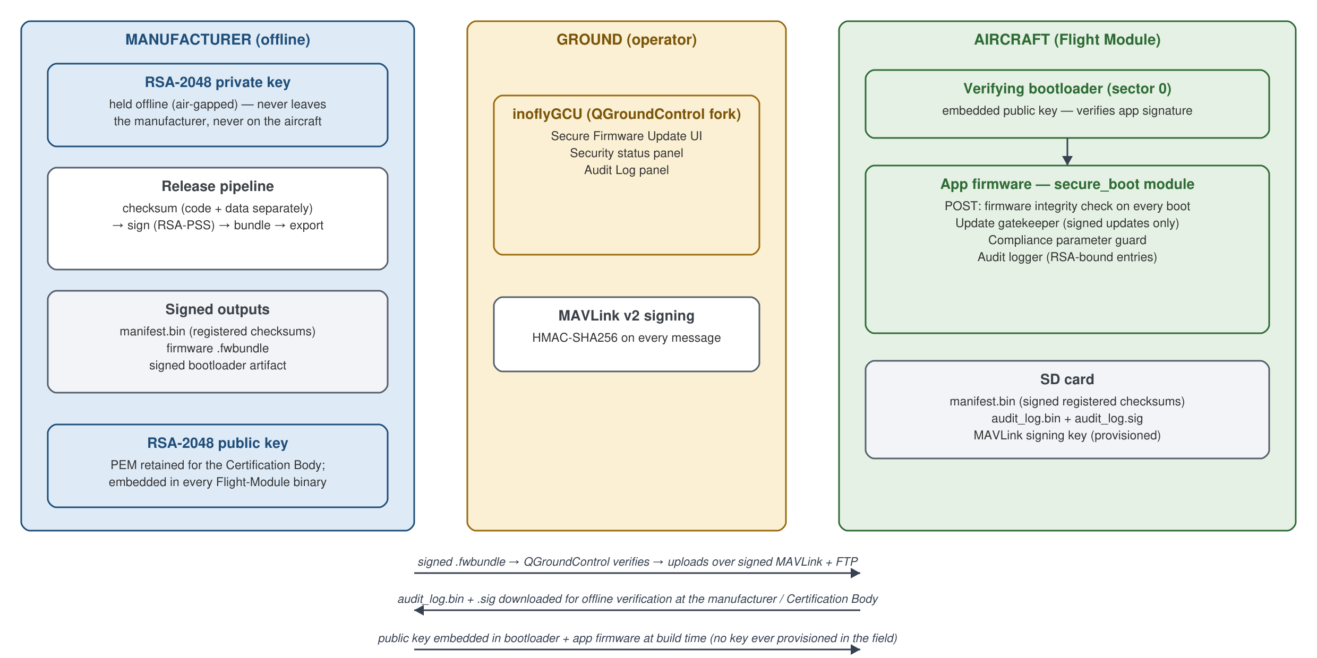
Figure 1 System components and trust boundaries

2.1.1 Registered Flight Module with in-built Key Management
The manufacturer's public key is stored inside the registered flight module only — compiled into the bootloader binary and into the application firmware, both of which live in the microcontroller's internal flash. It is never transmitted at runtime and never held on the ground station, so there is no key in transit to intercept.
The matching private key never leaves the manufacturer's offline signing environment. This asymmetry is the core of the design: the flight module can *check* a manufacturer signature with full confidence, but it carries nothing that could be used to *create* one. Even a completely compromised aircraft cannot sign anything on the manufacturer's behalf.
Key | Where it is held | What it is used for
Private key | Manufacturer, offline — never leaves | Signing firmware images, checksum manifests, update bundles and the bootloader; opening the drone's log signature during verification
Public key | Embedded in the bootloader and the application firmware; a copy is retained for the Certification Body | Verifying every signature on the aircraft; sealing the drone's own security log
Key parameters: RSA-2048 with SHA-256. Every signature in the chain — firmware image, checksum manifest, update bundle, bootloader — uses the RSA-PSS scheme, so there is a single verification mechanism to understand, review and test. The aircraft's own security log is sealed with the same key pair used in the complementary direction: the log's hash is encrypted with the public key, and only the private key can open it (Section 8).

2.2 inoflyGCU Software
A Ground Control Station (GCS) is the ground-based software used to plan missions, configure the aircraft and monitor it in flight. inoflyGCU is our ground control station — a QGroundControl-based application extended with the security functions this certification requires.
Alongside the standard mission planning, vehicle setup and telemetry features, inoflyGCU adds the panels that make the security of the aircraft visible and usable to the operator.

2.2.1 inoflyGCU has following functions:
a) Flight planning and flight view — mission planning, live telemetry, and the standard vehicle configuration screens.
b) Vehicle setup / RPA configuration — sensor calibration, radio setup, flight-mode configuration and the other standard setup steps.
c) Secure Firmware Update — the operator selects a firmware bundle supplied by the manufacturer. inoflyGCU checks its manufacturer signature before anything is sent to the aircraft: a valid bundle is marked VERIFIED and the *Install on Drone* action becomes available; a tampered or unsigned bundle is marked FAILED in red and installation is blocked.
d) Security status panel — shows the result of the aircraft's power-on integrity self-test, including the specific reason if a check failed, so the operator immediately knows why the aircraft will not arm.
e) Audit Log panel — downloads the flight module's security log and its signature file from the aircraft, for offline verification.
f) MAVLink signing (drone pairing) — the operator enters the drone's pairing passphrase once; the ground station then derives the same authentication key the flight module holds. A ground station without the passphrase cannot command the aircraft.
g) Drone details — firmware version and the flight controller's board identifier, shown alongside the live integrity status described above.

2.2.2 OEM Server
Our firmware distribution deliberately does not depend on a network-facing update server. Every release is produced by the manufacturer's offline release pipeline, which generates the code and data checksums, signs the manifest and the firmware image, and packages them into a single signed bundle. That bundle is the only file the customer or operator receives, and it is distributed through the manufacturer's controlled channel.
Security does not rest on how the file is delivered. Because the aircraft independently verifies the manufacturer's signature on whatever it is offered, a bundle that has been altered in transit — by any route, from any source — is rejected by the aircraft itself. Removing the online update server removes an attack surface without weakening any of the guarantees.

3 Firmware Tamper Avoidance

3.1 VERIFICATION OF SECURE BOOT
Compliance criteria: Protection of onboard computer firmware from tampering. UAS should not function if firmware is changed by any procedure other than the authorized update procedure.
Firmware tamper avoidance is implemented as a chain in which each layer is cryptographically verified by the layer above it, so that no unauthorized code can be introduced at any point in the chain.
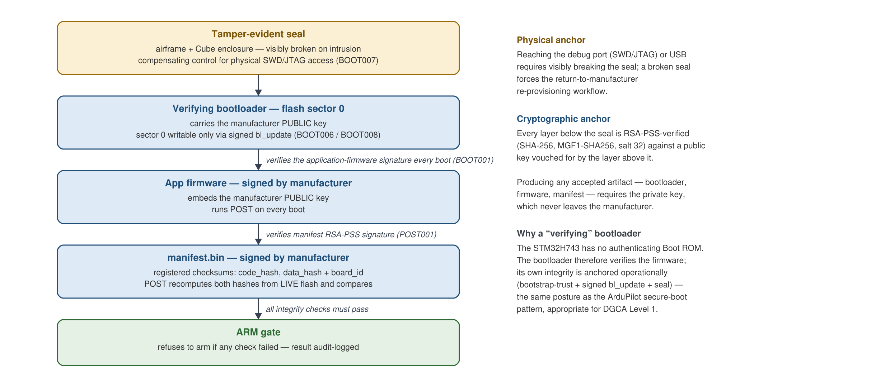
Figure 2 Verification of secure boot — the chain of trust
The methodology followed is:
a) The manufacturer holds an RSA-2048 signing key pair. The private half is kept in an offline signing environment; the public half is published to the Certification Body and embedded in the flight module. For production units the signing identity is adopted from a document-signing certificate issued by a CCA-licensed Certifying Authority, following the same procedure used across the industry.
b) The firmware is compiled with the compliance-critical parameters of the certified drone model built into the binary — maximum altitude AGL, maximum speed, fence range, frame type and frame configuration. Once compiled in, these values cannot be changed from any ground control station by any method (see Section 7).
c) The firmware image is digitally signed with the manufacturer's private key, and its code and data checksums are recorded in a signed manifest.
d) The signed firmware is loaded onto the flight controller. The first-time load is performed at the factory over a direct USB connection as part of the manufacturing procedure.
e) The manufacturer's public key is embedded in the secure bootloader, which is itself installed at the factory as a one-time step and can afterwards only be replaced by a bootloader image that carries a valid manufacturer signature.
f) The bootloader verifies the firmware's signature on every single boot. If the image has been modified by so much as one byte, or was signed by anyone other than the manufacturer, the bootloader refuses to launch it. The aircraft does not run unauthorized firmware — it does not start it at all.
g) Once the firmware is running, it performs a second, independent check: it re-computes the firmware's checksums from the live flash contents and compares them against the registered checksums in the signed manifest (Section 5). Any mismatch blocks arming and is logged.
h) The link between the ground station and the aircraft is authenticated. The flight module accepts commands only from a ground station that holds the drone's pairing key, so an unauthorized ground station cannot connect to the aircraft or attempt to change any critical parameter.
The result is that the only way to place working firmware on the aircraft is to hold the manufacturer's private key — which never leaves the manufacturer.

3.2 FLIGHT MODULE SECURITY
Compliance criteria: Flight Module should have 'Level 0' or 'Level 1' compliance as defined in Annexure E.
The provided solution is Level 1. All secure execution takes place inside the flight module, on the STM32H743 microcontroller of the CubeOrange+ flight controller:
- Signature verification — at boot and at update time — runs on the microcontroller.
- Checksum calculation runs on the microcontroller, over the actual contents of its own flash.
- The sealing of the security log runs on the microcontroller.
There is no separate companion computer. The flight module is a single module, so there is no inter-module link that would need to be protected, and no security-relevant operation ever leaves the microcontroller.

3.2.1 Public Private Key System
The public/private key pair is the foundation of the entire security system. The two halves have deliberately unequal powers:
- The private key can create signatures. It is held only by the manufacturer, offline.
- The public key can only check signatures — it can never create one. This is the half that is embedded in the aircraft.
Because of this, the public key can be distributed freely, including inside every unit shipped, without weakening anything. An attacker who extracts it from a flight module gains no ability to produce firmware, checksums or logs that the aircraft will accept.
The same key pair is used for the firmware, the manifests, the update bundles, the bootloader and the log signature. Using one key pair throughout keeps key management simple and auditable, and means there is exactly one verification routine to review.

3.2.2 Steps for Generating Keys
a) For production, a document-signing digital certificate (RSA-2048) is obtained from a CCA-licensed Certifying Authority. RSA-2048 is specified at purchase, because the flight module's key storage and signature sizes are built around it. The certificate is normally supplied as an exportable PFX file; where a Certifying Authority issues it bound to a hardware token instead, the signing step is performed on the token and the rest of this procedure is unchanged.
b) The public and private keys are extracted from the certificate using standard OpenSSL commands, in the manufacturer's offline signing environment.
c) The private key is retained offline and is used to sign the firmware, the checksum manifest, the update bundles and the bootloader. It is never copied to a build server, a ground station or an aircraft.
d) The public key is embedded into the bootloader and the application firmware at build time, and a copy is retained in PEM form for submission to the Certification Body.
e) The signed firmware, together with its checksums, is released to the customer as a single signed bundle.

3.2.3 Generation of CSR, Keys and Signature
The public key is stored inside the registered flight module only, within the flight controller's microcontroller. This avoids any possibility of the key being tampered with in transit and keeps key handling entirely within the module.
The signing operation itself is performed offline by the manufacturer:
- The SHA-256 hash of the artifact to be signed (firmware image, manifest, update bundle or bootloader) is computed.
- That hash is signed with the private key using the RSA-PSS scheme.
- The resulting 256-byte signature travels with the artifact.
On the aircraft, verification is the mirror image of this: the flight module computes the SHA-256 hash of what it actually received, and uses the embedded public key to confirm that the signature belongs to exactly that hash. A pass proves two things simultaneously — the artifact is byte-for-byte what was signed, and the signer held the manufacturer's private key.

3.2.4 Communication Requirements
Compliance criteria: Flight modules should follow the communication requirement (if applicable) as defined in Annexure E.
The solution offers Level 1 with a single flight module — the flight controller and its security functions are one module, and no companion computer is used. The Annexure E requirement for 128-bit encryption *between* modules therefore does not apply, because there is no inter-module link to protect.
The link that does exist — between the ground control station and the flight module — is authenticated as follows:
- Each drone is assigned a pairing passphrase at manufacture. The flight module derives a 32-byte authentication key from it using SHA-256 and stores that key on the aircraft.
- The operator enters the same passphrase once into inoflyGCU, which derives the identical key.
- Every command message then carries an authentication tag computed with that key. The flight module recomputes the tag on receipt and silently discards any message whose tag does not match.
- A ground control station that does not hold the passphrase therefore cannot command the aircraft over a telemetry link — it cannot produce valid tags, so no other ground control station can be paired with the firmware over the air.
- The setting that makes this authentication mandatory is itself a locked compliance parameter (Section 7) and cannot be switched off at runtime.
The registered setting requires authentication on every link except a direct USB cable connection, which is exempt so that the aircraft can always be recovered and serviced on the bench. This is a deliberate choice and not a gap in the protection: reaching the USB port requires physical possession of the aircraft with its tamper-evident seal broken, which is the same access level the seal exists to make evident. Nothing about the USB exemption weakens the firmware chain — an attacker at the USB port still cannot install unsigned firmware, alter the registered checksums, or move a compliance parameter, because all of those are enforced by signature verification rather than by the link.

3.2.5 Root of Trust
Compliance criteria: FM should have a root of trust mechanism implemented (using, for example, TPM or TEE for Level 1 compliance) which is used to sign the data generated inside the FM.
The root of trust is the manufacturer's RSA-2048 key pair, anchored inside the flight module by embedding the public key in the bootloader and the application firmware.
The Certification Scheme treats a flight module as Level 1 compliant when signing and verification are performed in an environment where host processes and host users have no way to obtain the private key or to inject fraudulent flight logs. Our solution satisfies this by construction, in the strongest available form: there is no private key on the aircraft at all. Nothing can be extracted from a flight module — by its operator, by its user, or by an attacker in possession of the hardware — that would allow fraudulent firmware, checksums or logs to be produced.
All key management and all cryptographic operations take place inside the flight controller's microcontroller. Because the flight module is a single module, no key or hash ever crosses a link between chips, so there is no inter-chip communication to secure. All compliance data generated inside the flight module — specifically its security log — is cryptographically bound to this root of trust (Section 8).
The cryptographic operations on the flight controller are implemented with the libtomcrypt library, which is a standard, well-established component of the flight controller's operating environment.

3.2.6 Verification of Root of Trust
Compliance criteria: The verification key of the root of trust may be recorded and retained. (This key will also be used for verifying the origin of logs generated by the FM.)
All security functions are implemented within the firmware itself — no companion computer and no additional hardware module is added to the aircraft.
The verification key (the manufacturer's public key) is recorded and retained in PEM form and is supplied to the Certification Body for its records. The same key is used to verify the origin of the logs generated by the flight module: the aircraft seals its log with the public key, and only the manufacturer's private key can open that seal (Section 8). A successful verification therefore proves that the log came from a flight module carrying this root of trust.

4 CALCULATIONS OF CHECKSUMS
Compliance criteria: Manufacturer to submit checksums of the firmware to the CB and these checksums may be called 'registered checksums'.
Yes. Every firmware release is processed by the manufacturer's release pipeline, which produces the registered checksums in three forms:
- a human-readable manifest for submission to the Certification Body,
- the same manifest wrapped with the manufacturer's digital signature, and
- a compact binary manifest that is provisioned onto the flight module and read by the aircraft at every boot.
The registered checksum values for a given release are recorded in the build identity sheet that accompanies it, so the values a unit was certified against are always available in documented form. On the aircraft itself the checksums are not exposed as an operator-facing readout — the comparison against live flash is performed by the flight module at every power-on and reported as a pass or fail (Section 5), which is the property that matters operationally.

4.1 Code and Data Separate Checksum
Compliance criteria: Code part and data part checksums to be calculated separately to enable updating of data/parameters in the future easily.
Yes. Two entirely independent SHA-256 checksums are calculated and stored:
Checksum | What it covers
Code checksum | The firmware's executable code region in flash
Data checksum | The compliance-parameter table in flash — the registered values of the certified flight parameters (Section 7)
Keeping them separate means the certified parameter values can be revised in a future release, and re-registered with a new data checksum, without disturbing the code checksum or blurring the distinction between a code change and a parameter change.
The manufacturer's pipeline computes these checksums over exactly the same regions of flash that the aircraft re-computes at power-on, so the value calculated on the host and the value calculated by the aircraft are directly comparable.

4.1.1 Secure Hash Algorithm
Compliance criteria: All the checksums should be calculated using a Secure Hash Algorithm (SHA2 or SHA3).
Yes. SHA-256 — a member of the SHA-2 family, specified in NIST FIPS 180-4 — is used for every hash in the system: the firmware code and data checksums, the digests underlying every signature, the security log hash and the derivation of the ground-station pairing key.
MD5 and SHA-1 are not used anywhere in the chain. This is a standing engineering rule, and the automated test suite asserts SHA-256 explicitly at each point where a checksum is produced or recorded.

4.1.2 Storing Checksum
Compliance criteria: Registered checksums should be stored securely in the flight module such that they cannot be updated without the authorization of the manufacturer.
Yes. The registered checksums are held on the flight module inside the signed manifest, and they are protected by cryptography rather than by concealment — the strength of the protection does not depend on an attacker failing to find the file.
Three mechanisms protect them:
- Manufacturer's digital signature. The manifest is signed with the manufacturer's private key over exactly the fields that matter — the code checksum, the data checksum, the hardware identifier, the firmware version and the release timestamp. Altering any stored checksum invalidates that signature; the aircraft detects this at the next power-on, fails its self-test and refuses to arm. Including the release timestamp inside the signature is what makes the downgrade protection in Section 6 sound: an attacker cannot rewind the date on an otherwise genuine manifest to make old firmware look current.
- Integrity check. A CRC is stored alongside, so accidental corruption is detected and reported distinctly from deliberate tampering.
- A single authorized replacement path. The only way to install a different manifest is a manufacturer-signed firmware update, which the flight module verifies against its embedded public key before accepting (Section 6).
Substituting a manifest signed by a different key fails, because the aircraft trusts only its embedded key. Replaying an older but genuinely signed manifest also fails, because its checksums describe different firmware from what is actually in flash. There is no combination of altered checksums and altered firmware that the aircraft will accept.
Physical access to the microcontroller's debug port is closed separately by a tamper-evident seal applied to the airframe and the flight-controller enclosure during manufacture. Any attempt to reach the hardware directly is visible on inspection, and a unit returned with a broken seal is re-provisioned from scratch before it is allowed to fly again.

4.1.3 Checksum to be signed by CB
Compliance criteria: These registered checksums may be digitally signed by the CB and retained.
Supported. For every release, the manufacturer supplies the code and data checksums to the Certification Body in file form, ready for the Certification Body to digitally sign and retain under its own process. This step is performed by the Certification Body; as the firmware manufacturer we supply the artifacts.

5 POWER ON SELF-TEST

5.1 Implementation of Power on Self-Test
Compliance criteria: Manufacturers should implement a Power On Self-Test (POST).
Yes. A Power On Self-Test is implemented and runs automatically on every power-on. It requires no action from the operator and cannot be skipped.
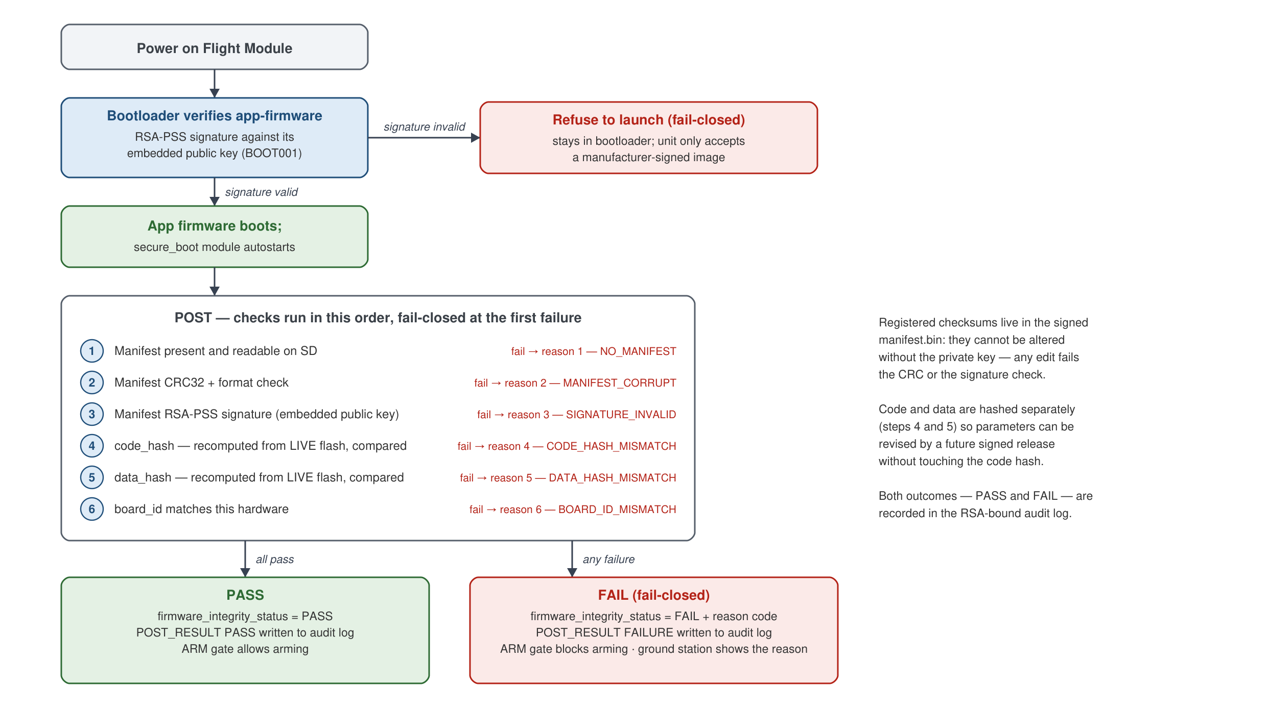
Figure 3 Boot sequence and Power On Self-Test (POST)
The sequence at every power-on is:
- The bootloader verifies the manufacturer's signature on the application firmware before launching it. If the signature does not verify, the firmware is not started at all.
- The firmware then runs its integrity self-test, in a fixed order, stopping at the first failure:
- the registered manifest is present,
- its integrity check (CRC) passes,
- its manufacturer signature verifies,
- the code checksum re-computed from live flash matches the registered value,
- the data checksum re-computed from live flash matches the registered value,
- the manifest belongs to this model of flight controller.
- The result is published to the rest of the system, written to the security log, and used by the arming gate.
Only when all checks pass is the aircraft allowed to arm.

5.1.1 Calculate Checksum on Power on Self-Test
Compliance criteria: It should include calculation of checksums of the firmware (code and data part) and the checksum should be matched with the registered checksum stored in the flight module which was supplied at the time of certification.
Yes. At every boot the flight module re-calculates SHA-256 over the actual contents of its own flash — separately for the code region and for the compliance-parameter data region — and compares each result against the registered checksum held in the signed manifest.
This is real measurement of the real firmware, not a stored value being read back: the microcontroller hashes the same bytes it is about to execute. Two distinct protections therefore apply at every boot — a signature check proves the registered checksums are authentic and could only have come from the manufacturer, and a byte-for-byte comparison proves the firmware in flash matches them.
This behaviour has been validated on the actual CubeOrange+ hardware, including cases where a correctly signed manifest carried a deliberately incorrect checksum; the aircraft detected the discrepancy and refused to arm.

5.1.2 Logging Results
Compliance criteria: The result of the POST should be logged.
Yes. Every self-test writes a result entry to the security log held on the aircraft's SD card. Both outcomes are recorded — passes as well as failures — so the log is a continuous record of the aircraft's integrity state rather than only an exception report.
Each entry carries a timestamp, a sequence number, the result and, where applicable, the specific reason for failure, and each entry is individually integrity-protected. The log file as a whole is signed after every write (Section 8).

5.1.3 Prevention from mismatch checksum
Compliance criteria: Mismatch of checksum should prevent the UAS from booting and be logged.
Yes. On any self-test failure the aircraft is rendered non-functional: arming is blocked. The operator is shown a pre-flight failure message stating that the firmware integrity check failed, the aircraft will not arm, and it therefore cannot take off or fly. The failure is written to the security log with a distinct reason code identifying which check failed, and is displayed in the inoflyGCU security panel.
By design, the flight module boots far enough to report and log the failure rather than halting silently. A module that stopped without a word could neither log the mismatch — which this same clause requires — nor tell the operator why the aircraft is refusing to fly. "Prevent the UAS from booting" is therefore implemented as "prevent the UAS from operating," which is the interpretation applied in practice.
Where the firmware image itself has been tampered with, the stricter behaviour also applies literally: the bootloader refuses to launch it, and the aircraft genuinely does not boot.

5.2 TESTING OF FIRMWARE PROTECTION

5.2.1 Attempting and testing firmware with unauthorized keys
Compliance criteria: Attempt to modify the firmware (code and data) in an unauthorized manner. The firmware update should fail. In case the firmware gets updated in an unauthorized manner, then verify that the UAS fails the POST. Test to be conducted in presence of the CB.
Yes — demonstrated, and repeatable in front of the Certification Body. Each unauthorized route was attempted deliberately on real hardware and each was blocked:
Attack attempted | Layer that blocked it | Observed result
Load a tampered firmware bundle from the ground station | inoflyGCU signature check | Signature FAILED (red); the install action is disabled; nothing is sent to the aircraft
Push a corrupted update manifest directly onto the aircraft | Flight module update gate | Update REJECTED with an integrity-failure reason; failure entry written to the security log
Present an update signed with a non-manufacturer key | Flight module signature check against the embedded public key | Update REJECTED with a signature-failure reason; failure entry written to the security log
Alter the registered checksums stored on the aircraft | Power On Self-Test | Self-test FAILED, arming blocked, failure logged
Firmware modified anyway, with a validly signed but non-matching manifest | Self-test checksum comparison | Self-test FAILED, arming blocked, failure logged
Flash an unsigned or modified firmware image | Secure bootloader | The bootloader refuses to launch the image
Attempt to replace the bootloader with an unsigned one | Signed bootloader-update gate | Refused before any part of the bootloader is erased
The ground-station check before flashing and the flight-module check against the embedded public key together implement exactly the mechanism the Certification Scheme describes: the flight module verifies the hash and the signature using the public key it holds, and only then is firmware flashing permitted.

6 SAFETY AND SECURITY OF FIRMWARE UPDATE
A firmware update is treated as an untrusted input until it has proved itself, and it must prove itself three separate times, to three independent components.
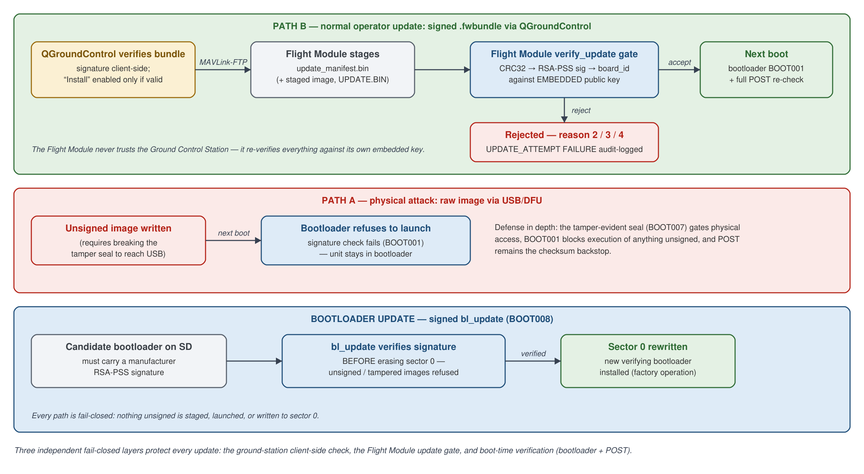
Figure 4 Firmware update paths — each one independently gated
The workflow is:
a) The manufacturer produces the new firmware, with any revised parameter values compiled in.
b) The release pipeline computes the new code and data checksums and produces a new signed manifest.
c) The firmware image, the manifest and the checksums are packaged into a single manufacturer-signed bundle. This bundle is the only file the customer receives.
d) The operator loads the bundle in inoflyGCU, which verifies the manufacturer's signature before offering to install it.
e) On install, the flight module verifies the update independently — it does not trust the ground station's verdict. It re-checks the integrity, the manufacturer signature and the hardware identifier, and it binds the new manifest to the new firmware image by re-computing the image's checksums itself, so that a genuine manifest cannot be paired with a different image.
f) An update whose manifest is older than the one currently registered is refused, preventing an attacker from forcing a downgrade to superseded firmware.
g) The new image is written only after the bootloader has re-verified its signature, and the write is performed in a way that survives a power loss mid-update: if power is lost, the update resumes and completes on the next power-on rather than leaving the aircraft in a broken state.
h) At the next boot the registered checksums are updated to the new values only if the firmware actually in flash matches them.
i) Every update attempt — accepted or rejected — is recorded in the security log.
Current delivery status of the two routes. The security properties described in this section are implemented in the flight module and have been proven on CubeOrange+ hardware: verification at every gate, hash-binding, downgrade refusal, application of the new image, activation of the new registered checksums at the following boot, and unattended recovery from a power cut mid-write. The manufacturer/service route — where the signed image and manifest are placed on the aircraft's SD card and the update is applied — is validated end to end. The operator route through the ground station, which uses the same aircraft-side gates and the same signed bundle, is complete on the aircraft side and its bundle verification is proven. No part of the security model depends on which route is used: the aircraft applies the identical checks either way.

6.1 SECURE UPGRADE TEST

6.1.1 Update with Digital Certificate
Compliance criteria: The update should be permitted only if it is signed by the manufacturer's digital certificate.
Yes. A firmware update is permitted only when it carries a valid manufacturer signature. Verification happens at three independent layers, and every one of them fails closed — that is, when in doubt they refuse rather than proceed:
- At the ground station. inoflyGCU verifies the bundle before allowing installation. An unsigned or tampered bundle is shown as FAILED and cannot be installed; nothing is transmitted to the aircraft.
- On the aircraft. The flight module independently re-verifies the update against the public key embedded in its own firmware, before accepting anything.
- At boot. Even if both earlier layers were somehow bypassed, the bootloader checks the firmware's signature on every boot and refuses to launch unsigned firmware, and the self-test provides the checksum backstop behind it.
The bootloader itself is held to the same discipline: a replacement bootloader is signature-verified before any part of the existing bootloader is erased.

6.1.2 Authenticity of Update
Compliance criteria: UAS should be able to verify the authenticity of the update by verifying it with the public key of the manufacturer.
Yes. All verification on the aircraft is performed against the manufacturer's RSA-2048 public key compiled into the firmware and the bootloader, using RSA-PSS with SHA-256.
Verification is not a comparison of two stored secrets — it is a one-way mathematical check. The flight module computes the SHA-256 digest of what it actually received and applies the public-key operation to the signature; the scheme confirms whether that signature binds exactly that digest. A pass proves both that the update is byte-identical to what was signed and that the signer held the manufacturer's private key.
Interoperability between the manufacturer's signing tools and the verification code running on the flight controller has been proven on the actual hardware.

6.1.3 Recording Changes
Compliance criteria: Firmware change should be recorded in the logs.
Yes. Every update attempt writes an entry to the security log on the aircraft — recording whether it succeeded or was rejected and, when rejected, the reason. The log itself is signed (Section 8), so these records cannot be quietly removed or edited afterwards.
inoflyGCU additionally shows the outcome of the installation on screen and displays the live stream of security events in its Audit Log panel.

6.1.4 Update Checksum
Compliance criteria: After the UAS is upgraded, the registered checksum should be updated in the flight module securely.
Yes. Each signed release carries its own signed manifest containing the new registered checksums. During the update, that manifest replaces the one held on the aircraft — but only after the flight module has verified its manufacturer signature, so the registered checksums can never be changed by an unauthorized party.
The new checksums are activated at the following boot only if the firmware actually present in flash matches them and the manifest is not a downgrade. From that point on, the self-test verifies the updated firmware against the updated registered checksums. If anything does not agree, the aircraft keeps the previous known-good state rather than accepting an inconsistent one.
This complete flow — verify, apply, survive power loss, and activate the new checksums on the next boot — has been demonstrated end to end on CubeOrange+ hardware.

6.1.5 Signing Checksum by CB
Compliance criteria: The checksums of the updated firmware (code and data) to be digitally signed by the CB and retained.
Supported. For every release — the initial certified build and every subsequent update alike — the code and data checksums are furnished to the Certification Body in a form ready for it to digitally sign and retain. This action is performed by the Certification Body.

7 SECURE CHANGES OF FLIGHT PARAMETERS
Every drone model has specifications, and several of them are critical from a compliance perspective. In the delivered solution these parameters are compiled into the signed firmware binary itself and are covered by the registered data checksum. They cannot be moved away from their certified values from any ground control station, by any method.
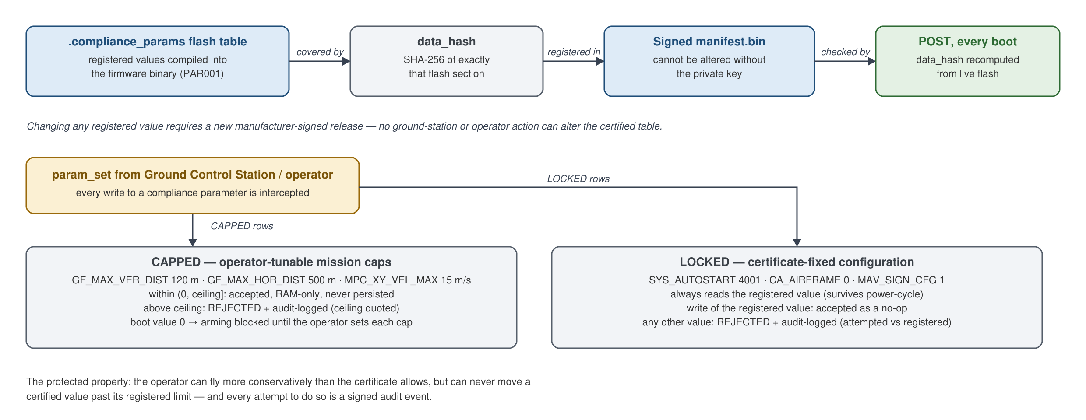
Figure 5 Compliance parameter protection
The protection works in four ways:
1) The certified values are statically defined when the firmware binary is built, not stored in an editable settings file.
2) The parameter table is covered by the data checksum and therefore by the manufacturer's signature. Any change to it is detected at the next power-on and blocks arming.
3) The flight module rejects an out-of-policy write at the moment it is attempted and records it in the security log, so the attempt is visible immediately and not only at the next boot.
4) The ground station link is authenticated, so an unauthorized ground station cannot connect to the aircraft to attempt a change in the first place.
The protected parameters fall into two categories:
Parameter | Type | Registered value | Meaning
Maximum altitude (AGL) | Ceiling | 120 m | The operator may fly lower, never higher
Fence range | Ceiling | 500 m | The operator may set a smaller fence, never a larger one
Maximum speed | Ceiling | 15 m/s | The operator may fly slower, never faster
Airframe model | Locked | Certified model | Fixed by the type certificate
Frame configuration | Locked | Multirotor | Fixed by the type certificate
Ground station authentication | Locked | Required | Message authentication cannot be switched off
- Ceilings exist because a mission genuinely needs an altitude or a speed appropriate to the task. The operator may set any value up to and including the certified limit, for the current flight only — the value is never written to permanent storage and is gone at the next power-on. A value above the limit is rejected outright, with the certified ceiling named in the message, and the attempt is logged. Until each of these has been deliberately set for the flight, the aircraft will not arm, so a certified ceiling can never be exceeded by accident or by omission.
- Locked parameters are not safety margins but statements of what was certified. They always read their registered value. Any attempt to write a different value is rejected and logged. The certified configuration cannot be moved.
Changing a *registered* value — the ceiling itself, or a locked value — is possible only through a new manufacturer-signed firmware release, which is precisely the authorized process the Certification Scheme requires.

7.1 TESTING OF PARAMETER UPDATE

7.1.1 Authenticity of Update
Compliance criteria: UAS should be able to verify the authenticity of the update by verifying it with the public key of the manufacturer.
Yes. The only way to change a registered parameter value is to issue a new firmware release. Doing so changes the compliance-parameter table in the binary, which changes the data checksum, which produces a new signed manifest — and that manifest is verified by the flight module against the manufacturer's embedded public key before it is accepted.
Any other route to a changed parameter value — editing the firmware, editing the parameter table, editing the stored checksums — fails the power-on self-test and blocks arming.

7.1.2 Recording changes
Compliance criteria: Change should be recorded in the logs.
Yes. Every rejected attempt to move a compliance parameter is recorded in the aircraft's signed security log as a blocked parameter change, naming the parameter concerned. The value the operator attempted and the registered limit are reported on the live console at the moment of rejection; the log deliberately records the event and the parameter rather than the numeric values, which keeps every entry a fixed size and guarantees no entry is ever truncated.
The mission values actually flown within the certified ceilings are captured in the aircraft's flight telemetry log, which is the authoritative operational record at audit time.

7.1.3 Update Checksum
Compliance criteria: After the UAS is upgraded, the registered checksum should be updated in the flight module securely.
Yes. A parameter revision is a firmware update, so it follows exactly the same secure path described in Section 6.1.4: a new signed manifest carrying the new data checksum is verified by the flight module before it replaces the previous one, and the new registered checksums take effect only if the firmware actually in flash matches them.

7.1.4 Signing Checksum by CB
Compliance criteria: The checksums of the updated firmware (code and data) to be digitally signed by the CB for their records.
Supported. The code and data checksums for every release, including parameter revisions, are furnished to the Certification Body for signing and retention under its own process.

7.1.5 Update parameters
Compliance criteria: Try to update the parameters that affect compliance conditions using the manufacturer's standard operating procedure. The parameter should remain unaffected.
Yes — demonstrated live. Attempting to set a locked parameter to any value other than its registered value is rejected, and reading the parameter back shows it still holds the registered value. Attempting to set a ceiling parameter above its certified limit is rejected, with the limit named in the error message.
Saving the parameters and power-cycling the aircraft confirms that nothing has persisted: the locked values are unchanged, and the ceiling parameters return to their unset state and must be deliberately set again before the aircraft will arm.

7.1.6 Failing update with invalid signature
Compliance criteria: Try to update the parameters in the firmware that affect compliance conditions using an invalid digital signature. The update should fail.
Yes — demonstrated live. A firmware image carrying modified parameter data but an invalid signature — or a signature made with a key that is not the manufacturer's — is rejected at every layer: at the ground station the bundle shows as FAILED; on the aircraft the update is rejected with a signature-failure reason; and if such an image were placed in flash by any other means, the power-on self-test fails and arming stays blocked.

8 LOG FILE SIGNING – ADDITIONAL
Compliance criteria: All binary logs should be signed using public key and they should get validated using private key when required.
Yes. The flight module maintains a security log on its SD card and seals it cryptographically, so that any later alteration is detectable offline.
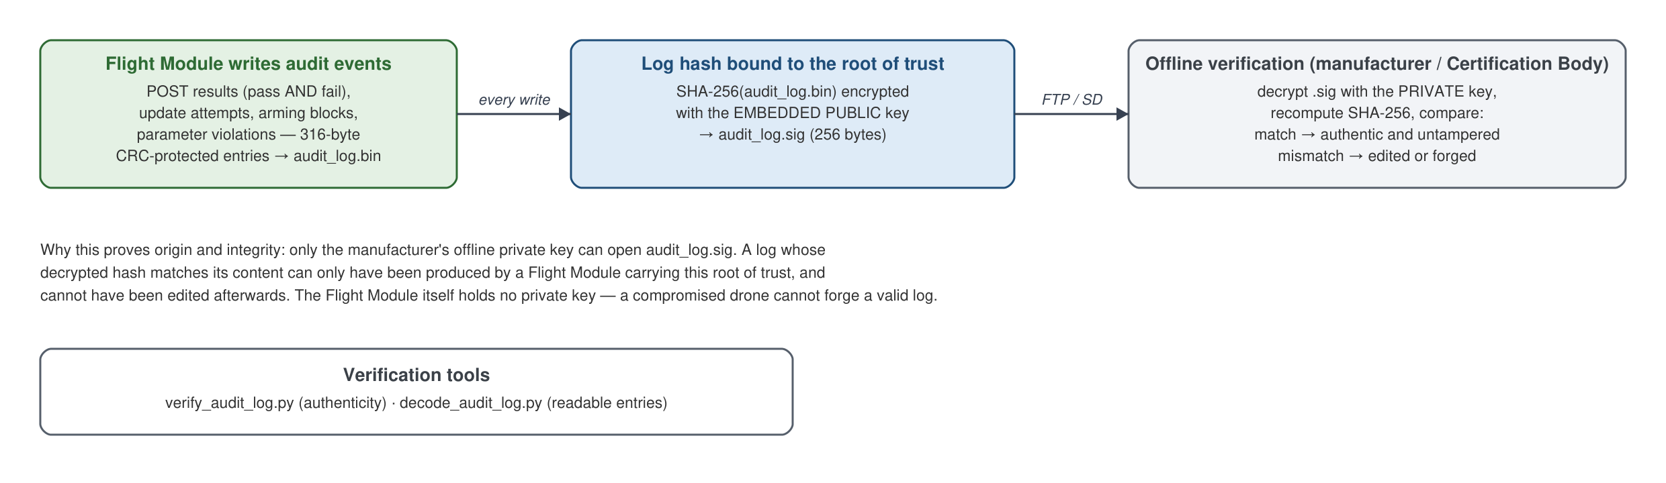
Figure 6 Log signing on the aircraft and offline verification
How it works:
- The flight module writes fixed-size, individually integrity-protected entries to the log. The events recorded are the ones that matter for compliance: power-on self-test results (both passes and failures), firmware update attempts, the outcome of applying a staged update at the following boot, blocked arming attempts, and rejected changes to compliance parameters.
- After every write, the flight module computes the SHA-256 hash of the entire log file and encrypts that hash with the embedded public key, storing the result as a companion signature file next to the log.
- To verify, the log file and its signature file are downloaded from the aircraft — either through the inoflyGCU Audit Log panel or directly from the SD card.
- Offline, the manufacturer opens the signature with the private key and compares the recovered hash against a freshly computed hash of the log file. A verification tool performs this and reports the result. A second tool renders the binary log in human-readable form, with timestamps, so the events can be read directly.
Why this proves both origin and integrity. Encryption with the public key can be undone only with the private key. So when the manufacturer's private key successfully opens the signature and the recovered hash matches the log, two facts are established at once: the log was produced by a flight module carrying this root of trust — its origin — and not one byte of it has changed since the flight module sealed it — its integrity.
Because the flight module holds no private key, neither a compromised aircraft nor anyone who obtains the SD card can re-seal an edited log. An altered log will always fail verification.

