1. Add the mysql jar in server lib/mule folder

2. Add the mule-cluster.properties file in the .mule folder of server

3. Run studio in cluster mode

**Below are tables created as per the application. There are 2 Object store so 2 partition tables.**

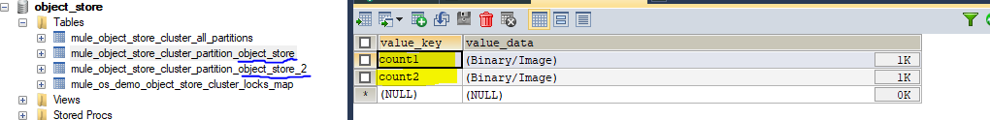

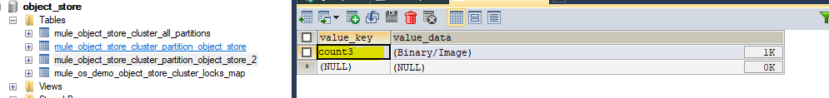

**Same below name is part of table created in DB.**

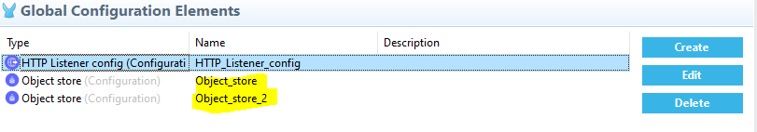

**Keys are created in DB table value as binary file**

