Project Report P1-navigation

Aim was to solve the Banana collection environment to collect an average reward of 13 in 100 subsequent runs

Student:

Rahul Kaplesh

Course:

Deep Reinforcement learning Nanodegree by Udacity

# Challenge 1

In this challenge an agent must be developed to collect the bananas on an environment which returns the state as a vector space.

Three methods were used to solve this challenge. Their results are as follows:

# Double DQN

In this method a double layered deep Q Network was used to train the agent. Agent maintained a target Q Network and a local Q Network. Local Q Network was used to make predictions, but the target Q Network was used for training the weights of the model. The parameters for the local Q Network was translated to the Target Q Network using a factor tau. The training notebook can be found in the “DoubleDQN/ DoubleDQNFromEx.ipynb”. The agent definition is in the file “DoubleDQN/agent.py”. The model definition is found in “DoubleDQN/model.py”.

Model summary:

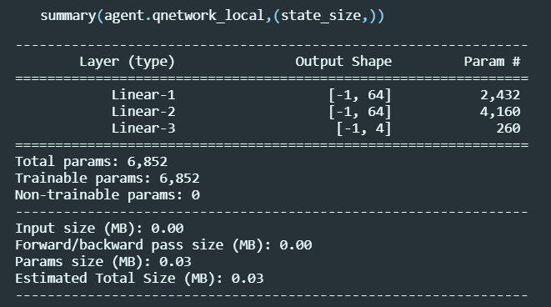

Results:

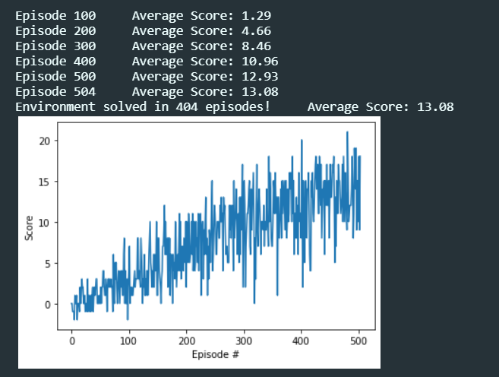

Experiments gets trained in 504 episodes.

# Double DQN

This is like the double DQN except the model is a fully connected and deeper layered network. The training notebook can be found in the “DoubleDQN_moreFCLayers/ DQN3Layers.ipynb”. The agent definition is in the file “DoubleDQN_moreFCLayers/agent.py”. The model definition is found in “DoubleDQN_moreFCLayers/model.py”.

Model summary:

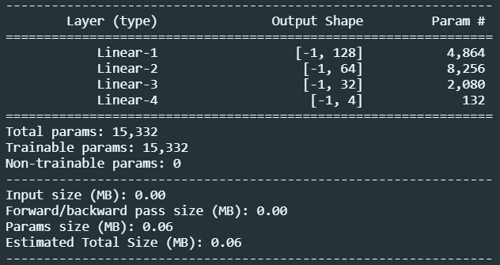

Results:

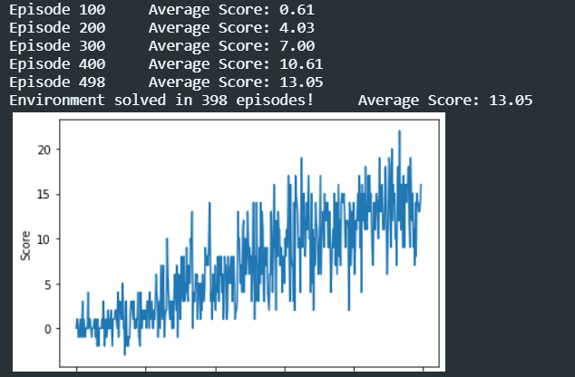

Agent gets trained in 498 episodes.

# Double DQN With Exp Replay

This is like the double DQN, but the experiences used for training the model are selected based on temporal difference error and biases. The training notebook can be found in the “DoubleDQN4LayersExpReplay/ ExperienceReplay.ipynb”. The agent definition is in the file “DoubleDQN4LayersExpReplay/agent.py”. The model definition is found in “DoubleDQN4LayersExpReplay/model.py”.

Model summary:

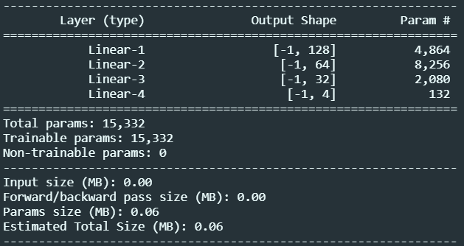

Results:

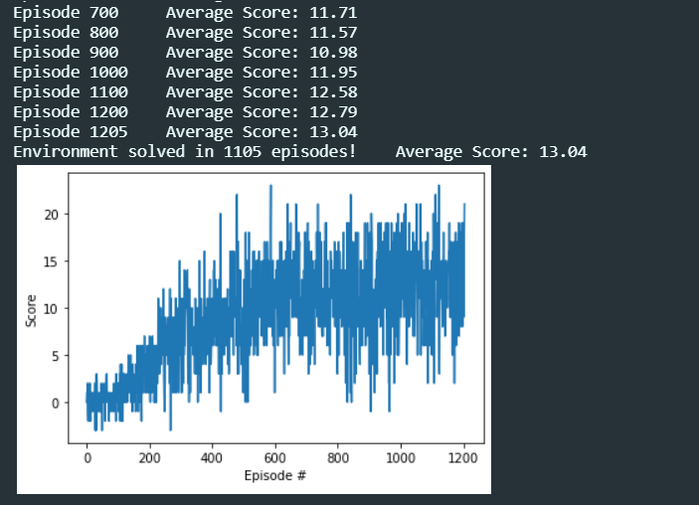

Agent gets trained in 1205 episodes. This training is very slow maybe a faster implementation of this method can be explored.

# Double DQN With Dueling Network

This is like the double DQN, but the state value is also computed using another similar neural network. The training notebook can be found in the “Dueling_NN_DQN/ Duelling_NN_DQN.ipynb”. The agent definition is in the file “Dueling_NN_DQN/agent.py”. The model definition is found in “Dueling_NN_DQN/model.py”.

Model Summary:

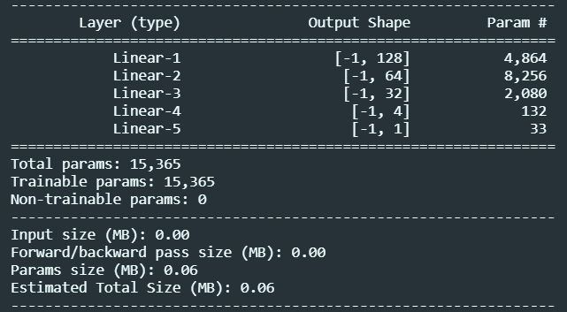

Results:

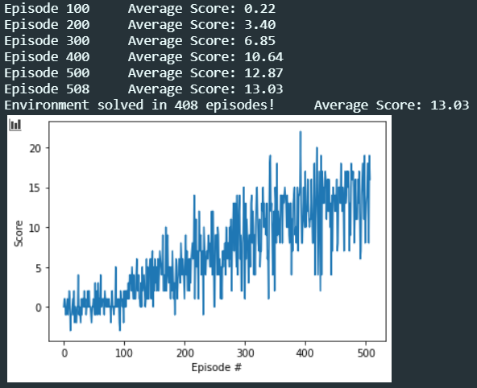

Agent gets trained in 508 episodes.

Final observations:

* A normal DQN with more layers is a better model for this environment

# Challenge 2

In this challenge an agent must be developed to collect the bananas on an environment which returns the state as a RGB image of what the agent is looking at. I reduced the reward which the agent needs to attain for this challenge to 12.

State was built as frame comprising of 4 such images and was passed to a neural network implementing a 3d convolution to extract features info from a stack of frames. These features were used for then estimating the agent actions. State space as captured from environment:

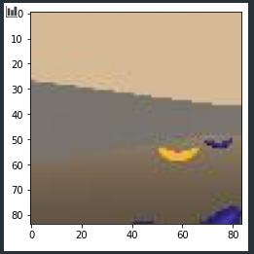

Model summary:

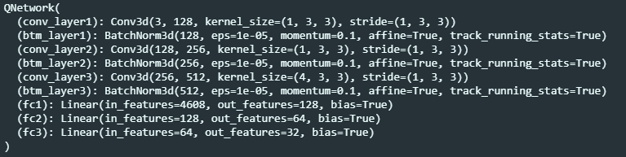

A deep Q Network with the above-mentioned architecture was chosen for the above problem.

Results:

# Further Work

Further work can be done at improving the neural network to extract the features out of the video. The implementation of experience replay is very slow in executing, this can be improved. Other techniques for implementing deep Q Networks can also be explored.

## Subtitle ut labore et dolore magna

|  |  |  |
| --- | --- | --- |
| * Lorem ipsum dolor sit amet, consectetur adipiscing elit * Sed do eiusmod tempor incididunt ut labore et dolore magna aliqua. Ut enim ad minim veniam, quis nostrud exercitation ullamco laboris nisi ut aliquip ex ea commodo consequat. * Duis aute irure dolor in reprehenderit in voluptate velit esse cillum dolore eu fugiat nulla pariatur. |  | * Nemo enim ipsam voluptatem quia voluptas sit aspernatur aut odit aut fugit, sed quia consequuntur magni dolores eos qui ratione voluptatem sequi nesciunt. * Neque porro quisquam est, qui dolorem ipsum quia dolor sit amet, consectetur, adipisci velit, sed quia non numquam eius modi tempora incidunt ut labore et dolore magnam aliquam quaerat voluptatem. |

# Heading 04 adipiscing elit

|  |  |  |
| --- | --- | --- |
| Subtitle lorem ipsum |  | Subtitle dolor sit amet |
| Sed ut perspiciatis unde omnis iste natus error sit voluptatem accusantium doloremque laudantium, totam rem aperiam, eaque ipsa quae ab illo inventore veritatis et quasi architecto beatae vitae dicta sunt explicabo. Nemo enim ipsam voluptatem quia voluptas sit aspernatur aut odit aut fugit, sed quia consequuntur magni dolores eos qui ratione voluptatem sequi nesciunt. |  | Neque porro quisquam est, qui dolorem ipsum quia dolor sit amet, consectetur, adipisci velit, sed quia non numquam eius modi tempora incidunt ut labore et dolore magnam aliquam quaerat voluptatem. Ut enim ad minima veniam, quis nostrum exercitationem ullam corporis suscipit laboriosam, nisi ut aliquid ex ea commodi consequatur? |
| Subtitle consectetur |  | Subtitle adipiscing elit |
| But I must explain to you how all this mistaken idea of denouncing pleasure and praising pain was born and I will give you a complete account of the system, and expound the actual teachings of the great explorer of the truth, the master-builder of human happiness. No one rejects, dislikes, or avoids pleasure itself. |  | Nor again is there anyone who loves or pursues or desires to obtain pain of itself, because it is pain, but because occasionally circumstances occur in which toil and pain can procure him some great pleasure. To take a trivial example, which of us ever undertakes laborious physical exercise, except to obtain some advantage from it? |

Sed ut perspiciatis unde omnis iste natus error sit voluptatem accusantium doloremque laudantium, totam rem aperiam, eaque ipsa quae ab illo inventore veritatis et quasi architecto beatae vitae dicta sunt explicabo.

# Heading 05 Lorem Ipsum

Lorem ipsum dolor sit amet, consectetur adipiscing elit, sed do eiusmod tempor incididunt ut labore et dolore magna aliqua. Ut enim ad minim veniam, quis nostrud exercitation ullamco laboris nisi ut aliquip ex ea commodo consequat. Duis aute irure cupidatat non proident, sunt in culpa qui officia deserunt mollit anim id est laborum.

Sed ut perspiciatis unde omnis iste natus error sit voluptatem accusantium doloremque architecto beatae vitae dicta sunt explicabo. Nemo enim ipsam voluptatem quia voluptas sit aspernatur aut odit aut fugit.

# Heading 06 Sit Amet

|  |  |
| --- | --- |
| Lorem ipsum dolor sit amet, consectetur adipiscing elit, sed do eiusmod tempor incididunt ut labore et dolore magna aliqua. Ut enim ad minim veniam, quis nostrud exercitation ullamco laboris nisi ut aliquip ex ea commodo consequat. Duis aute irure dolor in reprehenderit in voluptate velit esse cillum dolore eu fugiat nulla pariatur. Excepteur sint occaecat cupidatat non proident, sunt in culpa qui officia deserunt mollit anim id est laborum.  Sed ut perspiciatis unde omnis iste natus error sit voluptatem accusantium doloremque architecto beatae vitae dicta sunt explicabo. Nemo enim ipsam voluptatem quia voluptas sit aspernatur aut odit aut fugit, sed quia consequuntur magni dolores eos qui ratione voluptatem sequi nesciunt. |  |