NetraJyoti AI
High-Level Design (HLD) | MVP architecture and future controlled AI option
Scope note: the core MVP is a deterministic, Bengali-first guidance and navigation system. Agent, MCP, Skills and Model capabilities below are post-MVP controlled-pilot options; they are not enabled in core safety routing.

1. Architecture principles
Principle | Design implication
Safety before automation | Reviewed Java rules alone select URGENT, ROUTINE or HUMAN_SUPPORT.
Bengali-first access | React PWA supports large bilingual controls, Bengali voice/text options and graceful browser fallbacks.
Privacy by design | Patient details are optional, local to the message composition flow and not routing inputs.
Resilience | Loss of AI, service lookup, location, speech or sharing must never block approved guidance.

2. Core MVP logical architecture
Layer | Component | Responsibility
Experience | React + TypeScript PWA | Bengali-first user journey, local workflow state, share/copy and progressive browser capabilities.
Application | Java 21 + Spring Boot REST API | Input validation, feature flags, content resolution, API security and safe error handling.
Safety domain | Deterministic Java safety-rules module | Classifies fixed reviewed inputs into urgent, routine or human-support outcomes.
Data | PostgreSQL + Spring Data JPA | Stores reviewed rule versions, approved content, service-directory data, flags and non-identifying audit events.
Operations | Coordinator workflow | Maintains reviewed care-service and eye-camp information with ownership and verification metadata.
Core flow: User PWA -> REST API -> reviewed safety rules -> approved result content -> care-navigation and share actions.
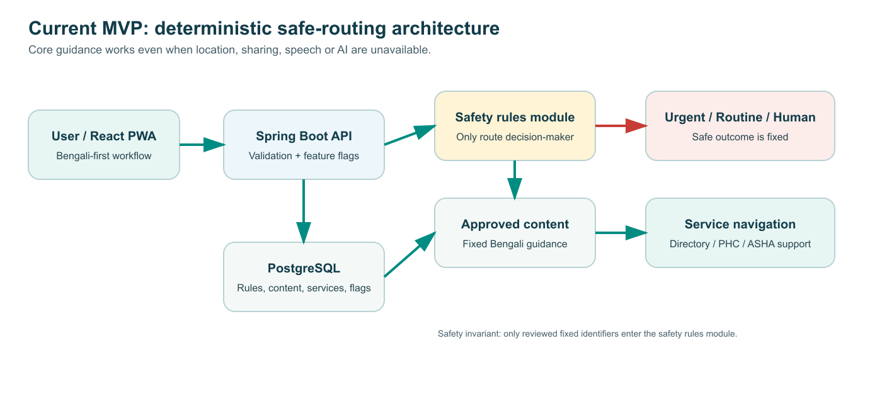

3. Current safety boundary
Only fixed, reviewed warning-sign identifiers determine the route. Free text, speech recognition, selected location, patient details, service-directory results, AI output and client-side UI logic cannot change urgency.

4. Future-state AI architecture (Post-MVP / controlled pilot)
The future option is downstream of completed deterministic routing. It may be introduced only through a feature flag and only after clinical/content review, privacy approval, usability testing and output evaluation.
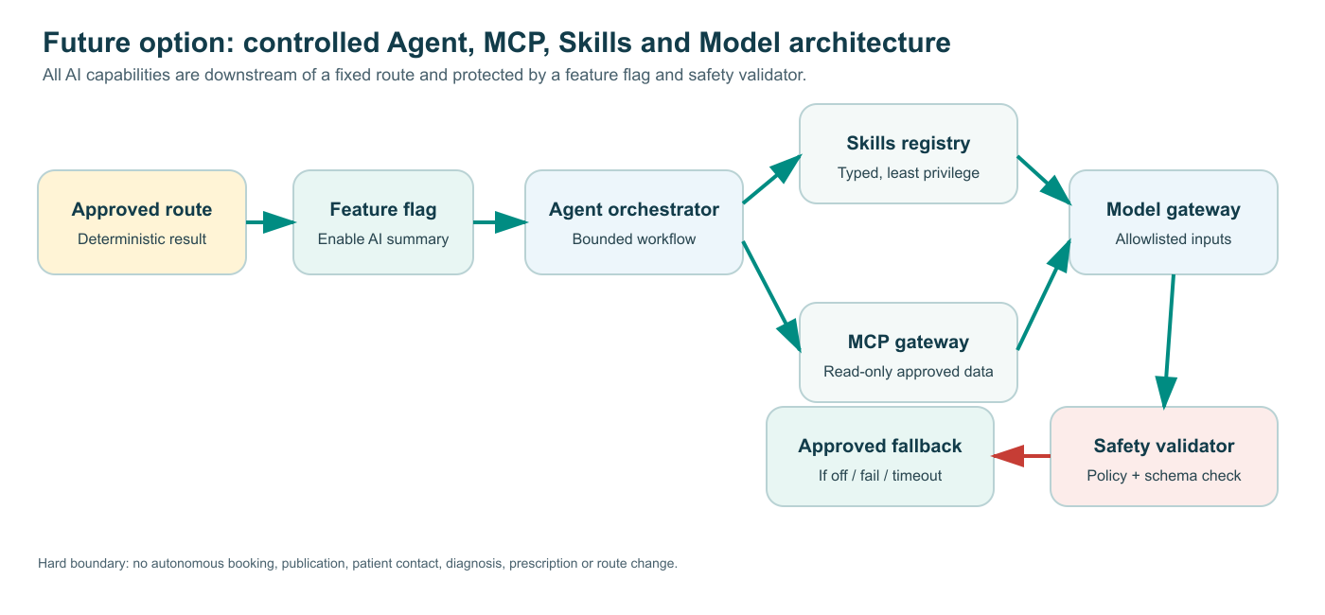
Sequence | Component | Role | Boundary
1 | Approved route and content | Provides fixed route, symptom labels and next-step content. | No model call occurs before the route is fixed.
2 | Feature flag | ENABLE_AI_SUMMARY enables the optional workflow. | Off by default; returns approved Bengali fallback when off.
3 | Agent orchestrator | Runs a bounded workflow: retrieve approved content -> call permitted skill -> validate -> show output. | No autonomous planning, messaging, booking or route change.
4 | Skills | Typed functions for Bengali summary formatting, translation, verified directory retrieval, coordinator drafting and data-quality checks. | Each skill is versioned, tested, least-privilege and cannot diagnose/prescribe/publish.
5 | MCP gateway | Server-side, allowlisted connection to a read-only verified service directory or approved content store. | No unapproved connector, browsing source, write action or direct client access.
6 | Model gateway | Produces an optional plain-Bengali summary from allowlisted approved inputs. | No raw voice, PII, precise location or unconstrained medical prompt.
7 | Safety validator | Checks schema, language, approved action, no diagnosis/prescription/route override/invented service. | Failure, timeout or policy violation returns approved fallback.
8 | Human review queue | Reviews coordinator drafts and service-data quality flags. | No autonomous publishing or care-service modification.

5. Future agent and MCP flow
Deterministic routing -> approved content resolver -> feature flag -> bounded agent -> allowlisted skills and optional read-only MCP retrieval -> model -> safety validator -> reviewable Bengali output OR approved Bengali fallback.

6. Security, privacy and governance controls
Control | Required implementation
Model and connector access | Backend-only credentials in secret manager; no API key in PWA; allowlisted endpoints/tools and scoped server identities.
Input minimisation | Only route/result code, approved symptom labels and approved next-step content may reach the model; consented data only where independently approved.
Auditability | Store correlation ID, rule/content version, feature flag, skill/MCP identifier, latency, validation decision and fallback status; omit PII and raw prompts by default.
Human oversight | A named owner approves prompts, models, skills, connectors, service records and content releases; every change has a rollback path.
Failure-safe behaviour | AI or MCP failure cannot interrupt routing, care guidance, share/copy or human-support navigation.

7. Deployment view
Zone | Current MVP | Future controlled-pilot addition
Public edge | React PWA on Vercel, Netlify or equivalent HTTPS host. | No model credential or MCP access exposed to browser.
Application | Spring Boot API on managed platform with Spring Security and validation. | AI gateway, agent orchestrator, skill registry, validator and audit service.
Data | Managed PostgreSQL for governed rules, content and service directory. | Prompt/skill/connector registry metadata and non-identifying evaluation/audit data.
External | Optional browser location/share/speech capabilities. | OpenAI model endpoint and approved read-only MCP service-directory/content connectors.

8. Implementation sequence and acceptance gates
Phase | Deliverable | Gate
MVP | Deterministic routing, approved Bengali content, care navigation, fallback and PWA. | All reviewed rules pass; no AI can influence route.
Controlled summary pilot | Feature-flagged caregiver summary from approved result content. | Clinician/content review, privacy review, Bengali output evaluation, failure fallback tests.
Retrieval and coordinator pilot | Verified-directory MCP retrieval, coordinator draft and data-quality skills. | Partner data source, freshness owner, audit logs, read-only scope and human approval workflow.
Future expansion | Governed conversational navigation assistance and aggregate analytics. | Measured user value, accessibility, bias/privacy assessment, incident process and rollback plan.
HLD decision: Agent, MCP, Skills and Model are assistive, bounded and downstream of reviewed deterministic routing. They can add access and operational value, but they cannot diagnose disease, prescribe treatment, alter urgency, autonomously book care, contact users or publish service changes.

