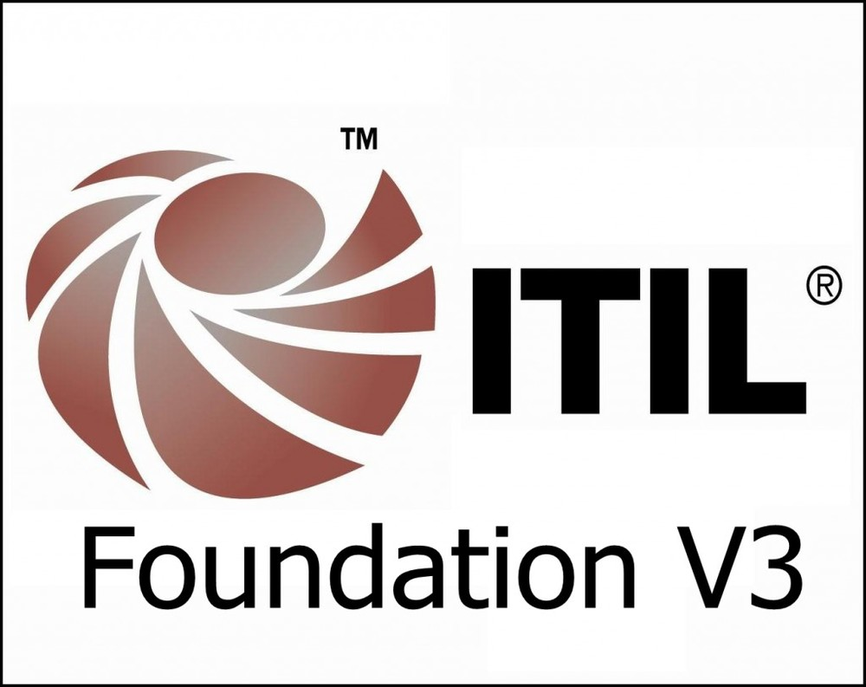
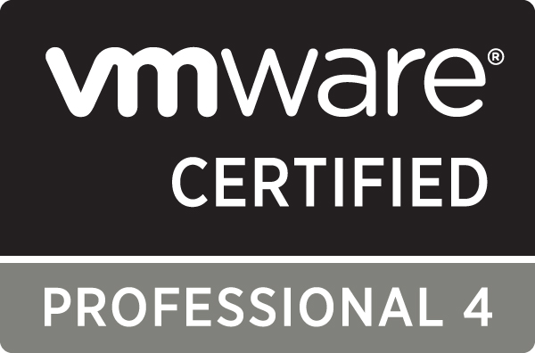


RAHUL M. KHATAVKAR

 Email ID - rahul.khatavkar@gmail.com Mobile No. 9423506853/9011799404

Objective:
To become a successful IT professional in the System Administration/Networking sector of the IT industry.
- Operations managements
- Client Relationship Management
- Transitions/Migrations Managements
- Team Recruitments
Certifications and Rewards:
Microsoft Certified Professional (70-270) | 2010
HP Certified Workstation “Expert” | 2006 - 2007
VSphere 4.1 Certified | 2011
ITIL Foundation Certified | 2015
SCCM 2007 authorized training | 2012
Pursuing AWS Certified SysOps Administrator-Associate | 2017
Received Certificate of Merit from Mphasis | For the Month of March 2011, Aug 2011, June 12, Dec 12, Aug 13
GS Lab (Sept 2018 to Till Date)
Role:– Lead Software Engineer
Process : Avaya (Wintel P5 Support)
- Maintaining SLA of 99.999% for major equipment’s deployed in Dubai Lab
- Perform the role of Incident manager/Recovery manager/Situation manager in critical incidents.
- Handling the CAB meetings and validating necessary changes.
- RCA Writing as per request.
- Currently Individual contributor and will build the teams as per new Lab’s setup
- Learning and working on Openstack (Queens) setup.
- Working on VMware Environment.
- Playing major role in service transitioning.
- Daily interaction with Dubai client for day to day tasks, project transitioning, SCRUM meetings.
- Strongly Follow ITIL practice for day to day activities and critical changes, incidents, Problem management.
Systems Plus Technologies Pvt. Ltd. (June 2016 to Aug 2018)
Role:–NOC Lead
Process : CEC Entertainment (Wintel P5 Support)
- Perform the role of Incident manager/Recovery manager/Situation manager in critical incidents.
- Handling the CAB meetings and validating necessary changes.
- RCA Writing as per request. Setup the process for team and educate them for new process updates.
- Working on Service Now and other tools integration.
- Working on VMware Horizon 7 for Client VDI's.
- Pool creation, entitlement for particular member or group.
- Troubleshoot VDI OS issues or recompose VDI’s.
- Handling P1 P2 calls.
- Engage all the necessary teams to get issue resolved within provided SLA.
- Leading the team of 17 people including Windows, SQL DBA, Network professionals.
- Experience working in SCRUM atmosphere.
- Task allocation to the team as per business requirements.
- Playing major role in service transitioning.
- Daily interaction with US client for day to day tasks, project transitioning, SCRUM meetings.
- Strongly Follow ITIL practice for day to day activities and critical changes, incidents, Problem management.
- Stand Alone Hyper-V management across the 525 Stores.
- Setup VMware Horizon VDI access for Users.
- Maintaining SLA of 99.999% for major equipment’s deployed in various Stores across the US.
- Handling escalations, new projects, new work assignment.
- Handling\Monitoring Solarwinds S&A tool, Cisco Meraki portal for switch managements.
- Install and configured Cisco IMC Supervisor monitoring tool.
- Working on EMS portal for VOIP Phones registrations.
- Basic troubleshooting on Fortnet D420 Firewall for WAN related issues.
- Azure basic administration
- Working on Office 365 for DL creations and managing users.
Mphasis Ltd. (Aug10 to June 2016)
Role:–Windows System Administrator\ Lead Infrastructure Engineer
Process : East Hub Wintel/Symantec/BMS (Wintel P5 Support)
- Strongly Follow ITIL practice for day to day activities and critical changes, incidents, Problem management.
- Working on Escalated, Severity one/two tickets in Vitalize tool. Maintaining SLA of 99.999% for GOLD and Platinum servers.
- Working with a team of support professionals, looking at escalations, new projects, work assignment.
- Provide 99% of patch management SLA for Wintel server.
- RCA Writing as per request.
- Working on Vitalize, HP Service Manager 9, Service now, Service Center (Peregrine 6.1), HP Digital Workflow, GEL/GBM /I-Task etc. ticketing systems.
- Monthly Patching server through HPSA/SCCM Console.
- Raise HP/Dell case for hardware replacement and take follow up on the same.
- On-call support, support 24X7, Recovery calls, Client meetings. Project discussions.
- Successfully implemented disaster recovery exercise for critical applications and servers in coordination with Network, backup and Server teams.
- Server certify/qualify through various tools like HP torque etc..
- Decommission of old hardware and installation of new Virtual machines in test and production environment.
- Clone, VMotion the VM’s as and when required.
- Resolve ESX Hardware cases with site support or vendor support.
- Assist team members with complex issues and escalations.
- Upgrade servers with latest patches, Antivirus updates and core application updates using SCCM link or manually.
- Implementation of DR activity as part of the yearly DR testing for servers.
- Co-ordinate with various client support teams for queries on vulnerabilities and track successful remediation.

Role:–Windows System Administrator\ Sr. Infrastructure Engineer (Technical Lead)
Process : RBS TSG (Transaction Support Group)
- Key Team Player for 2nd line Support to Royal Bank of Scotland (RBS).
- Project Management (Create Project Brief, MPP) and execution (Test Document).
- Basic SQL Query to get result from SQL Server.
- Done application functional, regression testing and implement in Production.
- As per customers requirement done changes in application with the help of vendor.
- Gaining a thorough understanding of the system architecture to be able to provide support to customers,
in production, DR and in User Acceptance Testing.
- Working with the level-3 development and application support teams to quickly diagnose and resolve
issues as they arise.
- Supporting account-management to ensure that customer issues are addressed and communicated in a
timely fashion.
- Attend Change Management and Change Approval Board (CAB) meetings.
- Handling Recovery Calls for Severity 2/3 incident.
- Remote support through Genesys/Netsupport/SMS console and HP Virtual Room Tool.
- Remotely access more than 50 Windows NT/2000/2003 servers (Production, QA, DR).
- On-call support.(12X7),Recovery calls, Client meetings. Project discussions.
- Working on Service Center (Peregrine 6.1), HP Digital Workflow, GEL/GBM /I-Task etc. ticketing systems.
- Worked on Decommission process of the Application Servers.
- Maintaining and upgrading the environment by implementing change requests.
- Liaising with customers and suppliers to implement and support customer and supplier data connections.
- Diagnosing a large variety of problems and taking responsibility for an issue all the way through to
resolution.
- Liaising with customers to support data delivery and processing on a daily basis.
- Experienced in managing Windows Server NT, 2000, 2003. 2008, 2012 versions
- Experienced in server migration and Server consolidation
- Well versed with ITIL process.
- Coordinate application migration
- Create requests with various teams to co-ordinate changes
- Providing general support to staff both within the office and those who work remotely
K-Air Gases : (June, 09 to April,10)
Company URL: http://www.k-airgas.com/
Role: Windows System Administrator
- Created and Managing Linux based firewalls (Centos).
- Analyzing system logs and identifying potential issues with computer systems.
- Windows Patching using WSUS.
- Introducing and integrating new technologies into existing environments.
- Performing routine audits of systems and software.
- Adding and configuring new workstations/ notebooks/servers/ network printers
- Applying operating system updates, patches, and configuration changes.
- Installing and configuring new hardware and software.
- Adding, removing, or updating user account information, resetting passwords, etc.
- Answering technical queries.
- Responsibility for security.
- Troubleshooting any reported problems.
- Ensuring that the network infrastructure is up and running.
- Troubleshoot and Install software’s on MAC PC and notebooks for higher level management.
GSG Telco (January, 08 to June, 2009)
Company Profile: Global Sourcing Group is the premier multi-shore telecommunications analytics company offering Business Intelligence reports and Outsourcing services that enable enterprises to rapidly reduce their telecom and associated overhead costs. It works in the field of Telecom Audit.
Role: Windows Ass. System Administrator
- Heading the team of 5 engineers.
- Installation of VMware Guest operating system on standalone machine.
- Take a data backup of fileserver using Windows Server 2003's backup utility.
- Giving recommendations for new equipment and services to purchase. Management of different
vendors for Procurement.
- IIS and MY SQL 2000/2005 Installation and basic troubleshooting for IT Team.
- Windows Patching using WSUS
- Creating users on third party web based email server and managing users group.
- Having hands on experience on ticketing tools (Quickbase, ManageEngine Service Desk)
- Maintaining & managing fileserver by Creating User Privileges.
- Installed and managing Norton Antivirus Server and client environment.
- Regular Backup of different servers like Fileserver, DC, ADC on tape drives.
- Implementation of Linux based firewall (Web based CentOS and IP Cop).
- Windows Servers, Client OS & Linux Installation.
- Executed VOIP installation.
- Rack redressing and assembly.
- Designing and implementation of network infrastructure.
- Troubleshoot and Install software’s on MAC PC and notebooks for higher level management.
- Installation & maintenance of different software’s and hardware’s.
Cybernet IT Pvt. Ltd (July, 2006 to December, 2007)
Company Profile: Cybernet IT is an authorized HP Products and service provider company.
Role: Sr. Service Engineer
- Heading the team of 8 engineers.
- Handling the daily reports (call management of engineers) to generate a weekly departmental report.
- Installation and Troubleshooting of workstations & servers.
- Installation of Wireless Devices.
- Data Recovery from laptops and desktops for corporate clients.
- Handling AMC of deferent clients.
- Handled MMF India Pvt. Ltd.& MIT School basic infrastructure installation successfully.
- Done Altiris Deployment Solution software Installation connected with Linux base 50 Thin clients.
- Assembling, Troubleshooting and Maintenance of various types of Desktop PCs, Notebooks and Servers.
- Installation, Configuration and Driver setup of various types of Hardware components such as SCSI cards, Dial-Up Modems, Network Interface Cards, DAT drives, Printers, ZIP drives, etc.
- Installation, Configuration and Driver setup of various types of Image processing devices such as Scanners, Web Cams, Digital Cams etc.
- Partitioning, Formatting and Installation of Operating System as per requirement.
- Worked on various types of Branded Systems such as HP, Dell, IBM etc.
Cognizant Technology (December, 2005 to July, 2006)
Company Profile: Cognizant is a leading provider of information technology, consulting and business process outsourcing services. With more than 35 global delivery centers and over 55,000 employees, combine a unique onsite/offshore delivery model infused by a distinct culture of customer satisfaction.

Role: Facility Management Support Engineer (Windows) (On Role of CMS)
- Installation and configuration of various software, setting up Network Printing facilities and other peripheral devices.
- Configuration MS Outlook & troubleshooting outlook related problems.
- Installation of LINUX and basic troubleshooting.
- Administering and Troubleshooting Windows XP computers using external tool.
- Providing helpdesk services for users.
- Installation & Configuration of network Printers
- Basic Troubleshooting of Operating System Problems
- Windows Patching using WSUS
- Image deployment using Alteris server and Symantec Ghost

Education :

Degree | University | Year of Passing
Diploma in Computer Management | Shivaji University | April, 2005
B.Com | Shivaji University | April, 2002
H.S.C. | Pune Board | March, 1997
S.S.C. | Pune Board | March, 1994

Personal Details:
Name | Rahul M. Khatavkar
Date of Birth | 23/03/1979
Passport Number | G7247012
Email ID | rahul.khatavkar@gmail.com
Contact Number | 9423506853
  Address | Flat No. A-302, Sun Sapphire Socity, Shinde wasti, Behind Magarpatta city, Hadapsar, Pune – 411028.

