**Write a Streaming Analytics job to read raw data from Event Hubs , transform it and store back to Azure Synapse Analytics (i.e. Azure Datawarehouse)**

**Prerequisite:**  
1) Azure Synapse Analytics

2)Streaming Data

**Workflow:**

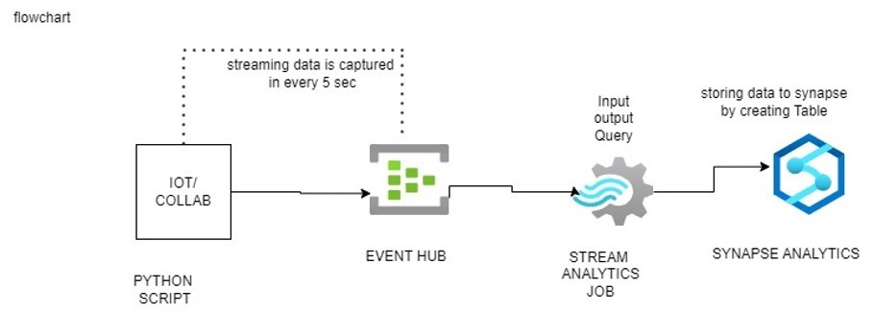

**In this demo we will create:**i)Generate sample python code to get streaming data and send it to Azure Event Hubs.

ii)Create a Stream Analytics job.

iii)Configure job input and output

iv)Query to ingest data into Azure Synapse Analytics dedicated pool.

V)Test and start the job

vi)Check data in dedicated SQL pool.

**End-to-end flow**

Create your event hub namespace and Navigate to your **Event Hubs namespace**

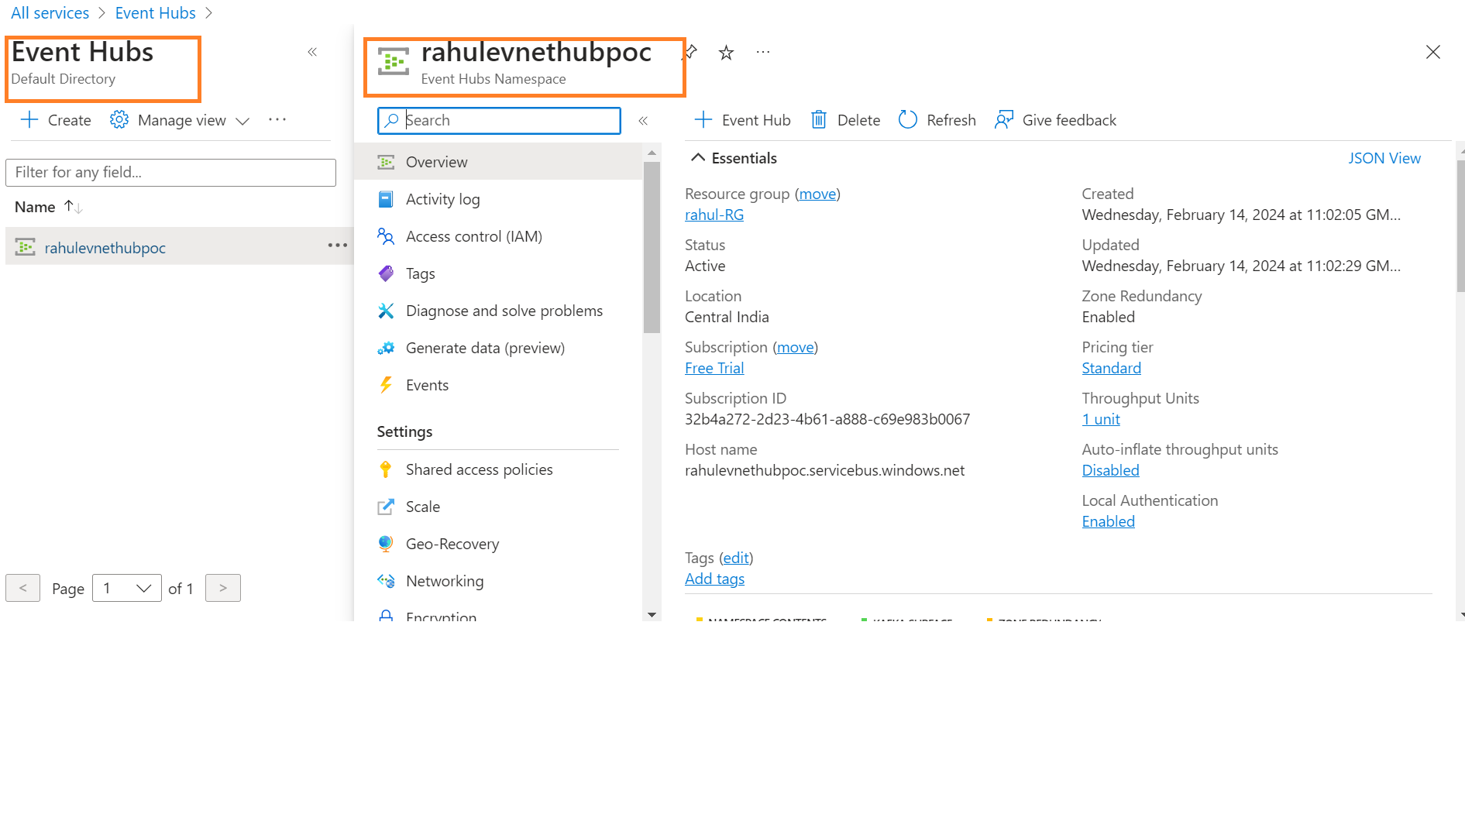

Once you have created an Event Hub namespace, you can then create an Event Hub inside that namespace.

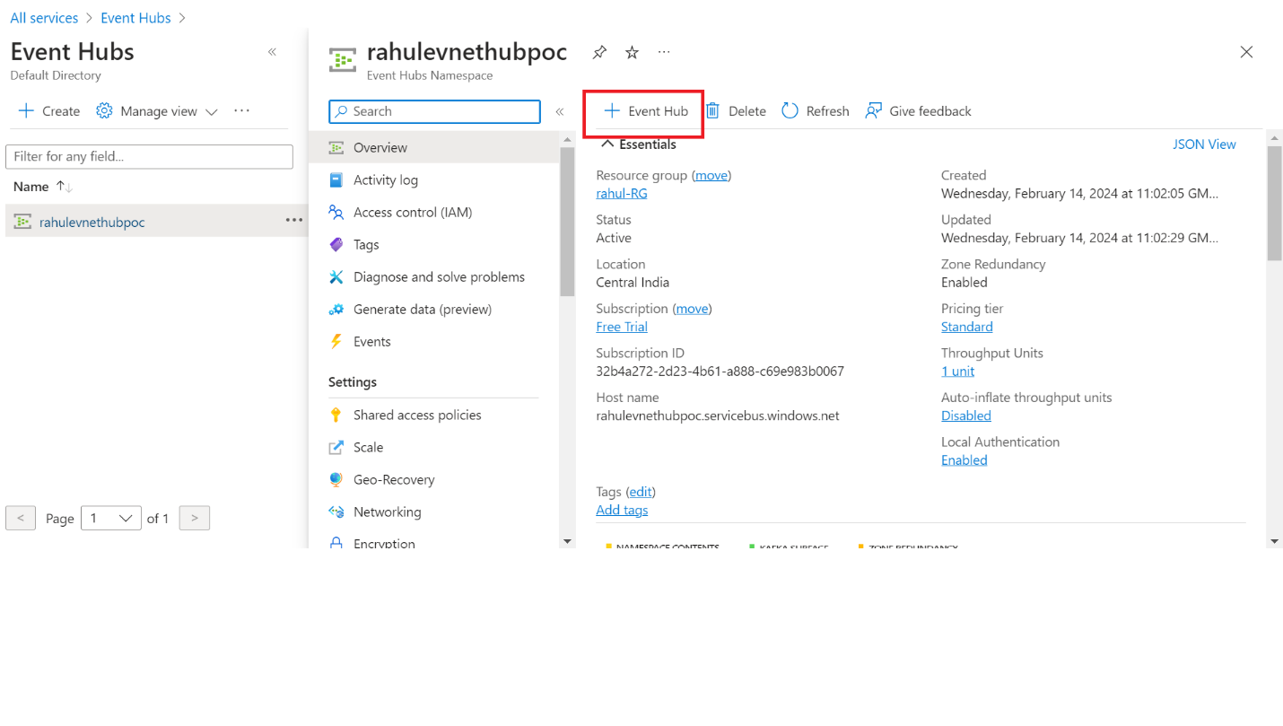

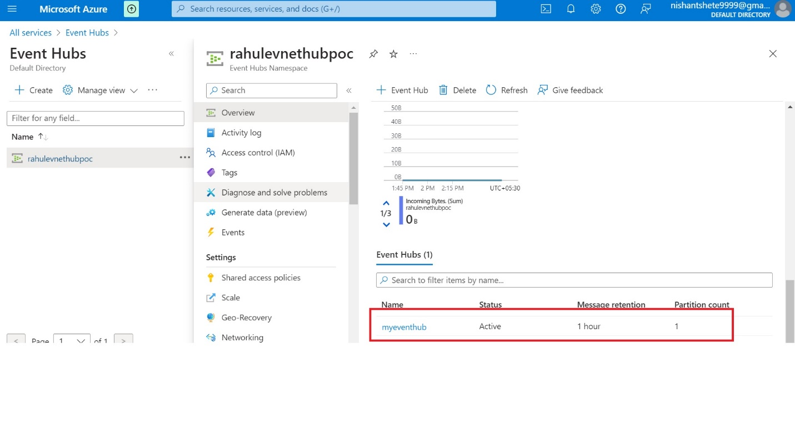

Next, we will need to grant the application or simulator, which will run on our desktop or system, the permission to send data to the event hub. To do this, open your event hub, click on "Shared access policies," and add your SAS policy name.

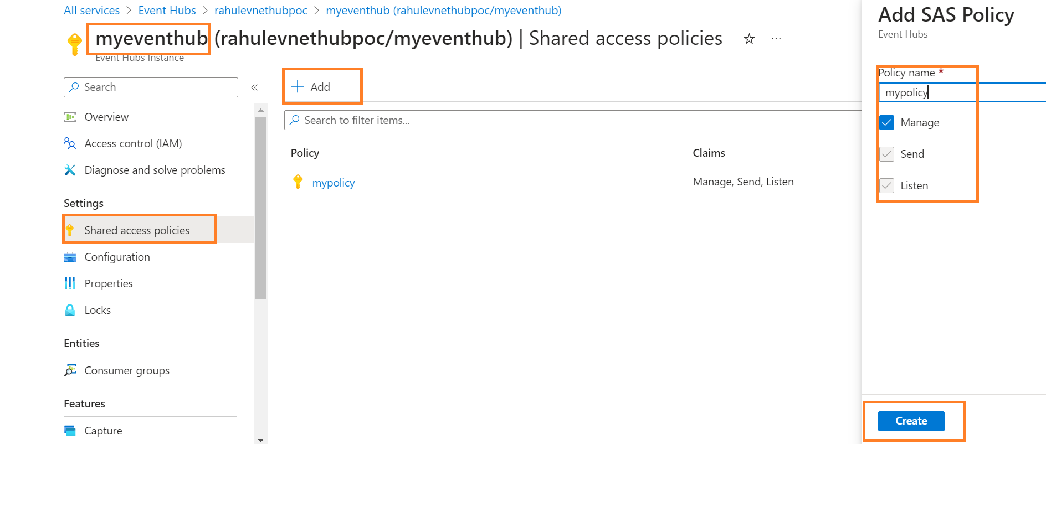

**Create a Stream Analytics job**

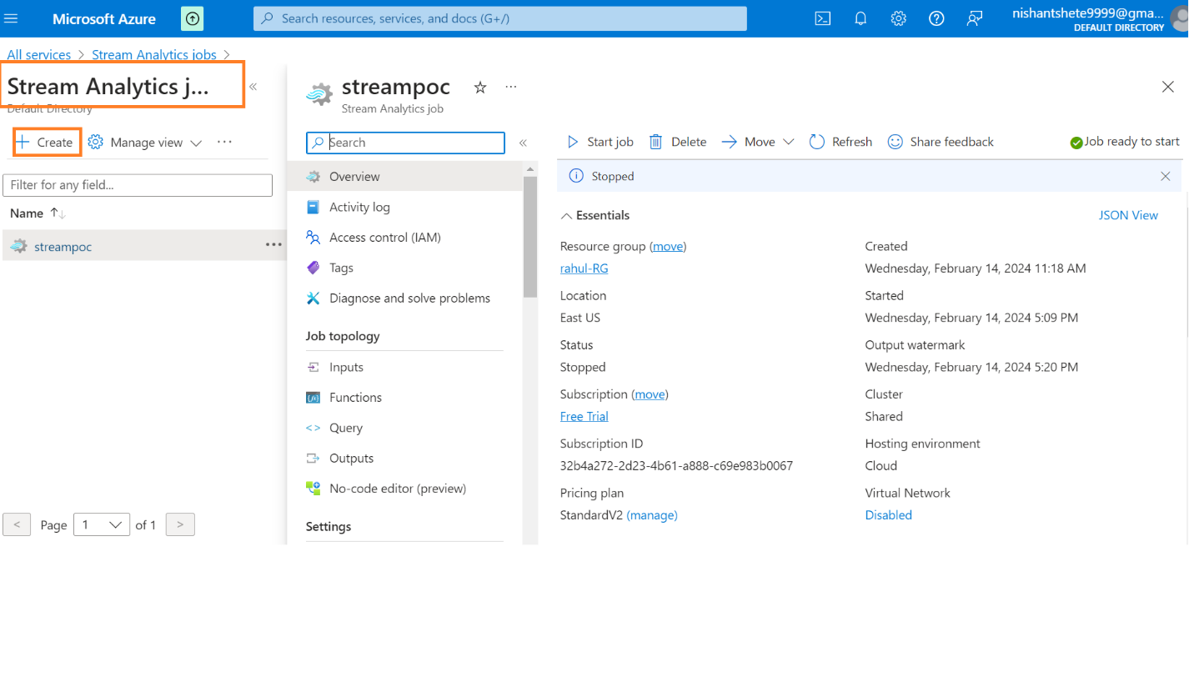

**ii) Create a Stream Analytics Job:**

• Open the Azure portal and navigate to the "Stream Analytics jobs" section.

• Click on "New" to create a new Stream Analytics job.

• Provide a name for the job, select the Azure subscription, choose the resource group, specify the region, and click on "Create" to initiate the job creation.

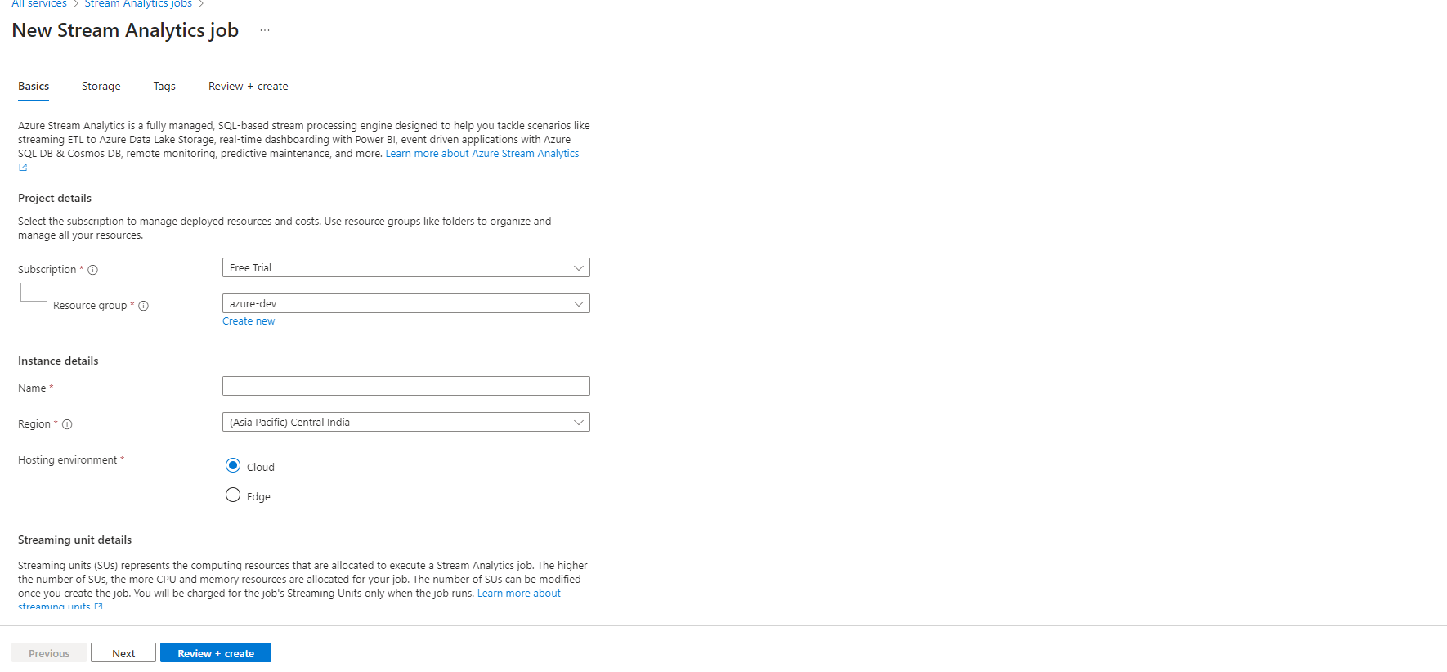

**Configure job input and output**

**Input:**

Azure Stream Analytics jobs connect to various data inputs. For this demo, we are using an Event Hub as an input.

In the Stream Analytics job, click on "Inputs," select Event Hub, provide the necessary details, and click on "Save."

Verify the successful creation of the input.

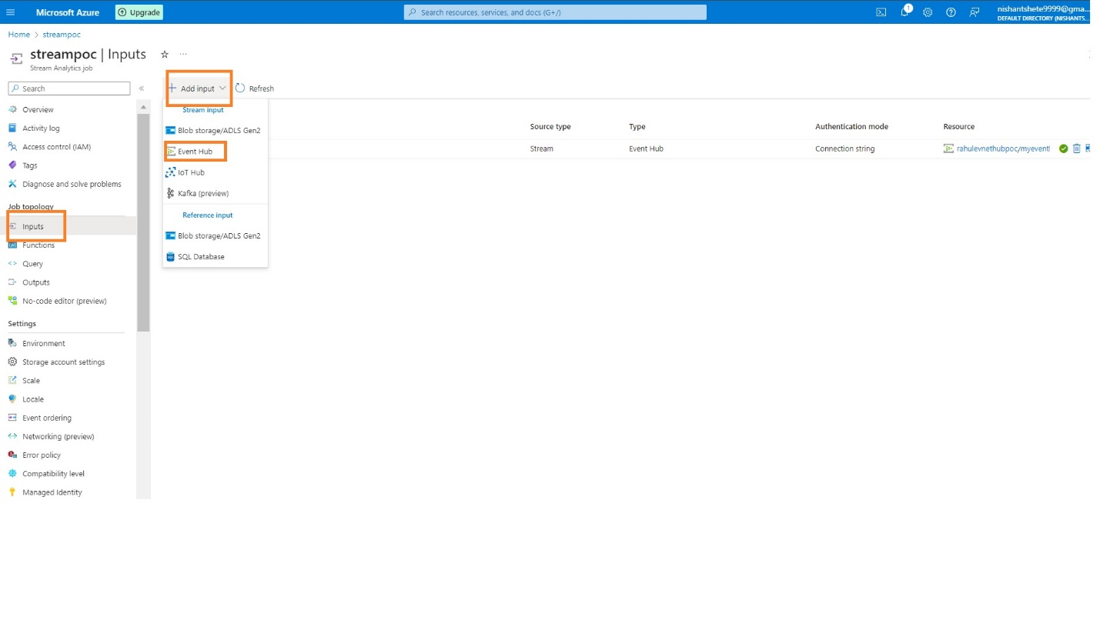

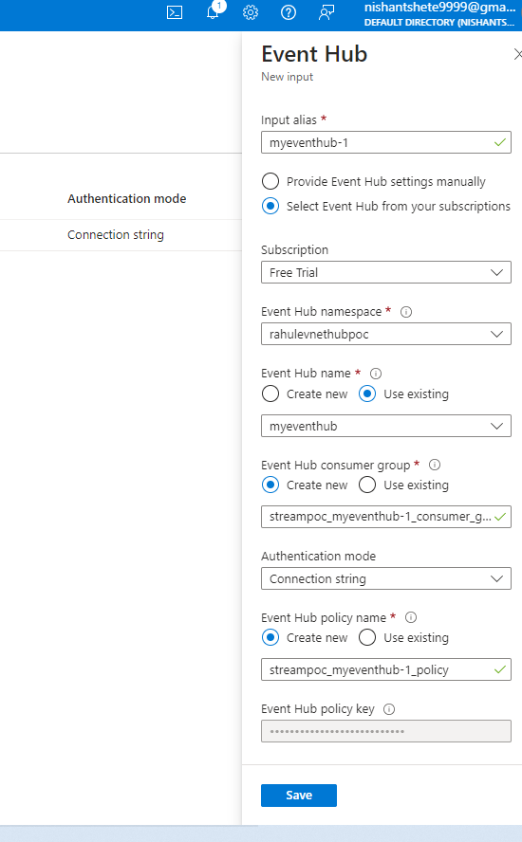

Once you have created an input, you need to check the connection to verify whether the input was successfully created or not.

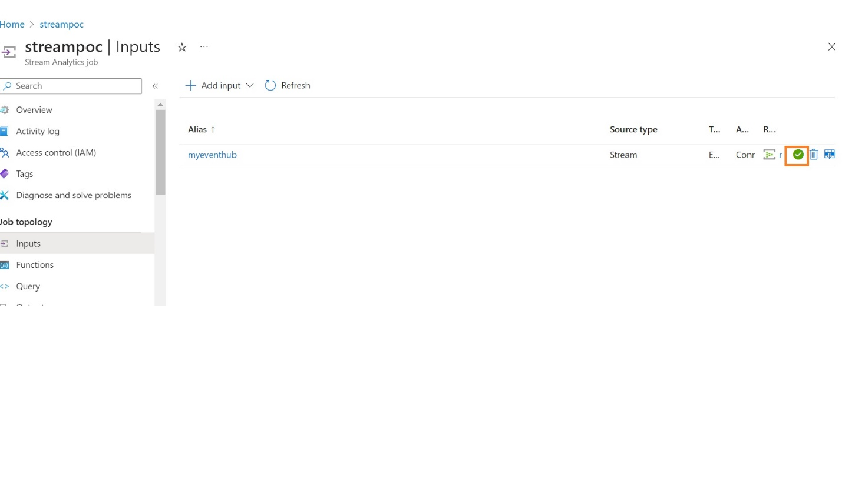

So far, we have created our **input**; now, we need to establish an **output** to which we can send the transformed data.

**Output:**

Define an output to which the transformed data will be sent. In this demo, we are using Azure Synapse Analytics.

Create a table in Azure Synapse Analytics to receive the data from Stream Analytics.

In the Stream Analytics job, click on "Outputs," add a storage account, select Azure Synapse Analytics as the output, and provide the output details.

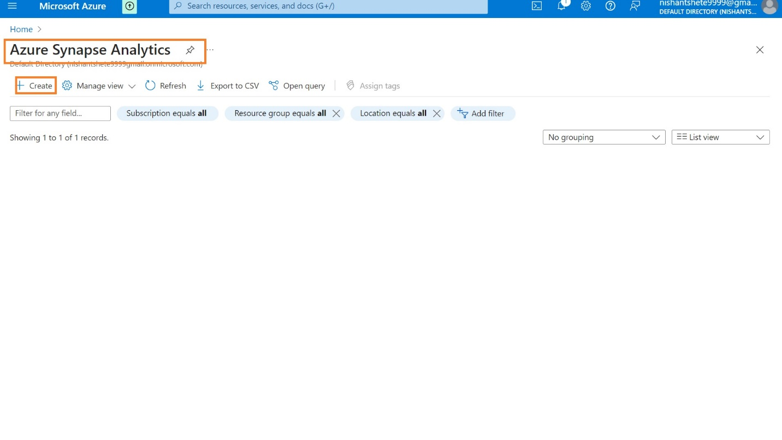

Once we have created an Azure Synapse Analytics we need to create table which can accept the data from our stream analytics.

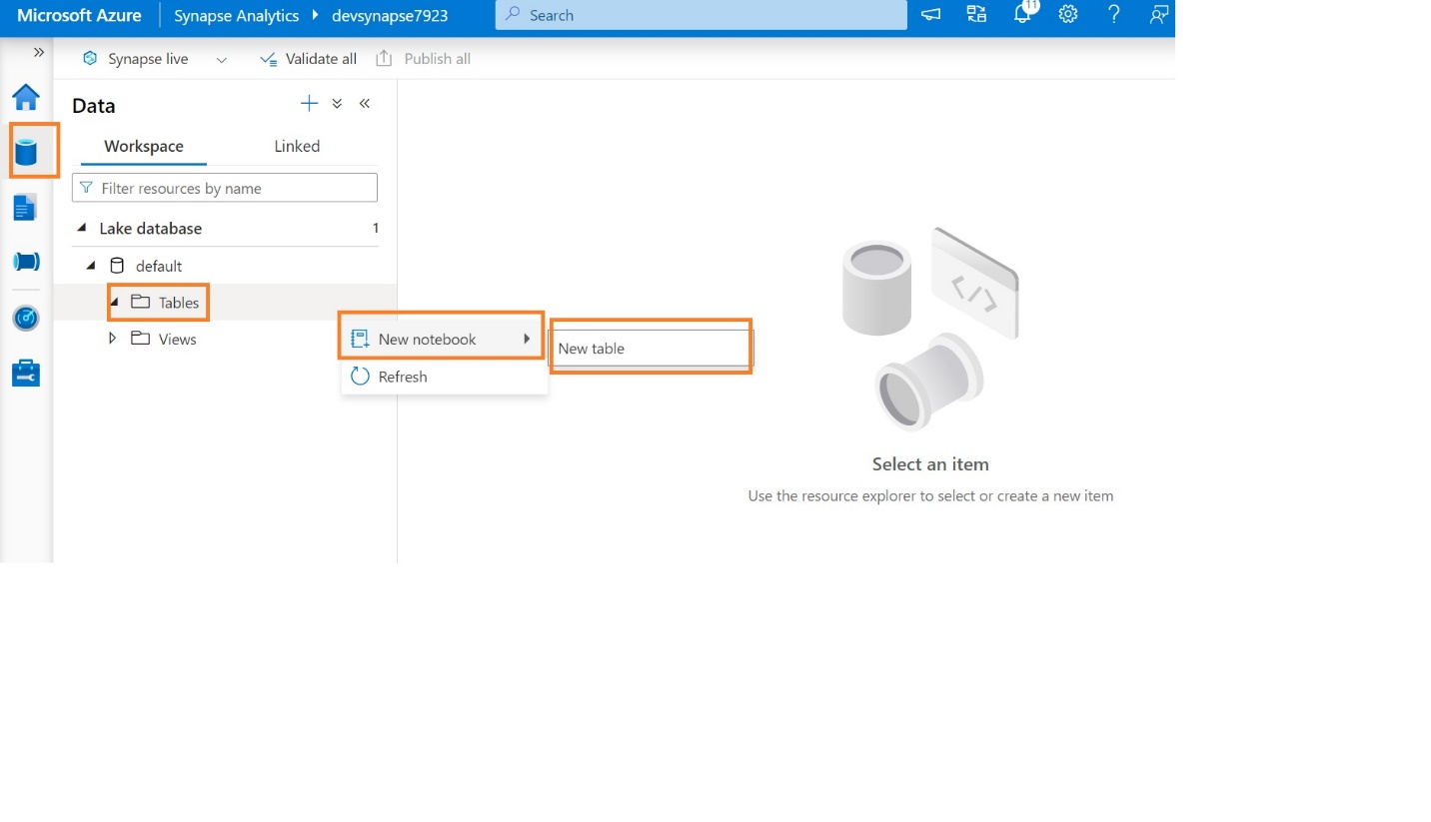

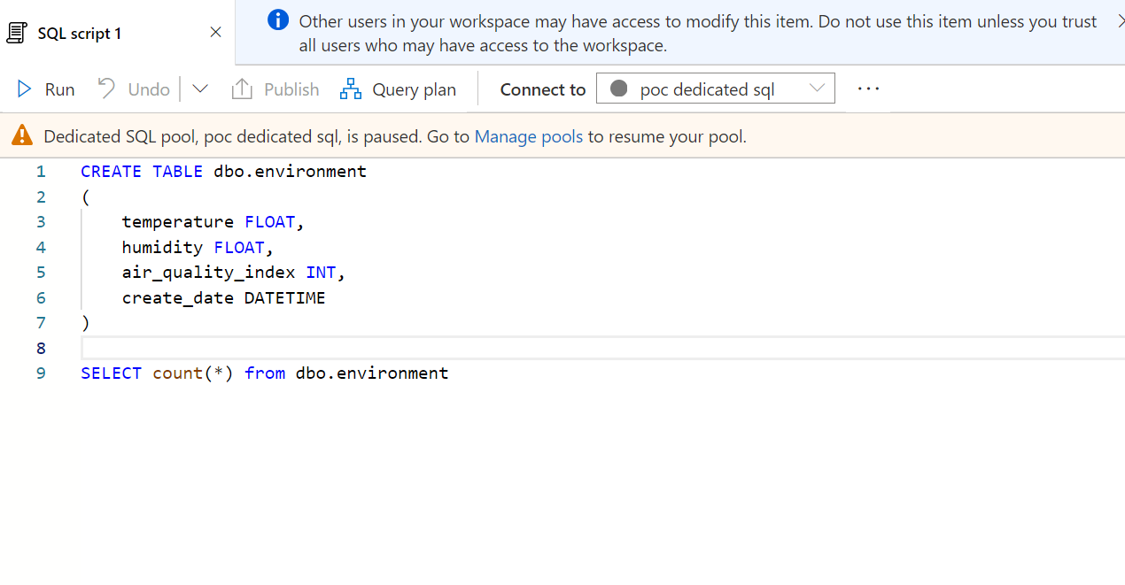

So now we create an output so let’s go to the Stream Analytics jobs to configure our output.

Before configure the output we need to add storage account.

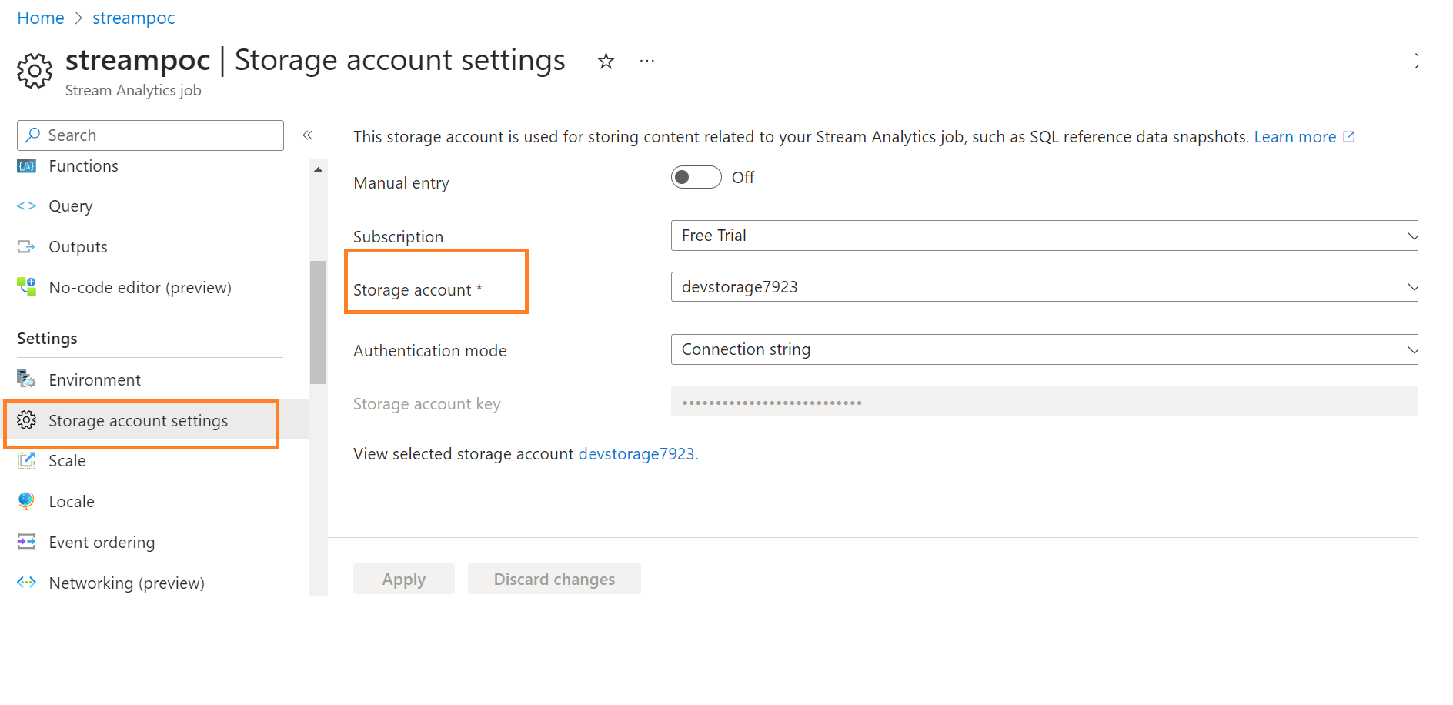

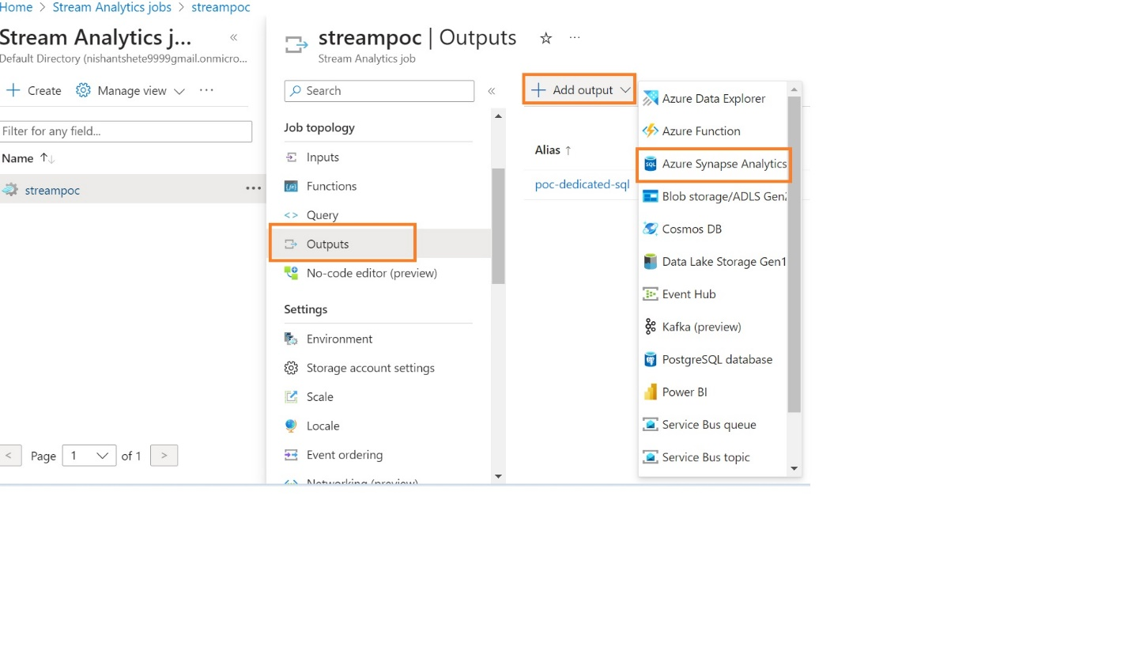

Once you select output as an Azure Synapse Analytics provide the output details.

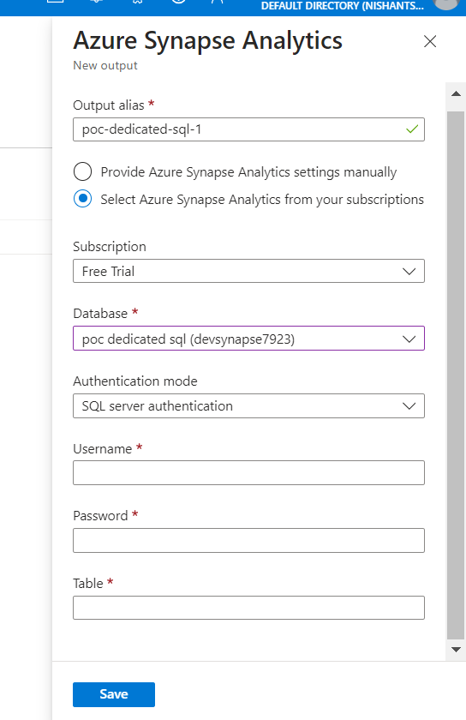

So far, we have covered our Input and Output.

**Generate Python Code for Event Hub:**

Utilize the provided Python code to get streaming data and send it to Azure Event Hubs.

Pass the connection string and Event Hub name as parameters.

Here is python code to get streaming data and send it to Azure Event Hubs.

import random

import time

from azure.eventhub import EventHubProducerClient, EventData

connection_string = "Event hub policy connection string"

eventhub_name = "event hub name"

producer = EventHubProducerClient.from_connection_string(connection_string, eventhub_name=eventhub_name)

while True:

    temperature = random.uniform(15, 35)

    humidity = random.randint(30, 80)

    air_quality_index = random.randint(0, 500)

    data = {

        "temperature": temperature,

        "humidity": humidity,

        "air_quality_index": air_quality_index

    }

    event_data_batch = producer.create_batch()

    event_data_batch.add(EventData(body=str(data).encode('utf-8')))

    producer.send_batch(event_data_batch)

    print("Sent data:", data)

    time.sleep(5)

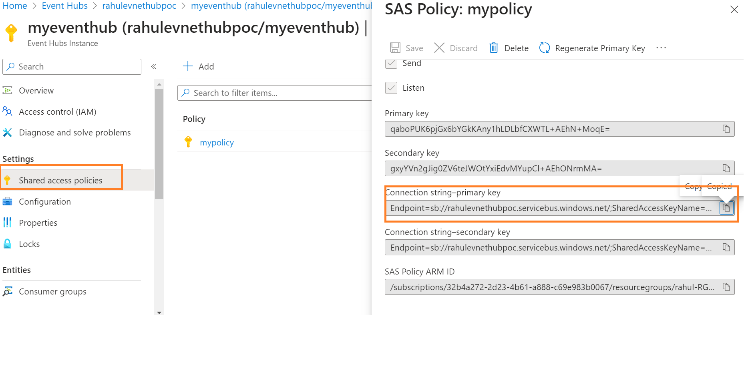

Once you Successfully run the above code then it will started to sending the data to Azure Event hub.

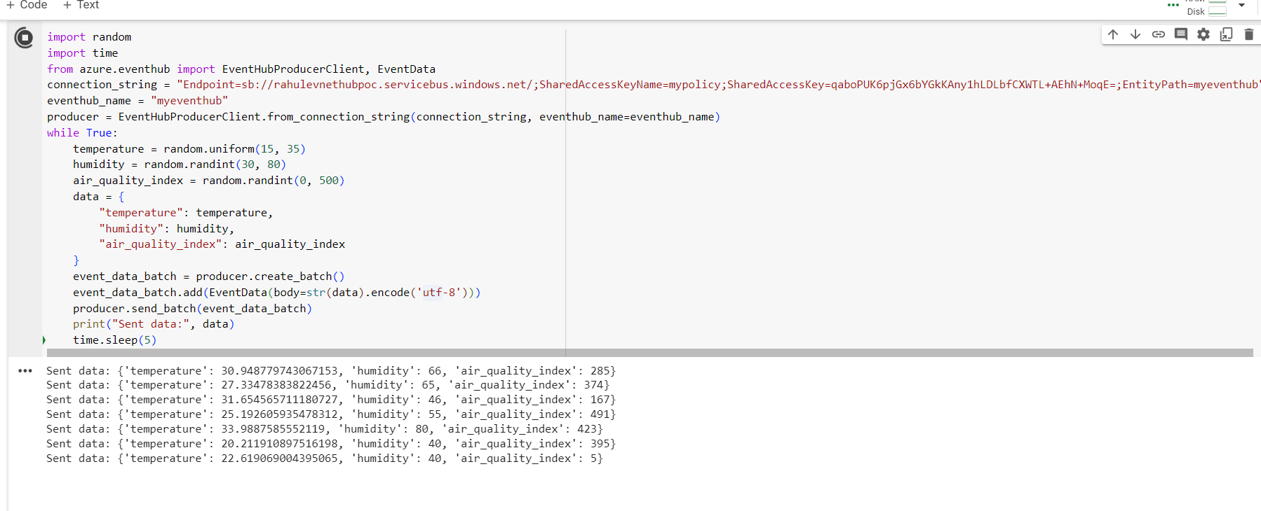

**Start the Stream Analytics Job:**

Initiate the Stream Analytics job to start processing the data.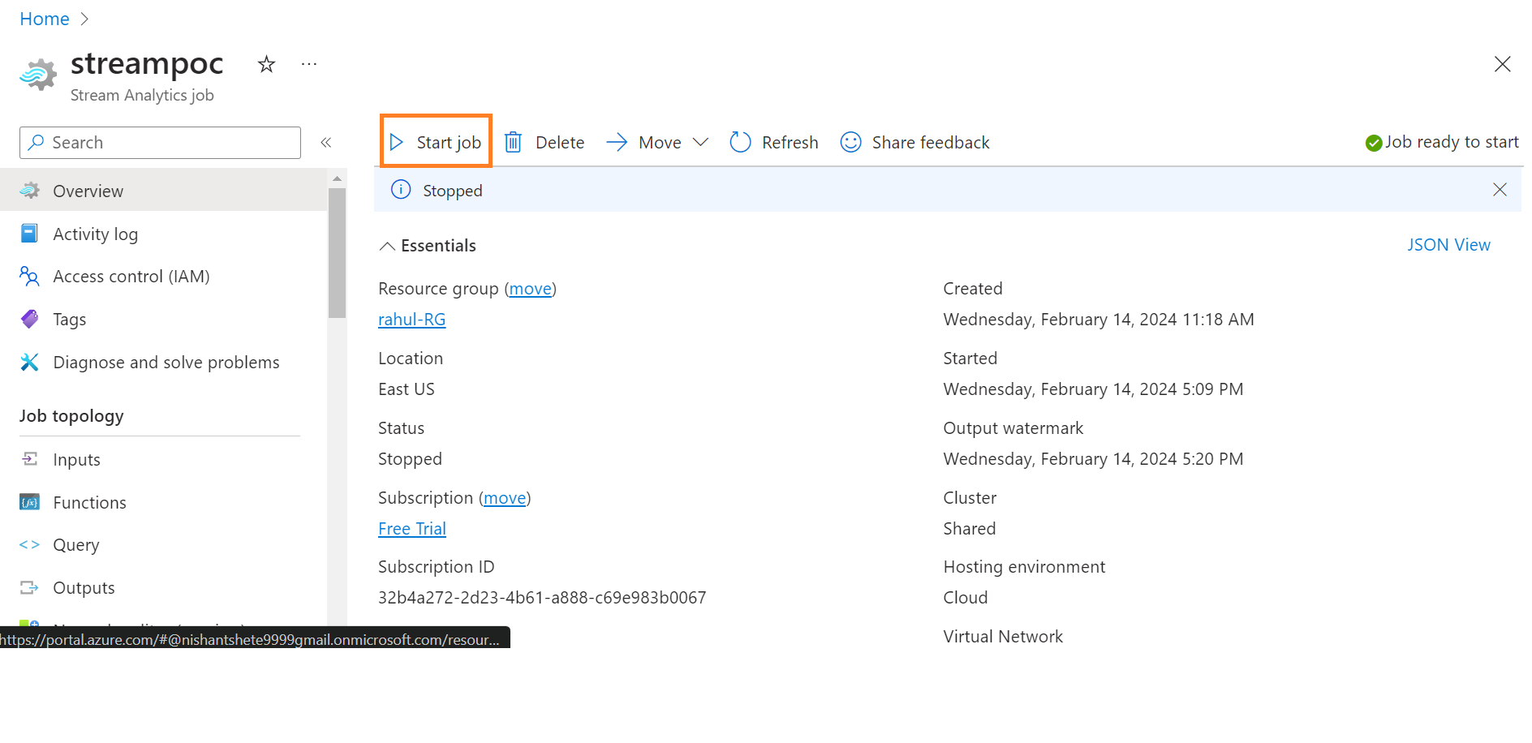

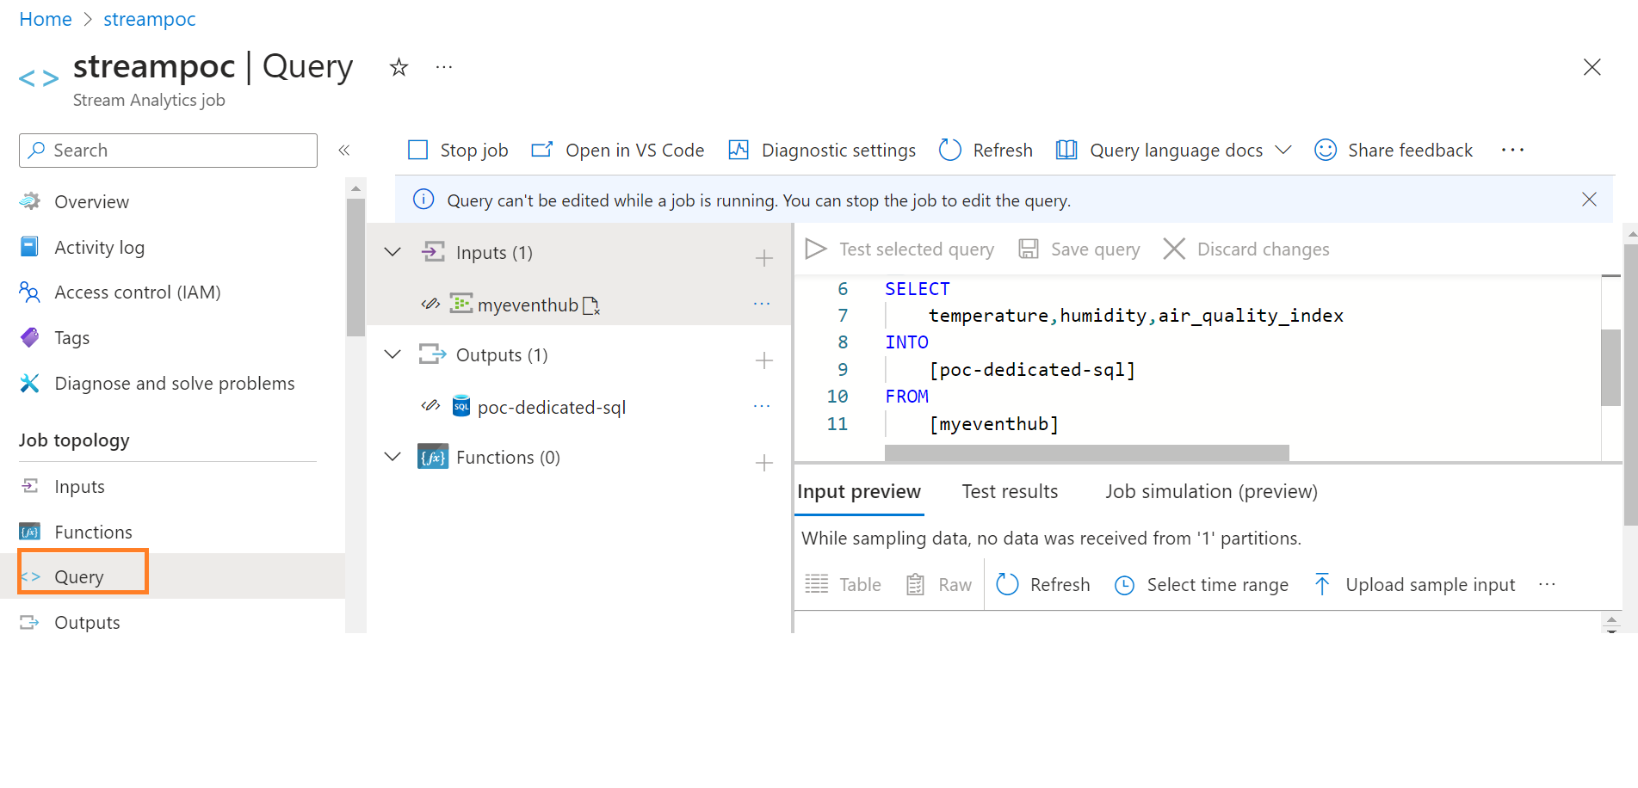

Now the data is streaming from our application to event hub the we used stream analytics job to transform it to Azure Synapse analytics

