Exercise - 1

App.js

import logo from './logo.svg';

import './App.css';

function App() {

return (

<center>

<h1>Welcome to the first session of React.</h1></center>

);

}

export default App;

Output

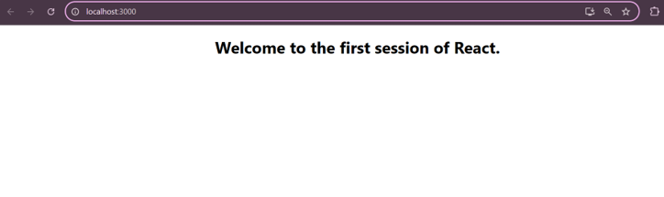

Exercise - 2

Home.js

import React from 'react'

export default function Home() {

return (

<h3>Welcome to the Home page of Student Management Portal</h3>

)

}

About.js

import React from 'react'

export default function About() {

return (

<h3>Welcome to the About page of the Student Management Portal</h3>

)

}

Contact.js

import React from 'react'

export default function Contact() {

return (

<h3>Welcome to the Contact page of the Student Management Portal</h3>

)

}

App.js

import './App.css';

import Home from './components/Home';

import About from './components/About';

import Contact from './components/Contact';

function App() {

return (

<div className="App">

<Home/>

<About/>

<Contact/>

</div>

);

}

export default App;

Output

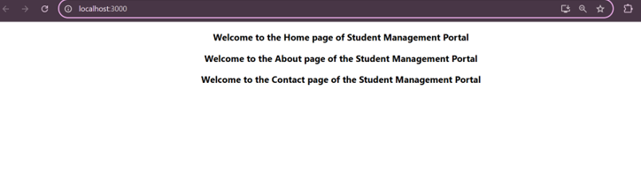

Exercise - 3

Calculatescore.js

import './Stylesheets/mystyle.css'

const percentToDecimal = (decimal) => {

return (decimal ).toFixed(2) + '%';

};

const calcScore = (total, goal) => {

return percentToDecimal(total / goal);

};

export const CalculateScore = ({ Name, School, total, goal }) => {

return (

<div className="formatstyle">

<h1 style={{ color: 'brown' }}>Student Details:</h1>

<div className="Name">

<b><span>Name: </span></b>

<span>{Name}</span>

</div>

<div className="School">

<b><span>School: </span></b>

<span>{School}</span>

</div>

<div className="Total">

<b><span>Total: </span></b>

<span>{total}</span>

<span> Marks</span>

</div>

<div className="Score">

<b>Score: </b>

<span>{calcScore(total, goal)}</span>

</div>

</div>

);

};

Mystyle.css

.Name {

font-weight: 300;

color: blue;

}

.School {

color: crimson;

}

.Total {

color: darkmagenta;

}

.Score {

color: forestgreen;

}

.formatstyle {

text-align: center;

font-size: large;

}

App.js

import { CalculateScore } from '../src/components/CalculateScore';

function App() {

return (

<div>

<CalculateScore

Name={"Steve"}

School={"DAV Public School"}

total={286}

goal={3}

/>

</div>

);

}

export default App;

Output

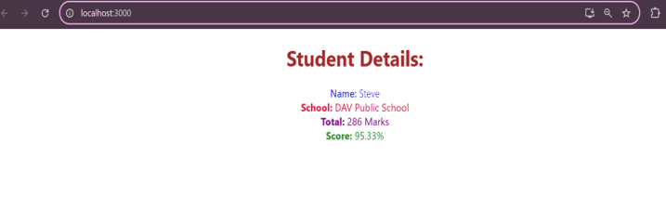

Exercise - 4

Post.js

class Post {

constructor(id, title, body) {

*this*.id = id;

*this*.title = title;

*this*.body = body;

}

}

export default Post;

Posts.js

import React from 'react';

import Post from './Post';

class Posts extends React.Component {

constructor(props) {

super(props);

*this*.state = {

posts: [],

hasError: false,

errorInfo: null

};

}

loadPosts() {

const post1 = new Post(1, 'First Post', 'This is the body of the first post');

const post2 = new Post(2, 'Second Post', 'This is the body of the second post');

*this*.setState({ posts: [post1, post2] });

}

componentDidMount() {

*this*.loadPosts();

}

componentDidCatch(error, info) {

*this*.setState({

hasError: true,

errorInfo: info

});

console.error("Error caught in Posts component:", error, info);

}

render() {

const { hasError, errorInfo, posts } = *this*.state;

if (hasError) {

return <h2>Something went wrong. {errorInfo?.componentStack}</h2>;

}

return (

<div>

<h1>All Posts</h1>

{posts.map(post => (

<div key={post.id} style={{ border: '1px solid gray', margin: '10px', padding: '10px' }}>

<h2>{post.title}</h2>

<p>{post.body}</p>

</div>

))}

</div>

);

}

}

export default Posts;

App.js

import logo from './logo.svg';

import './App.css';

import Posts from './Posts.js';

function App() {

return (

<div className="App">

<Posts/>

</div>

);

}

export default App;

Output

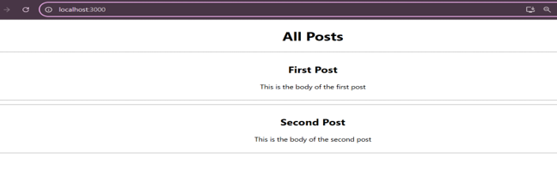

Exercise - 5

CohortDetails.Module.css

.box {

width: 300px;

display: inline-block;

margin: 10px;

padding: 10px 20px;

border: 1px solid black;

border-radius: 10px;

}

dt {

font-weight: 500;

}

CohortDetails.js

import styles from './CohortDetails.module.css';

function CohortDetails(props) {

const { cohortCode, technology, startDate, currentStatus, coachName, trainerName } = props.cohort;

return (

<div

className={styles.box}

style={{

width: '300px',

display: 'inline-block',

margin: '10px',

border: '2px solid #ccc',

verticalAlign: 'top'

}}

>

<h3 style={{ color: currentStatus.toLowerCase() === 'ongoing' ? 'green' : 'blue', fontWeight: 'bold' }}>

{cohortCode} - {technology}

</h3>

<p><strong>Started On</strong><br />{startDate}</p>

<p><strong>Current Status</strong><br />{currentStatus}</p>

<p><strong>Coach</strong><br />{coachName}</p>

<p><strong>Trainer</strong><br />{trainerName}</p>

</div>

);

}

export default CohortDetails;

Output

