EXERCISE 9

components/ListofPlayers.jsx

import React from "react";

const ListofPlayers = () => {

const players = [

{ name: "Virat", score: 85 },

{ name: "Rohit", score: 45 },

{ name: "Rahul", score: 73 },

{ name: "Shikhar", score: 66 },

{ name: "Pant", score: 88 },

{ name: "Jadeja", score: 55 },

{ name: "Ashwin", score: 78 },

{ name: "Shami", score: 64 },

{ name: "Bumrah", score: 90 },

{ name: "Kuldeep", score: 50 },

{ name: "Hardik", score: 70 },

];

*// Filter using arrow function*

const lowScorers = players.filter((player) => player.score < 70);

return (

<div>

<h2>All Players:</h2>

{players.map((player, index) => (

<p key={index}>

{player.name} - {player.score}

</p>

))}

<h2>Players with Score below 70:</h2>

{lowScorers.map((player, index) => (

<p key={index}>

{player.name} - {player.score}

</p>

))}

</div>

);

};

export default ListofPlayers;

components/IndianPlayers.jsx

import React from "react";

const IndianPlayers = () => {

const players = [

"Virat",

"Rohit",

"Rahul",

"Shikhar",

"Pant",

"Jadeja",

"Ashwin",

"Shami",

"Bumrah",

"Kuldeep",

"Hardik",

];

*// Destructure into odd and even players*

const oddPlayers = players.filter((_, index) => index % 2 === 0);

const evenPlayers = players.filter((_, index) => index % 2 !== 0);

*// Merge arrays*

const T20Players = ["Virat", "Rohit", "Pant", "Hardik"];

const RanjiPlayers = ["Rahul", "Ashwin", "Shami"];

const mergedPlayers = [...T20Players, ...RanjiPlayers];

return (

<div>

<h2>Odd Team Players:</h2>

{oddPlayers.map((name, index) => (

<p key={index}>{name}</p>

))}

<h2>Even Team Players:</h2>

{evenPlayers.map((name, index) => (

<p key={index}>{name}</p>

))}

<h2>Merged Team (T20 + Ranji Trophy):</h2>

{mergedPlayers.map((name, index) => (

<p key={index}>{name}</p>

))}

</div>

);

};

export default IndianPlayers;

App.js

import React from "react";

import ListofPlayers from "./components/ListofPlayers";

import IndianPlayers from "./components/IndianPlayers";

function App() {

const flag = true; *// change this to false to toggle*

return (

<div className="App">

<h1>🏏 Cricket App</h1>

{flag ? <ListofPlayers /> : <IndianPlayers />}

</div>

);

}

export default App;

Output

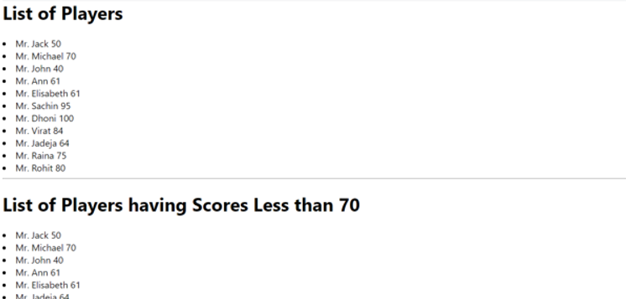

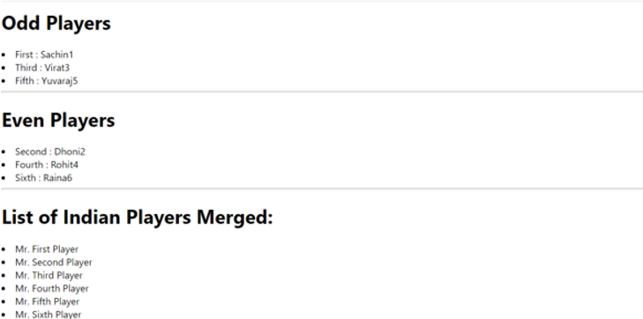

EXERCISE 10

components/OfficeList.jsx

import React from "react";

import "./OfficeList.css"; *// For styling*

const OfficeList = () => {

*// Object list of office spaces*

const offices = [

{

id: 1,

name: "Indiranagar Workspace",

rent: 45000,

address: "Indiranagar, Bangalore",

image: "https://via.placeholder.com/300x200?text=Indiranagar+Office",

},

{

id: 2,

name: "Koramangala Hub",

rent: 75000,

address: "Koramangala, Bangalore",

image: "https://via.placeholder.com/300x200?text=Koramangala+Office",

},

{

id: 3,

name: "Whitefield Tech Park",

rent: 62000,

address: "Whitefield, Bangalore",

image: "https://via.placeholder.com/300x200?text=Whitefield+Office",

},

{

id: 4,

name: "HSR Layout Office",

rent: 58000,

address: "HSR Layout, Bangalore",

image: "https://via.placeholder.com/300x200?text=HSR+Office",

},

];

return (

<div>

<h1>Office Space Rental Listings</h1>

{offices.map((office) => (

<div key={office.id} className="office-card">

<img src={office.image} alt={office.name} />

<h2>{office.name}</h2>

<p>Address: {office.address}</p>

<p className={office.rent < 60000 ? "rent-low" : "rent-high"}>

Rent: ₹{office.rent}

</p>

</div>

))}

</div>

);

};

export default OfficeList;

components/OfficeList.css

.office-card {

border: 1px solid #ccc;

padding: 16px;

margin: 16px auto;

width: 320px;

text-align: center;

border-radius: 8px;

box-shadow: 0 2px 4px rgba(0,0,0,0.1);

font-family: Arial, sans-serif;

background-color: #f9f9f9;

}

.office-card img {

width: 100%;

height: auto;

border-radius: 4px;

}

.rent-low {

color: red;

font-weight: bold;

}

.rent-high {

color: green;

font-weight: bold;

}

App.js

import React from "react";

import OfficeList from "./components/OfficeList";

function App() {

return (

<div className="App">

<OfficeList />

</div>

);

}

export default App;

Output

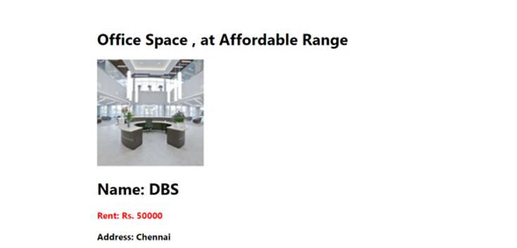

EXERCISE 11

components/Counter.jsx

import React, { useState } from "react";

const Counter = () => {

const [count, setCount] = useState(0);

const increment = () => {

setCount(count + 1);

sayHello();

};

const decrement = () => {

setCount(count - 1);

};

const sayHello = () => {

console.log("Hello! This is a static message.");

};

return (

<div>

<h2>Counter: {count}</h2>

<button onClick={increment}>Increment</button>

<button onClick={decrement}>Decrement</button>

</div>

);

};

export default Counter;

components/WelcomeButton.jsx

import React from "react";

const WelcomeButton = () => {

const sayMessage = (msg) => {

alert(msg);

};

return (

<div>

<button onClick={() => sayMessage("Welcome!")}>Say Welcome</button>

</div>

);

};

export default WelcomeButton;

components/ClickEvent.jsx

import React from "react";

const ClickEvent = () => {

const handleClick = (e) => {

console.log("I was clicked");

};

return (

<div>

<button onClick={handleClick}>OnPress</button>

</div>

);

};

export default ClickEvent;

components/CurrencyConvertor.jsx

import React, { useState } from "react";

const CurrencyConvertor = () => {

const [rupees, setRupees] = useState("");

const [euro, setEuro] = useState("");

const handleChange = (e) => {

setRupees(e.target.value);

};

const handleSubmit = () => {

const rate = 0.011; *// Example conversion rate*

const converted = parseFloat(rupees) * rate;

setEuro(converted.toFixed(2));

};

return (

<div>

<h2>Currency Convertor</h2>

<input

type="number"

placeholder="Enter amount in INR"

value={rupees}

onChange={handleChange}

/>

<button onClick={handleSubmit}>Convert</button>

{euro && <p>Euro: €{euro}</p>}

</div>

);

};

export default CurrencyConvertor;

App.js

import React from "react";

import Counter from "./components/Counter";

import WelcomeButton from "./components/WelcomeButton";

import ClickEvent from "./components/ClickEvent";

import CurrencyConvertor from "./components/CurrencyConvertor";

function App() {

return (

<div className="App">

<h1>Event Examples App</h1>

<Counter />

<WelcomeButton />

<ClickEvent />

<CurrencyConvertor />

</div>

);

}

export default App;

Output

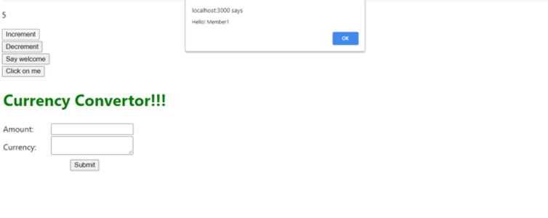

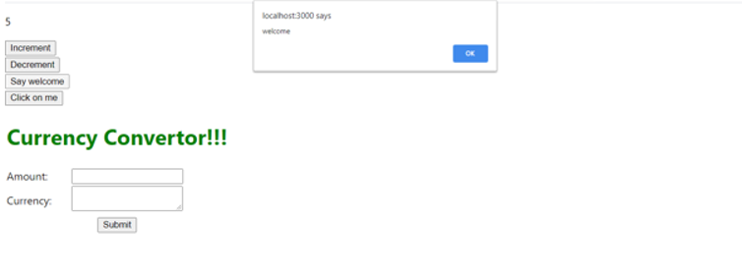

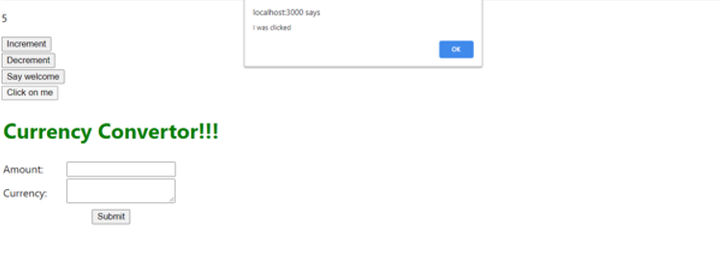

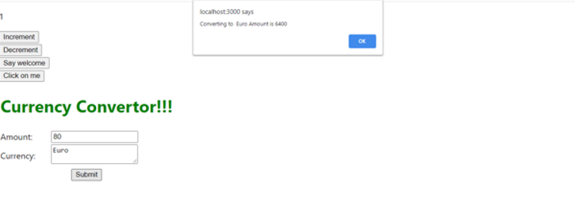

EXERCISE 12

components/FlightList.jsx

import React from "react";

const flights = [

{ id: 1, from: "Delhi", to: "Mumbai", time: "10:30 AM", price: "₹5,000" },

{ id: 2, from: "Bangalore", to: "Kolkata", time: "2:15 PM", price: "₹6,500" },

{ id: 3, from: "Chennai", to: "Hyderabad", time: "5:00 PM", price: "₹4,200" },

];

const FlightList = () => {

return (

<div>

<h2>Available Flights</h2>

{flights.map((flight) => (

<div

key={flight.id}

style={{ border: "1px solid #ccc", margin: "10px", padding: "10px" }}

>

<p>

<strong>From:</strong> {flight.from}

</p>

<p>

<strong>To:</strong> {flight.to}

</p>

<p>

<strong>Time:</strong> {flight.time}

</p>

<p>

<strong>Price:</strong> {flight.price}

</p>

</div>

))}

</div>

);

};

export default FlightList;

components/GuestPage.jsx

import React from "react";

import FlightList from "./FlightList";

const GuestPage = () => {

return (

<div>

<h1>Welcome Guest</h1>

<p>You can browse flight information below.</p>

<FlightList />

</div>

);

};

export default GuestPage;

components/UserPage.jsx

import React from "react";

import FlightList from "./FlightList";

const UserPage = () => {

return (

<div>

<h1>Welcome, User!</h1>

<p>You can now book tickets for the flights below:</p>

<FlightList />

<button style={{ marginTop: "10px" }}>Book Ticket</button>

</div>

);

};

export default UserPage;

App.js

import React, { useState } from "react";

import GuestPage from "./components/GuestPage";

import UserPage from "./components/UserPage";

function App() {

const [isLoggedIn, setIsLoggedIn] = useState(false);

const handleLogin = () => {

setIsLoggedIn(true);

};

const handleLogout = () => {

setIsLoggedIn(false);

};

return (

<div className="App">

<h1>✈️ Ticket Booking App</h1>

<div style={{ marginBottom: "20px" }}>

{isLoggedIn ? (

<button onClick={handleLogout}>Logout</button>

) : (

<button onClick={handleLogin}>Login</button>

)}

</div>

{isLoggedIn ? <UserPage /> : <GuestPage />}

</div>

);

}

export default App;

Output





EXERCISE 13

components/BookDetails.jsx

import React from "react";

const BookDetails = () => {

return (

<div>

<h2>Book Details</h2>

<p>Title: React for Beginners</p>

<p>Author: John Doe</p>

<p>Price: ₹500</p>

</div>

);

};

export default BookDetails;

components/BlogDetails.jsx

import React from "react";

const BlogDetails = () => {

return (

<div>

<h2>Blog Details</h2>

<p>Title: Why React is so Popular</p>

<p>Author: Jane Smith</p>

<p>Date: Aug 1, 2025</p>

</div>

);

};

export default BlogDetails;

components/CourseDetails.jsx

import React from "react";

const CourseDetails = () => {

return (

<div>

<h2>Course Details</h2>

<p>Course: React Full Stack Development</p>

<p>Instructor: Alex Johnson</p>

<p>Duration: 8 weeks</p>

</div>

);

};

export default CourseDetails;

App.js

import React, { useState } from "react";

import BookDetails from "./components/BookDetails";

import BlogDetails from "./components/BlogDetails";

import CourseDetails from "./components/CourseDetails";

function App() {

const [activeComponent, setActiveComponent] = useState("book");

const renderComponentUsingIf = () => {

if (activeComponent === "book") {

return <BookDetails />;

} else if (activeComponent === "blog") {

return <BlogDetails />;

} else {

return <CourseDetails />;

}

};

return (

<div className="App">

<h1>📚 Blogger App</h1>

{*/* Buttons to switch components */*}

<div style={{ marginBottom: "20px" }}>

<button onClick={() => setActiveComponent("book")}>Book</button>

<button onClick={() => setActiveComponent("blog")}>Blog</button>

<button onClick={() => setActiveComponent("course")}>Course</button>

</div>

{*/* --- Method 1: if-else Rendering --- */*}

<h3>Method 1: if-else</h3>

{renderComponentUsingIf()}

{*/* --- Method 2: Ternary Operator --- */*}

<h3>Method 2: Ternary Operator</h3>

{activeComponent === "book" ? (

<BookDetails />

) : activeComponent === "blog" ? (

<BlogDetails />

) : (

<CourseDetails />

)}

{*/* --- Method 3: Logical && Operator --- */*}

<h3>Method 3: Logical && Operator</h3>

{activeComponent === "book" && <BookDetails />}

{activeComponent === "blog" && <BlogDetails />}

{activeComponent === "course" && <CourseDetails />}

</div>

);

}

export default App;

Output

