Query 1:

select \* from instructors where CWID ='98763';

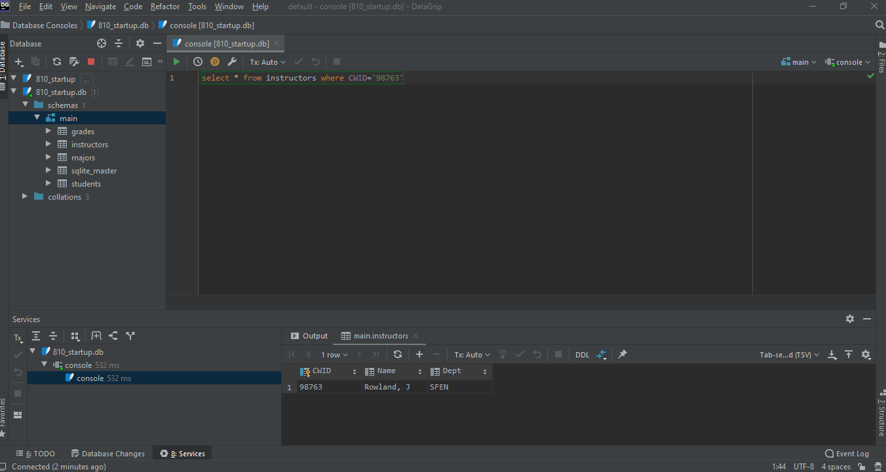

Query 2:

select Dept, *count*(\*) as cnt from instructors group by Dept;

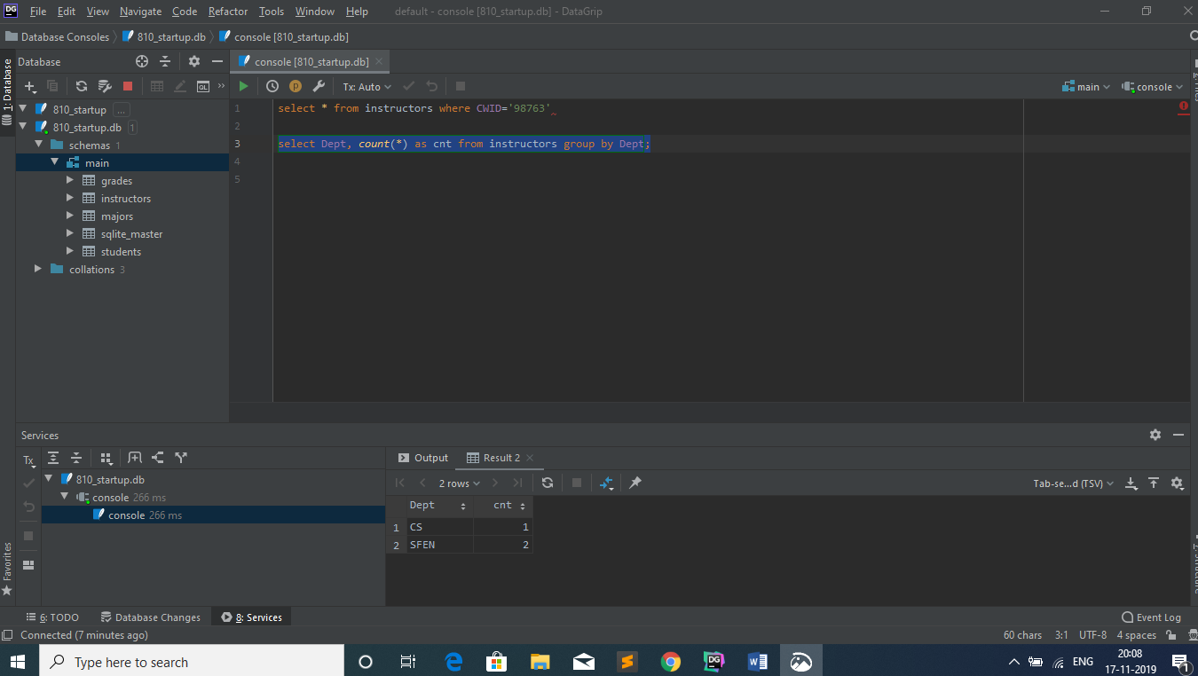

Query 3:

select Grade, *Max*(GradeCount) as FrequentGrade from ( select *count*(\*) as GradeCount, Grade from grades group by Grade);

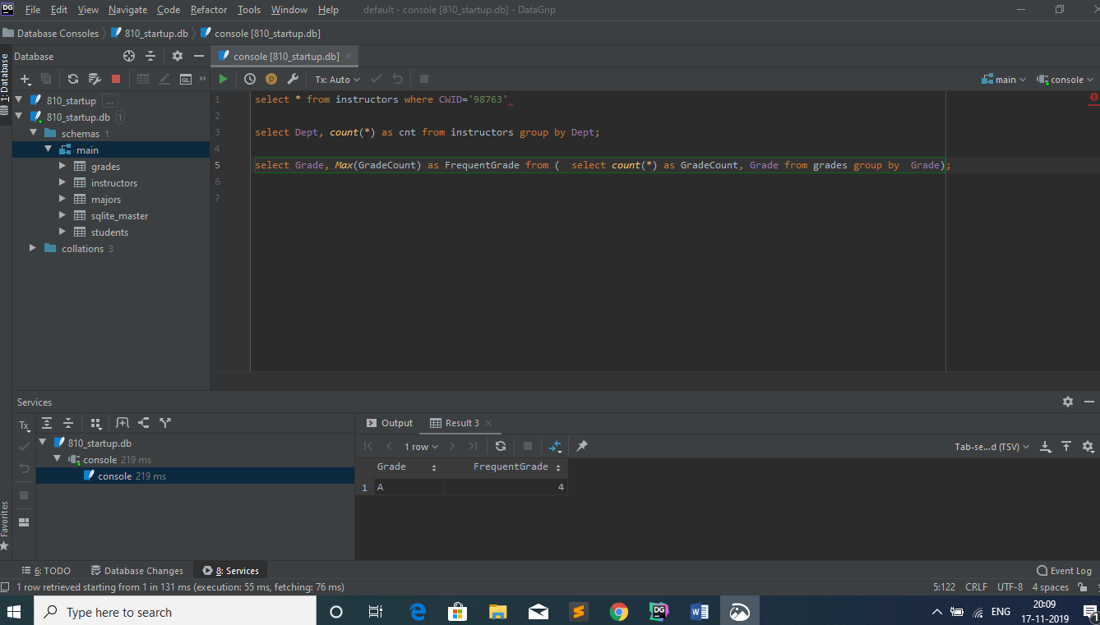

Query 4:

select S.Name, S.CWID, S.Major, G.Course, G.Grade from students S join grades G on S.CWID = G.StudentCWID;

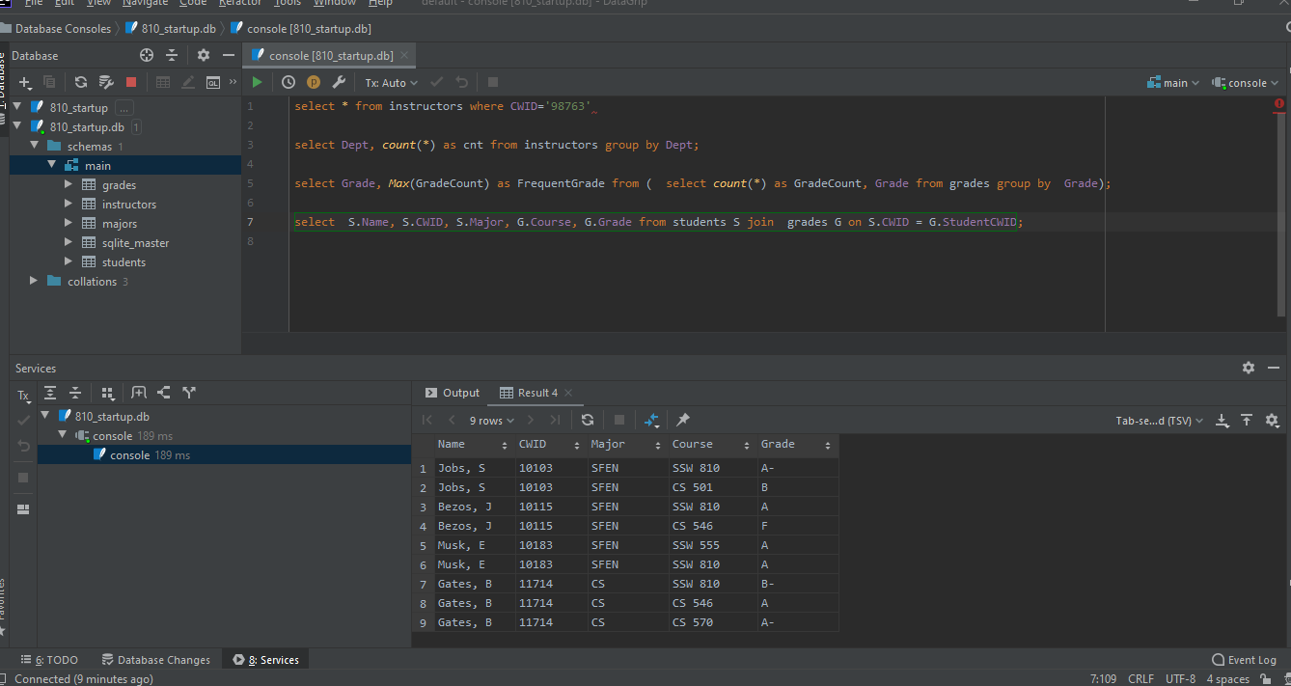

Query 5:

select S.Name, S.CWID, S.Major, G.Course, G.Grade from students S join grades G  
 on S.CWID = G.StudentCWID where G.Course = 'SSW 810';

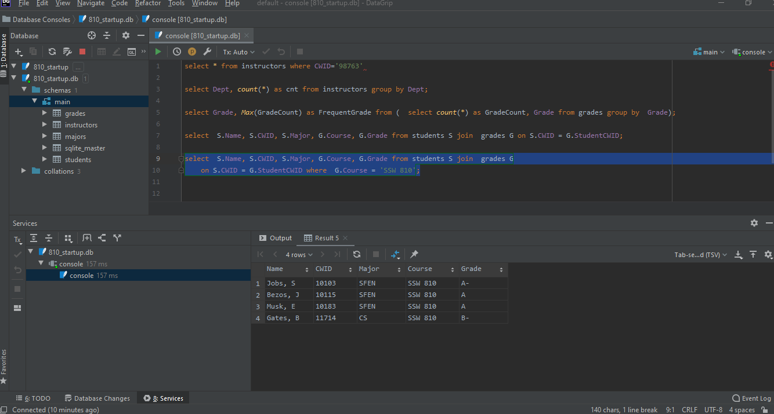

Query 6:

select I.CWID, I.Name , I.Dept, G.Course, *count*(\*) as Students from instructors I join grades G on I.CWID = G.InstructorCWID GROUP BY G.InstructorCWID,G.Course order by CWID desc;

