**1. Firstly, I find if any null values present in dataset.**

Total Percent

Interests 5 0.000299

Languages 0 0.000000

Country 0 0.000000

UserAgent 0 0.000000

IP 0 0.000000

Here only one feature named Interests contains null values and the percentage of null value is so small.So I removed all the rows in which that feature contains null values.

**2. Here is k means elbow diagram for finding number of clusters.**

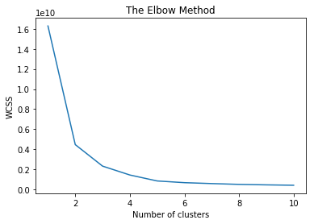

It forms elbow at cluster number 3. So there would be three cluster of dataset.

**3. The final graph of clusters is below.**

