Week-4 Assignment

Title:
Azure Cloud Fundamentals and Data Pipeline Implementation using ADF

Objective:
To understand Azure cloud concepts and build a complete data pipeline using Storage Account and Azure Data Factory.

Task 1: Explore Azure Portal & Create Resource Group

Deliverable:
Screenshot of Resource Group

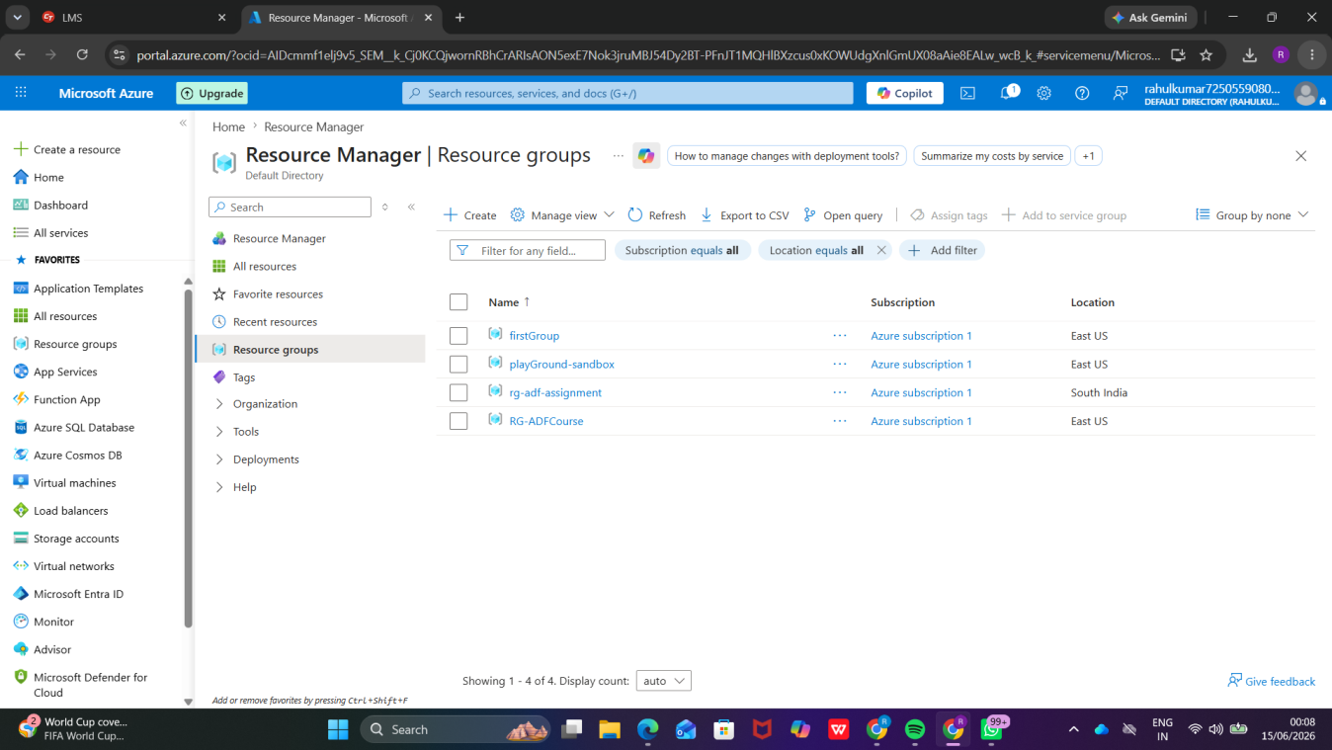

Task 2: Storage Setup

Do:
- Create a Storage Account
- Create a Blob Container
- Upload a CSV file

Deliverable:
Screenshot of Storage Account
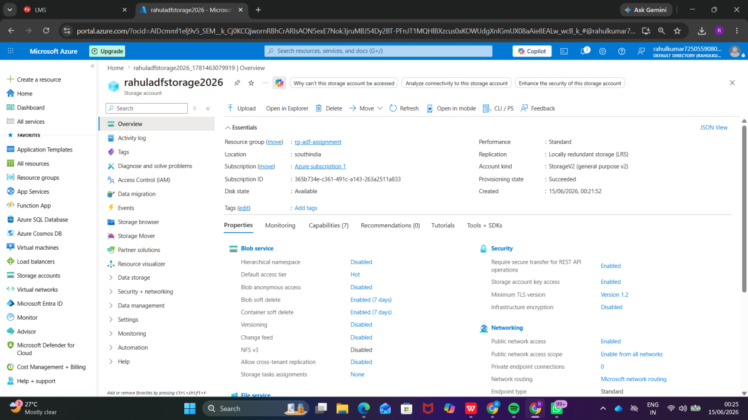

Task 3: ADF Basics

Do:
- Create Azure Data Factory
- Explore ADF UI (Author, Monitor, Manage)
- Create Linked Service (Blob Storage)
- Create Datasets (Source + Destination)
- Use Get Metadata Activity

Deliverable:
Screenshot of Azure Data Factory Creation

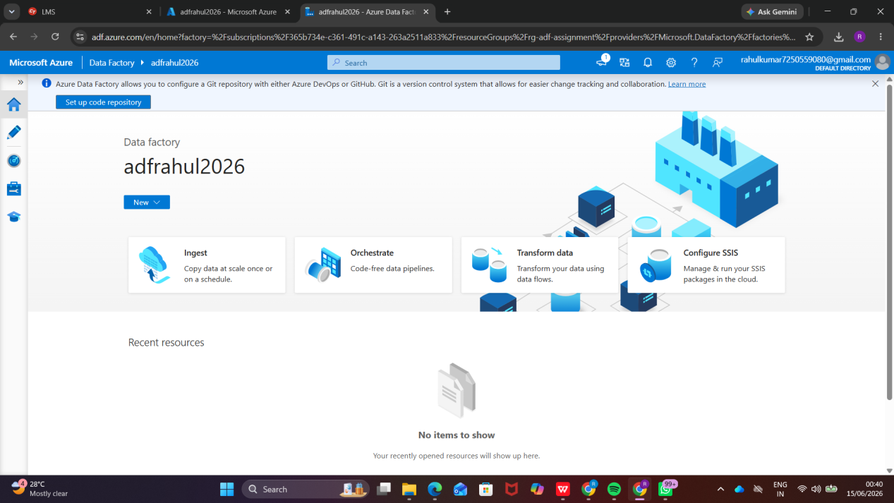

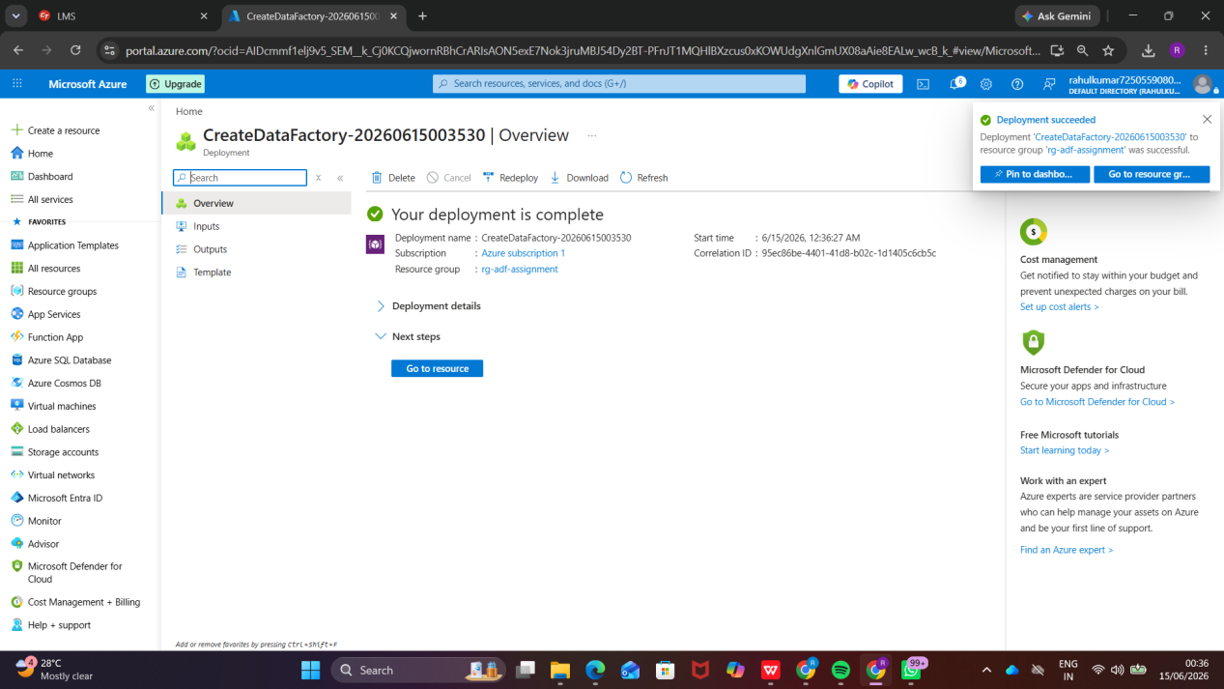

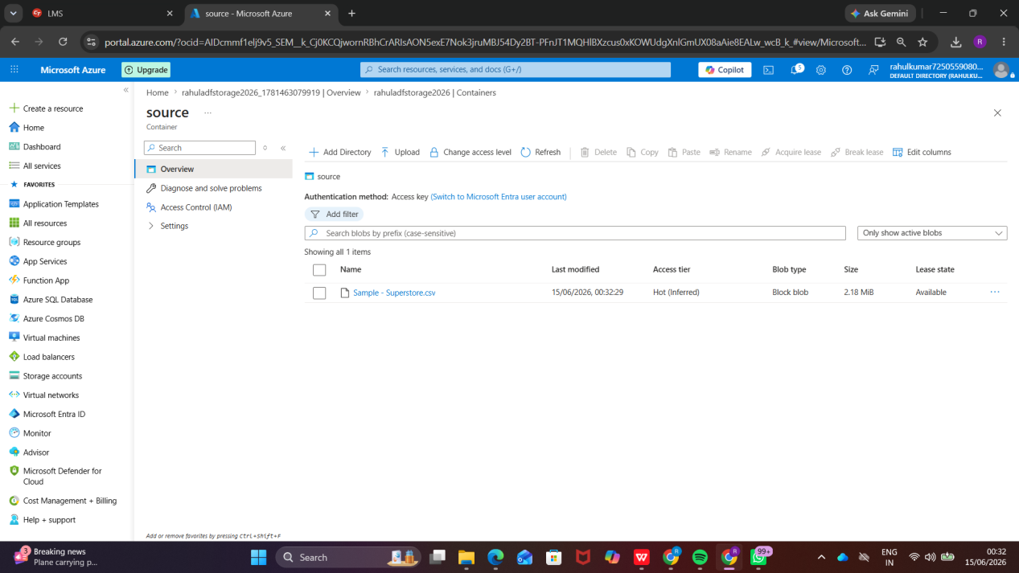

Linked Service
Linked Service in Azure Data Factory acts as a connection string that enables ADF to connect with external data sources and destinations. In this project, a Linked Service was created to establish connectivity between Azure Data Factory and Azure Blob Storage. It securely stores the authentication and connection details required for accessing data stored in the Blob Container. This connection is later used by datasets and pipelines to read and write data during execution.
Purpose:
- Connect Azure Data Factory with Azure Blob Storage.
- Store authentication and connection information securely.
- Enable data movement between source and destination systems.
- Provide reusable connectivity for datasets and pipelines.
Outcome:
The Linked Service was successfully configured, allowing Azure Data Factory to access the Blob Storage container and use it as a source/destination in the data pipeline.

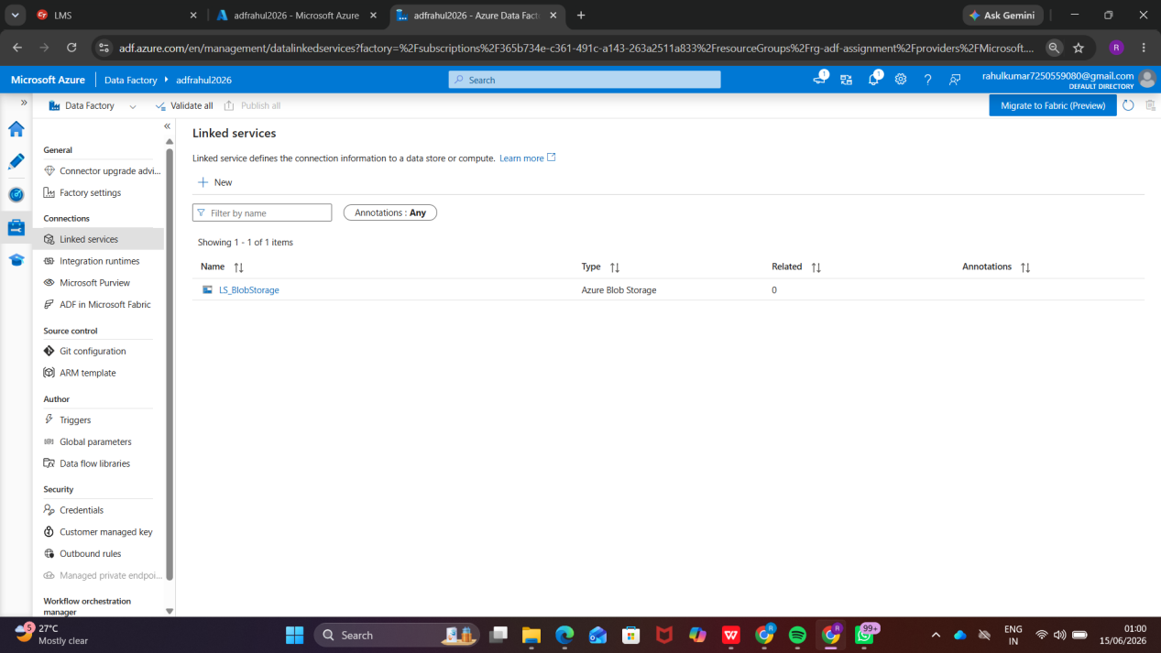

Dataset
A Dataset in Azure Data Factory represents the structure of the data that is stored in a data source or destination. It defines the location, format, and schema of the data that will be used in pipeline activities. In this project, datasets were created for the source CSV file stored in Azure Blob Storage and the destination location where the processed data would be copied. Datasets act as an interface between the Linked Service and the pipeline activities.
Purpose:
- Define the source and destination data.
- Specify file format, location, and schema.
- Enable pipelines to access and process data.
- Work together with Linked Services for data connectivity.
Outcome:
The datasets were successfully configured for both source and destination locations, allowing Azure Data Factory to identify and process the CSV data during pipeline execution.

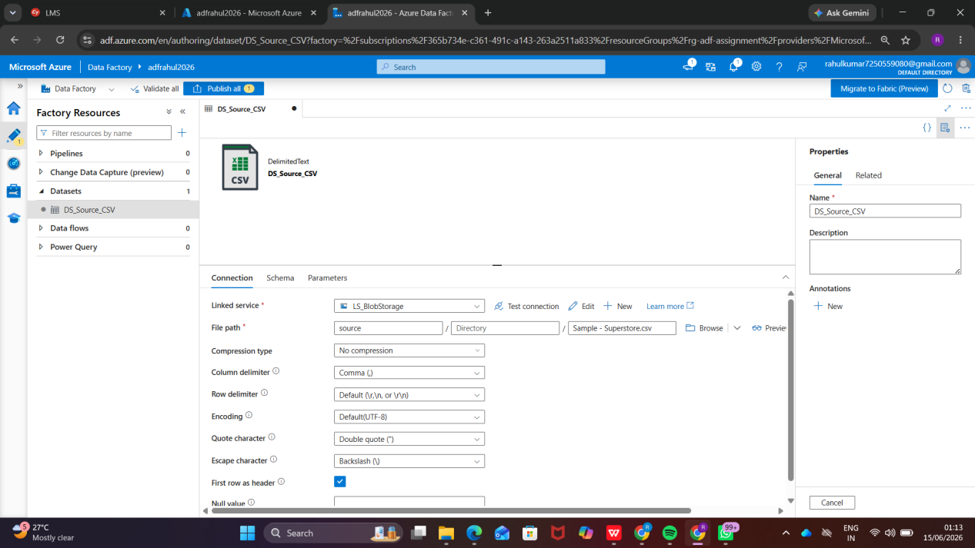

Pipeline Execution
Pipeline Execution is the process of running a pipeline in Azure Data Factory to perform the configured activities. After designing the pipeline and configuring all required components, the pipeline was executed using the Debug or Trigger Now option. During execution, Azure Data Factory monitored each activity and displayed the execution status. A successful execution indicates that the data movement and validation processes were completed without errors.
Purpose:
- Execute the data pipeline.
- Validate the workflow configuration.
- Monitor activity status and performance.
- Ensure successful data transfer from source to destination.
Outcome:
The pipeline was executed successfully, and all activities completed with a Succeeded status. The CSV data was transferred to the destination location, confirming that the end-to-end data pipeline was functioning correctly.

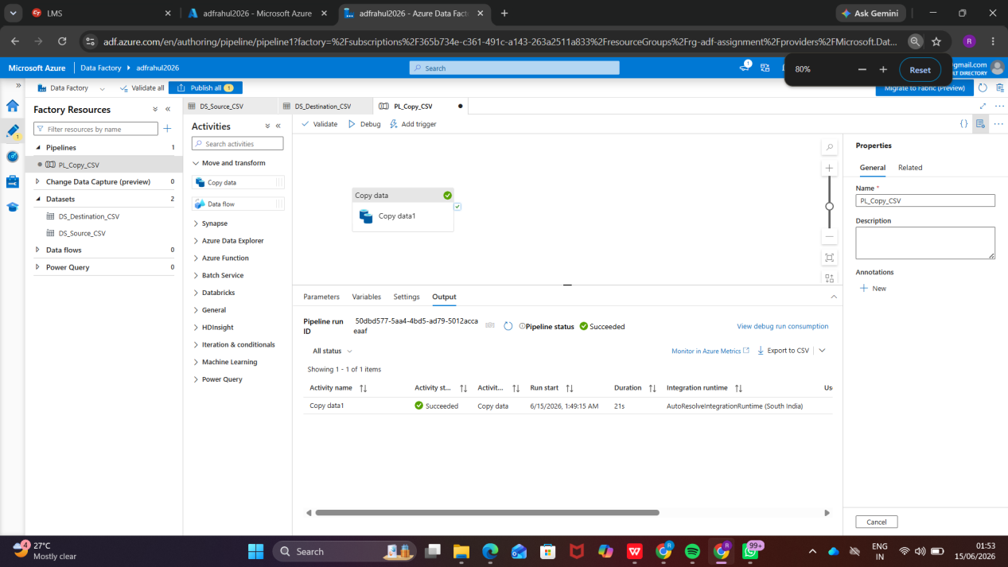

IAM (Identity and Access Management) is an Azure security feature used to control access to Azure resources. It allows administrators to assign specific roles to users, groups, or applications so that they can perform authorized actions on Azure resources.
In this assignment, IAM Role Assignment was used to grant the required permissions for accessing and managing Azure resources. By assigning appropriate roles, secure and controlled access is ensured while following the principle of least privilege.
Purpose of IAM Role Assignment:
- Manage user access to Azure resources.
- Provide role-based access control (RBAC).
- Enhance security by limiting permissions.
- Ensure only authorized users can perform specific operations.
Role Assigned:
The required Azure role was assigned to the user for managing Azure Data Factory and Storage resources used in the project.
Outcome:
After successful role assignment, the user was able to access and configure Azure Storage, Azure Data Factory, datasets, linked services, and pipelines without permission-related issues.
Conclusion:
IAM Role Assignment is an essential security mechanism in Microsoft Azure that enables secure resource management through controlled access and role-based permissions.
