ASSIGNMENT 2 E-Commerce Sales Database Using SQL
Submitted By:
Devansh Saini_MMDU
Role:
Data engineer intern
Objective:
The primary goal of this task is to utilize SQL to systematically construct, manage, and analyze a relational database for an e-commerce platform. This workflow encompasses creating structured tables with strict primary and foreign key constraints, loading sample data, and ensuring overall data integrity. Furthermore, it involves applying robust filtering, mathematical aggregations, multi-table joins, and advanced database concepts such as conditional logic (CASE) and transaction management (ACID properties) to extract actionable business insights regarding sales patterns, customer behavior, and product performance
1. Scenario & Business Context
You are a Junior Data Analyst at ShopEase, a mid-sized e-commerce company that sells electronics, clothing, and home products across India. The management team wants to understand sales patterns, customer behavior, and product performance to make better business decisions.
You have been given access to the company's relational database containing information about customers, products, orders, and order details. Your task is to write SQL queries to extract meaningful insights from this data.
⚠ Note: You may use MySQL, PostgreSQL, or any SQL-compatible RDBMS to complete these tasks. All queries should follow standard SQL syntax.
2. Database Schema & Constraints
The database consists of 4 tables. Study the schema below carefully — pay attention to Primary Keys, Foreign Keys, and Constraints.
Table: customers
CREATE TABLE customers (
customer_id INT PRIMARY KEY,
first_name VARCHAR(50) NOT NULL,
last_name VARCHAR(50) NOT NULL,
email VARCHAR(100) UNIQUE NOT NULL,
city VARCHAR(50) NOT NULL,
state VARCHAR(50) NOT NULL,
join_date DATE NOT NULL,
is_premium BOOLEAN DEFAULT FALSE
);
-- Index for filtering by city/state
CREATE INDEX idx_customers_city ON customers(city);
CREATE INDEX idx_customers_state ON customers(state);
Table: products
CREATE TABLE products (
product_id INT PRIMARY KEY,
product_name VARCHAR(100) NOT NULL,
category VARCHAR(50) NOT NULL,
brand VARCHAR(50) NOT NULL,
unit_price DECIMAL(10,2) NOT NULL CHECK (unit_price > 0),
stock_qty INT NOT NULL DEFAULT 0 CHECK (stock_qty >= 0)
);
-- Index for filtering by category
CREATE INDEX idx_products_category ON products(category);
Table: orders
CREATE TABLE orders (
order_id INT PRIMARY KEY,
customer_id INT NOT NULL,
order_date DATE NOT NULL,
status VARCHAR(20) NOT NULL DEFAULT 'Pending'
CHECK (status IN ('Pending','Shipped','Delivered','Cancelled')),
total_amount DECIMAL(12,2) NOT NULL CHECK (total_amount >= 0),
FOREIGN KEY (customer_id) REFERENCES customers(customer_id)
);
-- Index for date-based filtering and sorting
CREATE INDEX idx_orders_date ON orders(order_date);
CREATE INDEX idx_orders_status ON orders(status);
Table: order_items
CREATE TABLE order_items (
item_id INT PRIMARY KEY,
order_id INT NOT NULL,
product_id INT NOT NULL,
quantity INT NOT NULL CHECK (quantity > 0),
unit_price DECIMAL(10,2) NOT NULL CHECK (unit_price > 0),
discount_pct DECIMAL(5,2) DEFAULT 0 CHECK (discount_pct BETWEEN 0 AND 100),
FOREIGN KEY (order_id) REFERENCES orders(order_id),
FOREIGN KEY (product_id) REFERENCES products(product_id)
);
Entity Relationships
customers ──(1:N)──▶ orders
orders ──(1:N)──▶ order_items
products ──(1:N)──▶ order_items
customers.customer_id ◀──FK── orders.customer_id
orders.order_id ◀──FK── order_items.order_id
products.product_id ◀──FK── order_items.product_id

3. Sample Data
Below is sample data to help you understand the tables. Use the provided INSERT statements to load data into your database.
customers (sample rows)
customer_id | first_name | last_name | email | city | state | join_date | is_premium
101 | Aarav | Sharma | aarav.s@email.com | Mumbai | Maharashtra | 2024-01-15 | TRUE
102 | Priya | Patel | priya.p@email.com | Ahmedabad | Gujarat | 2024-02-20 | FALSE
103 | Rohan | Gupta | rohan.g@email.com | Delhi | Delhi | 2024-03-10 | TRUE
104 | Sneha | Reddy | sneha.r@email.com | Hyderabad | Telangana | 2024-04-05 | FALSE
105 | Vikram | Singh | vikram.s@email.com | Jaipur | Rajasthan | 2024-05-12 | TRUE
106 | Ananya | Iyer | ananya.i@email.com | Chennai | Tamil Nadu | 2024-06-18 | FALSE
107 | Karan | Mehta | karan.m@email.com | Pune | Maharashtra | 2024-07-22 | TRUE
108 | Divya | Nair | divya.n@email.com | Kochi | Kerala | 2024-08-30 | FALSE

products (sample rows)
product_id | product_name | category | brand | unit_price | stock_qty
201 | Wireless Earbuds | Electronics | BoAt | 1499.0 | 250
202 | Cotton T-Shirt | Clothing | Levi's | 799.0 | 500
203 | Smart Watch | Electronics | Noise | 2999.0 | 150
204 | Running Shoes | Clothing | Nike | 4599.0 | 120
205 | Bluetooth Speaker | Electronics | JBL | 3499.0 | 200
206 | Bedsheet Set | Home | Spaces | 1299.0 | 300
207 | Laptop Stand | Electronics | AmazonBasics | 899.0 | 180
208 | Cushion Covers (Set) | Home | HomeCenter | 599.0 | 400

orders (sample rows)
order_id | customer_id | order_date | status | total_amount
1001 | 101 | 2024-08-01 | Delivered | 4498.0
1002 | 102 | 2024-08-03 | Delivered | 799.0
1003 | 103 | 2024-08-05 | Shipped | 7498.0
1004 | 101 | 2024-08-10 | Delivered | 3499.0
1005 | 104 | 2024-08-12 | Cancelled | 2999.0
1006 | 105 | 2024-08-15 | Delivered | 5898.0
1007 | 106 | 2024-08-18 | Pending | 1299.0
1008 | 103 | 2024-08-20 | Delivered | 899.0
1009 | 107 | 2024-08-25 | Shipped | 6098.0
1010 | 108 | 2024-08-28 | Delivered | 1598.0

order_items (sample rows)
item_id | order_id | product_id | quantity | unit_price | discount_pct
5001 | 1001 | 201 | 2 | 1499.0 | 0
5002 | 1001 | 207 | 1 | 899.0 | 10
5003 | 1002 | 202 | 1 | 799.0 | 0
5004 | 1003 | 203 | 1 | 2999.0 | 0
5005 | 1003 | 204 | 1 | 4599.0 | 5
5006 | 1004 | 205 | 1 | 3499.0 | 0
5007 | 1005 | 203 | 1 | 2999.0 | 0
5008 | 1006 | 201 | 1 | 1499.0 | 10
5009 | 1006 | 204 | 1 | 4599.0 | 5
5010 | 1007 | 206 | 1 | 1299.0 | 0
5011 | 1008 | 207 | 1 | 899.0 | 0
5012 | 1009 | 205 | 1 | 3499.0 | 0
5013 | 1009 | 208 | 2 | 599.0 | 15
5014 | 1010 | 206 | 1 | 1299.0 | 0
5015 | 1010 | 208 | 1 | 599.0 | 0

Data Loading — INSERT Statements
Copy and execute the following SQL to load sample data into your database:
-- ========== INSERT: customers ==========
INSERT INTO customers VALUES
(101, 'Aarav', 'Sharma', 'aarav.s@email.com', 'Mumbai', 'Maharashtra', '2024-01-15', TRUE),
(102, 'Priya', 'Patel', 'priya.p@email.com', 'Ahmedabad', 'Gujarat', '2024-02-20', FALSE),
(103, 'Rohan', 'Gupta', 'rohan.g@email.com', 'Delhi', 'Delhi', '2024-03-10', TRUE),
(104, 'Sneha', 'Reddy', 'sneha.r@email.com', 'Hyderabad', 'Telangana', '2024-04-05', FALSE),
(105, 'Vikram', 'Singh', 'vikram.s@email.com', 'Jaipur', 'Rajasthan', '2024-05-12', TRUE),
(106, 'Ananya', 'Iyer', 'ananya.i@email.com', 'Chennai', 'Tamil Nadu', '2024-06-18', FALSE),
(107, 'Karan', 'Mehta', 'karan.m@email.com', 'Pune', 'Maharashtra', '2024-07-22', TRUE),
(108, 'Divya', 'Nair', 'divya.n@email.com', 'Kochi', 'Kerala', '2024-08-30', FALSE);
-- ========== INSERT: products ==========
INSERT INTO products VALUES
(201, 'Wireless Earbuds', 'Electronics', 'BoAt', 1499.00, 250),
(202, 'Cotton T-Shirt', 'Clothing', 'Levis', 799.00, 500),
(203, 'Smart Watch', 'Electronics', 'Noise', 2999.00, 150),
(204, 'Running Shoes', 'Clothing', 'Nike', 4599.00, 120),
(205, 'Bluetooth Speaker', 'Electronics', 'JBL', 3499.00, 200),
(206, 'Bedsheet Set', 'Home', 'Spaces', 1299.00, 300),
(207, 'Laptop Stand', 'Electronics', 'AmazonBasics', 899.00, 180),
(208, 'Cushion Covers (Set)', 'Home', 'HomeCenter', 599.00, 400);
-- ========== INSERT: orders ==========
INSERT INTO orders VALUES
(1001, 101, '2024-08-01', 'Delivered', 4498.00),
(1002, 102, '2024-08-03', 'Delivered', 799.00),
(1003, 103, '2024-08-05', 'Shipped', 7498.00),
(1004, 101, '2024-08-10', 'Delivered', 3499.00),
(1005, 104, '2024-08-12', 'Cancelled', 2999.00),
(1006, 105, '2024-08-15', 'Delivered', 5898.00),
(1007, 106, '2024-08-18', 'Pending', 1299.00),
(1008, 103, '2024-08-20', 'Delivered', 899.00),
(1009, 107, '2024-08-25', 'Shipped', 6098.00),
(1010, 108, '2024-08-28', 'Delivered', 1598.00);
-- ========== INSERT: order_items ==========
INSERT INTO order_items VALUES
(5001, 1001, 201, 2, 1499.00, 0),
(5002, 1001, 207, 1, 899.00, 10),
(5003, 1002, 202, 1, 799.00, 0),
(5004, 1003, 203, 1, 2999.00, 0),
(5005, 1003, 204, 1, 4599.00, 5),
(5006, 1004, 205, 1, 3499.00, 0),
(5007, 1005, 203, 1, 2999.00, 0),
(5008, 1006, 201, 1, 1499.00, 10),
(5009, 1006, 204, 1, 4599.00, 5),
(5010, 1007, 206, 1, 1299.00, 0),
(5011, 1008, 207, 1, 899.00, 0),
(5012, 1009, 205, 1, 3499.00, 0),
(5013, 1009, 208, 2, 599.00, 15),
(5014, 1010, 206, 1, 1299.00, 0),
(5015, 1010, 208, 1, 599.00, 0);

Section A — SQL Basics (SELECT, Constraints, Primary Keys)
These questions test your understanding of basic data retrieval, table structure, and database constraints.

Q1. Write a query to display all columns and rows from the customer's table.
Ans- SELECT * FROM customers;

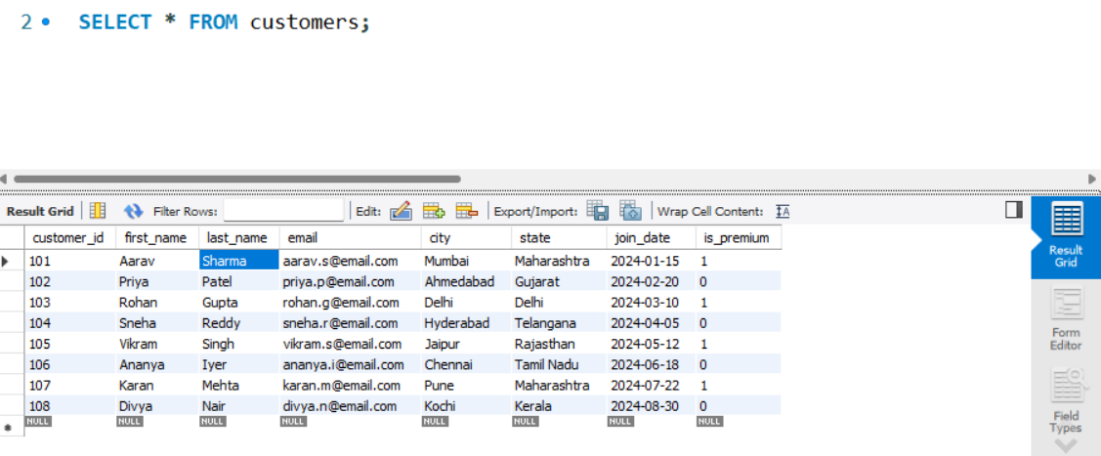

Q2. Retrieve only the first_name, last_name, and city of all customers.

Ans- SELECT first_name, last_name, city FROM customers;

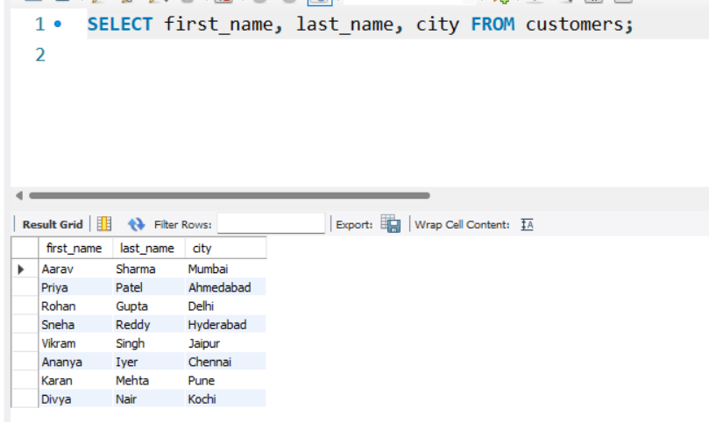

Q3. List all unique categories available in the products table.

Ans- SELECT DISTINCT category FROM products;

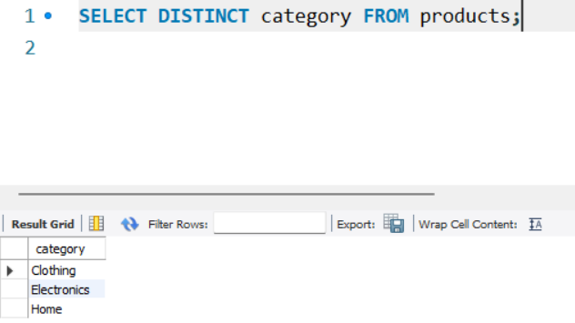

Q4. Identify the Primary Key of each table in the schema. Explain why a Primary Key must be unique and NOT NULL.
Ans-
• customers: customer_id
• products: product_id
• orders: order_id
• order_items: item_id
Explanation: A Primary Key serves as a unique identifier for each record in a table. It must be UNIQUE to ensure that no two rows share the same identifier, preventing ambiguity. It must be NOT NULL because an unknown (NULL )value cannot reliably identify a specific row.

Q5. What constraints are applied to the email column in the customers table? What would happen if you tried to insert a duplicate email?

Ans-The email column has the UNIQUE and NOT NULL constraints. If you try to insert a duplicate email, the database engine will throw a constraint violation error (e.g., ”Duplicate entry for key”), and the entire INSERT operation will be rejected

Q6. Try inserting a product with unit_price = -50. What happens and which constraint prevents it? Write both the INSERT statement and explain the error.

Ans- INSERT INTO products (product_id, product_name, category, brand, unit_price, stock_qty) VALUES (209, 'Test Item', 'Electronics', 'TestBrand',-50.00, 10);
Explanation:
The query fails. The database prevents this insertion because of the CHECK (unit_price > 0)constraint defined on the unit_price column. A negative price evaluates to FALSE against this rule, triggering a check constraint violation error

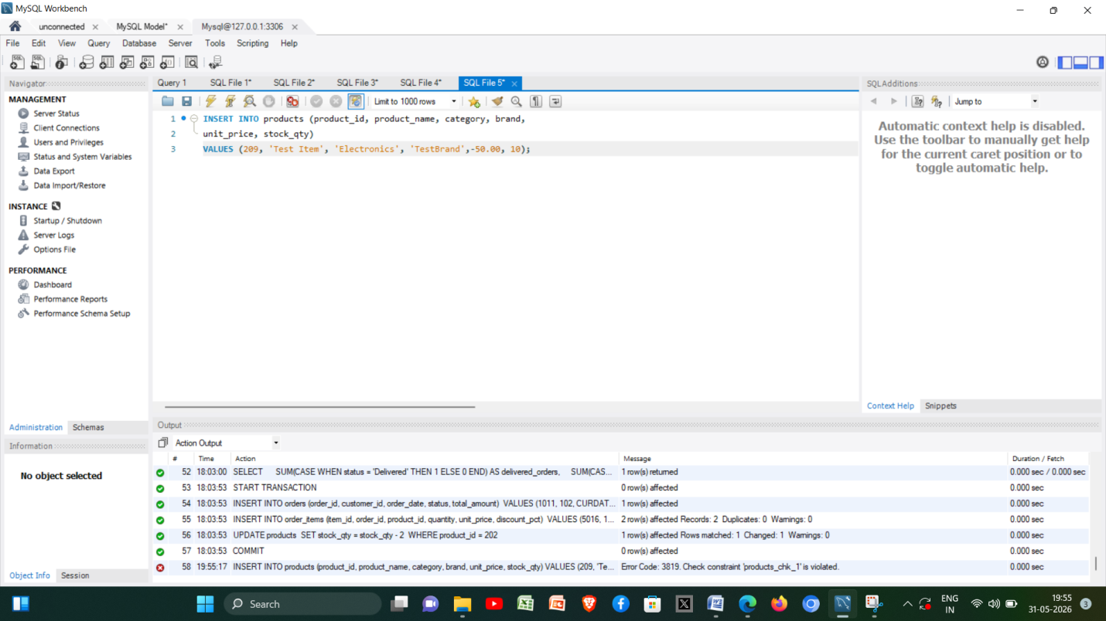

Section B — Filtering & Optimization (WHERE, Indexes)
These questions test your ability to filter data effectively and understand how indexes improve query performance.
Q7. Retrieve all orders with status = 'Delivered'.

Ans- SELECT * FROM orders WHERE status = 'Delivered';

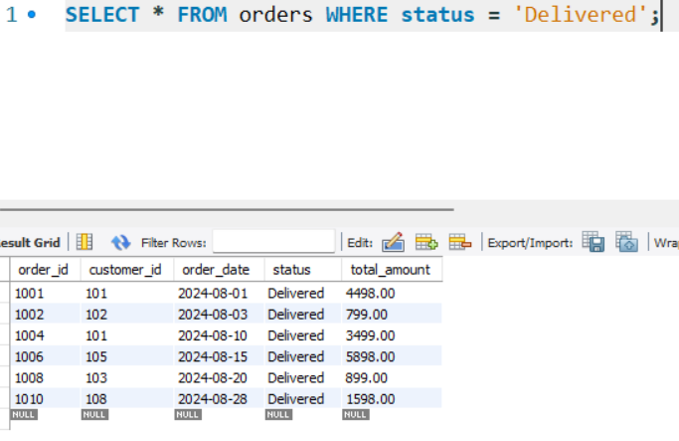

Q8. Find all products in the 'Electronics' category with a unit_price greater than ₹2000.

Ans- SELECT * FROM products WHERE category = 'Electronics' AND unit_price > 2000;

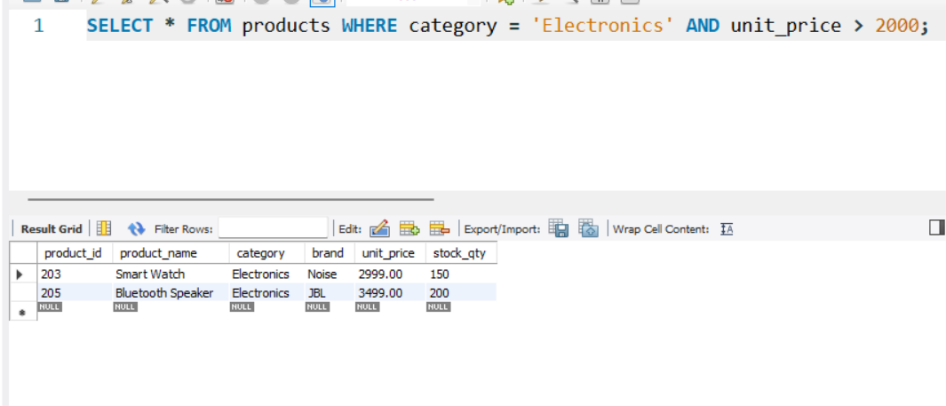

Q9. List all customers who joined in the year 2024 and belong to the state 'Maharashtra'.

Ans- SELECT * FROM customers WHERE EXTRACT(YEAR FROM join_date) = 2024 AND state = 'Maharashtra';

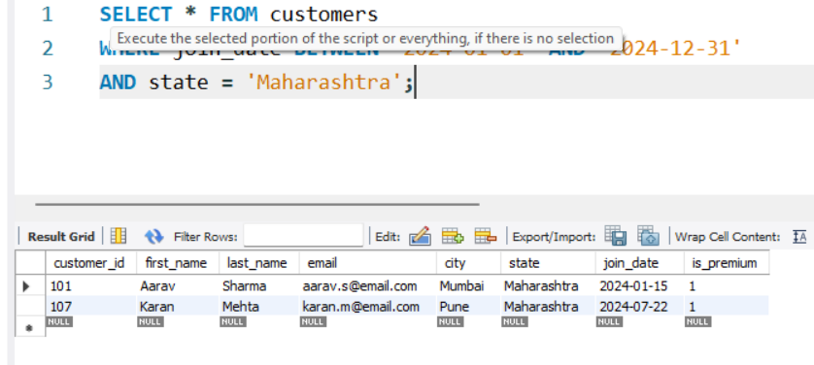

Q10. Find all orders placed between '2024-08-10' and '2024-08-25' (inclusive) that are NOT cancelled.

Ans- SELECT * FROM orders WHERE order_date BETWEEN '2024-08-10' AND '2024-08-25' AND status != 'Cancelled';

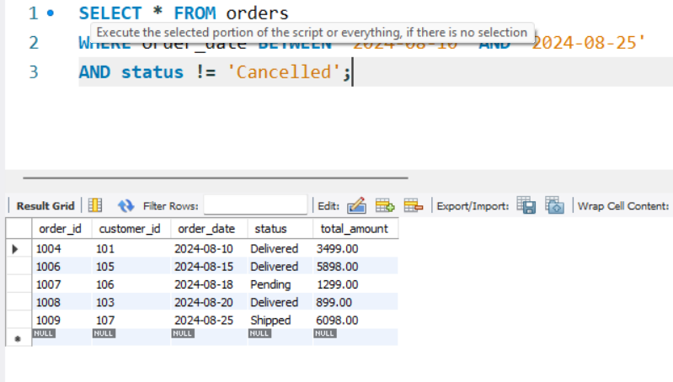

Q11. Explain what the index idx_orders_date does. How would it improve the performance of a query that filters orders by order_date? Write a sample query that would benefit from this index.
Ans- The index idx_orders_date creates a sorted underlying data structure (typically a B tree)organized by the order_date. Without it,finding orders on a specific date requires canning every row in the table (a full table scan). With the index, the database can rapidly seek directly to the matching dates, drastically improving read performance. Sample Query benefiting from it: SELECT * FROM orders WHERE order_date = '2024-08-15';

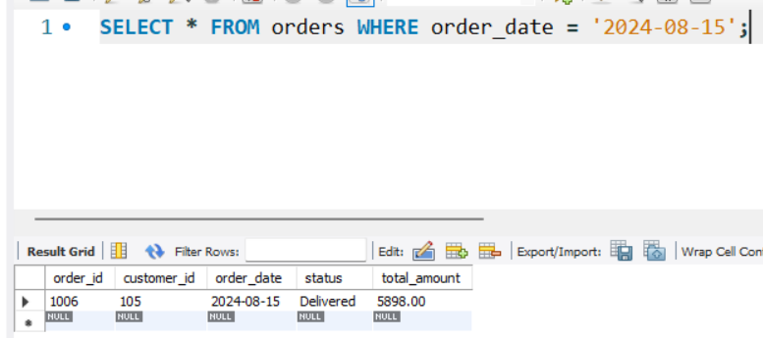

Q12. If you run: SELECT * FROM customers WHERE YEAR(join_date) = 2024; — would the index on join_date be used? Explain why or why not, and rewrite the query to be index-friendly (SARGable).

Ans- No, the index would likely not be used. Wrapping a column in a function like YEAR() makes the condition non-SARGable (Search Argument Able). The database optimizer is forced to calculate the function for every single row before it can compare the result, bypassing the index. Index-friendly

Query: SELECT * FROM customers WHERE join_date >= '2024-01-01' AND join_date <= '2024-12-31';

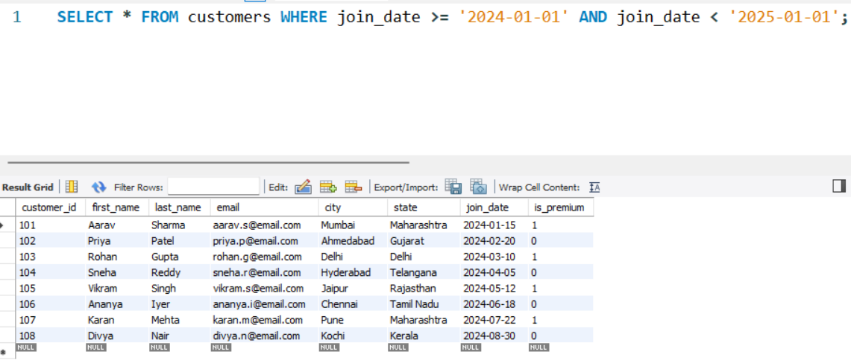

Section C — Aggregation (GROUP BY, SUM, COUNT, AVG, MIN, MAX)
Q13. Count the total number of orders in the orders table.

Ans- SELECT COUNT(*) AS total_orders FROM orders;

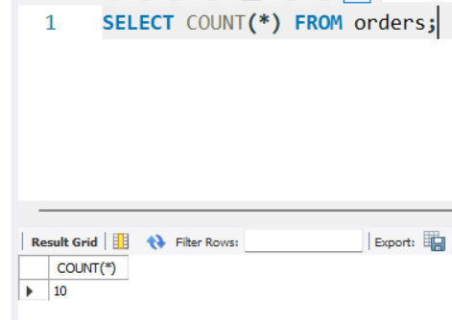

Q14. Find the total revenue (SUM of total_amount) from all 'Delivered' orders.

Ans- SELECT SUM(total_amount) AS total_revenue
FROM orders
WHERE status = 'Delivered';

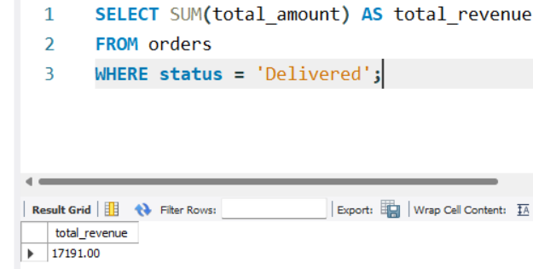

Q15. Calculate the average unit_price of products in each category.

Ans- SELECT category, AVG(unit_price) AS avg_price
FROM products
GROUP BY category;

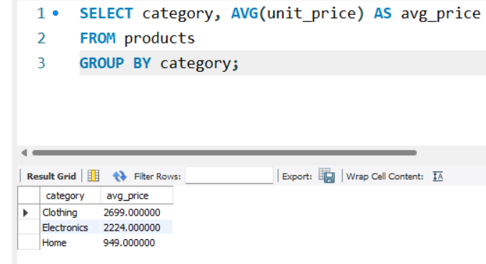

Q16. For each order status, find the count of orders and the total revenue. Sort the result by total revenue in descending order.

Ans- SELECT status, COUNT(*) AS order_count, SUM(total_amount) AS total_revenue
FROM orders
GROUP BY status
ORDER BY total_revenue DESC;

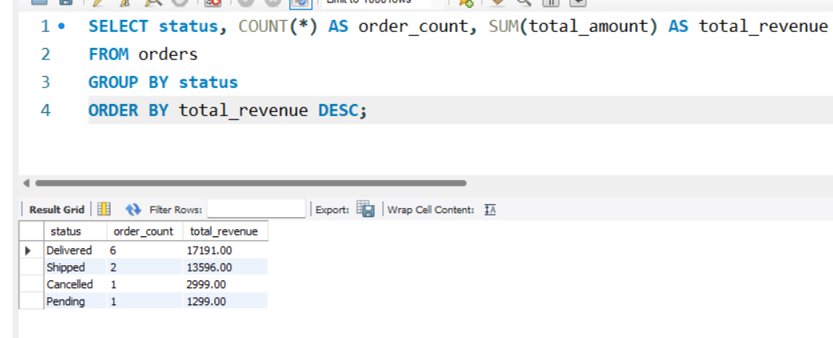

Q17. Find the most expensive (MAX) and cheapest (MIN) product in each category.

Ans-SELECT category, MAX(unit_price) AS max_price, MIN(unit_price) AS min_price
FROM products
GROUP BY category;

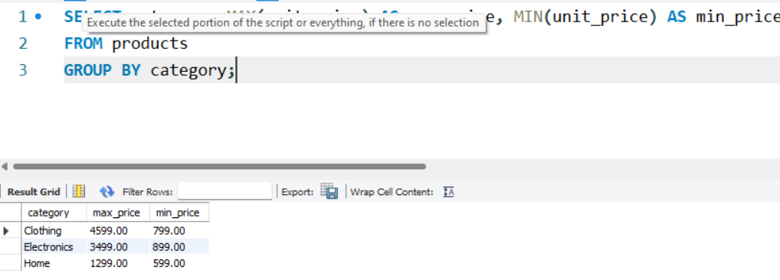

Q18. List all product categories where the average unit_price is greater than ₹2000. (Hint: Use HAVING clause)

Ans- SELECT category FROM products GROUP BY category HAVING AVG(unit_price) > 2000;

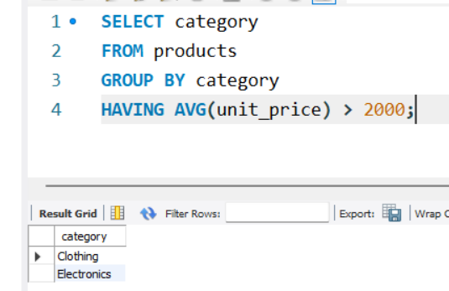

Section D — Joins & Relationships
.
Q19. Write an INNER JOIN query to display each order along with the customer's first_name and last_name. Show: order_id, order_date, first_name, last_name, total_amount.

Ans- SELECT o.order_id, o.order_date, c.first_name, c.last_name, o.total_amount
FROM orders o
INNER JOIN customers c ON o.customer_id = c.customer_id;

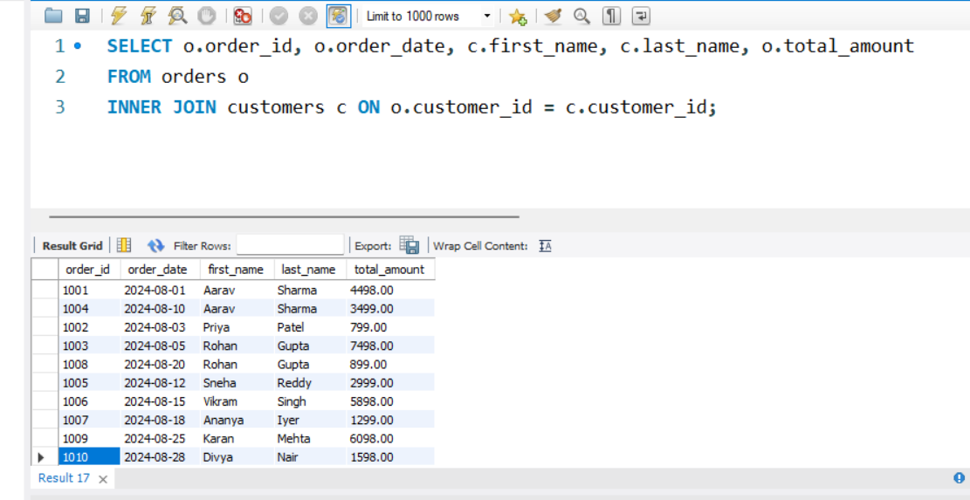

Q20. Using a LEFT JOIN, list ALL customers and their orders (if any). Customers with no orders should still appear with NULL values for order columns.

Ans-SELECT c.first_name, c.last_name, o.* FROM customers c
LEFT JOIN orders o ON c.customer_id = o.customer_id;

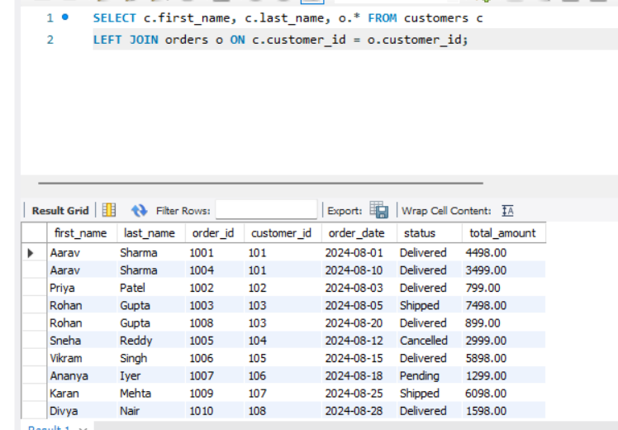

Q21. Write a query using JOINs across three tables (orders → order_items → products) to show: order_id, product_name, quantity, unit_price, and discount_pct for each order item.

Ans- SELECT o.order_id, p.product_name, oi.quantity, oi.unit_price, oi.discount_pct
FROM orders o
JOIN order_items oi ON o.order_id = oi.order_id
JOIN products p ON oi.product_id = p.product_id;

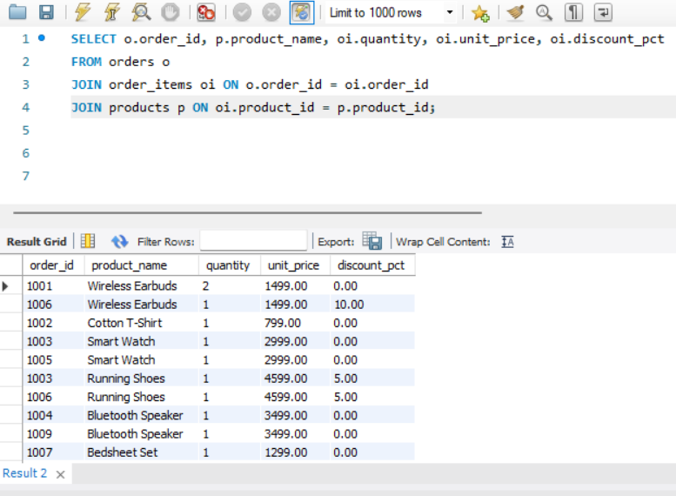

Q22. Explain the difference between LEFT JOIN and RIGHT JOIN with an example from this schema. When would you use a FULL OUTER JOIN?

Ans-
LEFT JOIN: Returns all records from the left table (customers), and matched records from the right (orders). If a customer hasn't bought anything, they still show up with NULL for order details.
RIGHT JOIN: Returns all records from the right table (orders). If you swapped the tables (orders RIGHT JOIN customers), you get the exact same result as above.
FULL OUTER JOIN: Used when you want all records from both tables, regardless of a match. This is helpful for total reconciliation (e.g., finding customers with no orders AND orders with orphaned customer IDs).

Q23. Identify all Foreign Key relationships in the schema. Explain what would happen if you tried to insert an order with customer_id = 999 (which doesn't exist in customers).

Ans-
• Foreign Keys: orders.customer_id (references customers), order_items.order_id (references orders), order_items.product_id (references products).
• Error Explanation: Inserting an order with customer_id = 999 will fail because 999 does not exist in the parent customers table. The Foreign Key constraint enforces referential integrity, blocking orphaned records.

Section E — Advanced Concepts (CASE, ACID, Transactions)
Q24. Write a query using CASE to classify products into price tiers:
• 'Budget' → unit_price < 1000
• 'Mid-Range' → unit_price BETWEEN 1000 AND 3000
• 'Premium' → unit_price > 3000
Display: product_name, unit_price, price_tier.

Ans-
SELECT product_name, unit_price,
CASE
WHEN unit_price < 1000 THEN 'Budget'
WHEN unit_price BETWEEN 1000 AND 3000 THEN 'Mid-Range'
ELSE 'Premium'
END AS price_tier
FROM products;

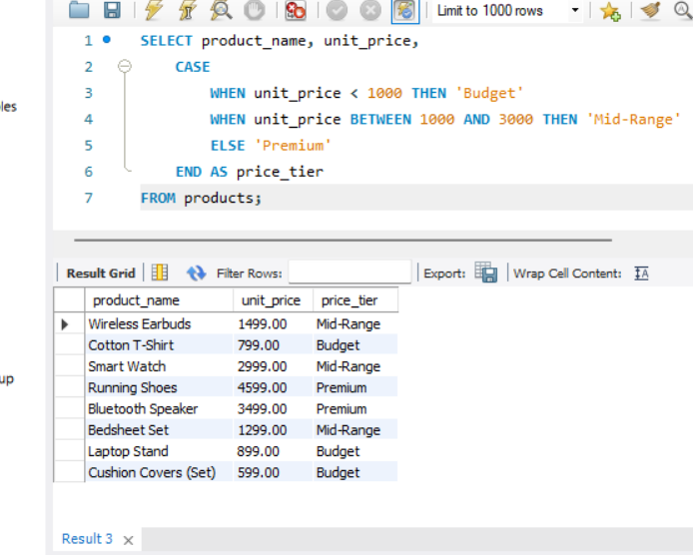

Q25. Using a CASE statement inside an aggregate function, count how many orders are 'Delivered' vs 'Not Delivered' (all other statuses). Display the result in a single row.

Ans-

SELECT
SUM(CASE WHEN status = 'Delivered' THEN 1 ELSE 0 END) AS delivered_orders,
SUM(CASE WHEN status != 'Delivered' THEN 1 ELSE 0 END) AS not_delivered_orders
FROM orders;

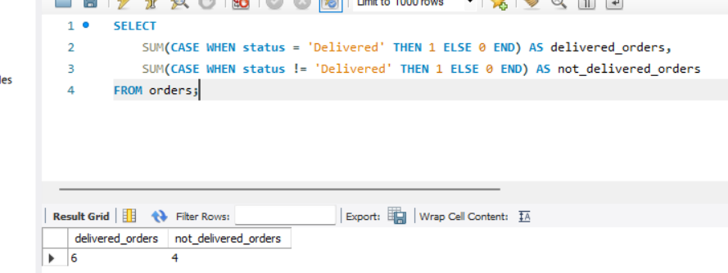

Q26. Explain each letter of ACID:
• A – Atomicity
• C – Consistency
• I – Isolation
• D – Durability
Give a real-world example (e.g., bank transfer) showing why each property is important.

Ans-

• Atomicity: "All or nothing." If you transfer $100 from Account A to B, money must be deducted from A and added to B. If either fails, the whole transaction fails.
• Consistency: The database rules are never broken. B balances can't drop below zero if there's a constraint against negative balances.
• Isolation: Simultaneous transactions don't interfere. If two people try to withdraw $100 from an account with $150 at the same exact millisecond, they are processed sequentially, avoiding overdrafts.
• Durability: Once the transfer says "Complete," it is saved permanently, even if the database server crashes 2 seconds later.

Q27. Write a SQL transaction that does the following atomically:
1. Insert a new order (order_id=1011, customer_id=102, today's date, 'Pending', 1598.00)
2. Insert two order items for that order
3. Update the stock_qty of the purchased products
4. If any step fails, ROLLBACK the entire transaction. Otherwise, COMMIT.
Write the complete BEGIN...COMMIT/ROLLBACK block.
Ans-
START TRANSACTION;
-- 1. Insert new order
INSERT INTO orders (order_id, customer_id, order_date, status, total_amount)
VALUES (1011, 102, CURDATE(), 'Pending', 1598.00);
-- 2. Insert two order items
INSERT INTO order_items (item_id, order_id, product_id, quantity, unit_price, discount_pct)
VALUES (5016, 1011, 202, 1, 799.00, 0),
(5017, 1011, 202, 1, 799.00, 0);
-- 3. Update stock quantity
UPDATE products
SET stock_qty = stock_qty - 2
WHERE product_id = 202;
-- 4. COMMIT if successful (Use ROLLBACK instead of COMMIT to undo if you encounter an error)
COMMIT;
