FINAL INTERNSHIP PROJECT REPORT
Comprehensive Data Analysis, Visualization and Predictive Modeling Using R
Virtual R Data Analyst Internship | Yuva Learn Platform, Pune
Student Name: Rahul Kundu
Internship Project Duration: Weeks 1–4
Dataset: Titanic Passenger Dataset

Executive Summary
This final report integrates the four-week data analytics project completed using the Titanic passenger dataset. The work progressed through data cleaning and preliminary analysis, visualization and insight communication, statistical hypothesis testing, and predictive modeling. R and RStudio were selected as the primary analytical environment. The report presents the workflow, key findings, model performance, limitations, and recommendations in a single document for both technical and non-technical readers.

1. Introduction
The purpose of this project was to demonstrate an end-to-end data analytics workflow: prepare raw data, explore patterns, communicate insights visually, test statistical relationships, and develop a predictive model. The Titanic dataset is a useful learning dataset because it contains numerical and categorical passenger attributes and a binary outcome variable, Survived. The analysis is observational; results identify associations and predictive patterns rather than causal effects.

2. Dataset Overview and Selection Rationale
The project uses the public Titanic passenger training dataset. It contains 891 passenger records and variables such as passenger class (Pclass), sex, age, family counts (SibSp and Parch), fare, embarkation point (Embarked), and survival status (Survived). The dataset was selected because it is well suited to data cleaning, categorical and numerical visualization, hypothesis testing, and binary classification.

3. Integrated Methodology

3.1 Week 1 – Data Cleaning and Preliminary Analysis
The initial dataset was inspected using str(), summary(), and missing-value counts. Age contained 177 missing values (19.87%), Cabin contained 687 missing values (77.10%), and Embarked contained 2 missing values (0.22%). Cabin was excluded from the retained analytical feature set because of its high proportion of missing values. Age was imputed using the median (28), while Embarked was imputed using its mode (S). The retained analysis columns had no missing values after cleaning. IQR-based screening flagged 66 Age observations and 116 Fare observations as potential outliers; they were retained because extreme values may represent genuine passengers and should not be removed automatically. Numeric normalization and categorical encoding were also explored.
The analysis retained 891 records and found 342 survivors and 549 non-survivors. The overall survival proportion was approximately 38.38%. No exact duplicate records were removed.

3.2 Week 2 – Data Visualization and Insight Communication
The second week focused on communicating distributions and relationships through histograms, bar charts, box plots, scatter plots, density plots, and a correlation heatmap. The visual analysis highlighted a strong descriptive difference in survival by gender and passenger class. Female survival was approximately 74.20%, compared with 18.89% for male passengers. Survival rates by passenger class were approximately 62.96% for First Class, 47.28% for Second Class, and 24.24% for Third Class. These are descriptive comparisons and should not be interpreted as proof of causation.

3.3 Week 3 – Statistical Analysis and Predictive Modeling
The third week added formal hypothesis tests and a logistic regression classifier. Chi-square tests assessed associations between survival and gender, and survival and passenger class. Age was checked for normality and compared across survival groups using an appropriate two-sample procedure. Fare was compared using the Wilcoxon rank-sum test due to its skewed distribution. Spearman correlation was used to assess monotonic relationships among numerical predictors.
The classification target was Survived, encoded as a binary outcome. Predictors included Pclass, Sex, Age, SibSp, Parch, Fare, and Embarked. The data was split using stratified sampling into 80% training and 20% test subsets. Five-fold stratified cross-validation was performed on the training set. The logistic regression model was evaluated on the held-out test set.

4. Statistical Results
Hypothesis comparison | Test | P-value | Decision
Gender vs survival | Chi-square | 1.1974e-58 | Reject H0
Passenger class vs survival | Chi-square | 4.5493e-23 | Reject H0
Age among survivors vs non-survivors | Welch two-sample t-test | 0.058309 | Fail to reject H0
Fare among survivors vs non-survivors | Mann-Whitney U | 4.5535e-22 | Reject H0
At the 0.05 significance level, the reference analysis rejected the null hypotheses for gender versus survival, passenger class versus survival, and fare distributions across survival groups. It did not reject the null hypothesis for the age comparison in the reference test. Statistical significance indicates evidence of association or distributional difference under the test assumptions; it does not establish a causal relationship.

5. Predictive Model Performance
Evaluation metric | Reference result
Accuracy | 0.8045
Precision | 0.7931
Recall | 0.6667
F1-score | 0.7244
ROC-AUC | 0.8432
Mean 5-fold CV ROC-AUC | 0.8528
SD 5-fold CV ROC-AUC | 0.0217
The reference test-set model achieved approximately 80.45% accuracy, 79.31% precision, 66.67% recall, 72.44% F1-score, and 84.32% ROC-AUC. The mean five-fold cross-validation ROC-AUC was approximately 85.28% (standard deviation 2.17%). The model demonstrates useful discriminatory ability, while recall indicates that some passengers who survived were not identified at the default probability threshold of 0.50.

6. Visual Results
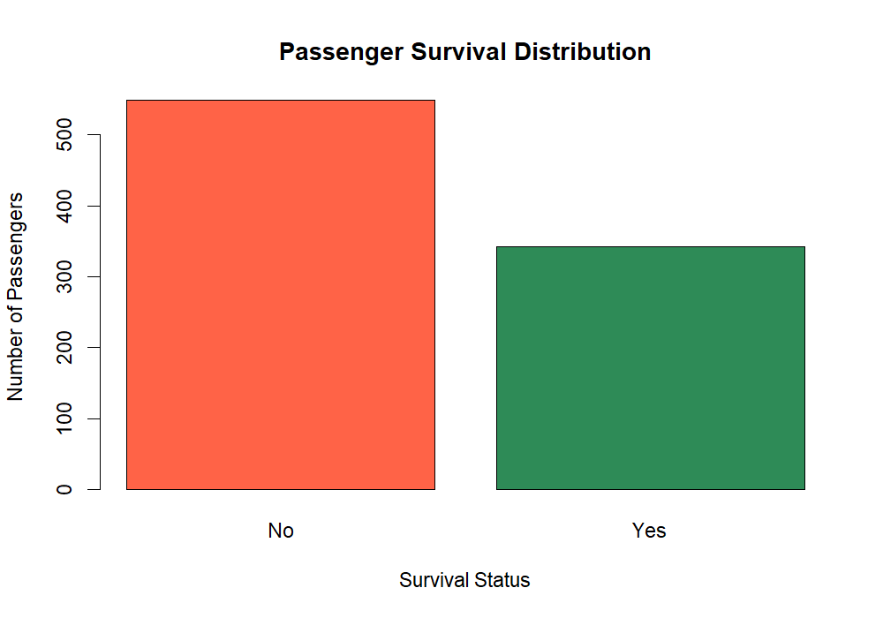
Week 1: Survival distribution
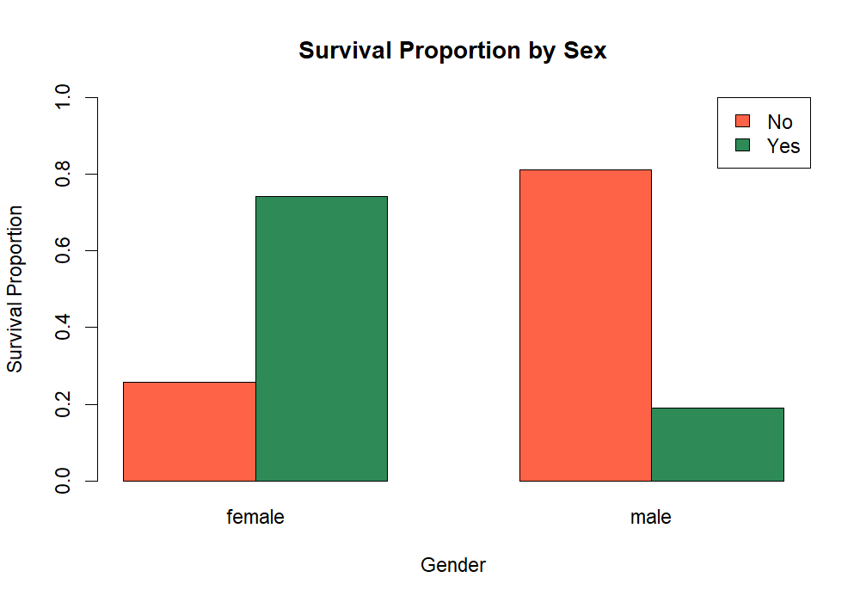
Week 1: Survival by sex
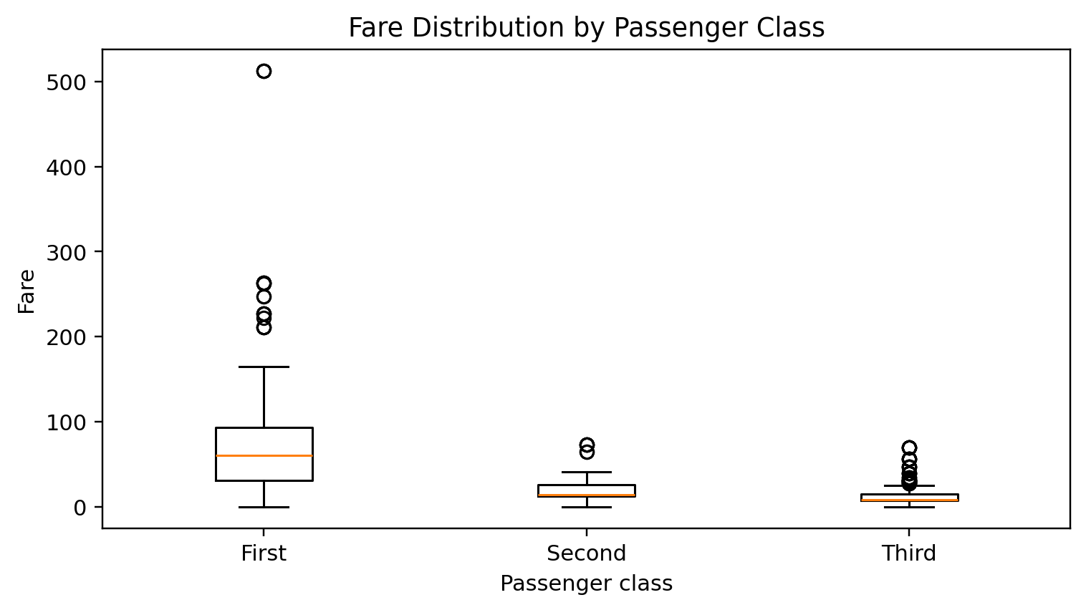
Week 2: Fare distribution by passenger class
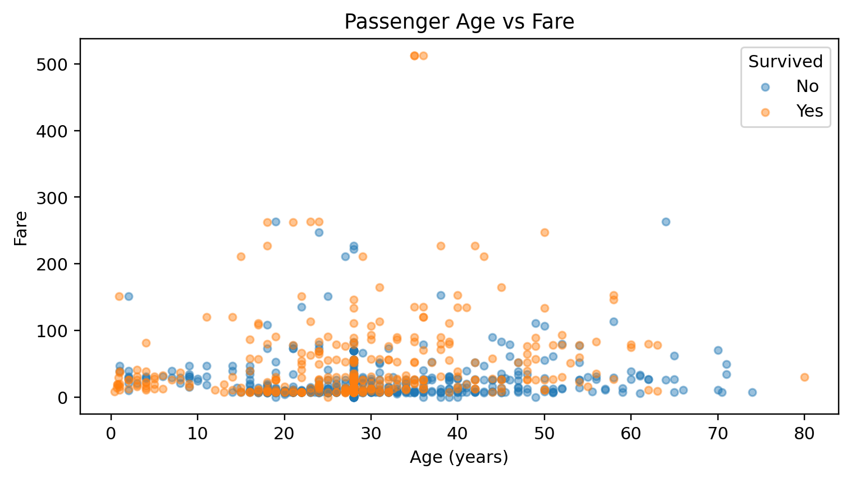
Week 2: Age versus fare
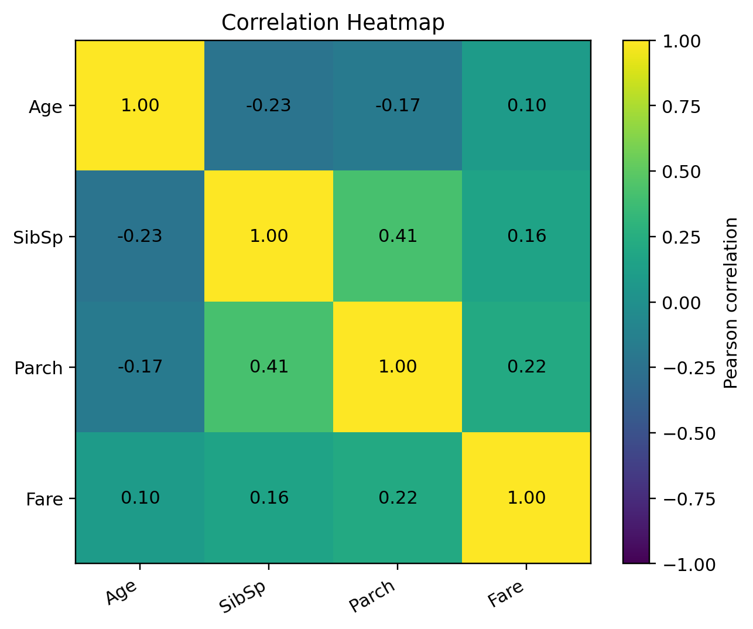
Week 2: Correlation heatmap
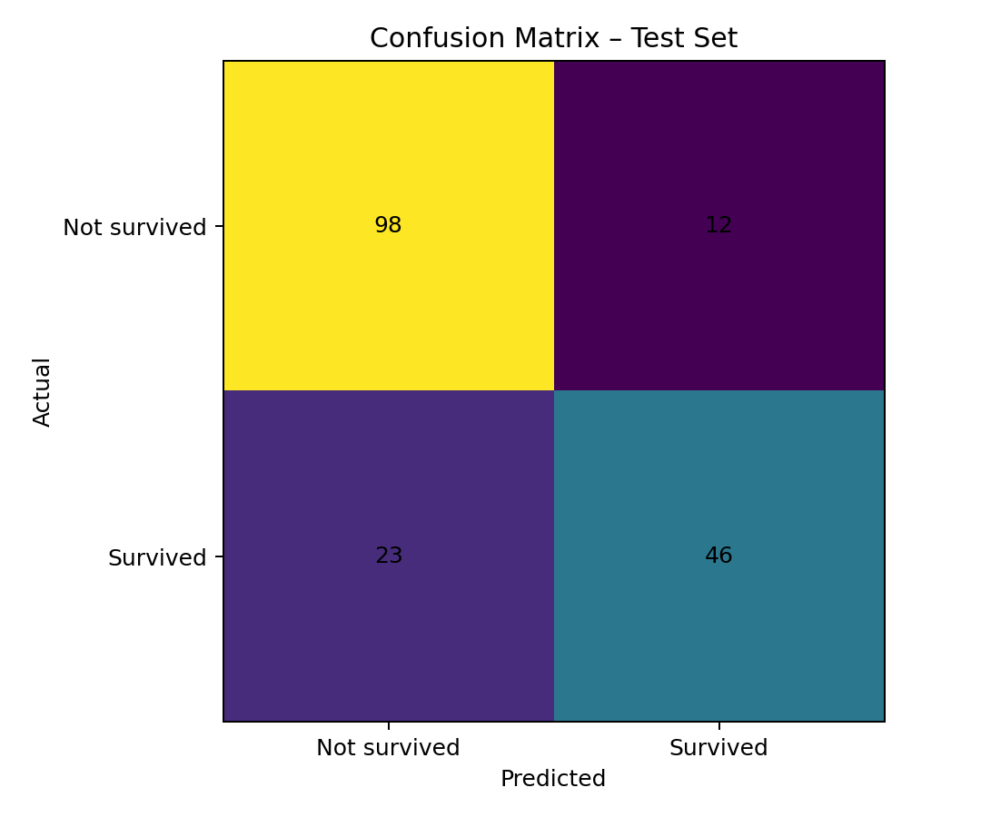
Week 3: Confusion matrix
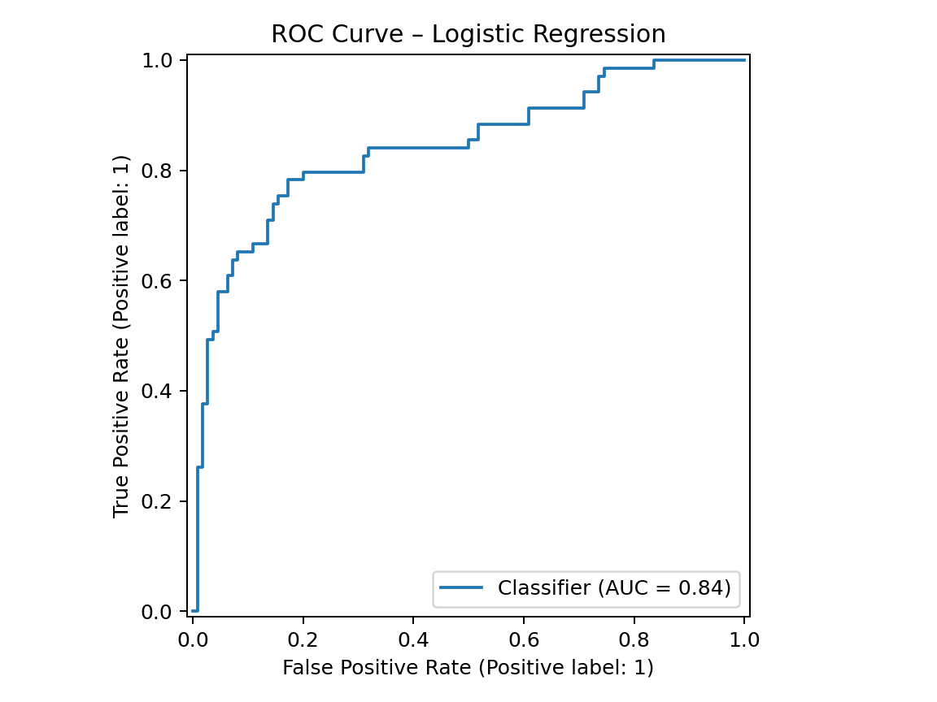
Week 3: ROC curve
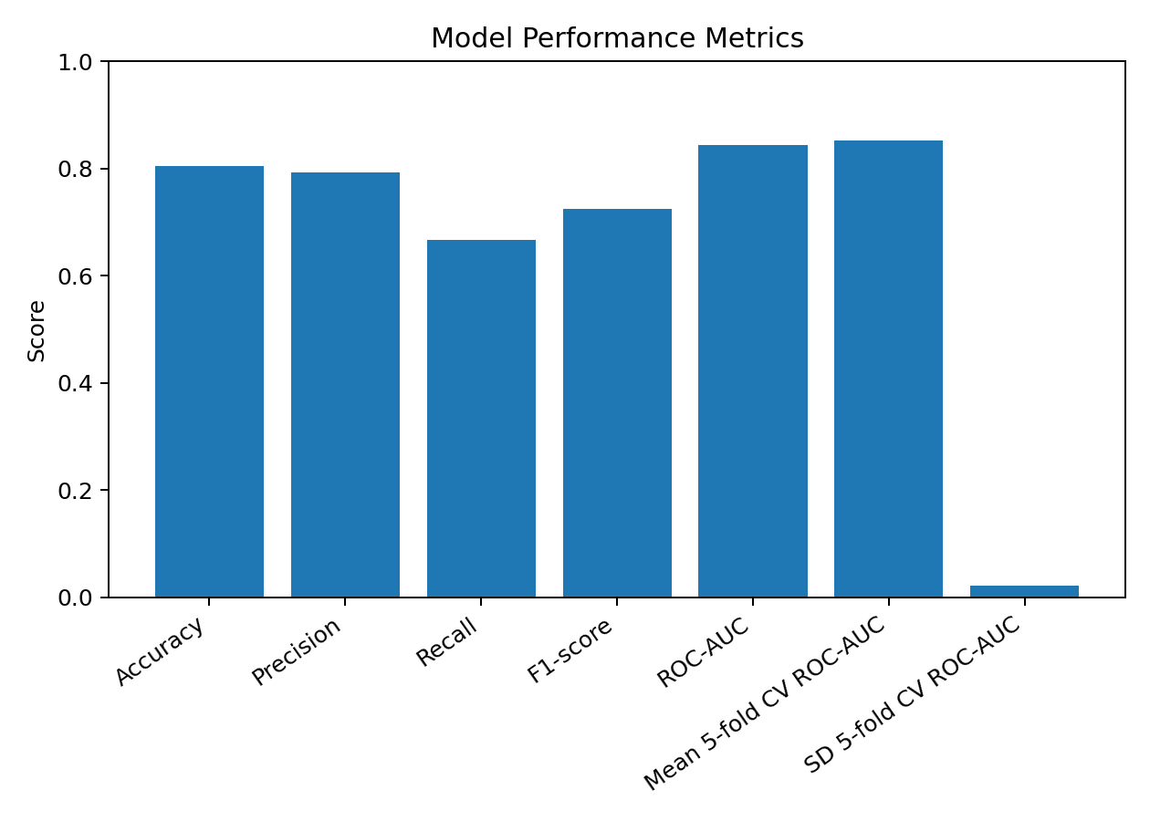
Week 3: Model performance metrics

7. R Code Highlights
The following excerpts illustrate the main analytical techniques. The complete scripts for each week are included in the accompanying project archive.
Data inspection and cleaning:
# Inspect data and summarize variables
str(titanic)
summary(titanic)
# Impute missing numerical and categorical values
titanic$Age[is.na(titanic$Age)] <- median(titanic$Age, na.rm = TRUE)
# Impute Embarked using its most frequent category
Logistic regression and cross-validation:
set.seed(42)
ctrl <- trainControl(method = "cv", number = 5,
classProbs = TRUE,
summaryFunction = twoClassSummary)
model <- train(Outcome ~ Pclass + Sex + Age + SibSp +
Parch + Fare + Embarked,
data = train_data, method = "glm",
family = binomial(), trControl = ctrl,
metric = "ROC")
Model evaluation:
predicted_prob <- predict(model, test_data, type = "prob")[, "Yes"]
predicted_class <- factor(ifelse(predicted_prob >= 0.5, "Yes", "No"),
levels = c("Yes", "No"))
confusionMatrix(predicted_class, test_data$Outcome,
positive = "Yes")

8. Discussion and Practical Implications
The descriptive and inferential results consistently indicate that passenger gender and class were strongly associated with survival in this dataset. For a non-technical audience, the central insight is that survival outcomes were not evenly distributed across passenger groups. The predictive model combines several passenger attributes to estimate survival probability, but it should be understood as a historical analytical exercise rather than a tool for real-world decisions. The model is useful for demonstrating how data can support evidence-based interpretation and prediction.

9. Challenges Encountered and Lessons Learned
Key challenges included handling missing values without discarding too much information, deciding how to treat potential outliers, selecting suitable statistical tests, converting categorical variables for modeling, and evaluating a classifier beyond accuracy alone. The project reinforced the importance of keeping training and test data separate, using cross-validation, checking model assumptions, documenting data transformations, and interpreting statistical results cautiously. It also demonstrated that clear visual communication is essential for making technical findings accessible.

10. Limitations and Future Directions
The dataset is historical, limited in size, and may contain sampling and recording biases. Age imputation may affect age-based analysis, and a single train/test split can produce results that vary with the random seed. Future improvements include repeated cross-validation, threshold tuning, calibration assessment, feature interaction analysis, and comparison with decision trees, random forests, and other classifiers. Additional external data would be needed to assess generalizability.

11. Conclusion
Across four weeks, this project completed an end-to-end analytical workflow using R: data preparation, exploratory analysis, visualization, statistical testing, and predictive modeling. The work produced interpretable descriptive findings and a logistic regression model with useful test-set discrimination. The most important lesson is that reliable data analysis depends not only on algorithms, but also on data quality, appropriate methods, transparent evaluation, and clear communication. A data-driven approach helps transform raw records into structured evidence that can inform understanding and further investigation.

12. Reproducibility and Submission Checklist
1. Extract the complete Week 4 project ZIP.
2. Open the Week 1, Week 2, and Week 3 R scripts in RStudio and run them from their respective project folders.
3. Confirm that generated outputs and graphs are present.
4. Replace [Enter your full name] and add the submission date.
5. Capture screenshots of R code, console output, statistical tests, and model diagnostics.
6. Upload the consolidated project to a public GitHub repository and add the repository URL to the final submission.
Data integrity note: Week 3 model metrics and charts in this integrated report are reference results computed from the supplied cleaned Titanic dataset using a stratified 80/20 split and fixed random seed. Run the included R script in RStudio and use its locally generated outputs as the final submission values if package versions or implementation details cause differences.

