WEEK 3: STATISTICAL ANALYSIS AND PREDICTIVE MODELING USING R
Project: Titanic Survival Prediction Using Logistic Regression
Virtual R Data Analyst Internship | Yuva Learn Platform, Pune
Student Name: [Enter your full name]

1. Introduction and Objective
The objective of this project is to perform statistical analysis, formulate and test hypotheses, and develop a classification model in R to predict passenger survival. Logistic regression is selected because the response variable, Survived, has two categories: survived and did not survive.

2. Dataset Selection and Rationale
The Titanic passenger dataset is reused from Weeks 1 and 2 to maintain continuity. It contains passenger-level demographic and travel information. The cleaned dataset contains 891 records. The target variable is Survived (Yes/No); predictors include passenger class, sex, age, number of siblings/spouses, number of parents/children, fare, and embarkation point. The dataset is suitable because it includes numerical and categorical predictors and a binary outcome.

3. Exploratory Statistical Analysis
The dataset contains 891 passenger records, including 342 survivors and 549 non-survivors. The observed survival proportion is 38.38%. Numerical predictors were examined using summary statistics and Spearman correlation. Categorical relationships were examined using contingency tables.

4. Hypothesis Formulation and Testing
The significance level was set at 0.05. The null hypotheses were: (1) survival is independent of gender; (2) survival is independent of passenger class; (3) age distributions/central tendency do not differ by survival outcome; and (4) fare distributions do not differ by survival outcome. Chi-square tests were used for categorical associations. Age was checked with Shapiro-Wilk tests; a two-sample test was selected according to the normality check. The Wilcoxon rank-sum test was used for fare because fare is typically skewed.
Comparison | Test | P-value | Decision
Gender vs survival | Chi-square | 1.1974e-58 | Reject H0
Passenger class vs survival | Chi-square | 4.5493e-23 | Reject H0
Age among survivors vs non-survivors | Welch two-sample t-test | 0.058309 | Fail to reject H0
Fare among survivors vs non-survivors | Mann-Whitney U | 4.5535e-22 | Reject H0
Interpretation: A p-value below 0.05 provides evidence against the corresponding null hypothesis. Statistical association does not establish causation.

5. Predictive Model: Logistic Regression
A logistic regression classifier was developed with Survived as the binary outcome. Predictors were Pclass, Sex, Age, SibSp, Parch, Fare, and Embarked. An 80% training and 20% testing split was created using stratified sampling. Five-fold stratified cross-validation was applied to the training set. Numeric variables were imputed/scaled and categorical variables were one-hot encoded within the modelling pipeline to avoid information leakage.
The final classification threshold was 0.50. Model performance was evaluated on the held-out test set using accuracy, precision, recall, F1-score, and ROC-AUC.
Metric | Test result
Accuracy | 0.8045
Precision | 0.7931
Recall | 0.6667
F1-score | 0.7244
ROC-AUC | 0.8432
Mean 5-fold CV ROC-AUC | 0.8528

6. Model Diagnostics
The confusion matrix compares predicted classes with actual classes. The ROC curve shows the trade-off between sensitivity and false-positive rate across classification thresholds. The AUC summarizes ranking ability: values closer to 1 indicate better separation of the two outcome classes. Logistic regression diagnostic plots and variance inflation factors should also be reviewed when running the supplied R script.
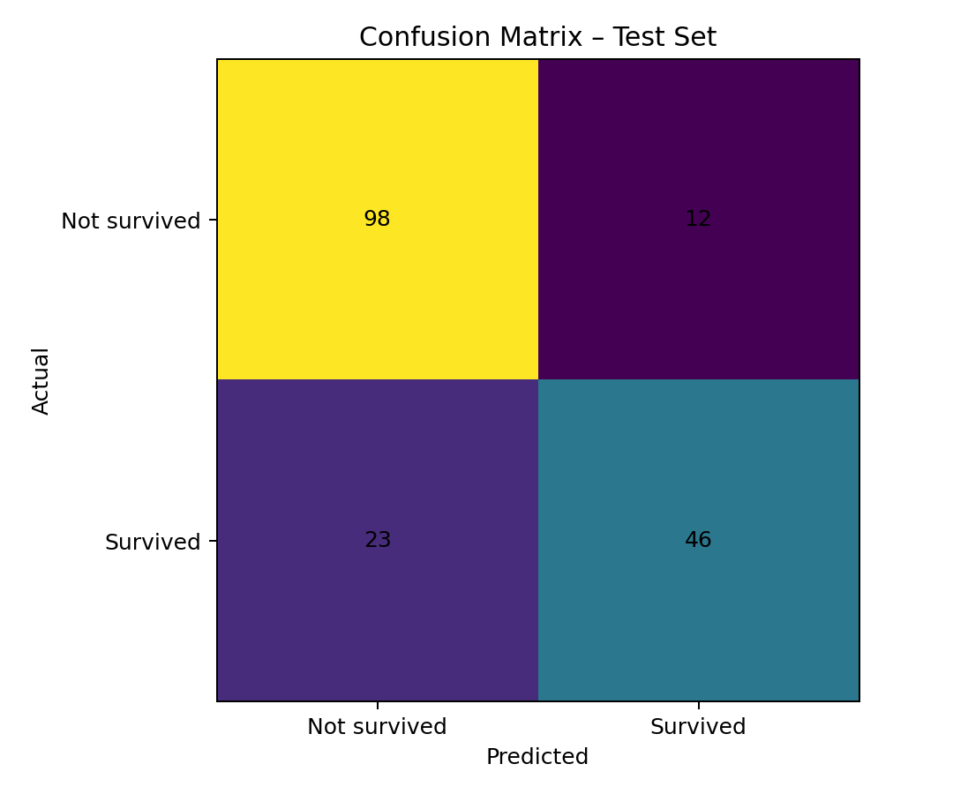
01 Confusion Matrix
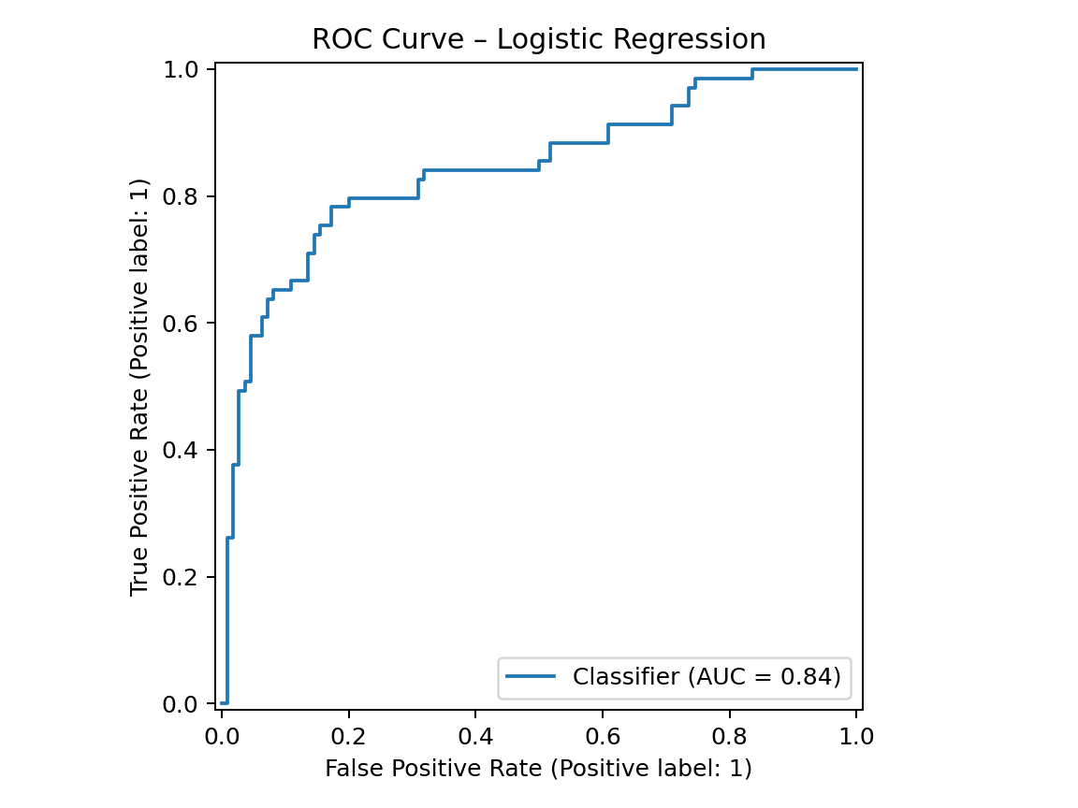
02 ROC Curve
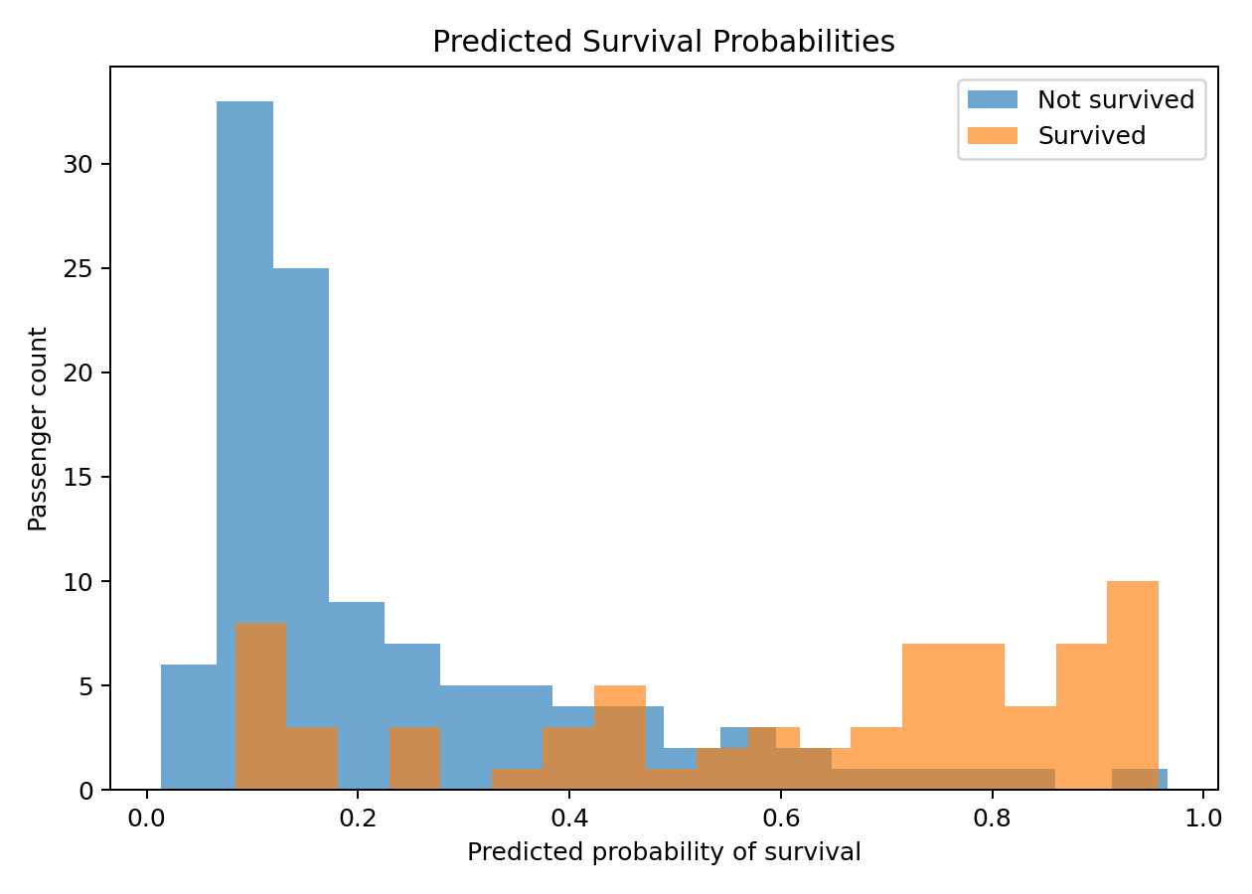
03 Predicted Probabilities
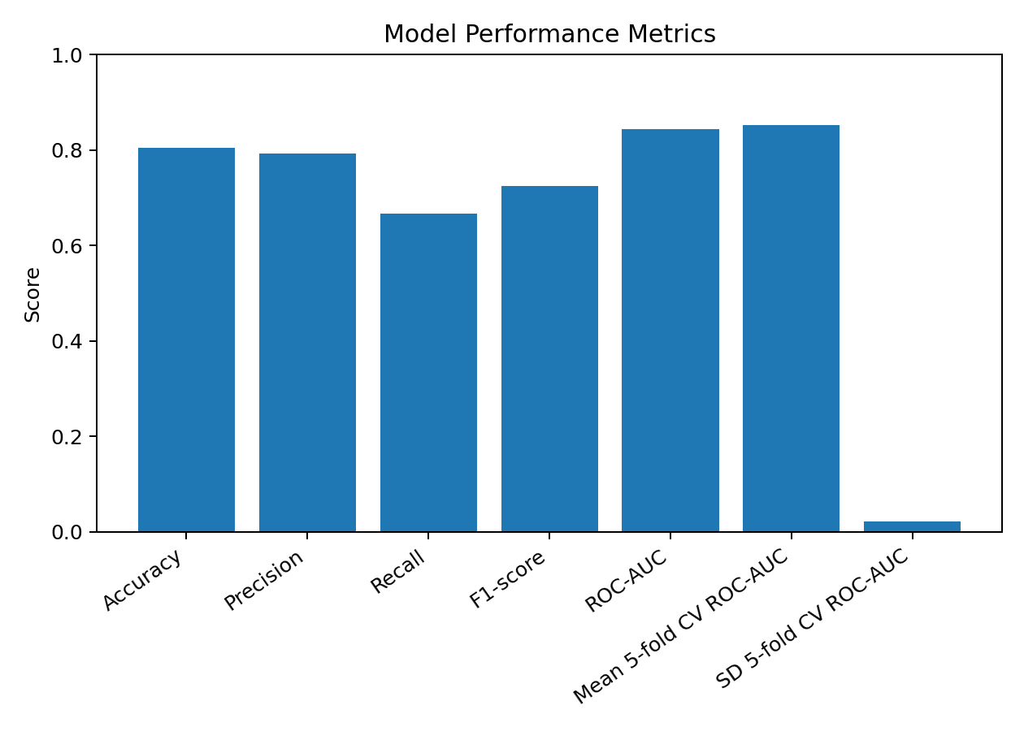
04 Model Performance

7. Interpretation, Strengths, and Limitations
On the held-out test set, the model achieved accuracy of 0.804, precision of 0.793, recall of 0.667, F1-score of 0.724, and ROC-AUC of 0.843. The mean 5-fold cross-validation ROC-AUC on the training data was 0.853 (SD 0.022). These results indicate useful predictive signal, while the recall score shows that some actual survivors may not be identified at the default 0.50 threshold.
Strengths include a clearly defined binary outcome, interpretable model coefficients, stratified validation, and multiple evaluation metrics. Limitations include the historical and relatively small dataset, possible bias in the recorded passenger sample, median-imputed age values inherited from Week 1, and the use of a single train/test split. The model identifies associations and predictive patterns, not causal effects.

8. Potential Improvements
Future work could tune the classification threshold, compare logistic regression with decision trees and random forests, use repeated cross-validation, evaluate calibration, investigate interaction terms (for example, sex by passenger class), and assess feature importance. A separate external dataset would provide a stronger test of generalization.

9. Conclusion
This project applied hypothesis testing and logistic regression to the Titanic dataset. It strengthened practical understanding of statistical inference, classification, cross-validation, model diagnostics, and communication of predictive results. The supplied R script reproduces the workflow and generates statistical outputs and diagnostic plots.

10. Reproducibility and Submission Checklist
Run R_Code/Week3_Statistical_Modeling.R from the project root in RStudio. Install the listed R packages if prompted. Review the generated Outputs and Graphs folders, capture screenshots of the R code and console results, replace the student-name placeholder, and add the public GitHub repository URL before submission.
Important note: The numerical results and charts in this starter report were calculated from the supplied cleaned Titanic data using a matching logistic-regression workflow. Run the provided R script in your own RStudio environment and use its generated results as the final authority if any minor differences occur due to package versions or implementation details.

