WEEK 1 INTERNSHIP PROJECT REPORT
DATA CLEANING AND PRELIMINARY
ANALYSIS WITH R
Titanic Passenger Dataset

Internship | Virtual R Data Analyst Internship
Intern Name | Rahul Kundu
Tools Used | R Programming / RStudio
Submitted as Week 1 task

Executive Summary
This report presents a reproducible data-cleaning and preliminary exploratory analysis of the Titanic passenger training dataset using R. The imported dataset contained 891 passenger records and 12 source variables. The analysis identified missing values in Age, Cabin and Embarked, checked for exact duplicate rows, treated missing values, flagged potential outliers, normalized Age and Fare, encoded categorical variables, and produced descriptive statistics, correlations and visualizations.
After the cleaning workflow, the analysis dataset contained 891 rows and 15 columns, with no missing values in the retained analysis fields. Cabin was excluded because 77.10% of its entries were missing. Median imputation was used for Age and mode imputation for Embarked. The IQR rule flagged 66 Age observations and 116 Fare observations as potential outliers; these were retained rather than automatically removed.

1. Introduction
Data cleaning and exploratory data analysis (EDA) are essential steps in a data analytics workflow. They help assess data quality, make variables suitable for analysis and reveal initial patterns before more advanced modelling. This project uses R to demonstrate these steps on a public Titanic passenger dataset.

2. Objectives
- Import and inspect a public dataset containing numerical and categorical variables.
- Identify missing values and exact duplicate records.
- Apply and document suitable missing-value treatments.
- Detect potential outliers using the interquartile range (IQR) rule.
- Normalize numerical variables and encode categorical variables.
- Generate descriptive statistics, correlations and visual summaries.

3. Dataset Selection and Overview
Dataset: Titanic passenger training dataset, commonly distributed for the Kaggle Titanic survival-prediction exercise. The source file contains 891 records and 12 variables: PassengerId, Survived, Pclass, Name, Sex, Age, SibSp, Parch, Ticket, Fare, Cabin and Embarked.
Source CSV used in the project: https://raw.githubusercontent.com/rebeccabilbro/titanic/master/data/train.csv

Variable | Description | Type
Survived | Passenger survival indicator (0 = No, 1 = Yes) | Categorical / binary
Pclass | Ticket class (1, 2, 3) | Categorical / ordinal
Sex | Passenger sex | Categorical
Age | Passenger age in years | Numeric
SibSp | Number of siblings / spouses aboard | Numeric count
Parch | Number of parents / children aboard | Numeric count
Fare | Passenger fare | Numeric
Embarked | Port of embarkation | Categorical
Cabin | Cabin identifier | Categorical / text

4. Tools and R Functions
The project was run in R/RStudio using base R functions. Key functions included read.csv(), head(), str(), summary(), is.na(), colSums(), duplicated(), median(), table(), quantile(), factor(), model.matrix(), cor(), hist(), boxplot(), barplot() and heatmap().

5. Data Import and Initial Inspection
The source CSV was imported into R. The initial dataset had 891 rows and 12 columns. The str() output identified integer, numeric and character fields. Survived, Pclass, Sex and Embarked were subsequently represented as factors for categorical analysis.
Inspection item | Observed result
Rows in source dataset | 891
Columns in source dataset | 12
Survival outcome | 549 did not survive; 342 survived
Age range after imputation | 0.42 to 80 years
Fare range | 0.00 to 512.3292

R code used:
titanic <- read.csv("Dataset/Original_Dataset.csv", stringsAsFactors = FALSE, na.strings = c("", "NA"))
head(titanic)
str(titanic)
summary(titanic)

6. Missing Value Analysis and Treatment
Missingness was measured with is.na(), colSums() and colMeans(). Before cleaning, Age had 177 missing values (19.87%), Cabin had 687 (77.10%) and Embarked had 2 (0.22%). Cabin was removed from the analysis because the high proportion of missing values made reliable imputation inappropriate. Age was imputed using its median (28 years), while Embarked was imputed using its mode (S).
Variable | Missing before | Missing % before | Treatment | Missing after
Age | 177 | 19.87% | Median imputation (28) | 0
Cabin | 687 | 77.10% | Excluded from analysis | Not retained
Embarked | 2 | 0.22% | Mode imputation (S) | 0

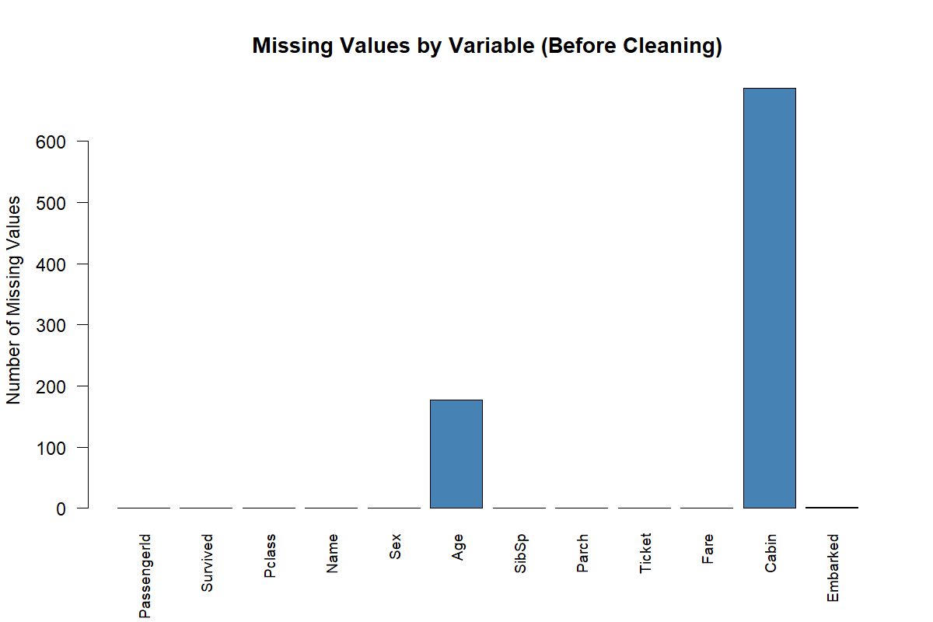
Figure 1. Missing-value counts by variable before cleaning.
Validation: the generated Missing_Values_After.csv file reports zero missing values in all retained analysis columns.

7. Duplicate Record Check
Exact duplicate rows were checked using duplicated() and removed if present. The analysis output retained 891 observations after this step. The script did not report a reduction in row count, indicating that no exact duplicate rows were removed.

8. Outlier Detection
Potential outliers in Age and Fare were identified with the 1.5 × IQR rule. An observation was flagged when it was below Q1 − 1.5 × IQR or above Q3 + 1.5 × IQR. The workflow flagged 66 Age values and 116 Fare values. These records were retained because an outlier flag is an investigation signal, not proof of an invalid observation.
Variable | Potential outliers flagged | Treatment decision
Age | 66 | Flagged; retained for analysis
Fare | 116 | Flagged; retained for analysis

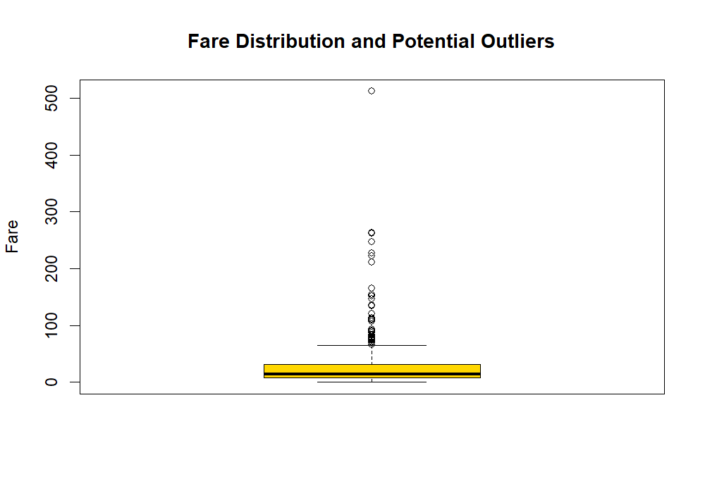
Figure 2. Fare distribution showing potential high-value outliers.

9. Data Normalization
Min-max normalization was applied to Age and Fare using (x − minimum) / (maximum − minimum). The normalized values range from 0 to 1. The original Age and Fare columns were retained, and the scaled values were added as Age_Normalized and Fare_Normalized.
Variable | Original minimum | Original maximum | Normalized minimum | Normalized maximum
Age | 0.42 | 80 | 0 | 1
Fare | 0 | 512.3292 | 0 | 1

10. Categorical Variable Encoding
Survived, Pclass, Sex and Embarked were converted to factors. A separate encoded dataset was generated using model.matrix() for Sex, Pclass and Embarked. This creates numeric indicator (dummy) columns while preserving the readable factor variables in the cleaned dataset. The project package includes Cleaned_Encoded_Dataset.csv.

11. Exploratory Data Analysis
The following visualizations were generated from the cleaned data. The survival distribution shows 342 survivors and 549 non-survivors, corresponding to approximately 38.38% and 61.62% respectively.
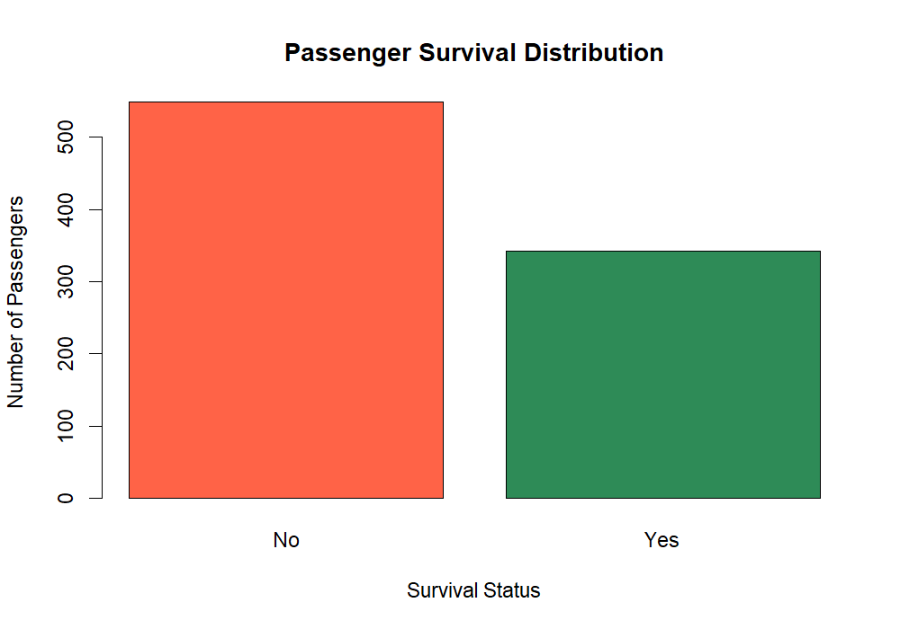
Figure 3. Distribution of survival outcomes.
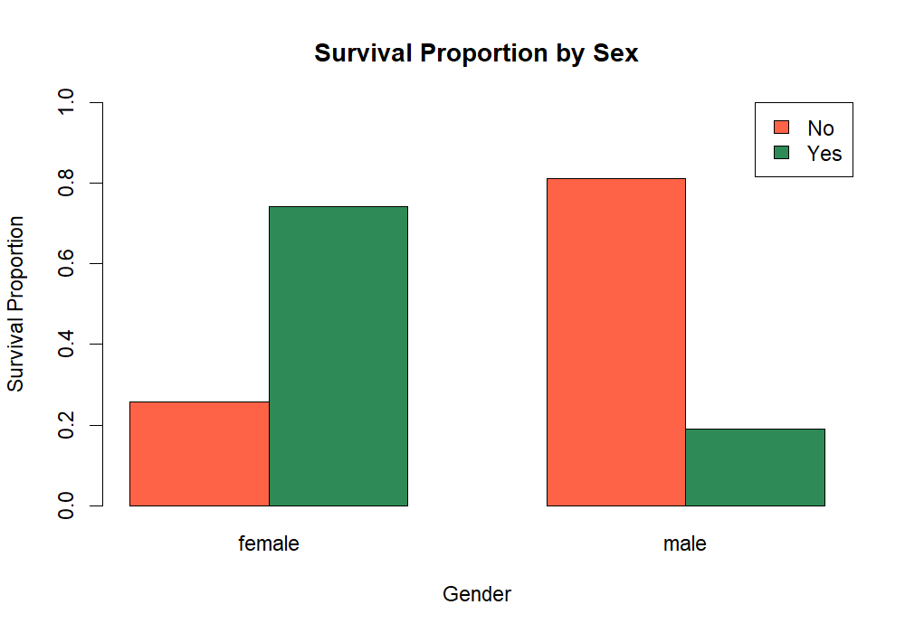
Figure 4. Survival proportions by sex.
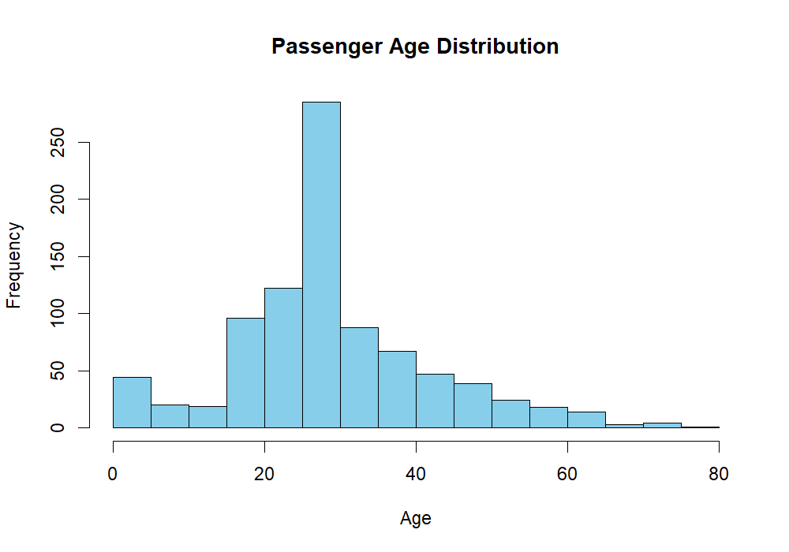
Figure 5. Distribution of passenger ages after median imputation.
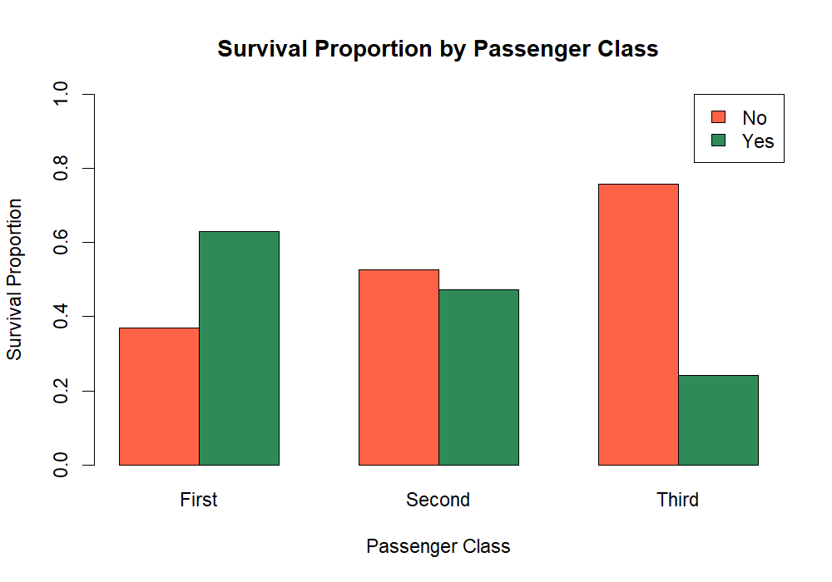
Figure 6. Survival proportions by passenger class.

12. Descriptive Statistics
The descriptive statistics below are calculated from the cleaned dataset. PassengerId is an identifier and should not be interpreted as a meaningful measured quantity.

Variable | Mean | Median | Std. dev. | Min | Max
Age | 29.36 | 28.00 | 13.02 | 0.42 | 80.00
SibSp | 0.52 | 0 | 1.10 | 0 | 8
Parch | 0.38 | 0 | 0.81 | 0 | 6
Fare | 32.20 | 14.45 | 49.69 | 0 | 512.33

13. Correlation Analysis
Pearson correlations were calculated for Age, SibSp, Parch and Fare. The strongest positive relationship in this matrix is between SibSp and Parch (r = 0.415), indicating a moderate positive association between the two family-count variables. Age has weak negative correlations with SibSp (r = −0.233) and Parch (r = −0.172). Fare has weak positive correlations with Age (r = 0.097), SibSp (r = 0.160) and Parch (r = 0.216). Correlation does not imply causation.
 | Age | SibSp | Parch | Fare
Age | 1.000 | −0.233 | −0.172 | 0.097
SibSp | −0.233 | 1.000 | 0.415 | 0.160
Parch | −0.172 | 0.415 | 1.000 | 0.216
Fare | 0.097 | 0.160 | 0.216 | 1.000

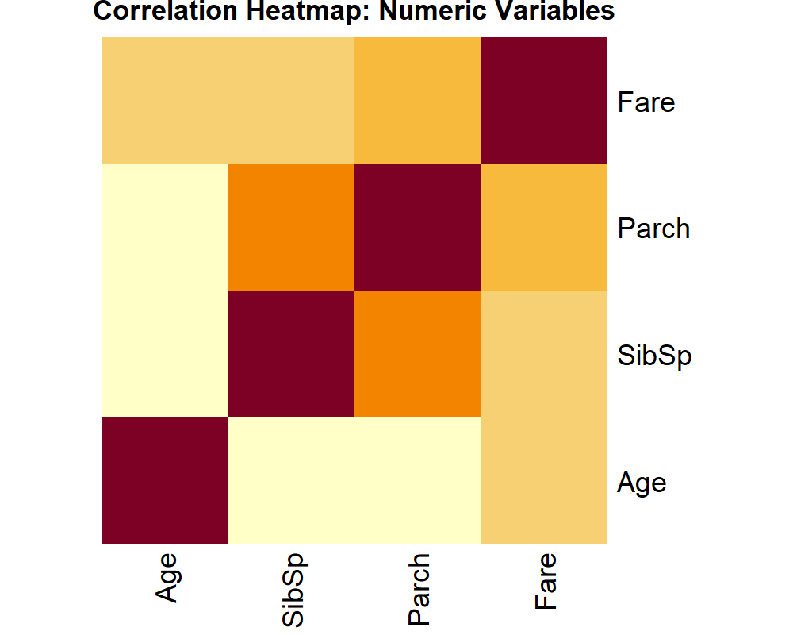
Figure 7. Correlation heatmap for numeric variables.

14. Key Findings and Initial Insights
The following findings are calculated from the supplied project outputs:
Comparison | Survival rate | Interpretation
Female passengers | 74.20% | A substantially higher share of female passengers survived.
Male passengers | 18.89% | A lower share of male passengers survived.
First class | 62.96% | Highest survival proportion among the three classes.
Second class | 47.28% | Intermediate survival proportion.
Third class | 24.24% | Lowest survival proportion among the three classes.

- The cleaned analysis data retained 891 passenger records and contained no missing values in retained columns.
- Cabin had the highest missingness (77.10%) and was excluded rather than imputed.
- Potential outliers were more numerous in Fare (116) than in Age (66).
- Female passengers and first-class passengers had higher observed survival proportions in this dataset.
- The correlation between SibSp and Parch was the strongest pairwise numeric association in the selected matrix (r ≈ 0.415).

15. Conclusion
This project completed the Week 1 data-cleaning and preliminary-analysis workflow using R. The work included data import and inspection, missing-value assessment and treatment, duplicate checking, IQR-based outlier flagging, min-max normalization, categorical factor conversion and dummy encoding, descriptive statistics, correlation analysis and visual EDA. The results suggest clear differences in survival proportions by sex and passenger class, while the numeric correlation matrix shows a moderate positive association between SibSp and Parch. These are descriptive findings from this dataset and should not be interpreted as causal conclusions.

16. Deliverables Included
- Original_Dataset.csv – source data.
- Cleaned_Dataset.csv – cleaned analysis dataset.
- Cleaned_Encoded_Dataset.csv – dataset with encoded categorical fields.
- Week1_Titanic_Analysis.R – R source script.
- Graphs/ – seven exported PNG visualizations.
- Outputs/ – missing-value summaries, descriptive statistics, outlier counts, correlations, survival tables and console output.

17. References
- Titanic training dataset CSV: https://raw.githubusercontent.com/rebeccabilbro/titanic/master/data/train.csv
- Kaggle Titanic competition: https://www.kaggle.com/competitions/titanic
- R Project for Statistical Computing: https://www.r-project.org/

Appendix A. Selected R Code
# Missing value counts
colSums(is.na(titanic))
# Median and mode imputation
age_median <- median(titanic$Age, na.rm = TRUE)
titanic$Age[is.na(titanic$Age)] <- age_median
# IQR outlier limits
q1 <- quantile(titanic$Fare, 0.25, na.rm = TRUE)
q3 <- quantile(titanic$Fare, 0.75, na.rm = TRUE)
iqr_value <- q3 - q1
lower <- q1 - 1.5 * iqr_value
upper <- q3 + 1.5 * iqr_value
# Min-max normalization
(titanic$Fare - min(titanic$Fare)) /
(max(titanic$Fare) - min(titanic$Fare))
# Categorical encoding
model.matrix(~ Sex + Pclass + Embarked - 1, data = titanic)
# Correlation
cor(titanic[, c("Age", "SibSp", "Parch", "Fare")],
use = "pairwise.complete.obs")
Note: The complete executable script is supplied separately as Week1_Titanic_Analysis.R. The tables and charts in this report were populated from the outputs included in the uploaded project ZIP.

