WEEK 2 INTERNSHIP PROJECT REPORT
DATA VISUALIZATION AND
INSIGHT COMMUNICATION USING R
Titanic Passenger Dataset
Project detail | Information
Internship | Virtual R Data Analyst Internship
Intern name | Rahul Kundu
Tools | R, RStudio, ggplot2, dplyr, corrplot

Week 2 Task | Data Visualization and Insight Communication

Executive Summary
This report communicates insights from the Titanic passenger dataset through ten visualizations created for the Week 2 R Data Analyst Internship task. The cleaned Week 1 dataset contains 891 passenger records. The visual analysis examines survival counts and proportions, passenger age and fare distributions, differences by sex and passenger class, embarkation-port patterns, and relationships among numerical variables.
The dataset includes 342 survivors and 549 non-survivors, giving an overall survival proportion of 38.38%. Female passengers had a survival proportion of 74.20%, compared with 18.89% for male passengers. Survival proportions also differed by passenger class: 62.96% in First class, 47.28% in Second class and 24.24% in Third class. These are descriptive patterns in the supplied dataset, not evidence of causation.

1. Introduction
Data visualization converts numerical and categorical information into visual forms that help analysts and non-technical audiences understand distributions, comparisons, relationships and unusual observations. This project uses R and ggplot2 to produce a consistent set of charts and interprets each chart in plain language.

2. Dataset Overview
The analysis continues with the cleaned Titanic passenger dataset from Week 1. It contains 891 passenger records and fields such as Survived, Pclass, Sex, Age, SibSp, Parch, Fare and Embarked. The target variable Survived is represented as No or Yes. Age and Fare are numeric variables; Sex, Pclass and Embarked are categorical variables.
Dataset measure | Value
Passenger records | 891
Survived | 342
Did not survive | 549
Overall survival proportion | 38.38%

3. Tools and Packages
The project uses R and RStudio. The principal packages are ggplot2 for plotting, dplyr for data manipulation, scales for percentage labels and corrplot for the correlation heatmap. The complete executable script is provided separately in R_Code/Week2_Data_Visualization.R.

4. Visualization Design Principles
- Select a chart type that matches the analytical question: bars for category comparisons, histograms and density plots for distributions, scatter plots for relationships, boxplots for spread and outliers, and line charts for ordered age groups.
- Use clear titles, axis labels and legends so charts can be understood independently.
- Use proportions when group sizes differ and counts when showing the overall number of records.
- Interpret patterns carefully and avoid causal claims from descriptive visualizations.

4.1 Passenger Survival Distribution – Bar Chart
Purpose: Compare the total number of passengers who survived with those who did not.
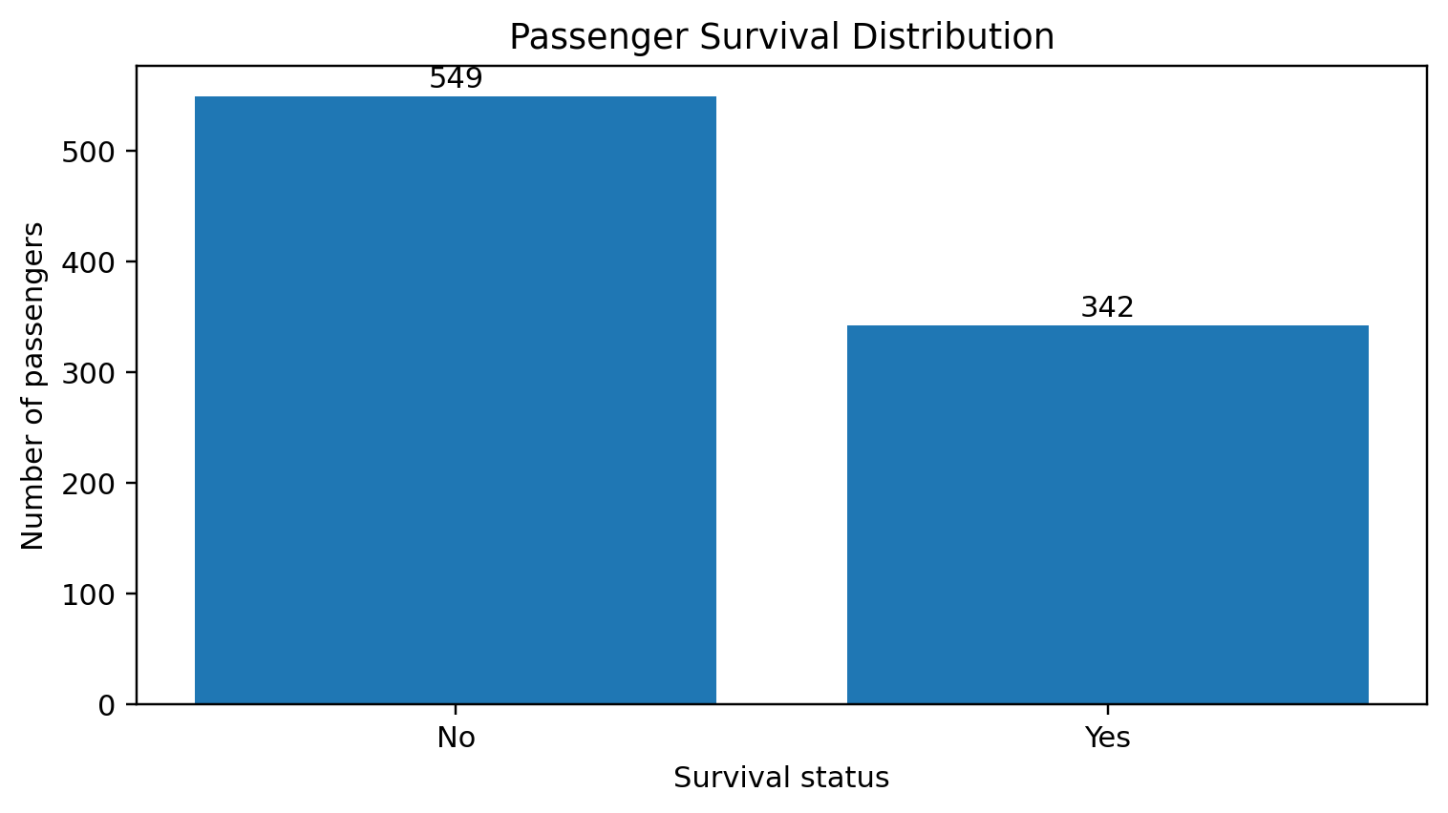
Figure: 4.1 Passenger Survival Distribution – Bar Chart
Interpretation: There were 549 non-survivors and 342 survivors. Thus, 61.62% did not survive and 38.38% survived. A bar chart is suitable because survival status is a categorical variable and the goal is to compare counts.
R code (core plotting statement):
ggplot(titanic, aes(x = Survived, fill = Survived)) + geom_bar()

4.2 Passenger Age Distribution – Histogram
Purpose: Show the frequency distribution of passenger ages.
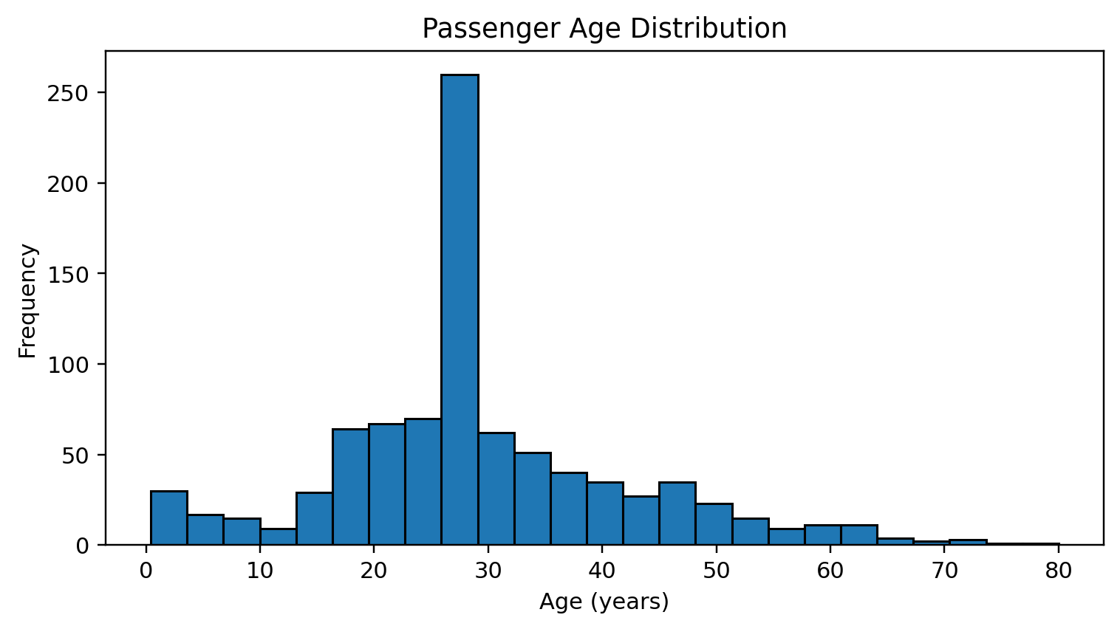
Figure: 4.2 Passenger Age Distribution – Histogram
Interpretation: The histogram shows the concentration and spread of passenger ages. The median age in the cleaned Week 1 data is 28 years and the mean is approximately 29.36 years. Median imputation affects the shape by adding imputed observations at the median, so this should be remembered when interpreting the distribution.
R code (core plotting statement):
ggplot(titanic, aes(x = Age)) + geom_histogram(binwidth = 5)

4.3 Survival Proportion by Sex – 100% Stacked Bar Chart
Purpose: Compare the share of survivors and non-survivors within each sex group.
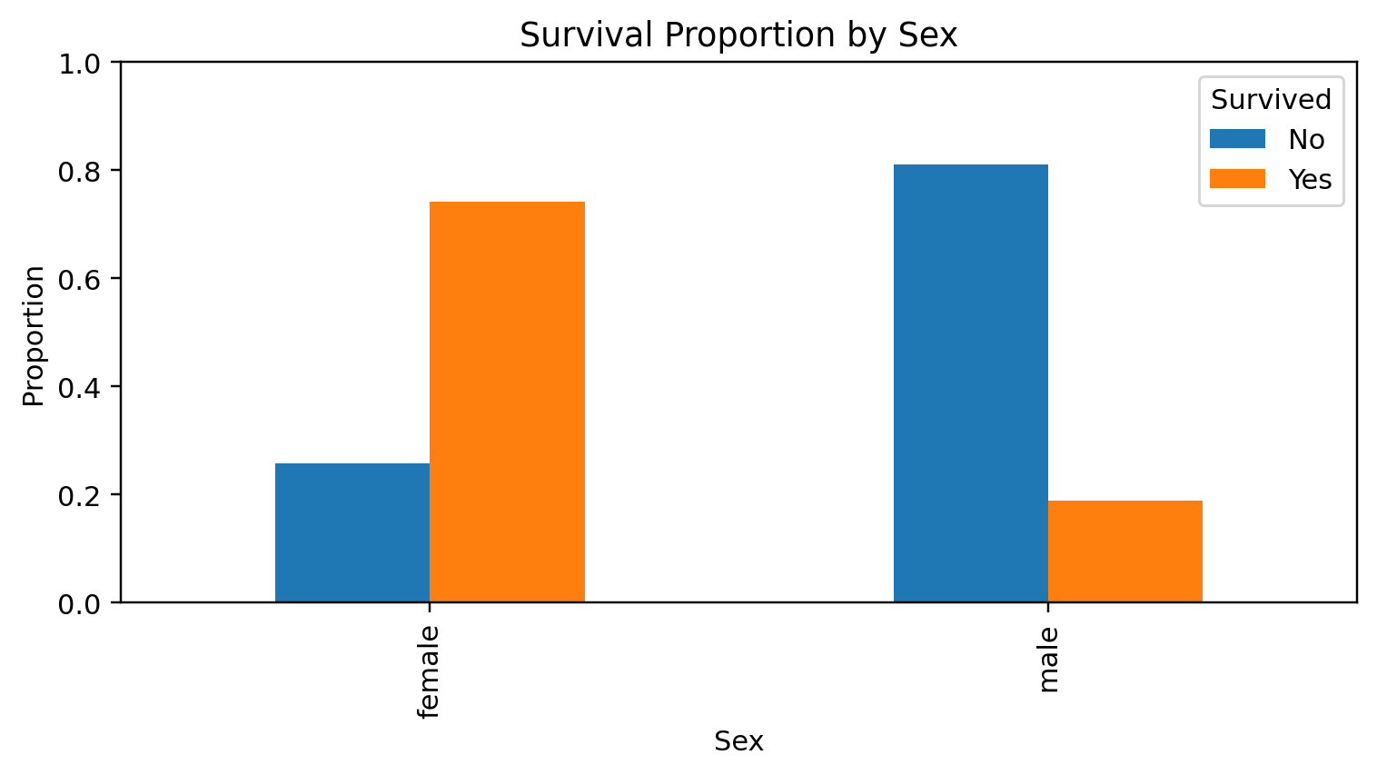
Figure: 4.3 Survival Proportion by Sex – 100% Stacked Bar Chart
Interpretation: The female survival proportion was 74.20%, while the male survival proportion was 18.89%. A 100% stacked bar chart is appropriate because it compares within-group proportions despite different group sizes.
R code (core plotting statement):
ggplot(titanic, aes(x = Sex, fill = Survived)) + geom_bar(position = "fill")

4.4 Fare Distribution by Passenger Class – Boxplot
Purpose: Compare the median, spread and potential extreme values of fares across passenger classes.
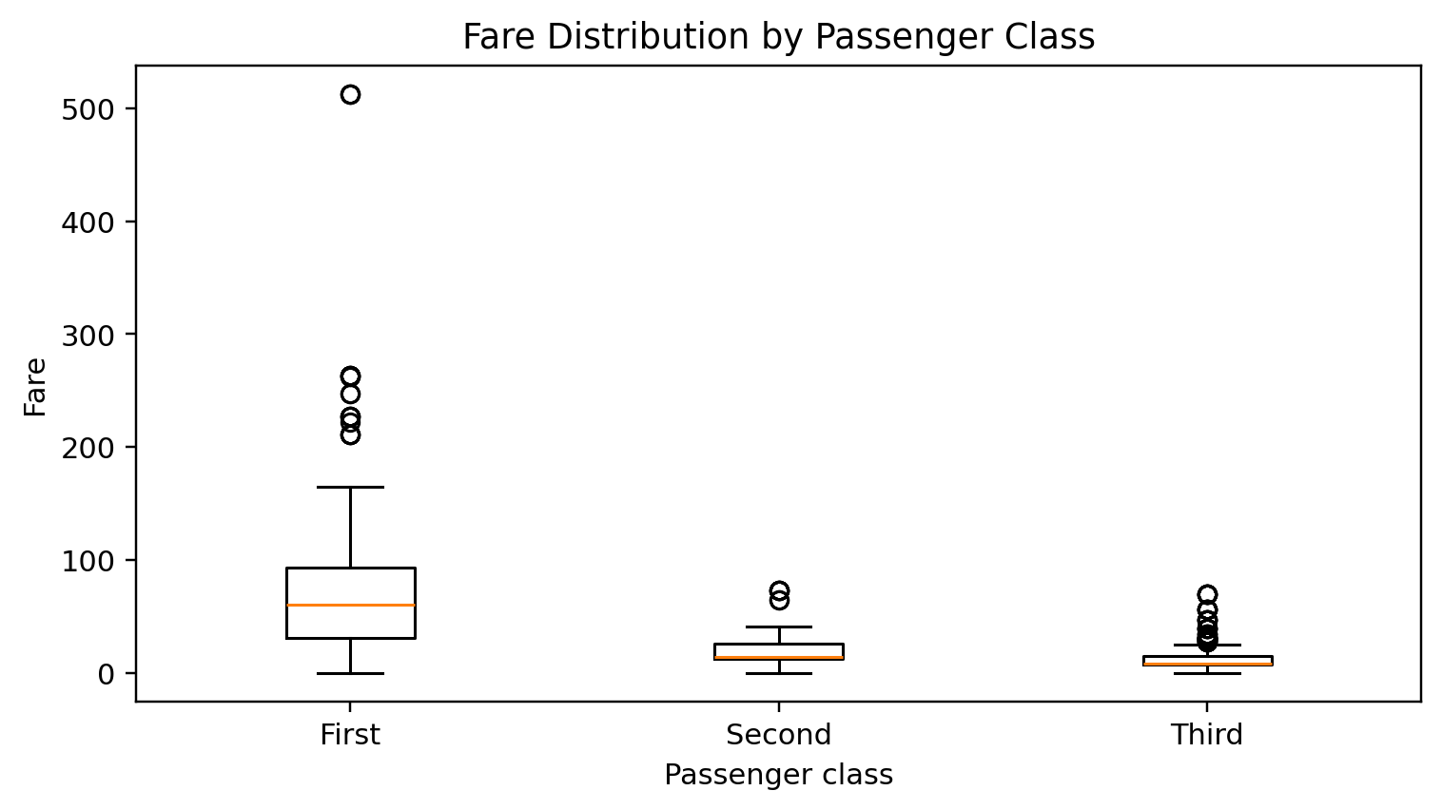
Figure: 4.4 Fare Distribution by Passenger Class – Boxplot
Interpretation: The boxplot compares fare distributions across First, Second and Third class. The chart helps show differences in typical fare levels and the presence of high-fare observations. Fare values are strongly right-skewed, so the median and interquartile range are useful summaries.
R code (core plotting statement):
ggplot(titanic, aes(x = Pclass, y = Fare)) + geom_boxplot()

4.5 Passenger Age vs Fare – Scatter Plot
Purpose: Explore whether passenger age and fare show an apparent relationship, while distinguishing survival status.
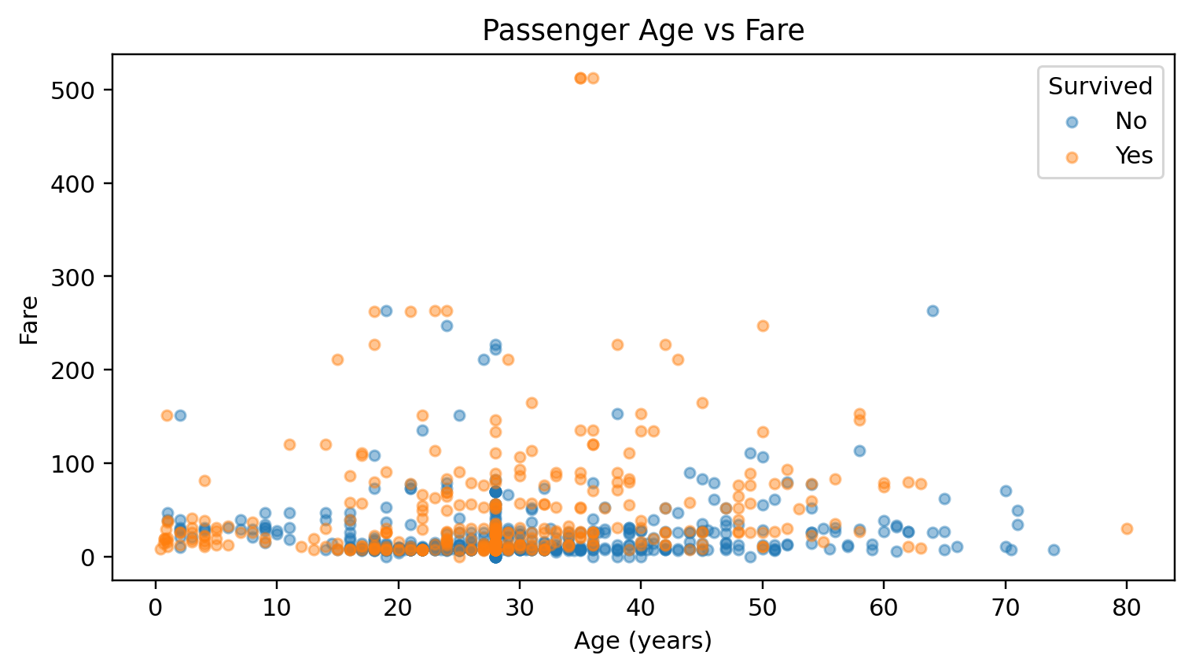
Figure: 4.5 Passenger Age vs Fare – Scatter Plot
Interpretation: The scatter plot displays individual passenger observations. Points are widely dispersed, so age alone does not appear to determine fare. The color grouping helps compare survival categories, but overlapping points and unequal group sizes should be considered.
R code (core plotting statement):
ggplot(titanic, aes(x = Age, y = Fare, color = Survived)) + geom_point(alpha = 0.55)

4.6 Survival Proportion by Passenger Class – 100% Stacked Bar Chart
Purpose: Compare survival outcomes within First, Second and Third class.
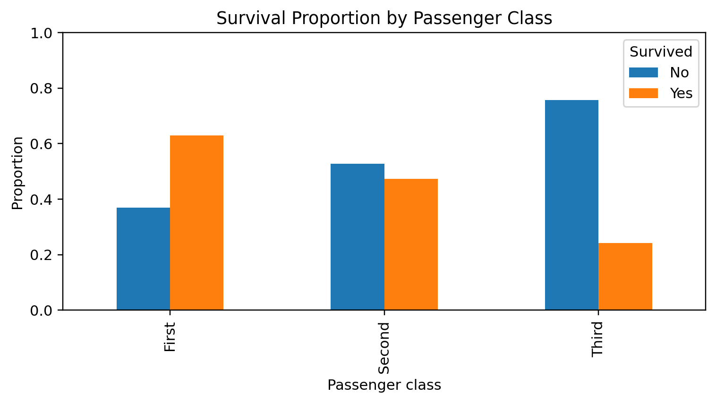
Figure: 4.6 Survival Proportion by Passenger Class – 100% Stacked Bar Chart
Interpretation: The survival proportions were 62.96% for First class, 47.28% for Second class and 24.24% for Third class. The ordered categories make the decline in observed survival proportion across passenger classes easy to communicate.
R code (core plotting statement):
ggplot(titanic, aes(x = Pclass, fill = Survived)) + geom_bar(position = "fill")

4.7 Age Density by Survival Status – Density Plot
Purpose: Compare the smoothed age distributions of survivors and non-survivors.
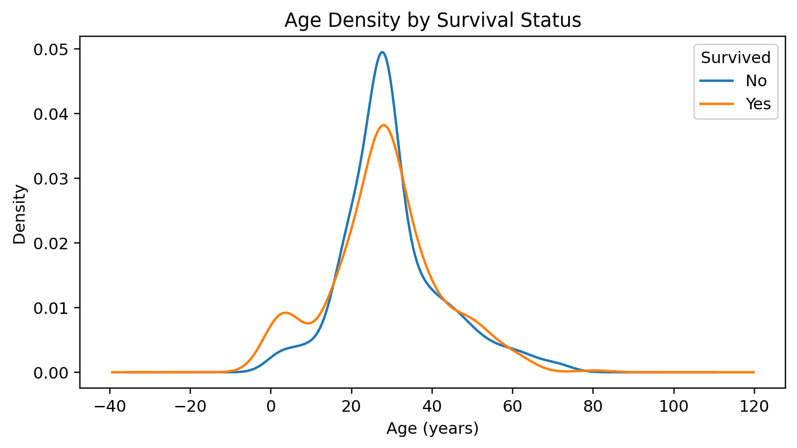
Figure: 4.7 Age Density by Survival Status – Density Plot
Interpretation: The density curves show how age values are distributed across the two survival groups. Areas of overlap indicate age ranges shared by both groups. Density plots are useful for comparing distribution shapes, but they do not directly show passenger counts.
R code (core plotting statement):
ggplot(titanic, aes(x = Age, color = Survived, fill = Survived)) + geom_density(alpha = 0.18)

4.8 Correlation Heatmap – Numeric Variables
Purpose: Summarize pairwise linear correlations among Age, SibSp, Parch and Fare.
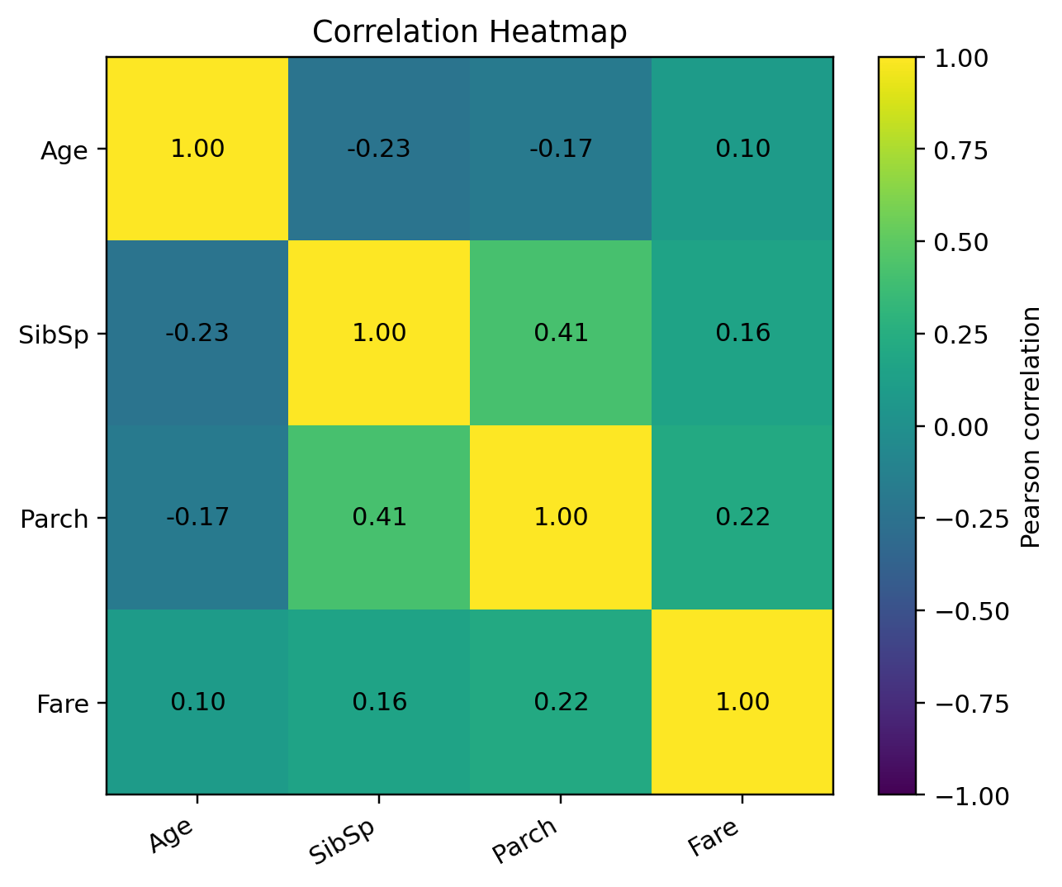
Figure: 4.8 Correlation Heatmap – Numeric Variables
Interpretation: The strongest positive correlation among these variables is between SibSp and Parch (r ≈ 0.415). Age has weak negative correlations with SibSp (r ≈ −0.233) and Parch (r ≈ −0.172). The heatmap supports rapid comparison of direction and strength; correlation does not imply causation.
R code (core plotting statement):
cor_matrix <- cor(titanic[, c("Age", "SibSp", "Parch", "Fare")], use = "pairwise.complete.obs")\ncorrplot(cor_matrix, method = "color", addCoef.col = "black")

4.9 Survival Proportion by Embarkation Port – 100% Stacked Bar Chart
Purpose: Compare the proportion of survival outcomes among passengers embarking at C, Q and S.
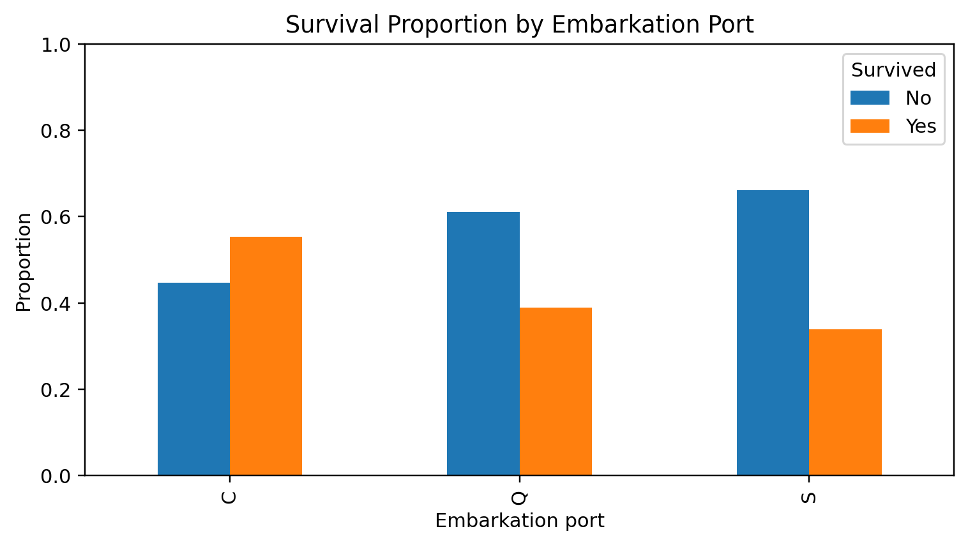
Figure: 4.9 Survival Proportion by Embarkation Port – 100% Stacked Bar Chart
Interpretation: The chart compares within-port proportions. Differences may reflect passenger composition and other factors such as class or sex; the visualization alone cannot establish that embarkation port caused different outcomes.
R code (core plotting statement):
ggplot(titanic, aes(x = Embarked, fill = Survived)) + geom_bar(position = "fill")

4.10 Survival Rate by Age Group – Line Chart
Purpose: Show how the observed survival proportion varies across ordered age bands.
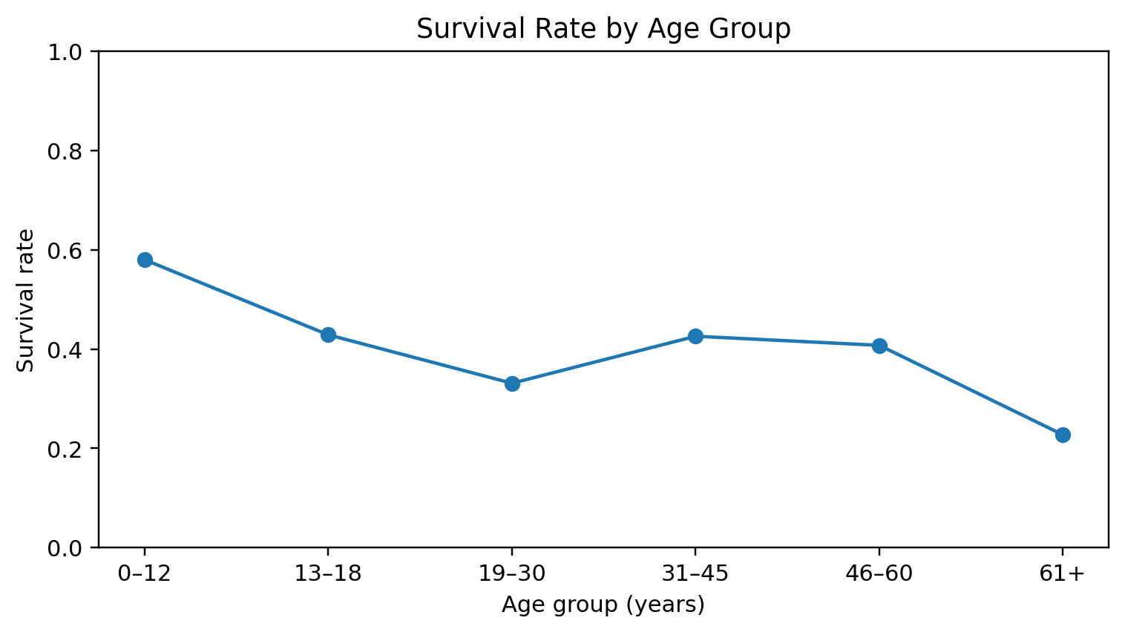
Figure: 4.10 Survival Rate by Age Group – Line Chart
Interpretation: The line chart connects age groups in their natural order and makes changes in survival proportion easier to see. Group sizes differ, so the number of passengers in each age band should be checked before comparing rates, especially in the oldest groups.
R code (core plotting statement):
ggplot(age_survival, aes(x = Age_Group, y = Survival_Rate, group = 1)) + geom_line() + geom_point()

5. Consolidated Key Insights
Measure | Survival proportion
Overall | 38.38%
Female | 74.20%
Male | 18.89%
First class | 62.96%
Second class | 47.28%
Third class | 24.24%

The largest descriptive difference is between female and male survival proportions. Passenger class also shows a clear gradient in the observed survival proportions. Age and fare distributions are skewed and include extreme observations, making histograms and boxplots useful complements to averages.

6. Conclusion
This project created ten visualizations using R to communicate patterns in the Titanic dataset. Bar charts and proportional stacked bars compared categorical outcomes; histograms and density plots described age distributions; a boxplot compared fare distributions; a scatter plot explored age and fare; a heatmap summarized numeric correlations; and a line chart compared survival proportions across ordered age bands. The findings demonstrate how selecting an appropriate chart and explaining its message can make data analysis more accessible. All conclusions are descriptive and limited to this dataset.

7. Deliverables
- Week2_Data_Visualization.R – complete R source code.
- Dataset/Cleaned_Dataset.csv – cleaned Week 1 dataset used for analysis.
- Graphs/ – ten high-resolution PNG visualizations.
- Outputs/ – summary statistics and supporting CSV tables.
- README.md – project overview and execution instructions.
- Week2_Data_Visualization_Report.docx – this report.

8. References
- Titanic dataset context: https://www.kaggle.com/competitions/titanic
- R Project: https://www.r-project.org/
- ggplot2 documentation: https://ggplot2.tidyverse.org/
- dplyr documentation: https://dplyr.tidyverse.org/

Appendix: Execution Instructions
Install the required R packages with install.packages(c("ggplot2", "dplyr", "tidyr", "scales", "corrplot")). Open the project root folder in RStudio, open R_Code/Week2_Data_Visualization.R, and run the complete script. The script writes ten PNG charts to Graphs/ and summary CSV files to Outputs/.

