**Implementation of Personal Fitness Tracker using Python**

A Project Report

Submitted in partial fulfillment of the requirements

of

AICTE Internship on AI: Transformative Learning

with

TechSaksham – A joint CSR initiative of Microsoft & SAP

By

**Kure Rahul Ankush**

**Kurerahul547@gmail.com**

Under the Guidance of

**Pavan Kumar U**

**ACKNOWLEDGEMENT**

I would like to take this opportunity to thank **Mr. Pavan Kumar** sincerely for his valuable guidance, constant support, and encouragement in the development of this project, Personal Fitness Tracker using Python. His technical knowledge, patience, and constructive criticism have played a crucial role in refining my understanding and implementation of this project. His guidance not only improved my technical skills but also gave me a better perspective on real-world software development.

I am also greatly thankful to my institution and faculty members for giving me the chance to work on this project, which enabled me to learn and implement my knowledge practically. Their support and encouragement have been instrumental in the successful completion of this internship project.

Also, I extend my deepest gratitude to my colleagues, friends, and relatives for their support and encouragement throughout this endeavor. Their untiring motivation and positive debates have aided me in overcoming obstacles and enhancing my work.

Lastly, I appreciate the chance to undertake this project, which has enabled me to improve my problem-solving skills, acquire experiential knowledge in Python programming, and be part of the creation of a valuable fitness-tracking system. This experience has been significantly rewarding and has greatly contributed to my development both personally and professionally.

#### **ABSTRACT**

Personal Fitness Tracker is a Python application developed to assist individuals in tracking and managing their everyday fitness activities such as step, calorie consumption, exercise sessions, and water intake. As the awareness of well-being and health increases, an effective and convenient fitness tracking system has become inevitable. This project is intended to offer users an all-inclusive platform to monitor their physical activity, create individualized fitness objectives, and assess their progress through time.

The software is built with Python, combining various libraries like Tkinter for the graphical interface, SQLite for secure and organized storage of data, and Matplotlib for graphically representing fitness trends. It provides functionalities such as user authentication, goal setting, real-time analytics, and interactive dashboards to ensure a smooth and interactive user experience.

With data-driven insights and progress monitoring, the project encourages users to remain motivated and engaged in their fitness regimen. Beyond being an electronic health companion, the Personal Fitness Tracker also proves the utility of Python in practical health and fitness applications, with the integration of UI development, database management, and data visualization approaches.

**TABLE OF CONTENT**

**Abstract**

**Chapter 1.**  **Introduction 1**

1.1 Problem Statement 1

1.2 Motivation 1

1.3 Objectives 2

1.4. Scope of the Project 3

**Chapter 2.**  **Literature Survey 4**

**Chapter 3.**  **Proposed Methodology 7**

**Chapter 4.**  **Implementation and Results 11**

**Chapter 5. Discussion and Conclusion 13**

**References** 15

**LIST OF FIGURES**

|  |  |  |
| --- | --- | --- |
| **Figure No.** | **Figure Caption** | **Page No.** |
| **Figure 3.1** | **Personal Fitness Tracker System Design** | **7** |
| **Figure 4.1** | **Personal Fitness Tracker Input-1** | **11** |
| **Figure 4.2** | **Personal Fitness Tracker Input-2** | **11** |
| **Figure 4.3** | **Personal Fitness Tracker Output-1** | **12** |

**LIST OF TABLES**

|  |  |  |
| --- | --- | --- |
| **Table. No.** | **Table Caption** | **Page No.** |
| **3.1** | **Hardware Requirements** | **9, 10** |
| **3.2** | **Software Requirements** | **10** |

**CHAPTER 1**

**Introduction**

**1.1 Problem Statement:**

In the modern busy world, it is getting tougher to lead a healthy lifestyle. Most people find it challenging to track their day-to-day physical activities, calorie consumption, and motivation to stick to a well-planned fitness regimen. The absence of a good and convenient fitness tracking solution results in inconsistent efforts towards personal health objectives.There are several fitness tracking applications available in the market, yet they have various disadvantages. While many of them demand expensive subscription fees, some rely on particular wearable devices and others do not provide flexibility in terms of modifying the fitness tracking experience. In addition, concerns regarding privacy evolve since many business fitness applications retrieve and store sensitive health information about users on a third-party server.

This project seeks to create a Personal Fitness Tracker with Python that provides an easy-to-use and effective solution for monitoring step count, calorie intake, exercise sessions, and water intake. In contrast to most commercial fitness applications, this project guarantees that user information is kept confidential and locally accessible, without the use of third-party servers or reliance on the internet. One of the major challenges that users encounter is the absence of real-time feedback and data visualization of their fitness progress. Without a proper overview of trends in progress, it is challenging for users to remain motivated. This project will overcome this challenge by including graphical displays of fitness trends, which will enable users to easily analyze their habits and enhance their routines accordingly.

**1.2 Motivation:**

The impetus for this project is the growing health and fitness awareness in recent times. As sedentary lifestyles increase and with it related health problems like obesity, diabetes, and heart disease, there is a rising demand for technology-based solutions that encourage an active lifestyle. Yet, in spite of the need for such programs, most available fitness trackers are either too complex for occasional users or necessitate the use of extra hardware such as smartwatches and fitness bands.

This project is inspired by the need for an uncomplicated, self-contained, and affordable fitness tracker application that anyone can use with any computer without needing additional hardware. The most important objective is to give people a tool with which they have control and the ability to observe their physical actions, set up goals, and track progress with ease.

Furthermore, the project also seeks to use Python, an open-source and easy-to-use programming language, to show how software can be used to foster healthier lifestyles. Through combining different Python libraries for user interface development, database, and data visualization, this project also acts as a learning platform for future developers interested in fitness app development and health-tech solutions.

**1.3 Objective:**

The Personal Fitness Tracker project is created with the following primary goals:

* To create an interactive and user-friendly fitness tracking system that assists users in tracking step count, calories burned, workouts, and hydration.
* To offer an effective goal-setting feature, enabling users to set and monitor their personal fitness goals.
* To create a Graphical User Interface (GUI) with Tkinter, providing a seamless and intuitive user experience.
* To incorporate SQLite database for safe and local storage of data, giving users complete control over their health records.
* To incorporate data visualization libraries with Matplotlib, allowing users to monitor their progress over time using charts and graphs.
* To develop a lightweight, cross-platform application that can be executed on Windows, macOS, and Linux without the need for extra hardware or external dependencies.
* To increase user motivation by offering visual feedback and progress tracking information through an interactive dashboard.

**1.4 Scope of the Project:**

The Personal Fitness Tracker project shall be implemented as a standalone application with basic fitness tracking features and emphasis on usability, privacy, and accessibility. The project will include developing the following features:

* User authentication system: A basic login/logout functionality that provides personalized fitness tracking.
* Daily tracking dashboard: Real-time tracking of step count, calorie consumption, water intake, and workout logs.
* Graphical progress analysis: Weekly, monthly, and yearly charts and graphs of fitness activity.
* Goal-setting module: Users are able to set and adjust their fitness goals, like daily step counts or calorie intake limits.
* Offline accessibility: In contrast with the majority of contemporary fitness apps that must be connected to the internet, this tracker will operate entirely offline, keeping information stored locally for user privacy and ease.
* Minimal hardware requirements: Programmed to perform well using basic desktop/laptop computers with minimal need for specialist hardware.

No intention here is to make money from and potentially replace specialist fitness equipment, only to deliver low-cost yet efficient means by which people might measure and increase fitness levels in training.

**CHAPTER 2**

**Literature Survey**

**2.1 Review relevant literature or previous work in this domain:**

* Google Fit & Apple Health:

These are commonly used fitness tracking apps that harvest step count, heart rate, and activity levels from smartphones and wearable devices. They offer comprehensive reports on user activity, aggregating data from third-party fitness apps.

**Limitation**: Overdependence on cloud storage and internet connectivity, which is a privacy issue.

* Fitbit & Garmin Fitness Trackers:

These companies provide smart fitness devices that automatically monitor activities such as steps, heart rate, and sleep patterns. Their mobile applications offer sophisticated analytics and insights into users' health patterns.

**Limitation**: Involves wearable devices and subscription to paid premium versions for additional features.

* MyFitnessPal & Lifesum :

These apps specialize in calorie counting and dietary management, enabling users to track their food consumption. They offer AI-based recommendations depending on the goals of users.

**Limitation**: Free editions have limited features, and food database accuracy can be variable.

* 1. **Mention any existing models, techniques, or methodologies related to the problem:**

**Sensor-Based Tracking:**

* Many fitness applications rely on accelerometers and gyroscopes in smartphones or smartwatches to measure step counts and activity levels.
* Wearable devices like Fitbit, Garmin, and Apple Watch use advanced motion sensors to capture real-time fitness data.
* **Limitation**: Requires external hardware and is not accessible for users without wearables.

**Cloud-Based Fitness Tracking:**

* Applications like Google Fit and Apple Health store user data in the cloud, allowing access from multiple devices.
* Cloud integration enables synchronization with third-party fitness applications.
* **Limitation**: Raises privacy concerns due to data being stored on external servers.

**Calorie Estimation Algorithms:**

* Diet tracking applications use food databases and AI-based calorie estimators to help users log meals.
* MyFitnessPal, for example, uses machine learning models to suggest food items based on user input.
* **Limitation**: Food tracking requires manual input, which can be time-consuming and prone to errors.

**Data Visualization Techniques:**

* Most fitness applications implement graphical charts and reports to help users track progress over time.
* Matplotlib, Plotly, and Seaborn are common Python libraries used for visual analytics.
* **Limitation**: Many free fitness apps do not provide advanced analytics, limiting the ability to compare long-term trends.
  1. **Highlight the gaps or limitations in existing solutions and how your project will address them:**

**Dependence on Wearables:**

* Many fitness tracking apps require smartwatches, fitness bands, or other external devices, making them inaccessible for users who do not own these gadgets.
* Solution in This Project: The Personal Fitness Tracker will use manual input options, allowing users to track fitness data without external hardware.

**Privacy Concerns:**

* Applications like Google Fit and Fitbit store data in the cloud, which can lead to privacy risks and potential data breaches.
* Solution in This Project: The proposed fitness tracker will store all user data locally using SQLite, ensuring complete user control over personal fitness records.

**Subscription-Based Models:**

* Many fitness apps require premium subscriptions to access detailed analytics and goal-setting features.
* Solution in This Project: The Personal Fitness Tracker will be completely free, allowing users to track fitness activities without hidden costs.

**Limited Customization in Goal Tracking:**

* Existing applications often provide predefined fitness goals rather than allowing users to set personalized objectives.
* Solution in This Project: This project will include a goal-setting module where users can customize their daily targets for steps, calories, hydration, and workouts.

**Offline Accessibility:**

* Most modern fitness applications require an internet connection to sync data across devices.
* Solution in This Project: The Personal Fitness Tracker will function completely offline, allowing users to track their progress without needing WiFi or mobile data.

**CHAPTER 3**

**Proposed Methodology**

* 1. **System Design:**

Provide the diagram of your Proposed Solution and explain the diagram in detail.

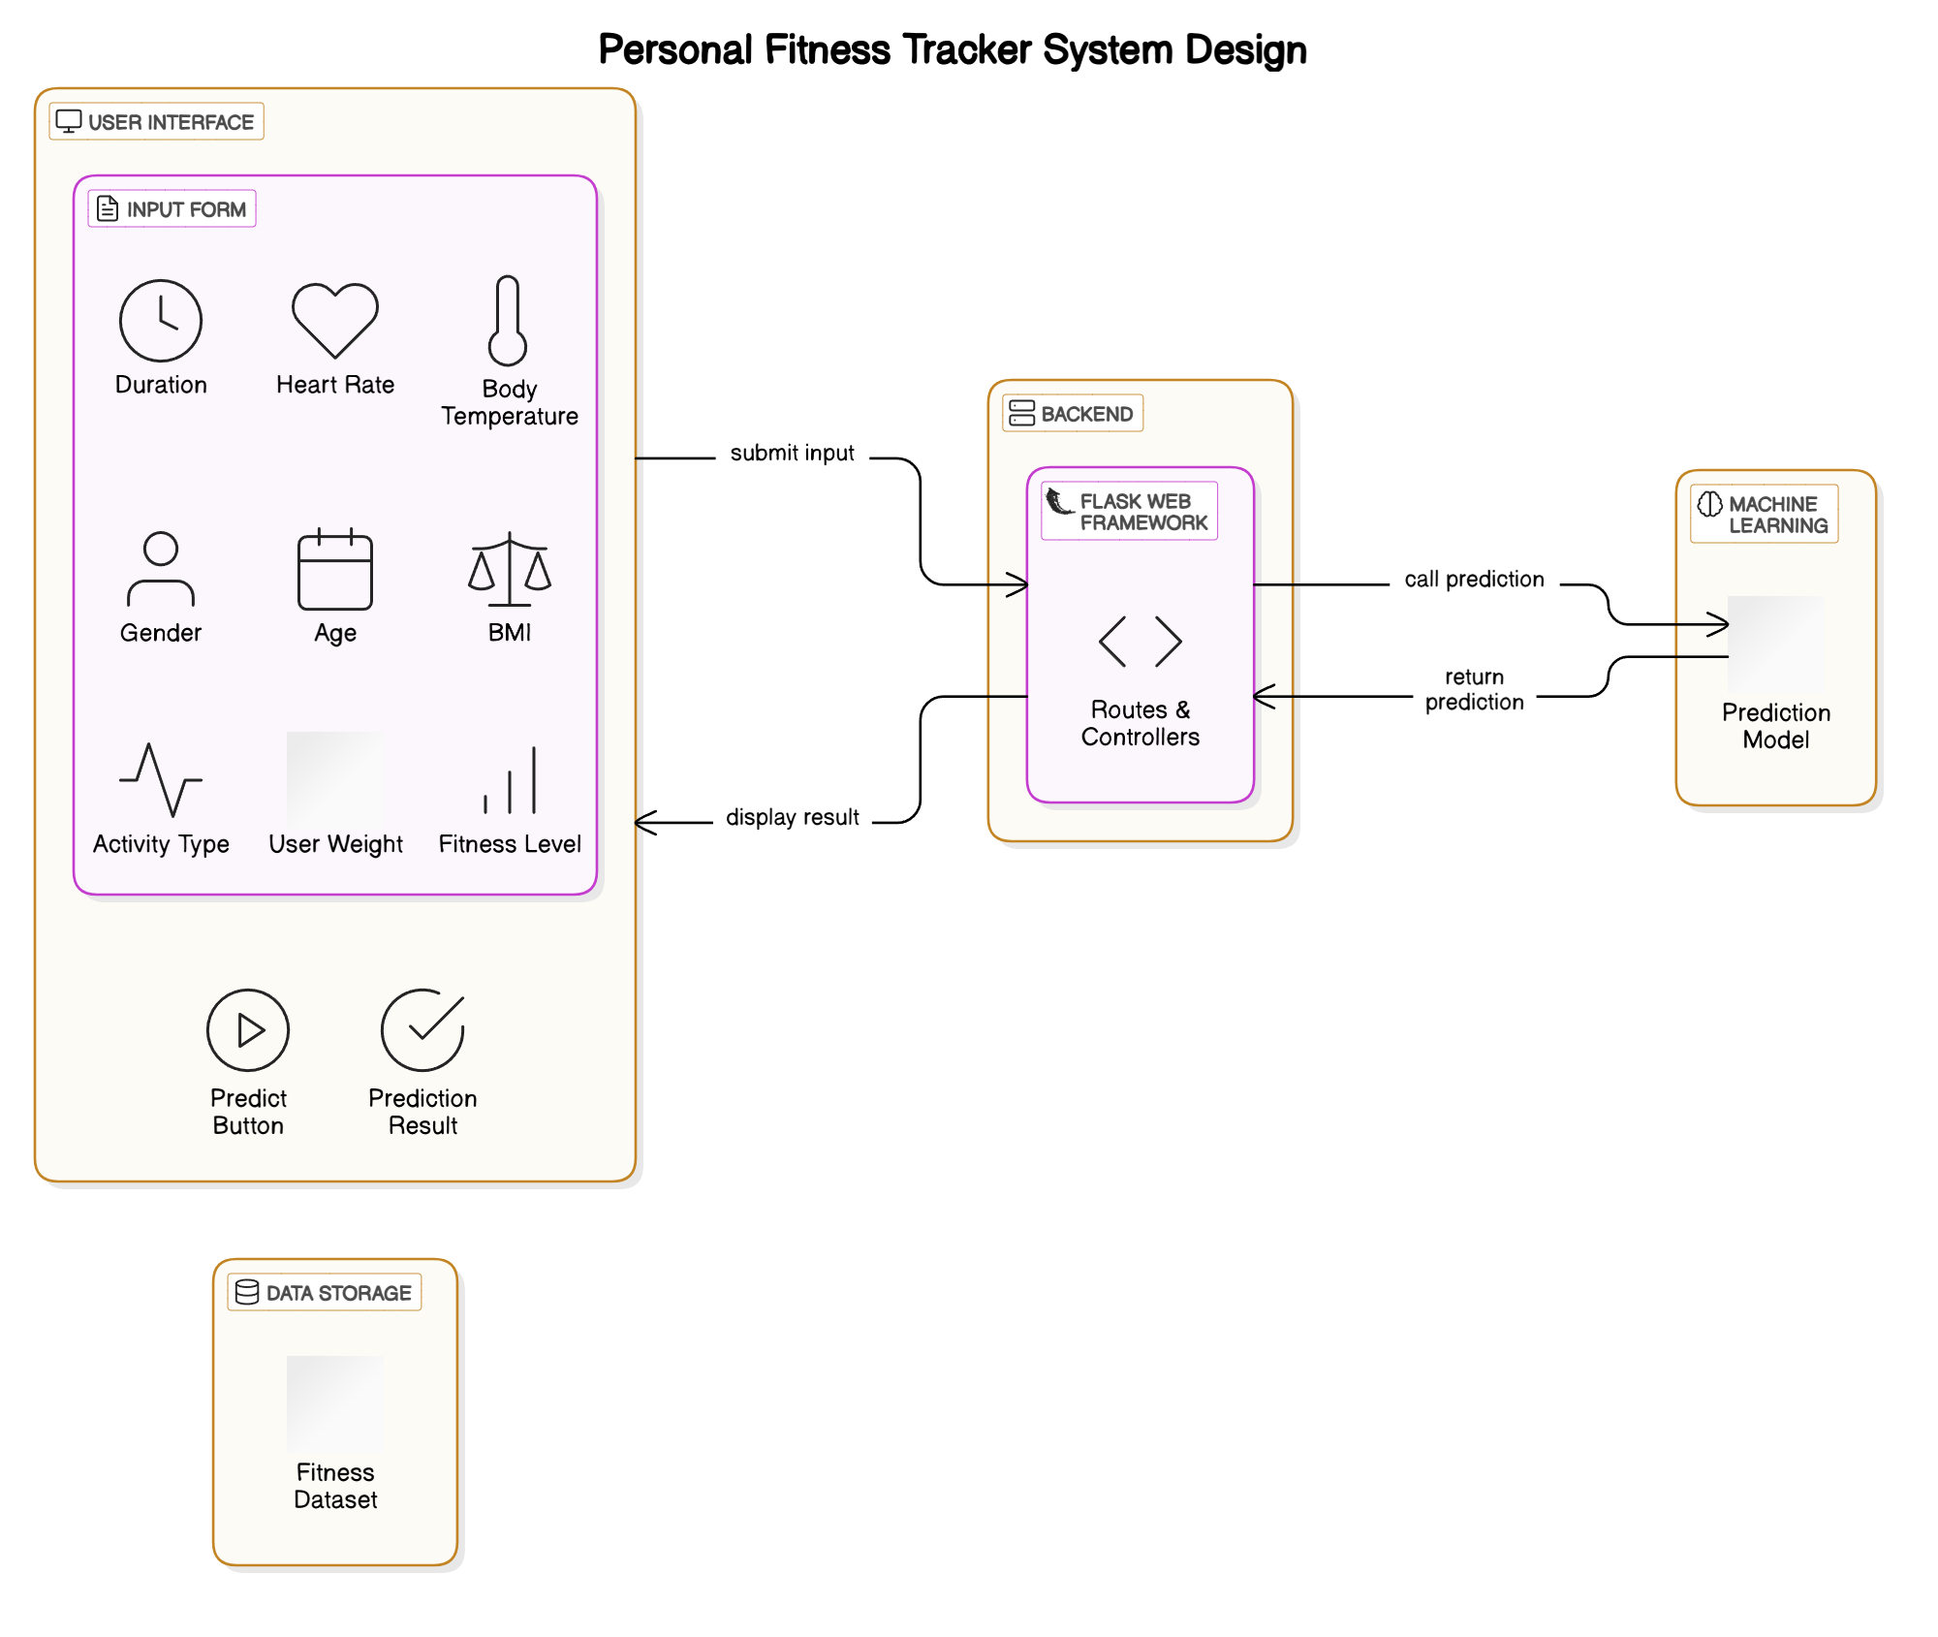

**Fig 3.1 Personal Fitness Tracker System Design**

**System Architecture Overview:**

The figure above illustrates the system architecture of the Personal Fitness Tracker Web Application, which enables users to predict the number of calories burned based on various physiological and activity-related inputs. The architecture is divided into four key components: User Interface, Backend, Machine Learning Model, and Data Storage.

**1. User Interface (Frontend)**

The **User Interface (UI)** serves as the primary interaction point for the user. It consists of an input form and control buttons.

* **Input Form**: Users are required to provide several parameters including:
  + Duration of physical activity
  + Heart rate
  + Body temperature
  + Gender
  + Age
  + Body Mass Index (BMI)
  + Activity type
  + User weight
  + Fitness level
* **Controls**:
  + **Predict Button**: Triggers the submission of input data to the backend server.
  + **Prediction Result**: Displays the output received from the machine learning model in terms of calories burned.

The UI is designed to be user-friendly and responsive, facilitating smooth data input and real-time feedback.

**2. Backend (Server-Side)**

The backend is developed using the **Flask web framework**. It acts as a middleware between the user interface and the machine learning model.

* **Routes and Controllers**: Handle HTTP requests from the frontend, process the input data, and interact with the prediction model.
* Upon receiving input from the frontend, the backend routes the data to the model, retrieves the prediction result, and returns it to the user interface for display.

**3. Machine Learning Model**

The machine learning component is responsible for generating calorie burn predictions based on the input parameters.

* A pre-trained **prediction model** is employed, developed using supervised learning techniques.
* The model receives the processed input from the backend and returns the predicted calorie expenditure.
* This model is trained using historical fitness data to ensure accurate and reliable predictions.

**4. Data Storage**

The data storage component consists of the **fitness dataset** used during the training phase of the machine learning model.

* This dataset contains relevant information such as user demographics, activity metrics, and calorie outputs.
* It is not directly accessed during runtime but is critical for model development and performance evaluation.

**Workflow Summary**

1. The user enters the required parameters into the input form.
2. Upon clicking the “Predict” button, the data is submitted to the backend server.
3. The backend forwards the data to the machine learning model and receives the prediction.
4. The predicted calories burned are sent back to the frontend and displayed to the user.
   1. **Requirement Specification:**

The project is designed to run efficiently on standard desktop/laptop computers.

* + 1. **Hardware Requirements:**

| **Component** | **Minimum Requirement** | **Recommended** |
| --- | --- | --- |
| **Processor** | Dual-Core 2.0 GHz | Quad-Core 2.5 GHz or higher |
| **RAM** | 4GB | 8GB or higher |
| **Storage** | 200MB free space | 500MB free space |
| **Display** | 1024×768 resolution | 1920×1080 resolution |
| **Operating System** | Windows/Linux/macOS | Windows 10+, macOS Ventura+, Ubuntu 20.04+ |

**Table 3.1 Hardware Requirements**

**3.2.2 Software Requirements:**

The Personal Fitness Tracker will be developed using Python and related libraries.

| Software | Version/Details |
| --- | --- |
| Operating System | Windows, macOS, Linux |
| Programming Language | Python 3.x |
| Graphical User Interface (GUI) | Tkinter |
| Database Management System | SQLite |
| Data Visualization | Matplotlib |
| Development Environment | PyCharm, VS Code, Jupyter Notebook (Optional) |

**Table 3.2 Software Requirements**

**CHAPTER 4**

**Implementation and Result**

**4.1 Screenshot of the User Interface & Result:**

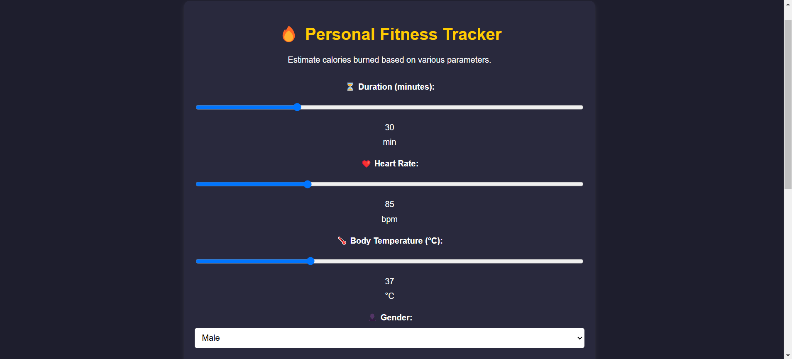

**Fig 4.1 Personal Fitness Tracker Input-1**

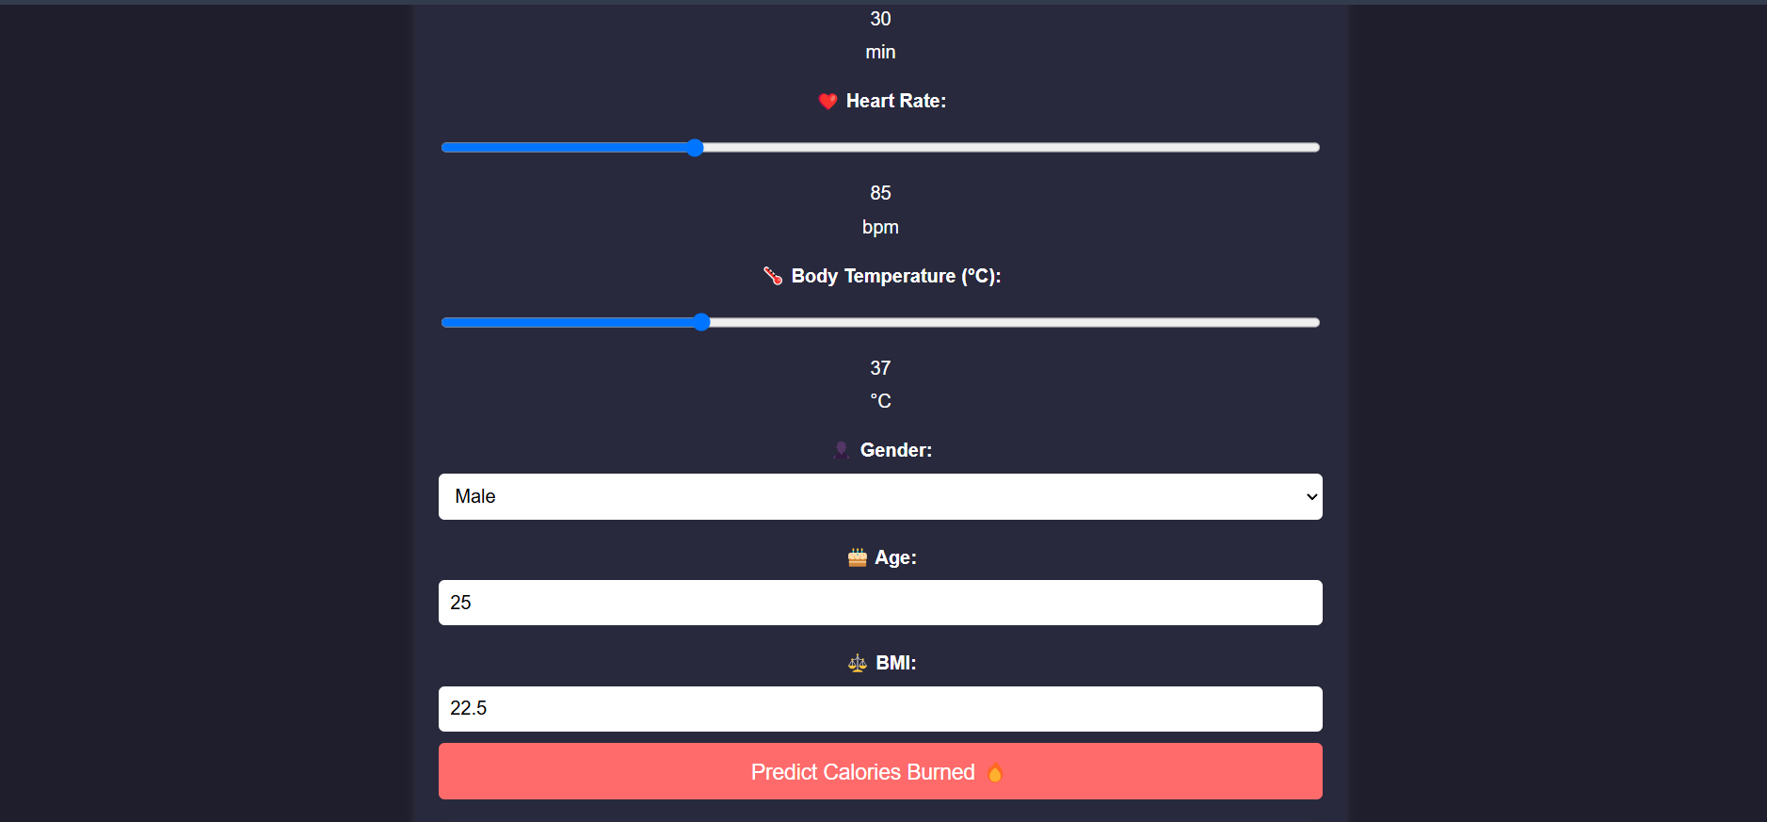

**Fig 4.2 Personal Fitness Tracker Input-2**

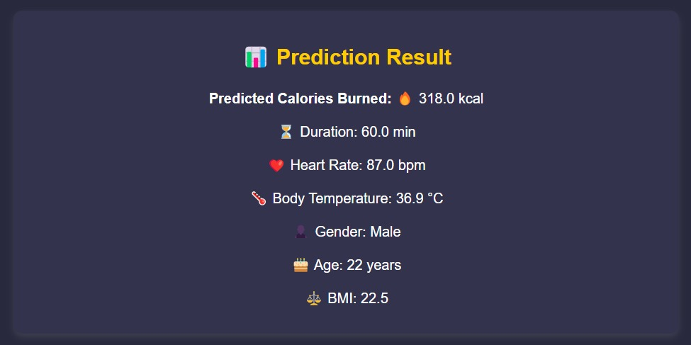

**Fig 4.3 Personal Fitness Tracker Output-1**

**4.2 GitHub Link for Code:**

<https://github.com/YashTilekar647/Personal_Fitness_Tracker_using_Python/tree/main/Personal-Fitness-Tracker-Flask-Web-App-main>

**CHAPTER 5**

**Discussion and Conclusion**

* 1. **Future Work:**

Though the Personal Fitness Tracker offers core fitness tracking functionality, there are a number of areas for possible future development and extension:

**Integration with Wearable Devices:**

* The system presently uses manual data input for workout monitoring and step counting.
* Future releases may support wearable devices such as Fitbit, Apple Watch, or Mi Band through APIs to collect data automatically.

**Mobile Application Development:**

* The app is currently developed as a desktop application with Python.
* Future enhancement may include building a mobile app for Android and iOS based on Flutter or React Native to ensure greater accessibility.

**AI-Based Recommendations:**

* Future releases could incorporate AI-powered recommendations according to user patterns.
* Based on machine learning algorithms, the system would be able to provide customized exercise routines, nutritional advice, and step targets on the basis of past usage patterns.

**Cloud-Based Syncing (Optional):**

* Although the system today is offline and privacy-oriented, an optional cloud backup option can be added.
* A user could have the option to securely sync data to the cloud for use on multiple devices.

**Data Analytics & Insights:**

* Predictive analytics to predict fitness achievement from trends could be included in future updates.
* More in-depth reports on calories burned, hydration, and activity levels over several weeks and months.

**Social & Community Features:**

* Including a social leaderboard so that users can compare their progress with friends.
* Allowing challenges and rewards to enhance motivation.
  1. **Conclusion:**

The Personal Fitness Tracker project was able to create a standalone, offline, and privacy-centered fitness tracking system with Python, Tkinter, SQLite, and Matplotlib. In contrast to commercial fitness apps, this tracker maintains user data privacy, has no wearable requirements, and is fully offline-enabled.

Major Contributions of the Project:

* User-Friendly Interface – An easy-to-use and intuitive GUI for monitoring daily activities.
* Local Data Storage – Provides privacy by keeping user data safely stored in SQLite.
* Custom Goal Setting – Enables users to set and monitor their own fitness goals.
* Graphical Progress Analysis – Utilizes Matplotlib for effective visualization of fitness trends.
* Offline Access – No external cloud services or internet access needed.

**References**

**6.1 References:**

* 1. Google Fit API Documentation
  2. Fitbit Developer Guide
  3. Python Tkinter Documentation
  4. SQLite Database Management