TaskBridge Assignment - Milestone Evidence Report

Milestone 1 - Server Startup
Command: go run ./cmd/server --addr :8080
The screenshot shows the TaskBridge server starting successfully on port 8080 with authentication disabled.

Milestone 2 - Agent Registration
Command: go run ./cmd/agent --server http://localhost:8080 --id agent-1
The agent starts, registers with the server, advertises capabilities and begins the polling loop.
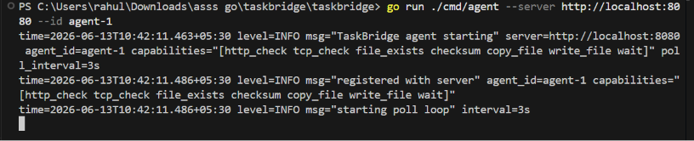

Milestone 3 - HTTP Job Execution
Commands: Create HTTP check job and list jobs
A http_check job is created and later appears with SUCCESS status, proving job execution and lifecycle progression.
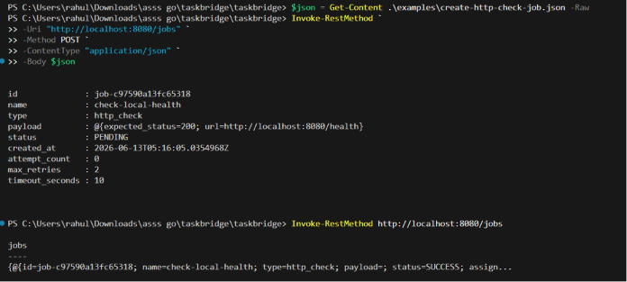

Milestone 4A - TCP/File Exists/Checksum Jobs
Commands executed using create-tcp-check-job.json, create-file-exists-job.json, create-checksum-job.json
Shows successful creation of multiple supported job types.
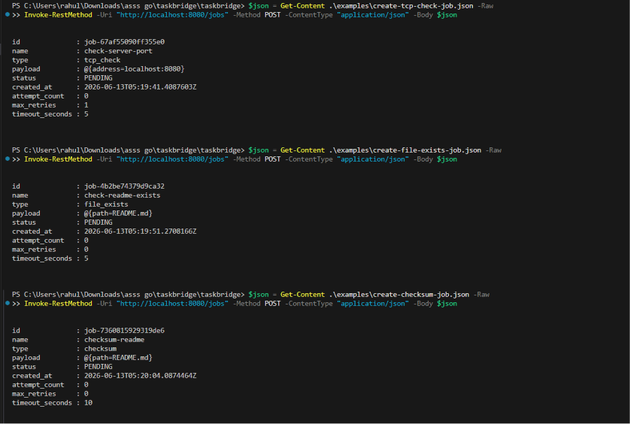

Milestone 4B - Write/Copy/Wait Jobs
Commands executed using create-write-file-job.json, create-copy-file-job.json, create-wait-job.json
Demonstrates additional supported executors and job creation.
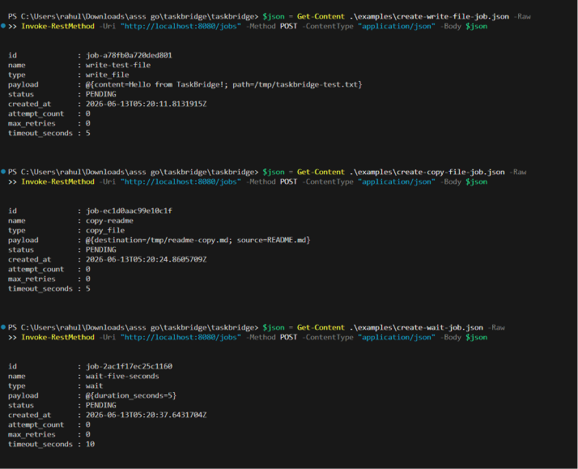

Milestone 5 - Job Listing
Command: Invoke-RestMethod http://localhost:8080/jobs
Displays executed jobs and assignment information.

Milestone 6 - Heartbeat & Scheduling
Server logs showing heartbeat and next-job polling
Validates agent heartbeat, scheduling, polling and server-agent communication.
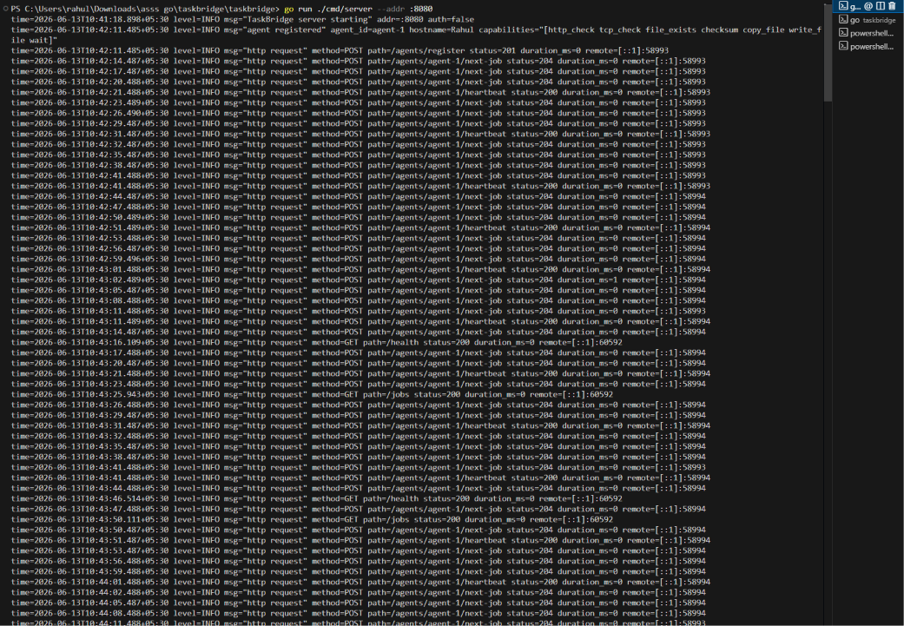

Summary
The screenshots collectively demonstrate successful completion of the assignment requirements: server startup, agent registration, job execution lifecycle, multiple executor types, heartbeat handling, job scheduling, and API functionality.

