Spreadsheet Project:

Zomato Restaurants Expansion

BY: RAHUL M
26/09/2025



Problem Statement:
You have been hired as a consultant data analyst by Zomato, where the team is looking for expansion and opening more restaurants. Your task is to develop strategies/suggestions for opening newer restaurants.


CONTENTS

- Data Pre-processing
- Objective Questions
- Subjective Questions

Objective Questions:

- What is the total no. of tables present in the data?
There are 2 tables [Worksheet] present in this Zomato Excel Data, i.e, Raw_Data and Country Description.
- What is the total no. of attributes present in the data?
The total no. of attributes present in the data is 24.
- How many categorical columns are there in the data? [Search about categorical and continuous data, and try to answer this question]

- Method I have used to identify how many categorical columns there are in the Zomato Dataset:-
I applied the formula =COUNTA(UNIQUE(range)) on each column individually.
Columns with a relatively small number of unique values (typically fewer than 50) are considered categorical, as they represent a limited set of categories or labels.
Based on this approach, I identified columns like country, city, restaurant name, cuisines, has table booking, has online delivery, is delivering now, switch to order menu, currency, locality, these are the categorical columns. A total of 10 categorical columns in the dataset.

- The Data consists of some inconsistent and missing values, so ensure that the data used for further analysis is cleaned.

- Methods I have used in cleaning the Data:-
Handling Missing Values Since missing values were found in the cuisines column, all the blank values were under the Country name, United States of America. So, blanks in cuisine were replaced with mode of cuisines, which is in the country United States of America, i.e, Mexican.
The formula I’ve used: =IF(ISBLANK(I2),MODE.SNGL(I:I),I2)

Removing Duplicates: I checked the Data for any Duplicate values. I checked it by Restaurant_Name column and Address column. There were duplicate values found in the given raw data, through Data tab and selecting Remove Duplicates I removed the duplicate records.
Formatting the Date column: The Datekey_Opening column in the raw data is not set in a proper date format. So, to format the Datekey column, the formula I have used is: =DATEVALUE(SUBSTITUTE(T2,"_","-"))
This formula helped in changing the date from 2013_9_21 to 21/09/2013
After formatting the Datekey_Opening column, I have created 3 helper columns, YEAR, MONTH, DAY, respectively. For YEAR column the formula I have used is: =TEXT(U2,"yyyy") For MONTH column the formula I have used is: =TEXT(U2,"mmmm") For DAY column the formula I have used is: =DAY(U2)
Hiding unwanted columns: In this data, I don’t need columns E, F and I. Those were removed due to redundancy. Similarly, since I formatted the date column, column T is no longer needed.

Currency Normalisation – INR Conversion of Costs: The dataset contained restaurants from multiple countries using different currencies. To enable comparative cost analysis, all cost values needed to be converted into INR.

So, I have standardised the Average Cost for Two across multiple countries into a single comparable unit, Indian Rupee (INR), for consistent analysis in visualisations and metrics. I created 2 helper columns, Rate_to_INR and Average_cost_for_two_INR. I have also created a lookup table in a new sheet, Currency Lookup. Used VLOOKUP to fetch data. For this my formula is: =VLOOKUP(J2,, CurrencyLookup!$A$2:$B$13, 2, FALSE). For calculating INR cost, =$R2*$K2

Auto Fit: The width of the columns and rows in the given data is unfit, and is making data readability complex. To fix this, I start by selecting the entire sheet, Ctrl+A. Under Home tab, through Format option, I resize the columns and rows width to fit my data for a better appearance.

Broder: The data provided did not have any borders; therefore, I added them to make the data look better.
Wrap Text: The columns in this data with text values were overlapping each other, which made it difficult to read. To fix this, I used wrap text method.
In the Excel file, Sheet name: country description & currency.

- Using the LookUp functions, fill up the countries in the original data using the country code.

- Method I have used for Data Transformation:-
Vlookup Function: To enhance readability and support location-based analysis, a new column, Country, was created beside the existing Country Code using the VLOOKUP function in Excel. The formula I used: =VLOOKUP($C2,'countrydescription'!$A$1:$B$16,2,FALSE) This function checks the Country Code in each row and retrieves the matching country name from the lookup table.
Here, $C2 is the country code selected for searching. countrydescription'!$A$1:$B$16: this is the lookup array where the code can be found. 2: the exact column no where country can be searched.
FALSE: to denote the exact match type.

- Create a table to represent the number of restaurants opened in each country.
For this, my approach is to use a Pivot Table.
I selected the entire raw dataset → go to Insert tab → PivotTable, and chose to place the PivotTable on a new worksheet [Analysis of Data].
Configured the Pivot Table Fields: Dragged Country into the Rows field, dragged Restaurant ID into the Values field.
Changed value setting to Count to get the number of entries.
Applied clean formatting for better readability.
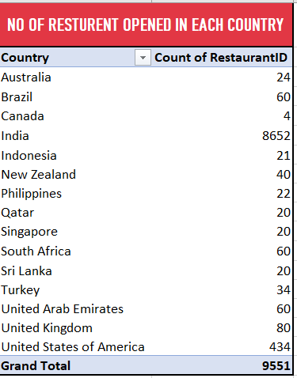
In the Excel file, Sheet name: Analysis of Data

- Also, the management wants to look at the number of restaurants opened each year, so provide them with something here.
For this, my approach is to use a Pivot Table, again.
I selected the entire updated dataset
Choose Insert → PivotTable
Created the PivotTable in the same worksheet [Analysis of Data].
Configured the Pivot Table Fields: I dragged Year into the Rows area and Restaurant ID into the Values area. Set aggregation to Count to count restaurant openings.
Applied clean formatting for better presentation.
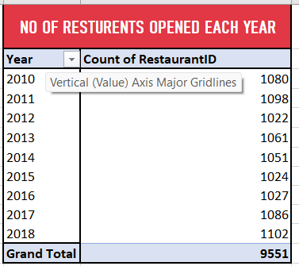
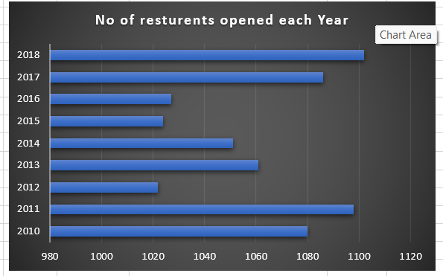
In the Excel file, Sheet name: Analysis of Data

- What is the total number of restaurants in India in the price range of 4?
To determine the number of restaurants in India that fall under Price Range 4, which represents the higher-end pricing category I used the COUNTIFS function to apply multiple conditions and filter the dataset without using a Pivot Table. The formula I used: =COUNTIFS(Table1[Country],"India",Table1[Price_range],4)
"India" and 4: The conditions applied to each column.
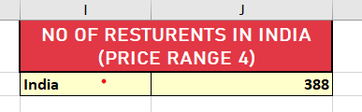
In the Excel file, Sheet name: Analysis of Data

- What is the average number of voters for the restaurants in each country according to the data?
I have analysed the average voter count per country via Pivot Table. I selected the fully cleaned dataset, went to Insert → Pivot Table. Placed the Pivot Table in the existing worksheet, [Analysis of Data].
Configured Fields: Dragged Country into the Rows field. Dragged Votes into the Values field. Changed aggregation from Sum (default) to Average.
Right-click → Summarise Values By → Average.
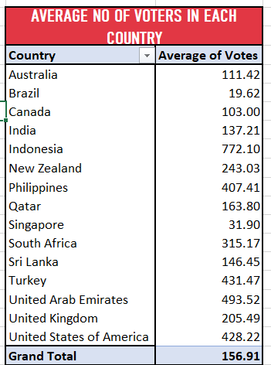
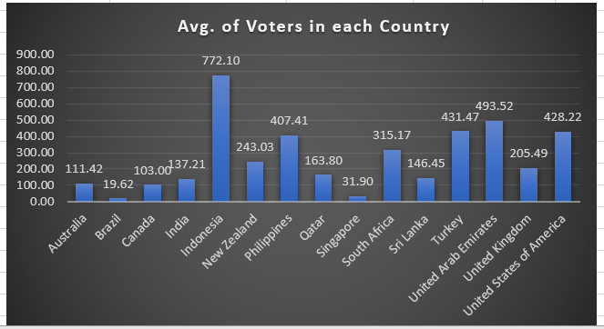
In the Excel file, Sheet name: Analysis of Data

- Calculate the average rating for all the restaurants that have price_range < 4 and provide online delivery. Use only the “IF” function, Logical Operators, and Aggregation functions to solve this problem. [Note: Don’t use Conditional aggregation in this question.]
To analyse this objective, I have first created a separate worksheet [Average Rating] for clarity.
Excel’s IF function was used in combination with logical operators to filter the dataset.
The AVERAGE function was applied to calculate the average rating of only those restaurants that meet both criteria, i.e have a price range less than 4 and provide online delivery.
The formula I have applied: =AVERAGE(IF((Table1[Price_range]<4)*(Table1[Has_Online_delivery]="Yes"),Table1[Rating]))
This is an array formula. In my older version, I enter it using Ctrl + Shift + Enter.
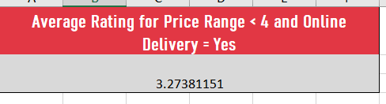
In the Excel file, Sheet name: country description & currency

- Using Conditional formatting highlight the rows of restaurants that are located in the countries or cities that you’ve suggested to the management for opening new restaurants.
To identify potential restaurants for expansion, I used Conditional Formatting in Excel to highlight restaurants that meet all of the following three criteria:
- The restaurant is located in one of the selected focus countries:
Australia, Canada, Singapore, Brazil, Sri Lanka
- The restaurant appears more than once in the dataset (i.e., it has been listed multiple times), indicating higher visibility or popularity.
- The restaurant has an average rating of 3.5 or higher, showing strong customer satisfaction.
To support this, I created two helper columns:
- Restaurant Count:
Calculated using the formula:
=COUNTIFS(B:B, B2)
This counts how many times each restaurant appears in the data.
- Average Rating:
Calculated using the formula:
=AVERAGEIFS(G:G, B:B, B2)
This computes the average rating for each restaurant across all its entries.
Conditional Formatting Logic: =AND(OR(D2="Australia", D2="Canada", D2="Singapore", D2="Brazil", D2="Sri Lanka"), Z2>1, AA2>=3.5)
In the Excel file, Sheet name: Highlight_with_CF

- Create a new customised price column that consists of the abbreviation/symbol of the currency along with the Average_cost_for_two value. [Use string operations to do this task]
I created a currency symbol table in sheet Currency Lookup, containing 2 columns: Currency_name and Symbol. I created Customised_price column in my raw data where I have used VLOOKUP along with STRING operations.
My applied formula: =VLOOKUP($J2,'3.Curency Lookup'!$E$2:$F$13,2,FALSE)&" "&TEXT('1.Raw Data'!$R2,"0")
This retrieves the correct currency symbol based on the value in the Currency column (J2) and appends it to the numeric cost (R2), formatted as text.
I have kept the column in General format so the symbol is preserved and ready for dashboard display.
In the Excel file, Sheet name: Raw Data

- How can you create an array formula in Excel or Google Sheets to count the number of restaurants listed that do not offer online delivery, are in the lowest price range, and have an average cost for two people less than or equal to 250 Indian Rupees?
For this particular question, we are given 3 criteria:
- No online delivery
- Lowest price range (price range = 1)
- Average cost for two ≤ 250 INR
Count restaurants that meet all three conditions.
I have already created a column named Average_cost_for_two_INR for an effortless calculation in such cases like this one: Average cost for two ≤ 250 INR
Now, my calculation is done on Excel sheet. The formula I have used here is: =SUM(('1.Raw Data'!M2:M9552="No")*('1.Raw Data'!P2:P9552=MIN('1.Raw Data'!P2:P9552))*('1.Raw Data'!S2:S9552<=250))
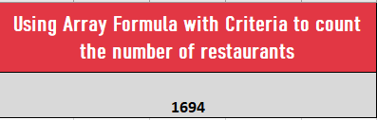
This is an array formula. In my older version, I enter it using Ctrl + Shift + Enter.
In the Excel file, Sheet name: country description & currency

- Note: Why I used Sum instead of Countifs. Conditions like M2:M9552= “No”, returns an array of TRUE/FALSE values. So, for each row, when all 3 conditions are must fulfilled, it returns 1 * 1 * 1 = 1. But if If any condition is false, it returns something like 1 * 0 * 1 = 0.
So, summing all conditions gives the count of number of restaurants.

Subjective Questions:


- Suggest a few countries where the team can open newer restaurants with lesser competition. Which visualization/technique will you use here to justify the suggestions?

Strategy: To analyse which countries can be suggested to open newer restaurants with lesser competition, I have considered 2 factors that can help in analysing this.
- The Count of Restaurant IDs in each city
- The Average of Rating of restaurants in each country.
In the Excel file, Sheet name: Suggesting_Countries & cities
I have inserted PivotTbles. In both the PivotTable, I have taken Country in Row field and in Value field, Count of ResturentIDs and Average of ratings.
The count of restaurants indicates market competition. High count shows high demand and strong competition, while on the other hand, low count shows a marginalised market with potential of growth.
The average rating in my next pivot table, along with chart visualisation clearly indicates customer satisfaction. A high rate gives us the information of high expectation, and a low rate shows the chances of opportunity to deliver a finer quality.

Data Analysis: After observation, I would recommend countries which fall under the condition of less competition with low rating,and where the count of restaurants is also less. The Average Of Rating was chosen since lower ratings, below 4, indicate that the people in that nation are dissatisfied with the restaurants. Same with count of restaurants, where the count is below 25. This can work to our benefit because we can conduct a market study and determine the causes of lower customer satisfaction, allowing us to concentrate on those issues when the restaurant opens.
Comparing the factors with respect to suggested countries:
Indonesia v/s Singapore (for example)
- Number of Restaurants-
Indonesia 21, Singapore 20 Both countries have very few restaurants compared to others, indicating low competition and high opportunity for market entry.
- Average Cost-
Indonesia has a much lower average cost, suggesting it's a cost-sensitive market, but more affordable to set up and operate.
Singapore is significantly more expensive, both for consumers and potentially for business operations (rent, salaries, etc.)
- Customer Ratings-
Indonesia has a high average customer rating (~4.30), suggesting strong satisfaction with the existing restaurants.
Singapore is not in the top 5 ratings among countries with fewer restaurants, possibly indicating lower average ratings or higher customer expectations.

Suggested Countries: The countries I would suggest where the team can open newer restaurants with lesser competition are:
- CANADA
- SRI LANKA
- AUSTRALIA
- SINGAPORE
- BRAZIL
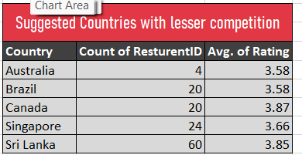

In the Excel file, Sheet name: Suggesting_Countries & cities
Table name: SUGGESTED COUNTRIES WITH LESSER COMPETITION.
Visualization/technique used : Clustered Column; Line with Markers.

2. Come up with the names of States and cities in the suggested countries suitable for opening restaurants.

Strategy: To suggest cities only (as we don’t have names of states) in the suggested countries suitable for opening restaurants, I have taken help of PivotTable to analyze the situation. In the PivotTable, I have taken the country and city in Row field. Count of resturentID, count of Has online delivery and average of rating, all 3 in the value field.

Suggested cities: Cities like Flaxton, Macedon, Penola and some others, which can be selected from Australia. Paulo from Brazil.
Cities like Yorkton, Consort from Canada. And city Colombo from Sri Lanka, and city Singapore can be considered as chosen cities for opening restaurants, as the rating is low but has an online delivery option available with lesser count of restaurants.

Comparing the factors with respect to cities of suggested countries:
(For example) Comparing the city of Indonesia (Jakarta) v/s Singapore-
Singapore is represented as a country, not by city. So, we’ll compare Singapore as a whole with the individual Indonesian cities.
Indonesia (Jakarta):
  - Largest Indonesian city represented.
  - Has moderate competition (16 restaurants).
  - Still a good opportunity given low costs and high ratings.
  - Good for urban reach and larger market base.
Singapore:
- Has 20 restaurants — a similar number to Jakarta.
- High average cost for 2 people (₹13,783), indicating:
  - High consumer purchasing power.
  - But also, high operational expenses (rent, salaries, ingredients).
- Not in top 5 for average customer ratings.
- May be saturated or more competitive given small geography.
Factor | Jakarta (Indonesia) | Singapore (Country)
Number of Restaurants | 16 | 20
Competition Level | Moderate | Moderate
Avg. Cost for 2 (INR) | ~₹1,518 (Indonesia Avg.) | ₹13,783
Customer Rating | 4.30 (Indonesia Avg.) | Not in Top 5 (unknown)
Opportunity Potential | High | Moderate
Setup & Operational Cost | Low | Very High

In the Excel file, Sheet name: Suggesting_Countries & cities
Highlighted name above PivotTable: Suggested cities from suggested countries.

- According to the countries you suggested, what is the current quality regarding ratings for restaurants that are open there?
Strategy: To analyse the current quality regarding ratings for restaurants that are open there, I have assumed Average Rating and Average_cost_for_two_INR as main factors to check it.

Again, with the help of PivotTable, I took the suggested countries on row field, and rating on value field. Changed the value field settings to average. Same method applied on average_cost_for_two_INR.

Visualization/technique used : I have created a combo chart using Clustered Column and Stacked Line with Markers, to help understand the relation between average rating and average of average cost of two.

My View: Compared to restaurants with an average cost of two people, those with lower average costs receive higher evaluations. When launching fresh dining establishments, companies should start off with a low average price for two people until they gather favourable reviews from patrons. Following that, they should keep the average rating and average cost in check. A drop in revenue may result if the average cost is too low.

In the Excel file, Sheet name: Quality_Regarding_Rating

- Also, what is the current expenditure on food in the suggested countries, so we can keep our financial expenditure in control?

Strategy: To evaluate the financial landscape of suggested countries and determine where opening new restaurants would be, I analysed the matter with PivotTable. On my pivot value fields, I have added count of resturentIDS, average of price range and average of average_cost_for_two_INR.
I have also created a table named: Estimated expenditure, keeping a formula logic in mind: Estimated Expenditure = Average Cost for Two in INR × Count of RestaurantIDs
Exact formula I have applied is: =GETPIVOTDATA ("Count of RestaurantID",$B$3,"Country","Singapore")*GETPIVOTDATA("Average of Average_Cost_for_two_INR",$B$3,"Country","Singapore")

[similar for all other 4 countries, Canada, Brazil, Australia, Sri Lanka.]
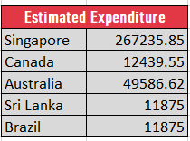

Visualization/technique used: For Visualisation, I created a 3-D Stacked Column Chart and a Filled
Map and a Pie Chart.

•Singapore dominates food spending with over ₹2.6 lakh, accounting for the vast majority of total expenditure.
•In contrast, countries like Sri Lanka, Brazil, and Canada contribute marginally, highlighting a significant spending gap across countries.

In the Excel file, Sheet name: Food_Expenditure

- Come up with the names of restaurants from the recommended states that are our biggest competitors and also those that are rated in the lower brackets, i.e. 1-2 or 2-3.

Method used: I have used a pivot table to analyse this. In the row section, Country (selected from the recommended ones) and restaurant name is there.
In the value field setting average of rating and average voters.
Based on ratings and votes, the competitors are evaluated.

pivot tables :
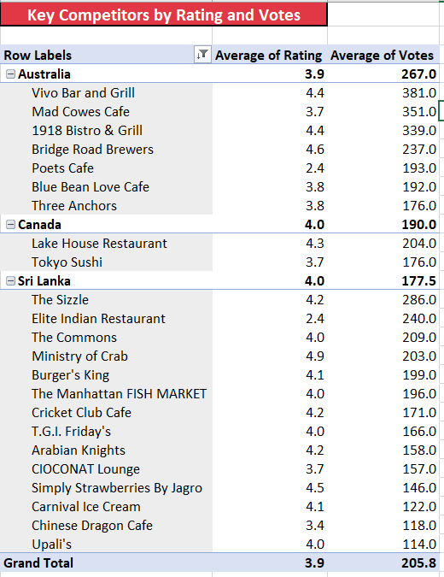
Competitor Insights:
The analysis highlights several top-performing restaurants across Australia, Canada, and Sri Lanka, with average ratings above 4.0 and high customer engagement (votes ranging from 150 to over 380). Notable competitors include Bridge Road Brewers, Vivo Bar and Grill, and Ministry of Crab, each demonstrating strong customer satisfaction and popularity. These restaurants represent key benchmarks for quality and experience within their regions, and should be closely monitored for competitive positioning.

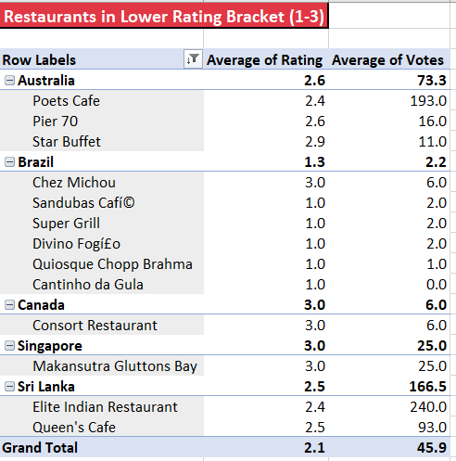

Insights:
- Overall Quality is Concerning:
  - All listed restaurants fall in the low satisfaction range (1.0 to 3.0), with the overall average rating being just 2.1 — a clear indicator of poor customer experience.
- Brazil Has the Most Critical Issues:
  - 5 out of 6 restaurants in Brazil have an average rating of 1.0, pointing to a serious lack of quality and reliability.
  - This market shows the most urgent need for intervention or cleanup.
- Australia and Sri Lanka Have Mid-Low Ratings:
  - Restaurants in Australia average around 2.6–2.9, with moderate vote counts, suggesting inconsistent service.
  - Sri Lanka shows similarly low ratings, but with relatively higher customer engagement (e.g., Elite Indian Restaurant with 240 votes).
- High Vote Count , High Satisfaction:
  - Restaurants like Poets Cafe (Australia) and Elite Indian Restaurant (Sri Lanka) have a large number of votes, but still maintain low ratings (2.4–2.6), implying consistent dissatisfaction over time.
Recommendations:
- Immediate Quality Review in Brazil:
  - Given the extreme concentration of 1.0-rated restaurants, Zomato should consider:
    - Conducting partner reviews
    - Removing consistently poor performers
    - Onboarding higher-quality alternatives
- Support Restaurants with High Engagement + Low Ratings:
  - Restaurants like Poets Cafe and Elite Indian Restaurant receive significant attention but deliver poor experiences.
  - They are ideal candidates for improvement initiatives, such as:
    - Staff training
    - Menu revamps
    - Service audits
- Strategic Focus on Mid-Tier Markets:
  - Sri Lanka and Australia could benefit from:
    - Curated onboarding of new, high-potential restaurants
    - Highlighting any existing 4.0+ performers (if found outside current filter)
- Use This Segment for Reputation Risk Management:
  - Restaurants within this 1–3 rating bracket should be closely monitored using automated triggers.
  - Negative customer experiences from these restaurants could damage Zomato's brand perception in global markets.
In the Excel file, Sheet name: Analysis_Of_Competitors

- Which cuisines should we focus on in the newer restaurants to get better feedback? Does the choice of cuisine affect the restaurant ratings?

Strategy: To analyse the circumstances that focus on cuisine preferences in the newer restaurants to get better feedback, I have taken the help of a chart visualisation: Line with Markers.

In the Excel file, Sheet name: Analysis_Of_Cuisines
In the chart, that defines the ratings of restaurants based on cuisines. I have also sorted each country's rating degree in descending order to showcase which food type is preferred most by the people of those countries.
My View: After reading and examining the chart, I can say that the majority of Australian people prefer Pizza, Bar food, Mediterranean and Modern Australian Breakfast. On the other hand, people from Canada like Japanese and Sushi, Chinese and Italian. In Singapore, Bakery, American Streak is famous as well as Continental. Sri Lankan people extensively prefer Seafood, Juices and Desserts.

Visualization/technique used : Line with Markers chart type.

With the usefulness of this visualisation, it is apparent that the type of cuisine influences the rating of restaurants. While extending the new restaurants among these suggested countries, cuisines can be taken into review. In addition, digging into cuisine varieties that align with emerging food tendencies like plant-based choices or farm-to-table ideas would certainly be a better option.

- According to our current data, should we go for online delivery and table booking? Does that affect the customer’s ratings?

Strategy: My strategy to examine our current data and the decision whether we should go for online delivery and table booking, I have applied the COUNTIFS function, taken the country column and the has_online_delivery column and the has_table_booking column into consideration.

In the Excel file, Sheet name: Online_delivery & Table _booking
In my Zomato excel workbook, I have created a separate worksheet named Analysis_of_OnlineBooking. Where I have created a table named Analysing Delivery and Booking availability.
My applied formula: =COUNTIFS('1.Raw Data'!D:D,"Australia",'1.Raw Data'!M:M,"Yes")
[ for Australia > Has Online Delivery]
=COUNTIFS('1.Raw Data'!D:D,"Australia",'1.Raw Data'!L:L,"Yes")
[ for Australia > Has Table Booking]
A similar formula for both online and table booking for the remaining 4 countries is applied in the same way.
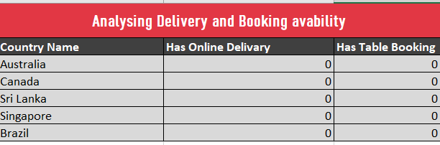
My View: According to me, I would surely suggest opting for an online delivery system and a table booking system for these suggested countries as the restaurants there don’t supply these 2 facilities. Examining whether the price for two and the availability of delivery or table reservations are related. Evaluate whether consumers are prepared to pay extra for these services. This could provide us with a competitive advantage.

- Should the team keep the rate of cuisines higher? Will that affect the feedback? According to our data are the rates of cuisines and ratings, correlated?

Strategy: I created a pivot table in the sheet named Correlation_betweenRC&CINR, where I filtered our suggested countries and took their cuisine types on row fields. I have taken the average value of ratings and the average value of cost of two INR on the value field. I then used a scatter chart to show the relationship between the two value fields.
I have also used CORREL function: =CORREL(L4:L101,M4:M101)
To find the correlation between cuisine ratings and avg. cost for two INR.
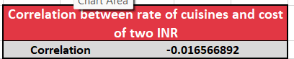
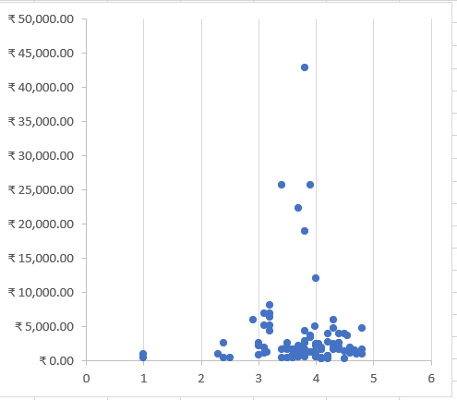

In the Excel file, Sheet name: Correlation_betweenRC&CINR
Visualization/technique used : Scatter plot

My View: The negative sign in my correl output denotes a negative connection. As restaurant ratings climb, the cost of two meals decreases enormously, and the opposite occurs. So, setting competitive pricing just below the highest-rated restaurants in our targeted cuisine can tempt consumers, mostly in price-sensitive markets, while keeping strong perceived value.
Recommendation:
- Do not rely only on higher prices to improve feedback.
- Keep pricing competitive and focus more on service, cuisine quality, and delivery.
If premium pricing is used, restrict it to high-rated cuisines only

- What is the distribution of the number of restaurants of different price ranges in all the countries?

From this pitot table we see that India has the most restaurants with a wide range of prices, according to the PivotTable from which I have obtained assistance. Indonesia has the lowest ranking.

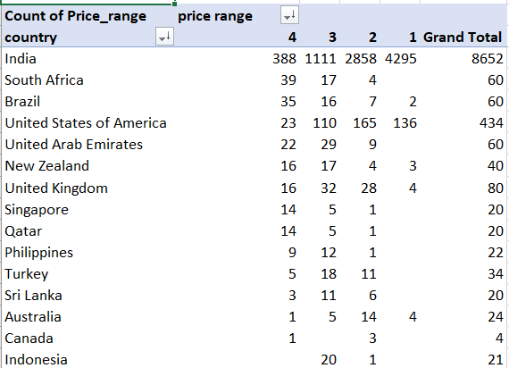

- Insights: India is by far the largest market in this dataset, with over 85% of its restaurants falling in the low to medium price ranges (1 & 2), showing strong demand for affordable dining options.
USA, UAE, and South Africa show a relatively more even distribution, but still lean toward price ranges 2 and 3, suggesting a mix of budget and mid-tier dining preferences.
Countries like Australia, UK, Singapore, and Canada show a higher presence of mid-to-premium restaurants than low-cost options, indicating a target audience with higher disposable income or more premium expectations.
Some countries (e.g., Qatar, Turkey, Indonesia) have minimal restaurant representation, but their few listings lean toward higher price brackets — potentially untapped or niche markets.

- Recommendations: In India and Brazil, Zomato should continue strengthening its partnerships with budget-friendly restaurants by:
- Offering combo deals, loyalty programs, and affordability filters.
- Promoting these restaurants through price-sensitive campaigns (e.g., “Best under ₹500”).
In USA, UAE, UK, and Australia, where premium and mid-tier restaurants are more common:
- Highlight premium listings with quality ratings, chef specials, or ambience tags.
- Introduce premium membership options offering table bookings, exclusive discounts, or curated picks.
For countries with low presence (e.g., Indonesia, Qatar, Sri Lanka), Zomato could:
- Conduct market feasibility studies to explore restaurant onboarding opportunities.
- Launch pilot marketing campaigns to attract local restaurants and understand pricing patterns.

In the Excel file, Sheet name: Price_Range & KPI

- Explain your approach in brief for suggesting countries/cities in order to open new restaurants, if the objective and subjective questions would have not been given to assist you. [you have to give bullet pointers in order to answer this question]

Some of the approaches I consider for suggesting countries/cities for opening new restaurants, if the objective and subjective questions would have not given to assist me….

- New Restaurants: By analysing the verity of cuisines in each country and their corresponding ratings, it could be useful to identify countries with limited cuisines and low ratings.
Then, focusing on opening new restaurants in countries with untapped potential and favourable competitive landscapes, like Brazil, Australia, Sri Lanka.
Equally prioritize cities within these countries with lower restaurant density for optimal market entry.

- Biggest Competitors: A higher number of voters across different countries totally indicates that more people are engaging with restaurants in those regions. This suggest that a strong consumer base and a thriving market, making these areas promising locations for operating new restaurants. This would definitely leads in identifying the biggest competitors, helps in understanding market leaders and their strategies. This information can guide differentiation strategies for new restaurants, such as offering unique cuisine, better service, or innovative dining experiences.

- Cost vs. Rating Analysis: Through analysation, the correlation between these two can simply help in identifying countries where both factors are low. Markets with high dining costs but low ratings highlight gaps where affordable, better-rated restaurants can gain a competitive edge.

- Cuisine Diversity & Ratings: Countries with limited cuisine variety and low ratings present opportunities to introduce diverse, high-quality dining options.

- Customer Engagement: Regions with high number of voters and rating reflect the user activity, indicating a robust and engaged customer base.

