**Data**

*Data Source 1:*

The city of Bangalore is divided into multiple areas or boroughs within which there are a set of neighbourhoods. Data on the boroughs and neighbourhoods was obtained from scraping Wikipedia.

Link : -

<https://en.wikipedia.org/wiki/List_of_neighbourhoods_in_Bangalore>

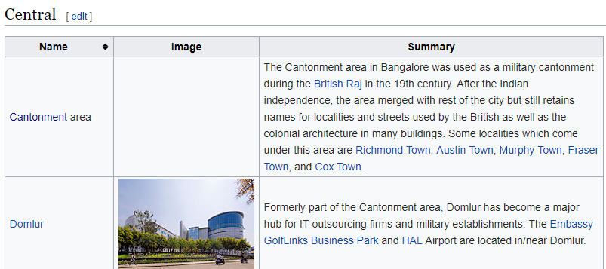

Central would be considered as Borough and Cantonment and Domlur would be Neighbourhoods

*Data Source 2:*

**Geocoding:** The latitude/longitude of the neighbourhoods was not easily available from the geocoder API. After multiple iterations, it was decided to populate this information manually by googling each neighbourhoods separately and finding its coordinates.

**Demographics:** The demographics of each locality were also determined through google search and reasonable approximations

**Commercial Property Rates:** Primary research with rental brokers for a few neighbourhoods was conducted to determine the average price per sqft. This was adjusted for error and approximated for other neighbourhoods

*Data Source 3:*

Data from Data Sources 1&2 were combined into an excel workbook ‘**Bangalore *Geocoding Information.xls’*** with all the information determined to be used for the actual data analysis. The excel workbook was uploaded on Dropbox. The workbook can be downloaded from the below link-

<https://dl.dropboxusercontent.com/s/fan21pjc5qwjov5/Bangalore%20Geocoding%20Information.xlsx?dl=0>