Assignment-1 Outputs

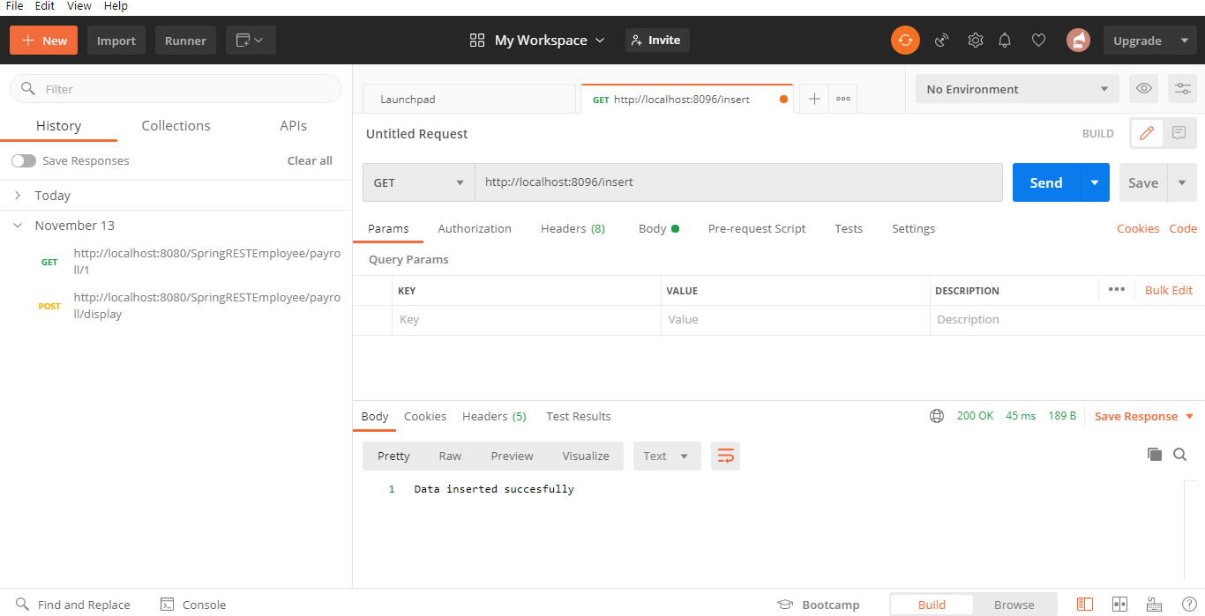

The above picture displays that the Insertion is successful using Get method.

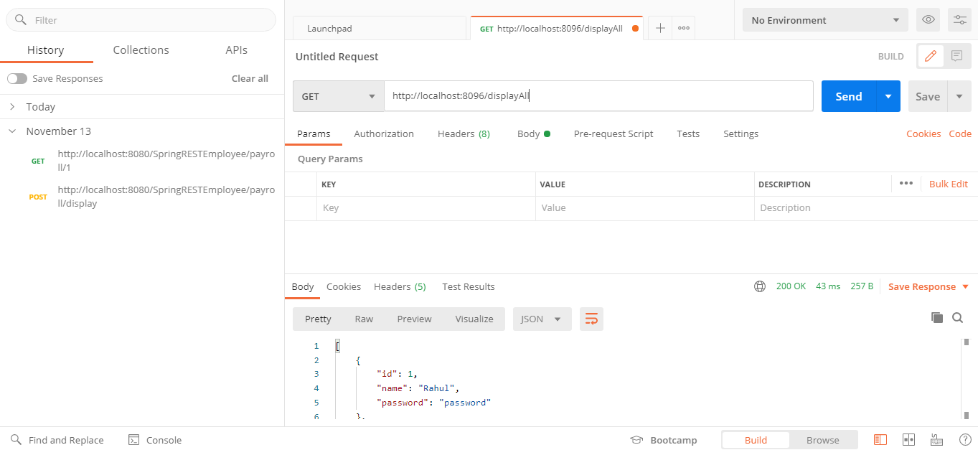

The above image displays all the users which is done using GET in POSTMAN.

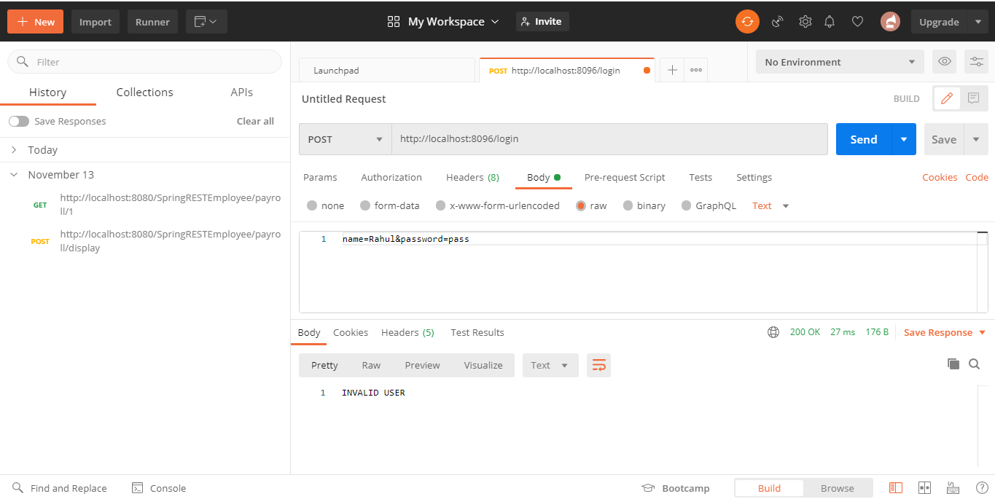

Post is used in the above image, wrong credentials result in invalid user.

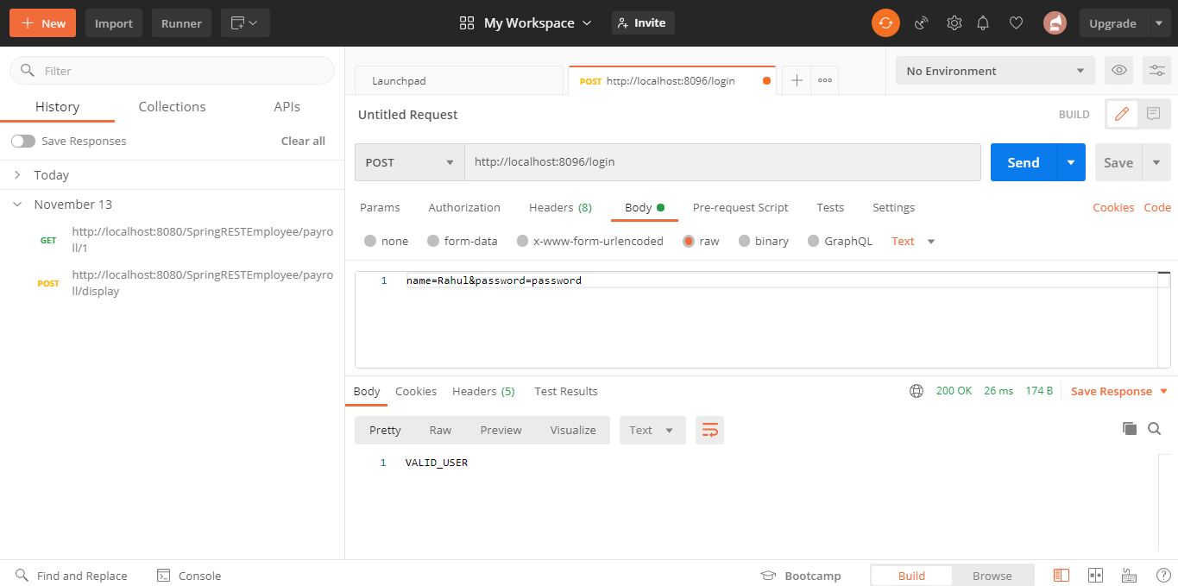

The above image shows the successful validation.

Assignments-2 Outputs

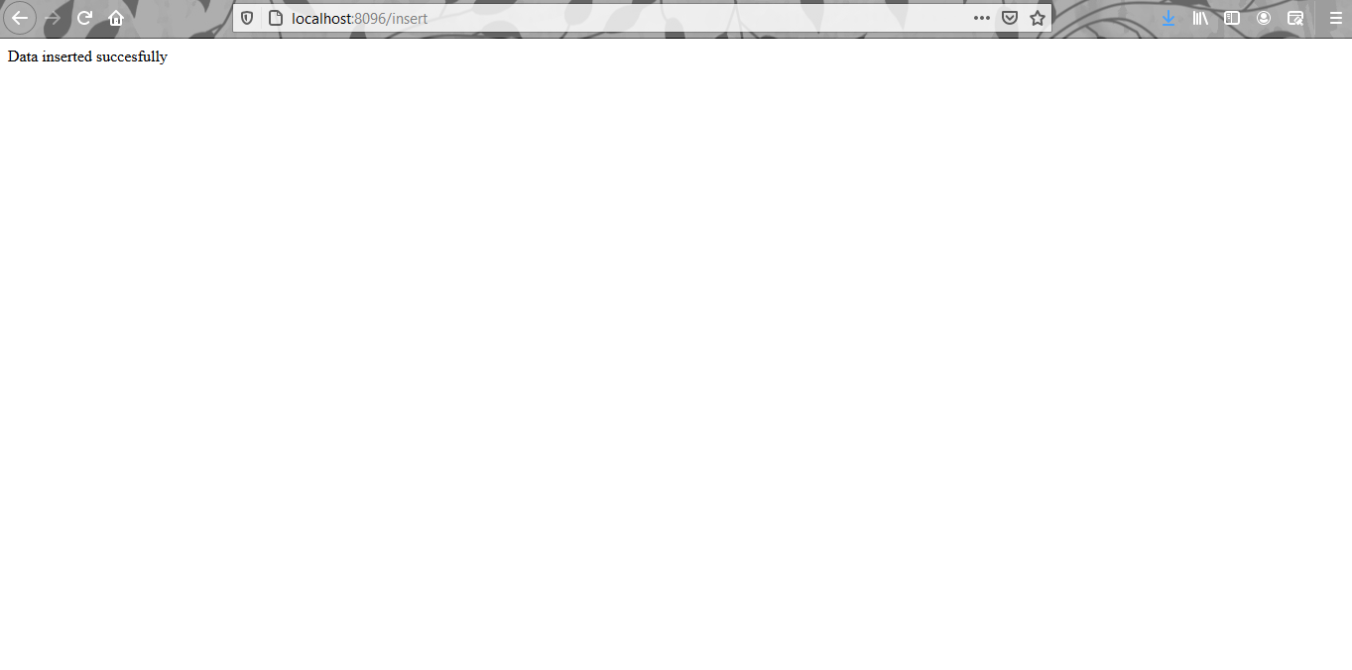

Crud options 1. Insert

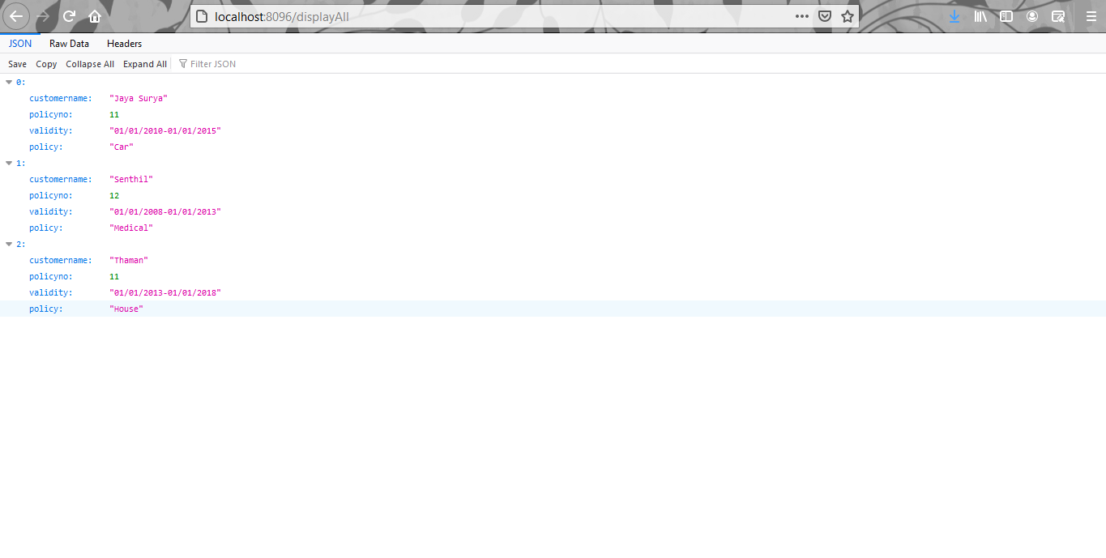

Displaying the details.

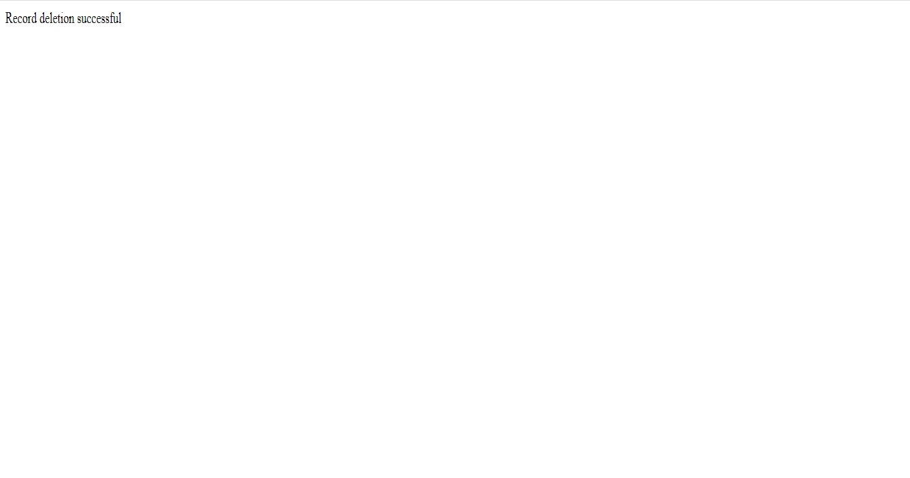

Deleting the record using id/policyno