**📄 AI Resume Ranking System**

**📌 Overview**

**The AI Resume Ranking System is a web application that automates resume screening using Google Gemini AI. It extracts text from uploaded resumes (PDFs and DOCX files), compares them against a given job description, and ranks them based on relevance.**

**🎯 Features**

**✅ Multi-format Resume Support (PDF & DOCX)  
✅ AI-powered Resume Ranking (Google Gemini API)  
✅ CSV Download (Ranked results)  
✅ Interactive Web UI (Powered by Gradio)**

**🛠️ Technologies Used**

* **Python 🐍**
* **Gradio 🎨 (Web UI)**
* **Google Gemini API 🧠 (AI-based resume analysis)**
* **PyPDF2 📄 (PDF text extraction)**
* **python-docx 📑 (DOCX text extraction)**
* **Pandas 📊 (Data processing)**

**⚙️ Installation & Setup**

**1️ Install Dependencies**

**pip install gradio pandas PyPDF2 python-docx google-generativeai**

**2️ Set Up Google Gemini API Key**

* **Sign up for Gemini API (if you haven't)**
* **Obtain API Key and add it in the script:**

**genai.configure(api_key="YOUR_GEMINI_API_KEY")**

**3️ Run the Application**

**python app.py**

**The app will launch at: http://127.0.0.1:7860/**

**🏗️ Application Architecture**

**1️ File Upload 📂**

* **Users upload multiple resumes (PDF/DOCX).  
  2️ Text Extraction 📝**
* **PDFs: Extracted using PyPDF2.**
* **DOCX: Extracted using python-docx.  
  3️ AI Ranking 🧠**
* **Resumes are analyzed against the job description using Gemini AI.**
* **The model returns relevance scores (0-100).**

**4️ Results Display & CSV Download 📊**

* **Ranked resumes are displayed.**
* **Users can download the results in CSV format.**

**📝 Prompt Structure for Gemini API**

**The AI ranking is based on this prompt:**

**You are an AI assistant ranking resumes based on job descriptions. Here is the job description:**

**{job_description}**

**Below are the resumes of candidates. Assign a relevance score (0-100) based on how well they match the job description.**

**Return results in valid JSON format:**

**[{"name": "resume1.pdf", "score": 85}, ...]**

**Resumes:**

**{resumes}**

**🖼️ Screenshots & Demo**

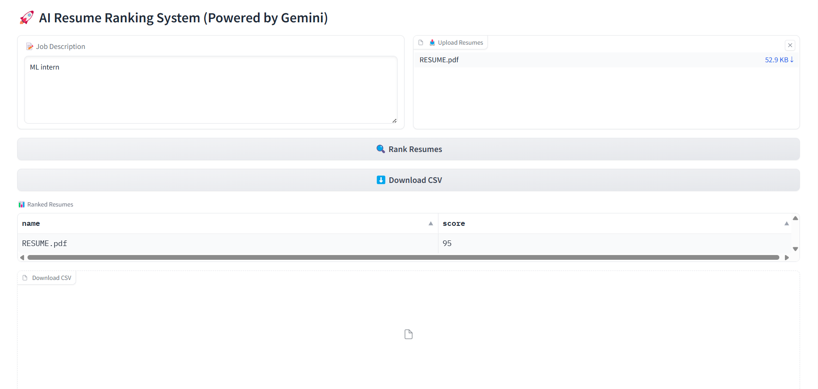

**User interface**

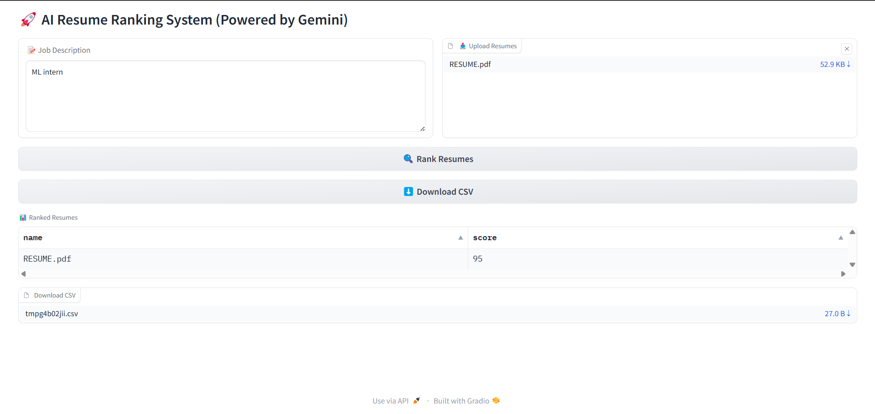

**Resume Score**

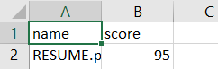

**Output can be downloaded in csv format**

**🔮 Future Improvements**

* **🛜 Cloud Hosting (Deploy on AWS/GCP)**
* **🔍 Keyword-based Matching (Using NLP)**
* **📈 AI Model Fine-Tuning (Better ranking accuracy)**
* **🗣️ Multilingual Resume Support**

**🤝 Contributing**

**🚀 Feel free to contribute! Fork the repo, create a new branch, and submit a PR.**

**📧 Contact**

**For queries or suggestions, contact:  
📩 Email: thatikondavigneshwar272@gmail.com  
🐙 GitHub:** [**rahulmani-28**](https://github.com/rahulmani-28) **💼 LinkedIn:** [**Vigneshwar Thatikonda**](https://www.linkedin.com/in/thatikonda-vigneshwar-8a94912a0/)