Below are the list of requirements mentioned in the **Technical Assessment document**

1. Have created the GIT HUB and code is available at <https://github.com/rahulmgtata/crud-demo>
2. Validated the INSERT / UPDATE / DELETE / GET_CUSTOMERBY_NUMBER / GET_ALL_CUSTOMER

Sample Output: **Create Customer**

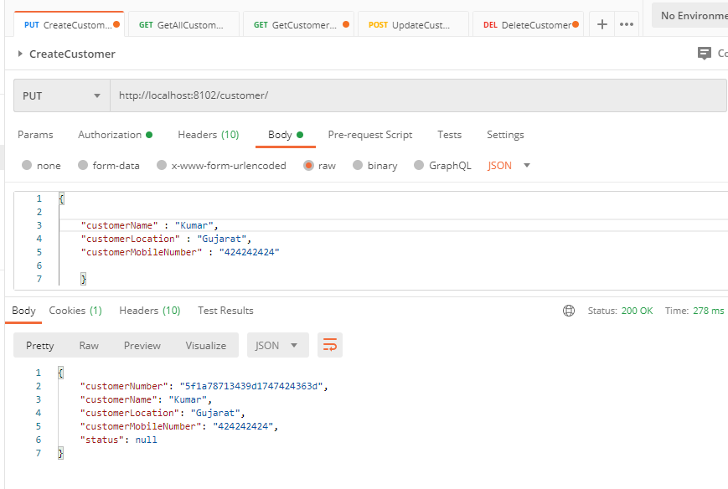

**GET Customer By Number**

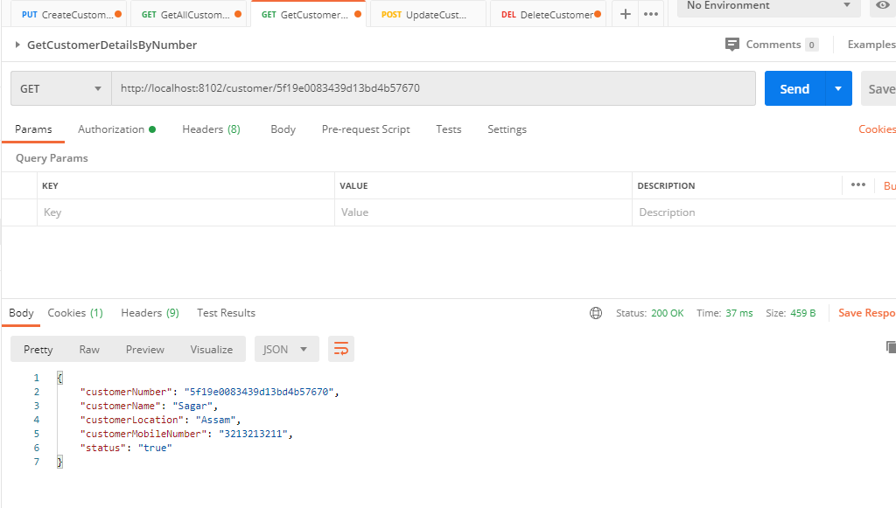

1. Implemented BASIC Authorization Header, all the REST service request are Authenticated. Below is the output for the request were authentication failed.

**Authentication Error:**

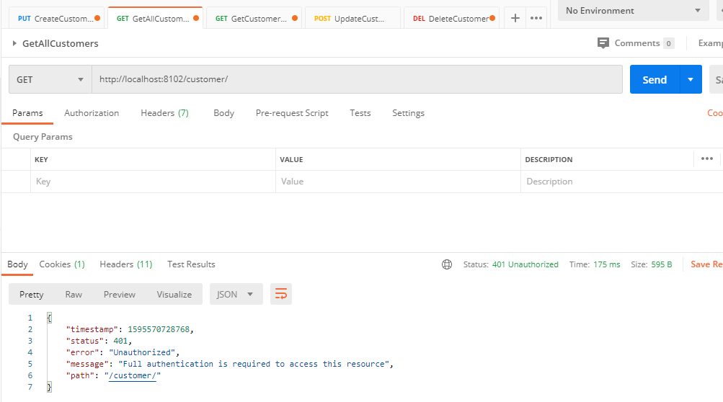

1. Check done using the status field, if status is FALSE, details are not fetched.

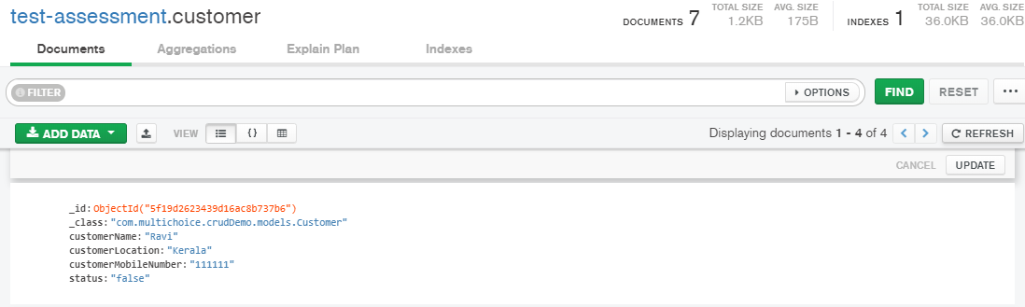

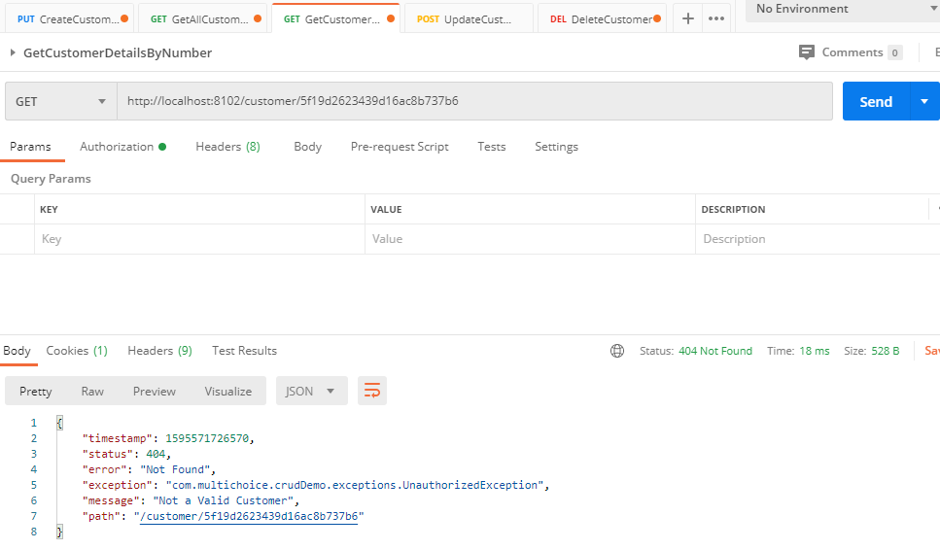

1. Cache the data was done using Caffeine, the getAllCustomers() method is using the feature of Cacheing.
2. Was able to completed the Unit tests for few of the REST services.