Solution - 4

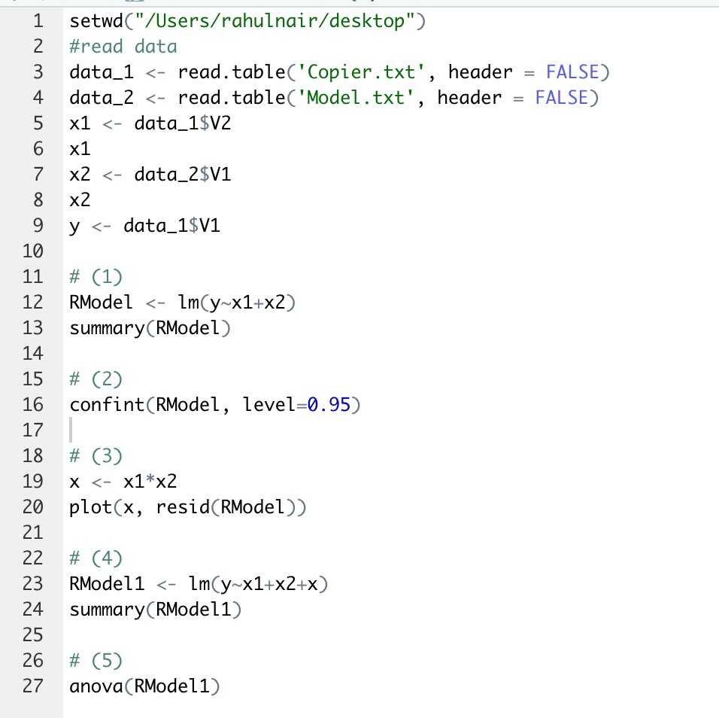

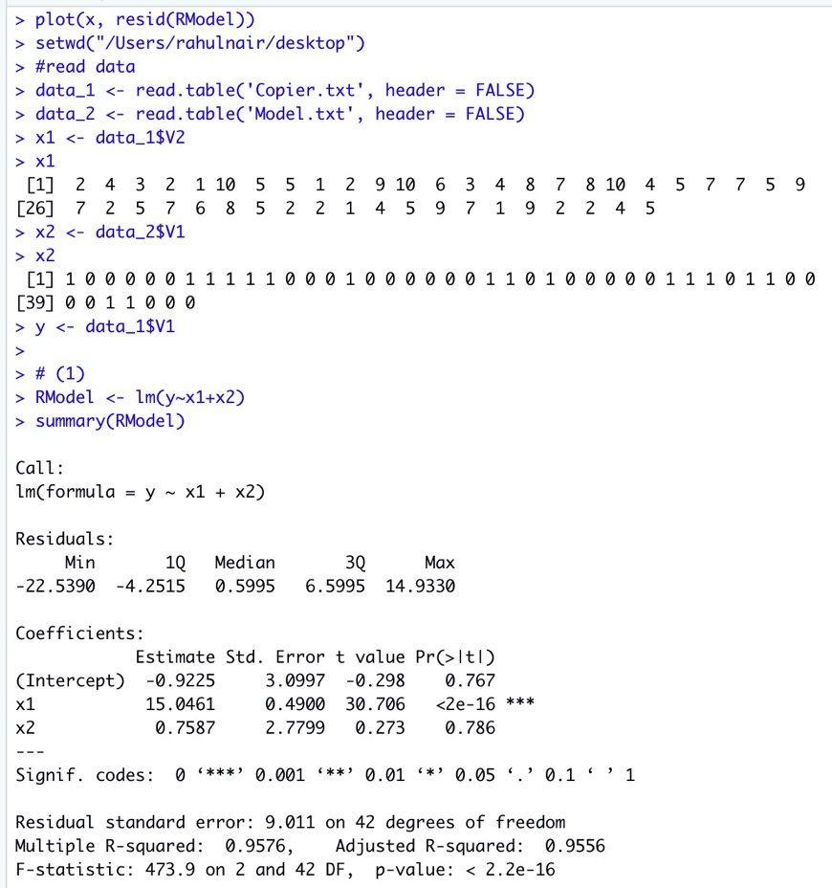

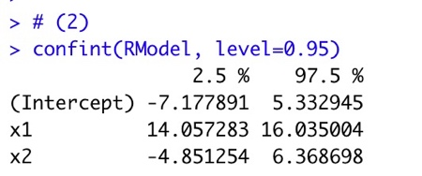

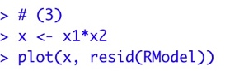

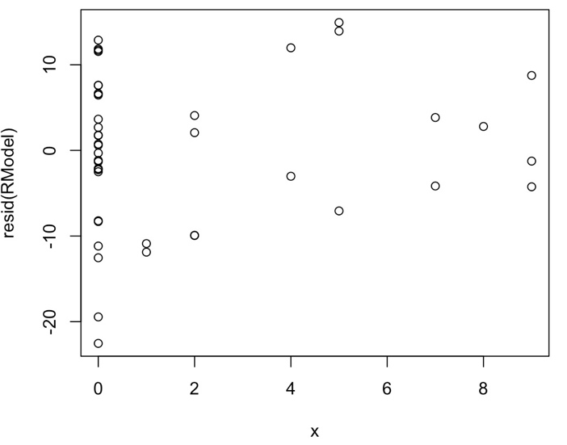

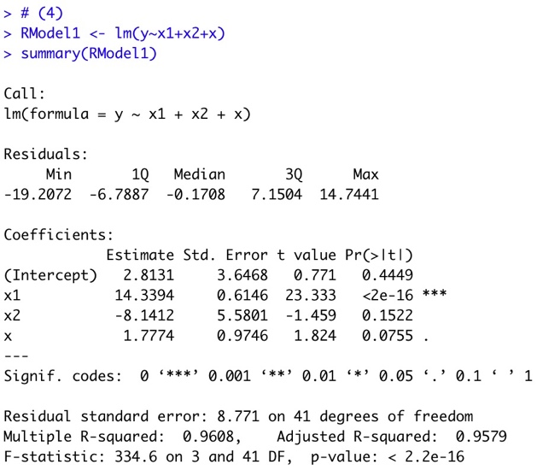

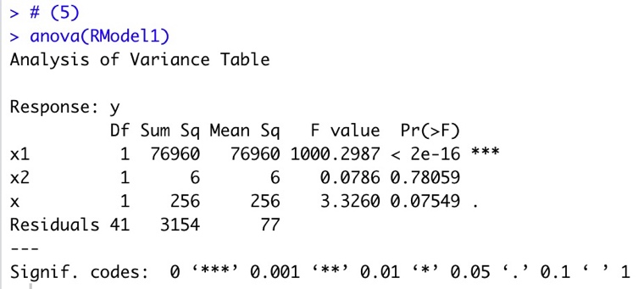

H0 : Interaction term should be dropped from the model.

Ha : Interaction term should not be dropped from the model.

α = 10%

Since F* of the model is less than the F for given α,

We **reject the null hypothesis**. Therefore, interaction term should be there in the model.