**RESUME**

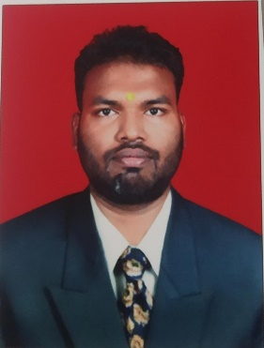

**Name of the student:** Rahul Dattatray Motipalle

# Mobile: +91-8624984001

**Email:** [rahulmotipalle99@gmail.com](mailto:rahulmotipalle99@gmail.com)

**CAREER OBJECTIVE**

To work in a firm with a professional work driven environment where I can utilize and apply my knowledge, skills which would enable me to grow while fulfilling organization goals.

|  |  |  |  |  |  |
| --- | --- | --- | --- | --- | --- |
| **Sr.**  **No** | **Degree** | **University/Board** | **Passing**  **Year** | **Score** | **Class/** |
| **1.** | **Bachelor of**  **Electrical Eng** | Shree Ramchandra Collage of  Engineering Lonikand, Pune | 2022. | 8.04  (CGPA) | First class |
| **2.** | **Diploma** | Vishweshwaryya Polytechnic  Alamala, Latur | 2018. | 69.52% | First  Class |
| **3.** | **SSC** | Tirupati Vidhyalaya pangaon, tq  Renapur dist.Latur | 2015. | 76.40% | First  Class |

**ACADEMIC QUALIFICATION**

**TECHNICAL SKILLS**

**SQL**

* Knowledge of **RDBMS Concept**
* Comfortable in writing **SQL statements** like **DDL, DML, DQ**L
* Good understand of **SQL** queries

**JAVA**

* Knowledge of **OOP's concept**
* Knowledge of **Abstractio**n and **Encapsulation**
* Knowledge of **Arrays, Collection** and **Generics**

**MANUAL TESTING**

* Knowledge of **Black Box Testing**
* Knowledge of **White Box Testing**
* Knowledge of **SDLC**

**WEBSERVICE**

* **Knowledge of API Testing**
* **Knowledge of JSON & XML**
* **Knowledge of SOAP & REST Webservice**
* **Knowledge of writing API test cases.**

**API Testing Project:**

**Domain: E-commerce**

# Academic Project:

**Project Name:**  “Solar Base Mini Refrigator for Rural Area medical Priventation,”

**Description:** Thise Project useful for rural area people for medicine storage for long time purpose.

The compact size and weight requirements, as well as portability in the design, rule out the use of conventional refrigeration

**Time Period: 6** Month

## **Extra-Curricular Activities:**

# Playing Chess

# Book Reading

# Food Cooking

**PERSONAL DETAILS**

* **Name:** Rahul Dattatray Motipalle
* **Date of Birth:** 03-01-1999-
* **Marital Status:** Unmarried
* **Nationality:** Indian
* **Languages Known:** Marathi, English and Hindi
* **Hobbies:** cooking, listening music and Playing chess

## **Declaration:**

I do hear by declares that the above mentioned information is true to the best of my knowledge and belief.