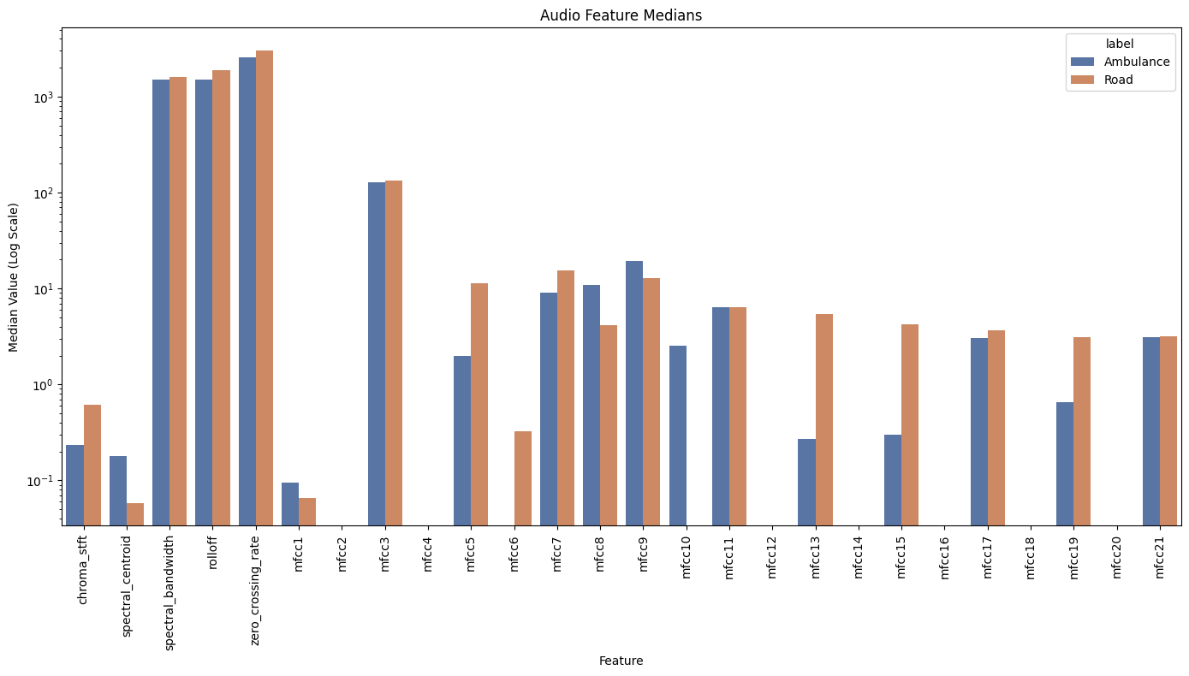

*Figure 1: Audio Feature Median Values For Ambulance vs. Road Noise (log scale)*

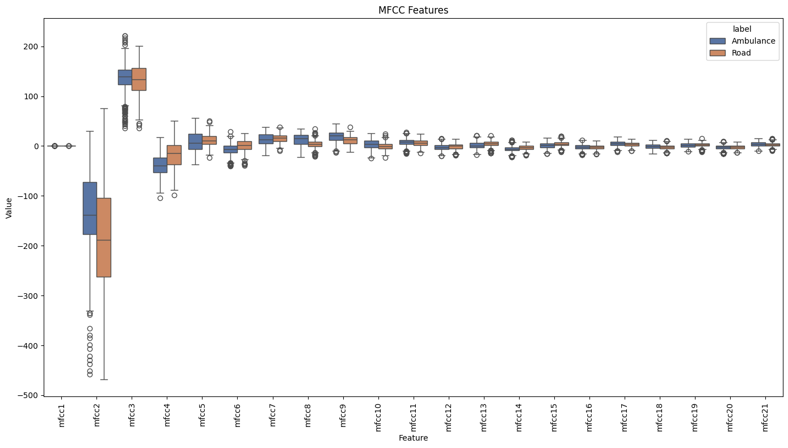

*Figure 2: Boxplots of MFCC Feature Values For Ambulance vs. Road Noise*

*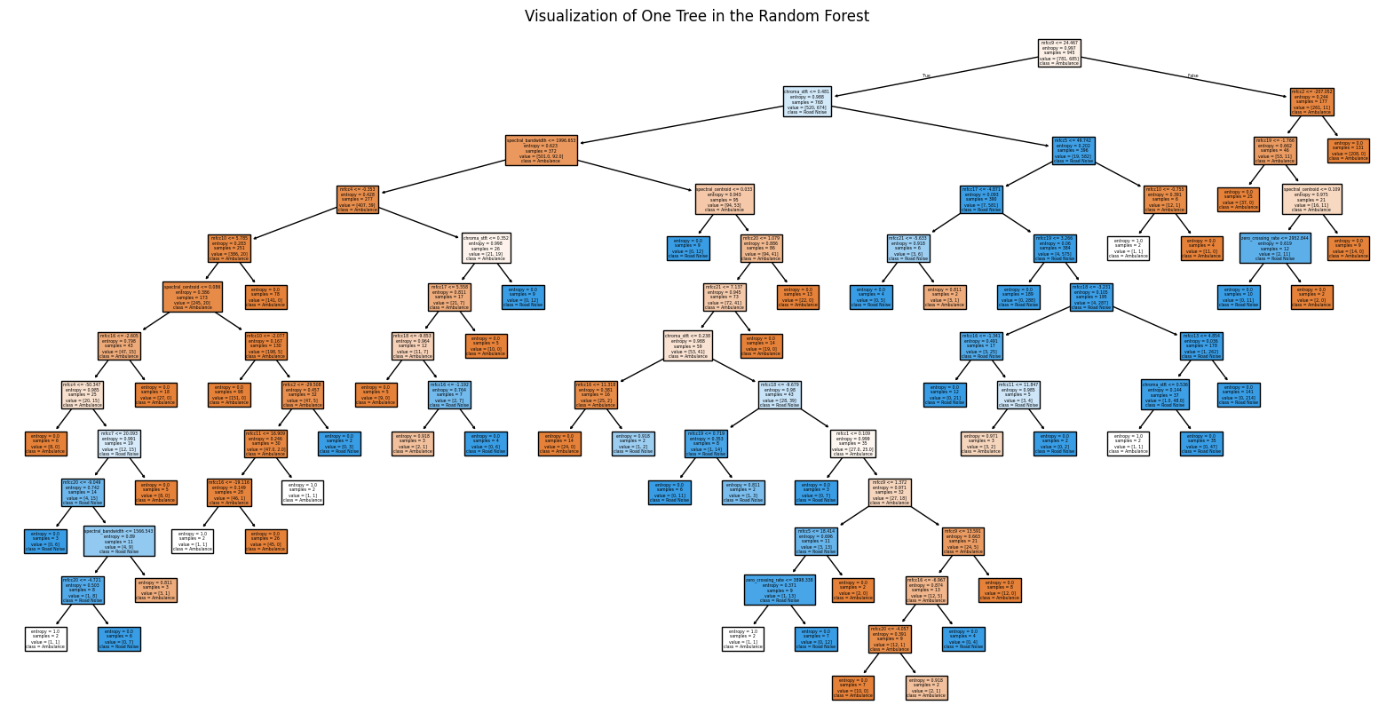*

*Figure 3: Visualization of one tree in the Random Forest Model*

*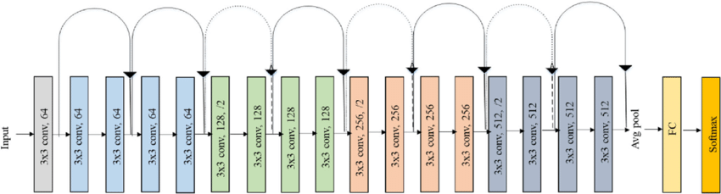*

*Figure 4: ResNet Architecture from [5]*

*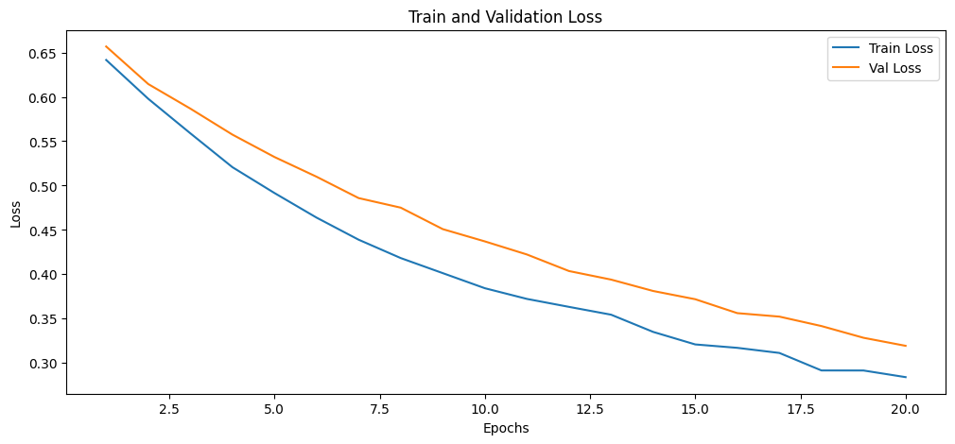*

*Figure 5: Phase 1 - Training and Validation Loss by Epoch Curve*

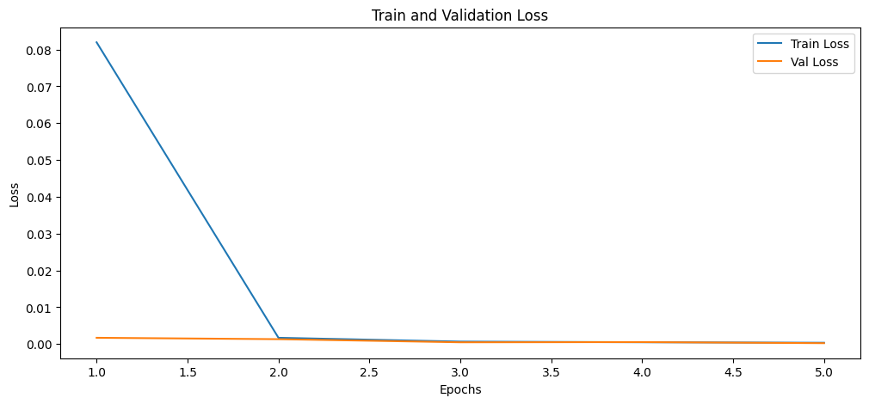

*Figure 6: Phase 2 - Training and Validation Loss by Epoch Curve*

*Figure 7: Feature Importances for Random Forest Model*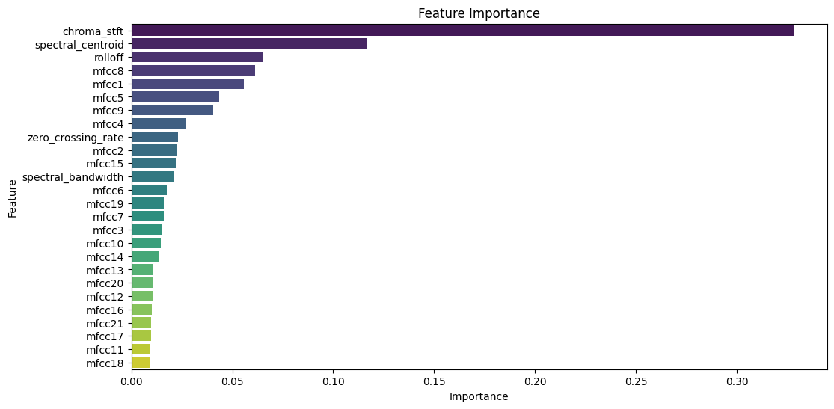

*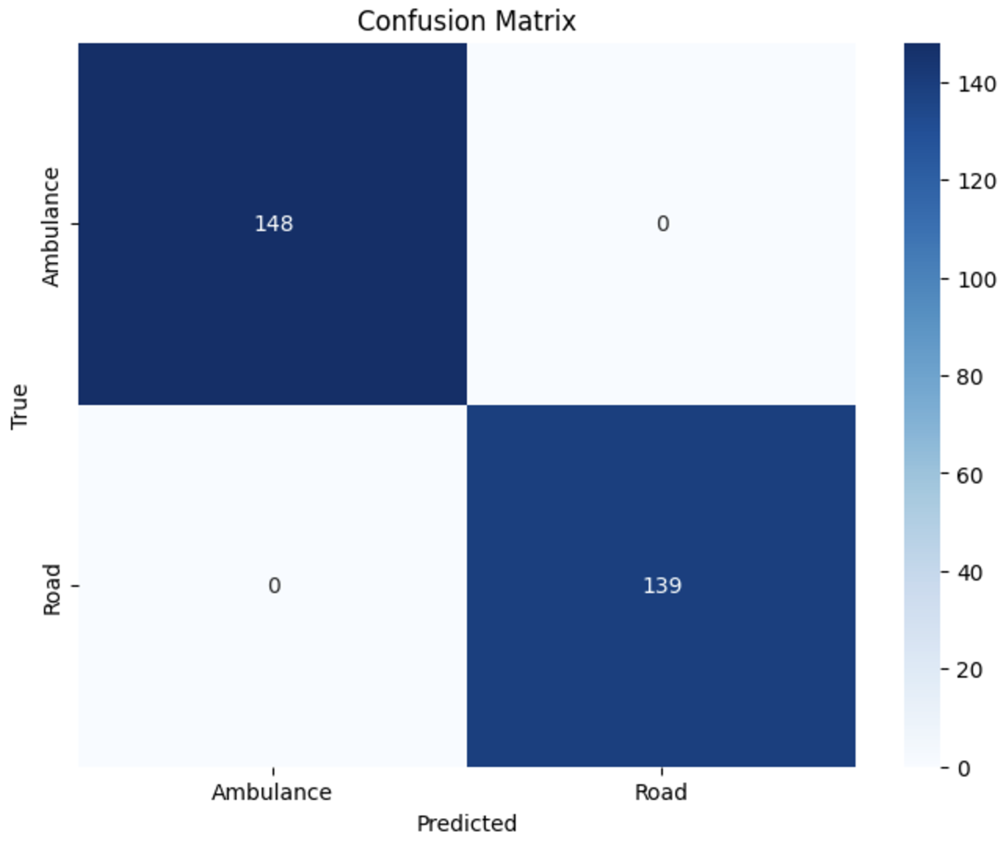*

*Figure 8: Confusion Matrix of ResNet 18 model*