#code_1

a=[1,2,3,4,5,6] #save with this file as file.py

import file

print(file.a). #save with this as a myfile.py

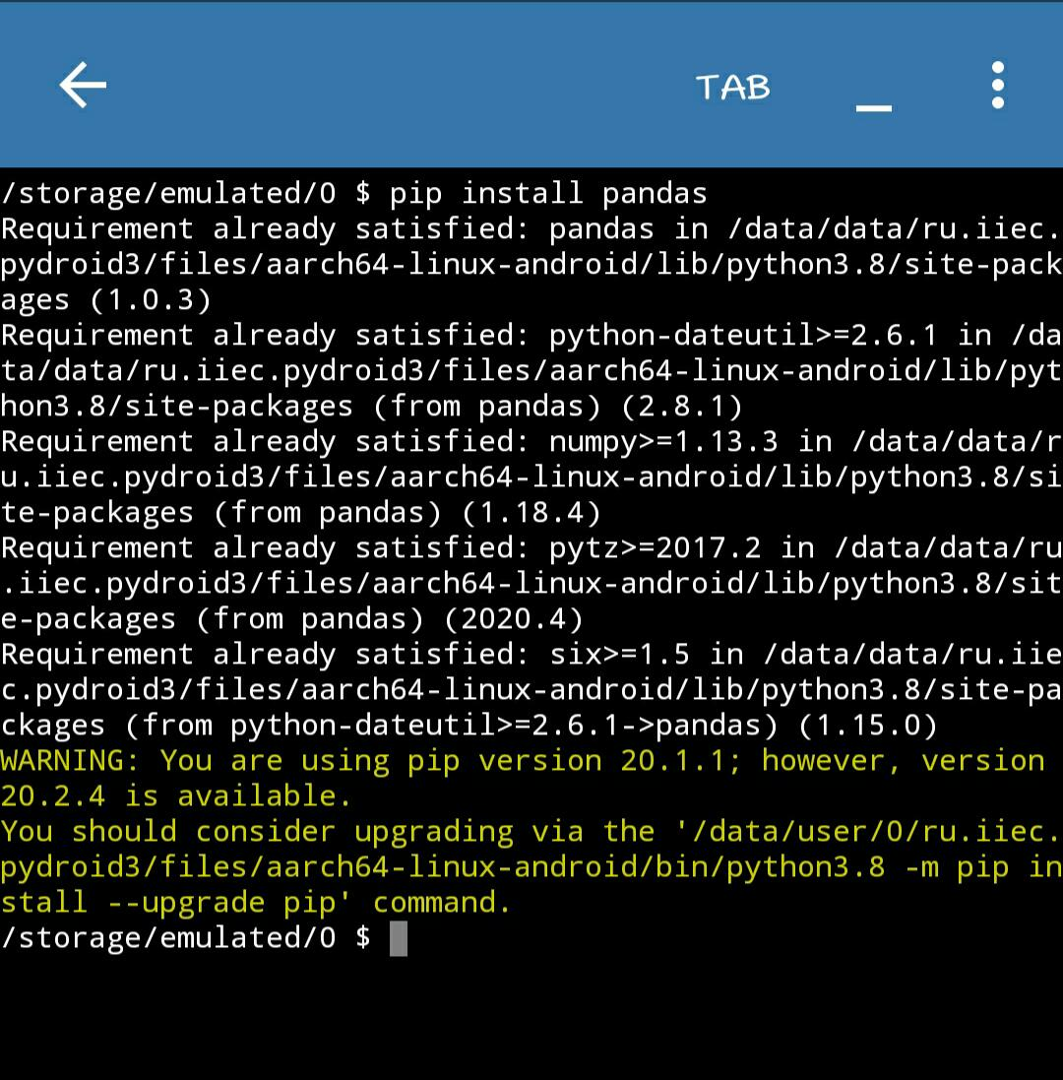#code_2

#code_3

import random

x = random.randint(0,50)

print(x)

#code_4

import sys

sys.argv[0]

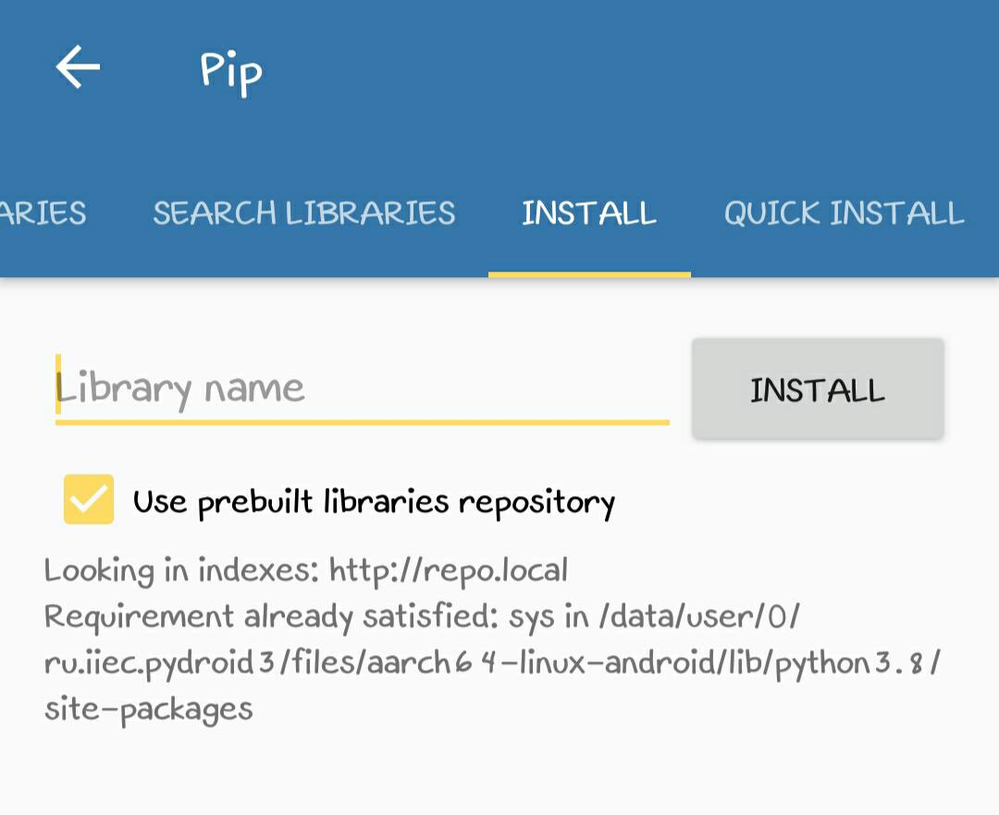

#this picture is of installation of sys package

#sys package runs on interpreter

import sys

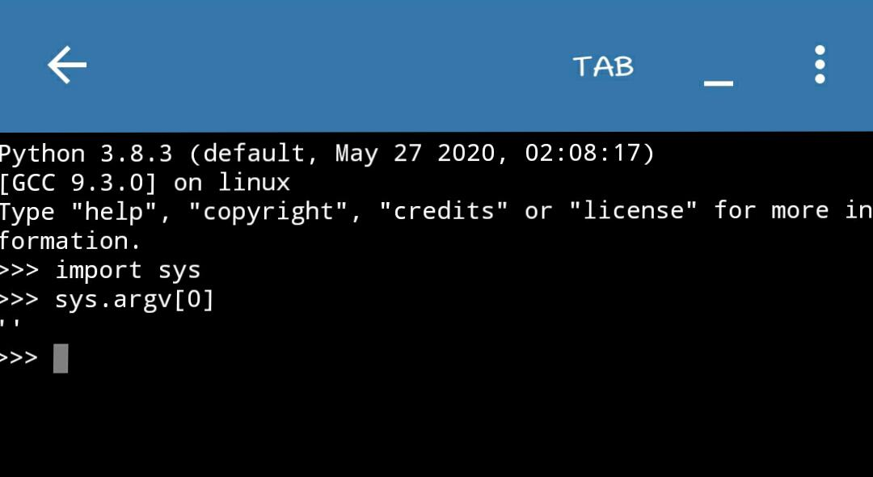sys.argv[0]